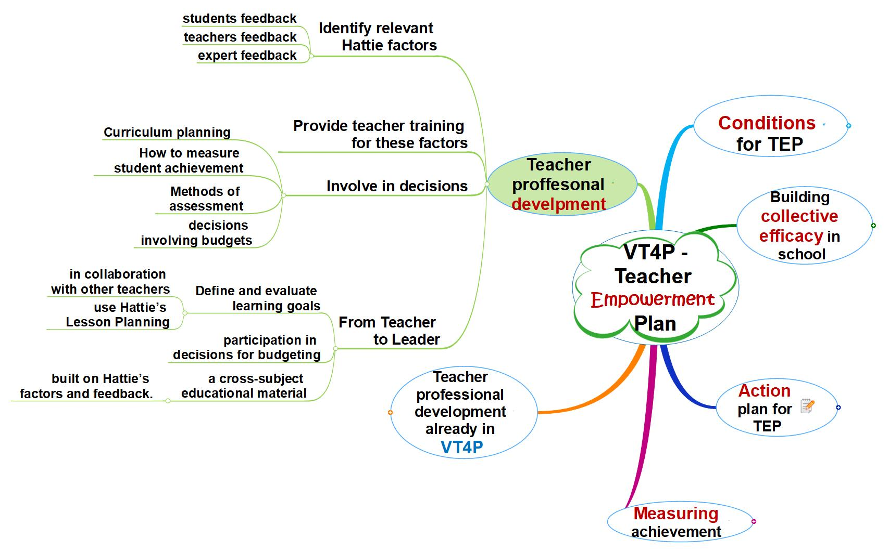
ERASMUS+ „Visible Teaching4Performance“(Strategic School Partnership) 2017-1-PL01-KA219-038284

