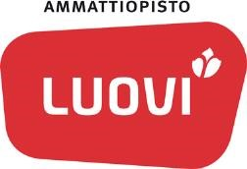Kuvaus 1 (1) Julkinen Anne Tornberg

5.3.2020

The pedagogical anchors of Luovi - direction towards good teaching and guiding
On going changes in our working enviroment require vocational school to renew teaching, pedagogical thinking and most of all the ways of working and operating. The role of teachers and assistant personnel is changing when learning is happening more in working life and outside of the walls of the school buildings. Teachers and assistants are coaches who enable learning. To be able to provide effectily the most important assignment to vocational eduacation and training which is proving competent labour force for labour market, it’s important to define common pedagogical guidelines according Luovi quality.

We started a project which aim was to define common understanding of special needs eduacation and training at Luovi. We wanted to define the pedagogical anchors of Luovi in the project and to crete also common guidelines of excellence teaching and guidance. In practis this ment bringing the strategy of Luovi to our day-to-day work of teaching personnel. We also wanted ensure our operational quality by developing a procedure for evaluation of competence of our teaching personnel. The evaluation brings out the strenghts of compentence and areas of improvement and also provides targets to support our strategy by development of competence

We defined pedagogical anchors in workshops (see the picture). To these workshops attended everybody in the staff of Luovi (about 700) and representatives from students, working life and companionships. In workshops we discussed together about the changes which new legislation and operational environment provides to teaching, guidance and the pedagogy of Luovi.

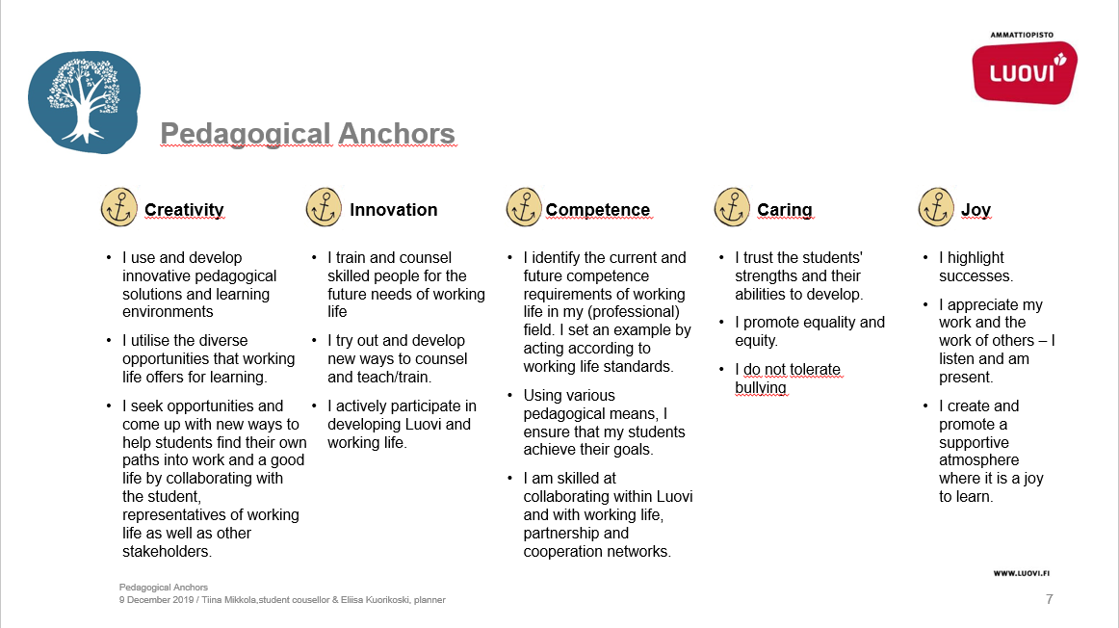
We have also developed 360-evaluation procedure, in which questions are based to pedagogical anchors which are specified together with the groups mentioned above. In evaluation the teachers, assistants and the staff of support services for studens evaluate themselves. They also get an evaluation of how they do their job from their boss and at least three collagues and students. After this the feedback was discussed in teams and everyone made their own Peda path to improve their competence.

Peda path -plan is a part of Luovis sparring management system. Everyone in staff will discuss together with their boss about ones own evaluation in development discussions and agree together how and when he/she will improve their compentence.

In the future pedagogical anchors and their currentness is going to be evalutuated every year as a part of Luovi’s annual leading calender (annual clock) and it will be updated if needed. Also 360-evaluations are going to be continouos and evaluations will be done for the personnel every 2-3 years. In this way we ensure Luovi quality in our operations and ongoing development of competence in our personnel.

Pedagogiset ankkurit -hanke, Ammatillisen koulutuksen strategiarahoitus 2018, OKM, https://luovi.fi/luovi/projektit/pedagogiset-ankkurit/

Ammattiopisto Luovi Veteraanikatu 2 Puhelin 020 757 4000
[Kirjoita toimipiste/yksikkö] 90130 Oulu www.luovi.fi Y-tunnus 0201472-1

