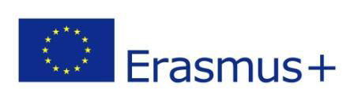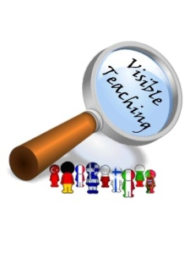
VT4P Erasmus plus 3rd TPM live online meeting Report 9th June 2020
Due to the extraordinary situation caused by the coronavirus pandemic the real meeting scheduled for March 2020 in Rybnik was transformed into collaborative online work whose part was the live online meeting with the use of the Zoom platform.
Objectives of the meeting: Realizing the objectives planned for the 3rd TPM in Rybnik:
- Teacher Empowerment Plans/ School development plans.
- Exchanging good practices. Team Empowerment.
- Final report.
- Future cooperation.
Delegations from the Bulgarian, Finnish, French, German, Greek, Polish, Portuguese and Turkish partner schools attended the meeting.
The meeting started with the project coordinator’s official welcome, presenting the objectives of the meeting followed by expressing the hope for the future collaboration of our schools in the challenging new reality after submitting the new Application form.
Partners exchanged information about the current situation in their local schools, regions and their countries with the predictions for the future school activities based on the government statements.
With the use of “mentimeter” participants were asked to write down words/expressions to empower the team. Also with this tool ideas supporting online teaching were collected ( ideas published here: https://twinspace.etwinning.net/50561/pages/page/922806 and in the following presentation: https://twinspace.etwinning.net/files/collabspace/1/61/561/50561/files/bb875d1c0.pptx)
Final product ( Teacher Empowerment Plan) was presented by the project coordinator. Afterwards Mrs Tiina Mikkola shared the objectives and ideas connected with the VT4P pedagogical anchors in Luovi Vocational school.
The presentations were followed by a discussion about useful tools and platforms used in online teaching, assessment and dealing with evaluation. Partners exchanged useful ideas about how they were dealing with online teaching bringing up crucial factors indispensable not only in the new reality.
Free webinars by Osiris Educational were recommended. Information and useful tips from the webinars already held and attended by the project coordinator were disseminated.
At the end of the meeting crucial points about the final products and report were discussed.
Finally our VT4P story was presented in the video format which brought back memories of our work together and the project team spirit.
It was a great pleasure to meet online, see one another and be able to shape the so far unknown new, with great support of each participant sharing good practices and empowering our team.
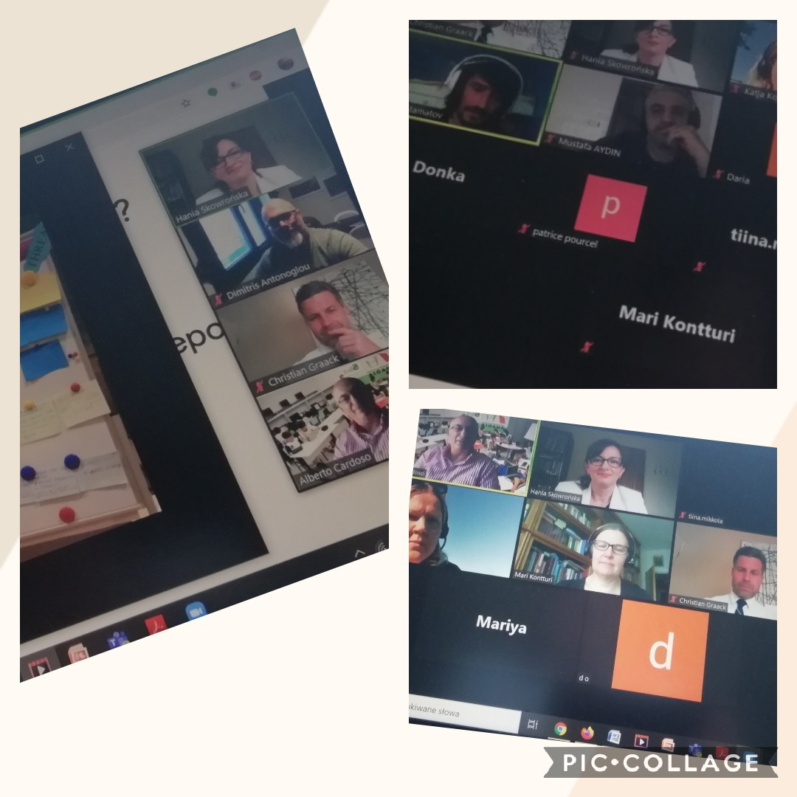
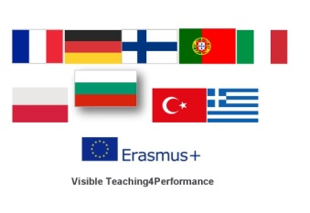
Project coordinator: Hanna Skowrońska
2017-1-PL01-KA219-038284_1

