FATVILLE
&
THINVILLE

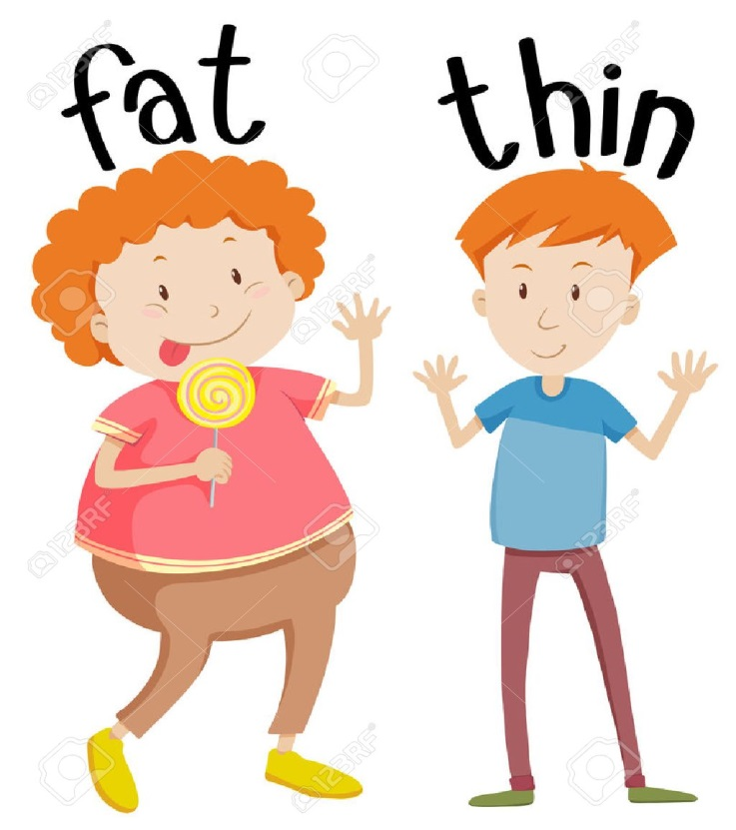

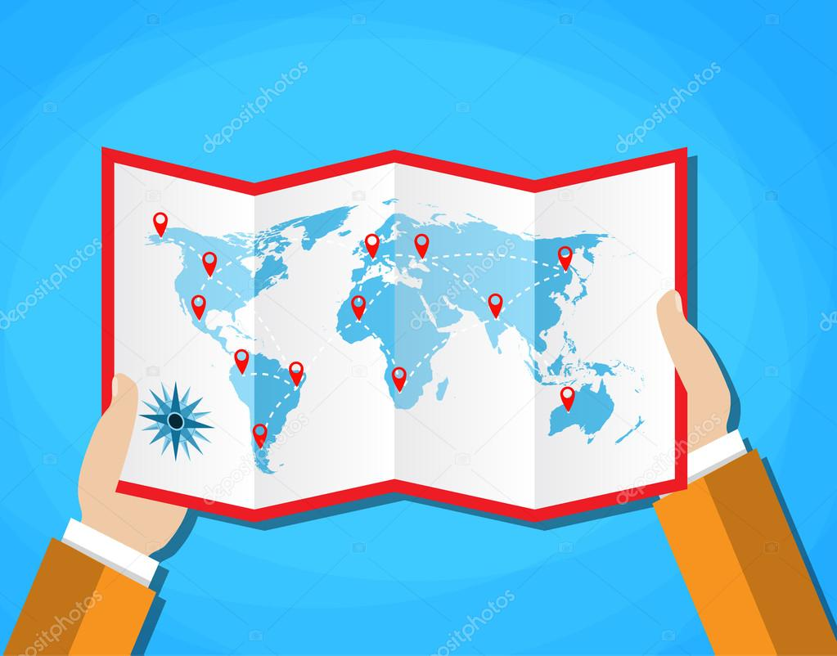
The Fatvillers and the Thinvillers were two races of strange people who lived in a strange and far away place of Europe. They had different opinions for everything and specially about the quantity and the quality of the food.

The fatvillers were very fat people because they were eating. At the morning they started eating. Salami,cheese,sweets,chocolate, ice cream, burgers,fries,chips,biscuits….They were eating and eating without stopping.Also,they wanted to do a surgery to get a second stomach so that they could eat a lot more. The only purpose in their life was eating!!!
Yummy
yummy!1

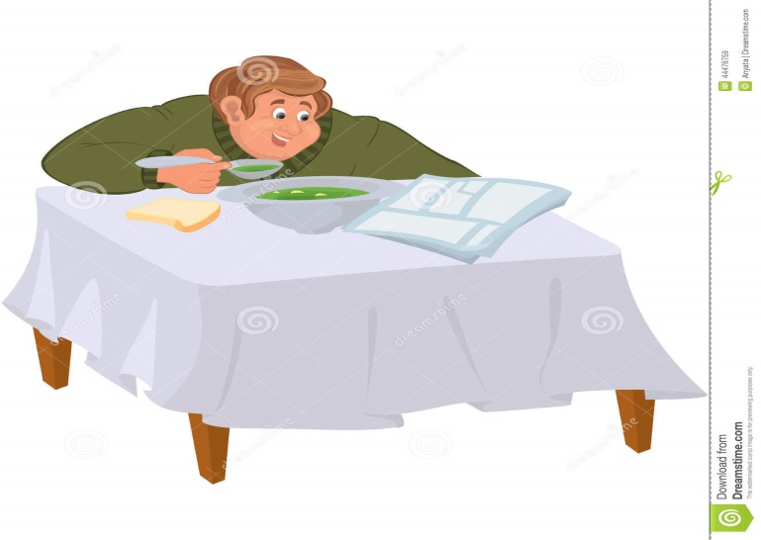

Not a lot far away, there were living the Thinvillers. They were some very thin people who were ready to fail because they hadn’t eaten for ages .And that’s because they didn’t like anything, they found every food immobile, unsolvable and sour and everything stank to them. They were just eating very little and that they could be maintened and not to hunger.

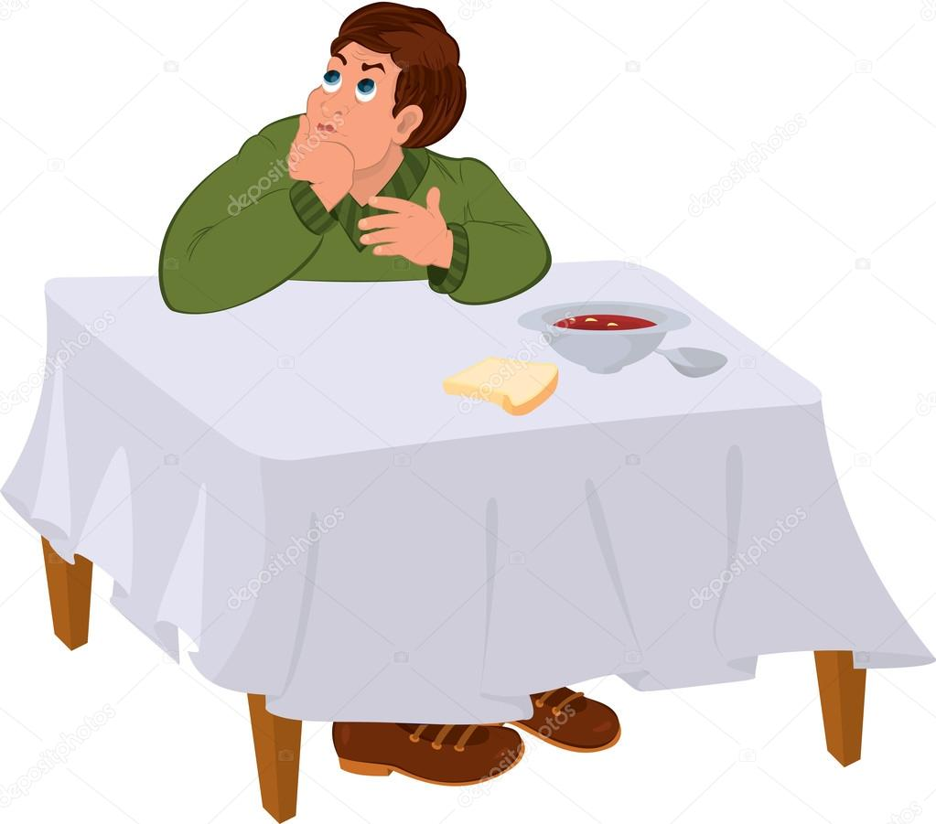
Their empty stomach was purring all the time. Purring and purring that at least it got bored and stopped purring.
yak

Like time was passing by, problems started appearing in the health of Fatvillers and in the life of Thinvillers . The doctors were going from Fatviller to Thinviller and from Thinviller 7 to Fatviller. The seriousness of the health problems were getting even worse.

One day,a team of Normalvillers arrived at their land.
The Normavillers had come to visit the Fatvillers and the Thinvillers because they had heard that something bad was going on in their lives. They had also brought with them:
“ THE MAGIC SOUVLAKOPITA”
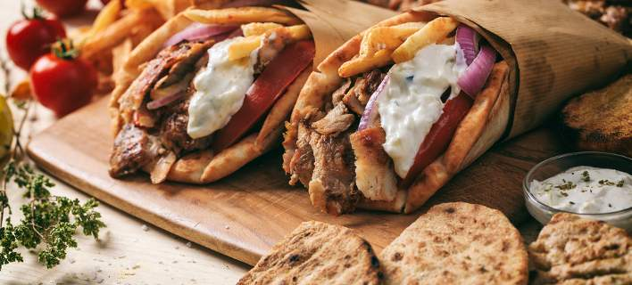

The leader of the Normalvillers explained to them that all the things have to be done with moderation.That is the secret of being healhy!
So ,the Fatvillers and the thinvillers made their big decision: TO EAT THE MAGIC SOUVLAKOPITA That would make them normal!

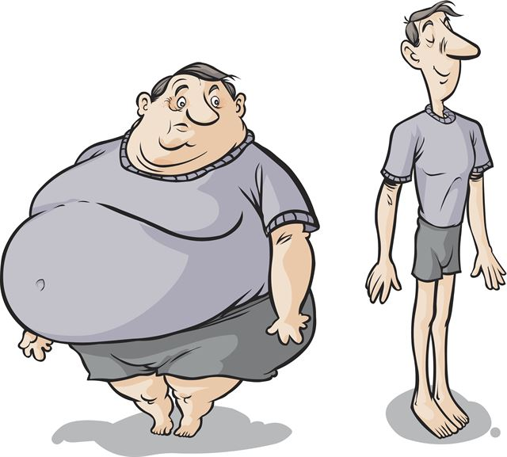
And actually, the Fatvillers started losing weight and the Thinvillers started gaining weight.

It was then Fatvillers and the Thinvillers decided to be joined and to live together in one land.

But there was still a problem… How should they name their land?

The Normalvillers had to help them so they decided to name their land:

NORMALTOWN
!!!!!!!!!!!!!!!

“These things happen when we go to the edge and we need others to solve our problems”
THE END

To make home-made skewers you will need:

- Meat cut into small pieces for souvlaki (pieces of chicken or pork without much fat)
-Butters (except for classics, such as rye, whole grains or Arab pies can be selected)
-Saltsa: strained yoghurt or home-made tzatziki or homemade mustard sauce
- Rye onion and optionally other vegetables: grated carrot, lettuce, cabbage
-Potatoes

Implementation:

You can buy meat (pork or chicken) ready, cut and straw. About ½ kilogram is enough for 5-6 skewers. Alternatively, you can put it in straws, adding among vegetables such as pepper, tomato and onion. Lubricate the meat with some olive oil and add spices such as oregano, some pepper and some salt. You can also marinate with a little mustard. Bake the straws in a preheated oven, on the oven grill with heating up and down for about 15-20 minutes at 180 ° C.

For pies:
You can cook the pies by baking them for about 1 minute on each side, on the grill grill or in a non-stick pan or toaster.

The sauce:
A simple solution is to use pure strained yogurt as a sauce (you can also have low fat) or to make tzatziki. In addition, for chicken souvlaki, you can make a simple yogurt sauce.

For potatoes:
Usually skewers contain or are accompanied by french fries. You can fry potatoes in olive oil as their quality will be clearly superior to those you buy from overseas. Alternatively, you can make delicious potatoes in the oven, which look like "fried" and contain fewer calories and fat

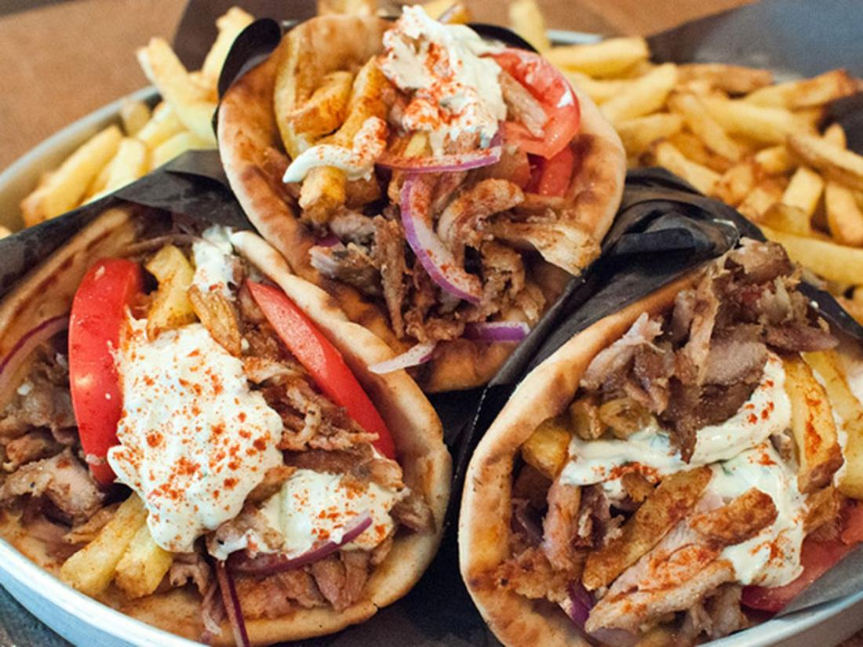
When everything is ready, do the final preparation. On each pie add the sauce, roasted meat, onion tomato slices and other vegetables you have selected and 3-4 fried potatoes. Wrap the pie in the middle with a little paper or sheet. On each dish you can accompany with extra vegetables with some olive oil and some more potatoes.

GREATED BY
YRO PAPPA
SOPHIA LINDHE

TEXT BY YRO PAPPA
TRANSLATED BY SOPHIA LINDE

