FOOD STORIES: Hard life of meals from school canteen (drama)

Main characters: potato cream “Prívarok”, chicken paprikas Paprikáš, apple Jabĺčko , ketchup Ketchup and pupils from grammar school Ladislava Novomeského

Do you know, what happens with meal after you ate it? Their spirits live forever. This story is about short life of Prívarok, Paprikáš and Jabĺčko.
„Hello? Is anybody here?“ says the apple Jabĺčko. „Jabĺčko? Is it you?“ asks chicken paprikas Paprikáš. „I´m here, too!“ says potato cream Prívarok, „What happened with us?“ „I remember...“ says Paprikáš, „... I lied on a plate... and suddenly I heard a noise...“ „I was there, too,“ says Jabĺčko, „but I lied in a bowl.“ „ Oh, yes, yes,“ says Prívarok, „and suddenly noisy pupils ran to me... some pupil took me to a table and then he was so disgusting!“ „Some pupil took me to a table, too,“ recalls Paprikáš, „but he laughed too much and poured half of me on ground... it was horrible!“ Jabĺčko says: „I lied in the bowl for very long time and then somebody caught me and bit me... it hurt so much!“ „...the pupil took me to the table,“ continues Prívarok, „and he went back to a kitchen window. I thought he left me and I was happy... I didn´t want to die, but... he went back and brought a red thing! It was ketchup Ketchup! He splashed it on me! I said – he was very, very disgusting...“ And Jabĺčko resists: „I know what is disgusting. A girl, who ate me, threw me into a bin!“ „... and this is not the end! says Prívarok, „He mixed me with Ketchup and... picked up his spoon and... Swallowed me...“ „Don´t cry, Prívarok, my destiny was very similiar,“ says Paprikáš, „ the half which was not poured on the floor was cut hard with knife and fork!“ Prívarok sighs: „And all these our stories happened in ten minutes time!“
Suddenly meals heard some sound... They turned back and.... there stays Ketchup and says: „Hi, did anybody say ketchup?“
The end
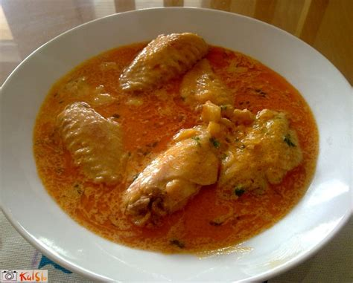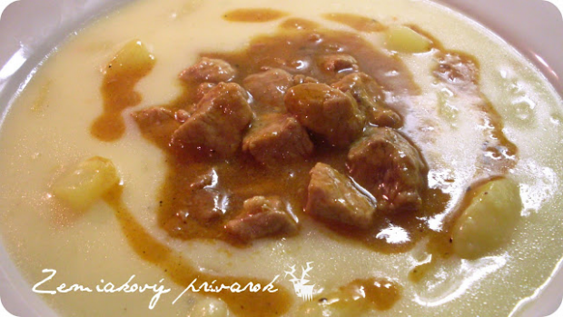
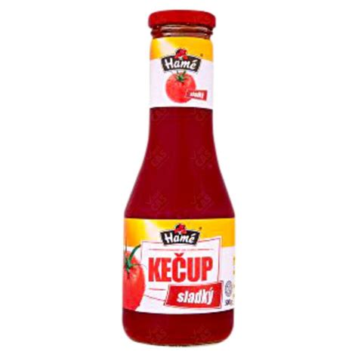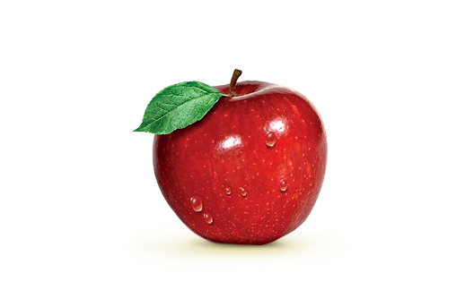
1. What did a pupil bring back to a table and pour it on the Prívarok?
2. What happens with meal after you eat it?
3. What happened with Jabĺčko after a girl are it?

