Food wars (,,mirror,, with happy end)

Characters: Broccoli Foodwalker, Princess Cabbage, Lemon Solo, Darth Curd
Once upon a time, in a far fridge there lived Broccoli Foodwalker, princess Cabbage and Lemon. Princess Cabbage reigned Shelf of Vegetable, but Broccoli Foodwalker lived in Shelf of bacon. Why? He did know this information, too.
Darth Curd lived in Shelf of Curd. He want to reign all of the fridge. He did not like Princess Cabbage, so he ruined her Shelf of Vegetable. How? He and his big army threw dumplings to her shelf. Darth Curd captured Cabbage. She was very angry and sad. But Broccoli Foodwalker and Lemon Solo came and they took her out from Shelf of Curd. They attacked Darth Curd. They threw fried gooseberries on his Shelf of Curd and they ruined it. And then they lived happily ever after.

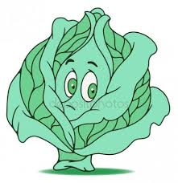
Questions:
1. What is the name of Curd´s shelf?
2. Cabbage was very happy. TRUE/ FALSE
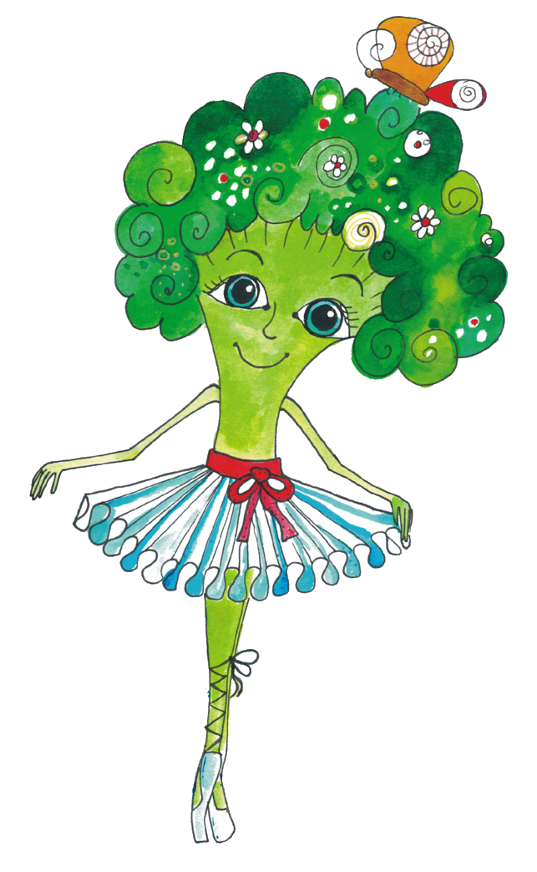
3. Is the name of one character of the story Orange? YES/NO

