FOOD AVENGERS
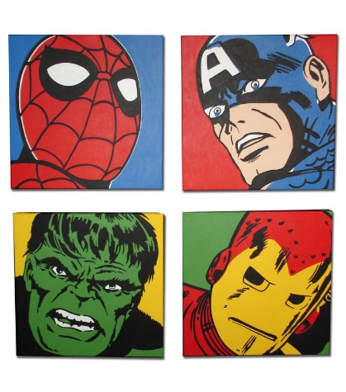
Main characters: Captain Banana
Iron Orange
Thor The Apple
Pepper Hulk
Chilly Locky

Once during a sunny day, Chilly Locky stole a mighty carrot.
When FOOD AVENGERS heard it, they went to save the mighty carrot. But Chilly Locky was ready for them. His base was full of traps. For example: ketchup blasters, broccoli bomb, lemon canons... When they came to the base, they saw Chilly Locky and they tried to catch him. Chilly Locky was very tricky. When FOOD AVENGERS were running to Chilly Locky, the traps stopped them. The ketchup blasters and lemon canons were shooting on FOOD AVENGERS. Five minutes later they broke Chilly Locky´s traps and they caught Chilly Locky. Then they took him to the prison on Ice-cream Island. They took the mighty carrot and ate it. Everybody was happier than Chilly Locky.

Q:
- What were the Chilly Locky´s traps?
- How many heroes were there in the story?
- The mighty carrot was blue. T/F/Not said

