The mysterious fridge
(thriller)
Main characters: Mr. Sausage, old milk, smelly lettuce, fat Hugo, crazy rotten eggs
Once upon a time there was a fridge. That fridge was rare, because the food in the fridge was the most rotten in the whole world. So this is the story how someone stole the salami.
"Mr. Sausage! Mr. Sausage! Where are you?!"shouted the smelly lettuce."I´m right here. Don´t panic.” said Mr. Sausage, "What do you want from me this time?""I can´t find my best friend salami!!!!" Mr. Sausage just said:"I don´t know..." The lettuce started to cry. But suddenly the old milk spoke. He was a very clever milk. He said: "It was some fat man who took her."Everyone was terrified, only the eggs were happy and they started jumping: "Haha, we know who it was! It was Hugo!" And they started laughing again. But Mr. Sausage said:"We need to stop this troublemaker. Right now." They made a deal together. They will make Hugo eat the rotten eggs because they are the most rotten of them all."We will do it tonight" spoke Mr. Sausage, "and we will make him leave."

Everyone hid in the corner of the fridge and they waited. Some eggs were covered with ham. In the middle of the night Hugo opened the fridge door."Oh there is some ham and eggs! Yummy!" he said and he ate them." These eggs are the most rotten I've ever had!
I´m going to die!" and then he finished.
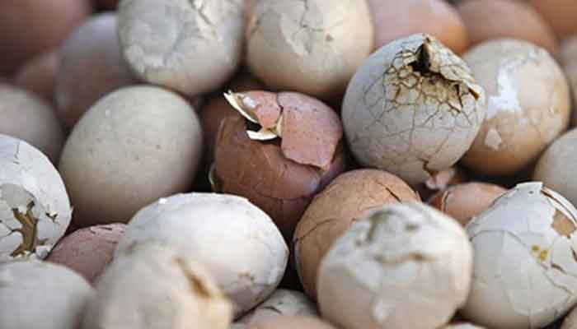

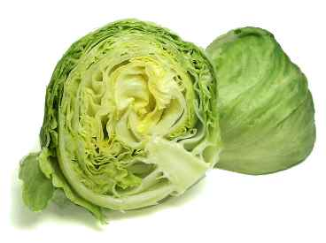

Q:
- Who was happy when the salami was stolen?
- What was the name of troublemaker?
- How did he die?

