Happy Cooky 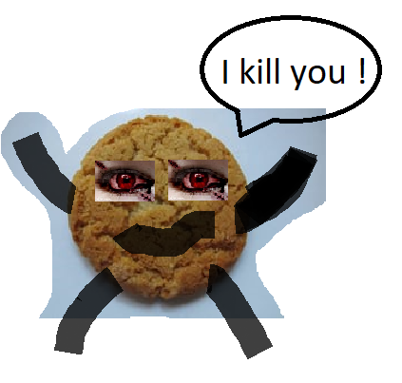
( funny horror story )
Main character : Cooky
Another characters : balcony, children, teacher, ketchup

Cooky is a biscuit. He is the happiest biscuit in the world. His best friend is balcony.
Cooky was in the classroom. Around him were many children. It was a break. One girl wanted to eat Cooky, but he was still happy. When the girl caught him, the balcony fell down of the sky and he said : ‘’Hello my friends!’’ Balcony fell on Cooky. Cooky was still happy, but he was destroyed.
Suddenly, it was night. Cooky rose up from dead biscuits. He was a horrible monster. He killed all the children in the classroom. Then the teacher came. He turned the light on and it was a day again. Ketchup sprayed out from the Cooky. He died.
From that day Cooky is waiting on the balconies. He wants the balcony to fall down on other children. Cooky is very, very, very happy killer.
The End!

