Lemon Norris
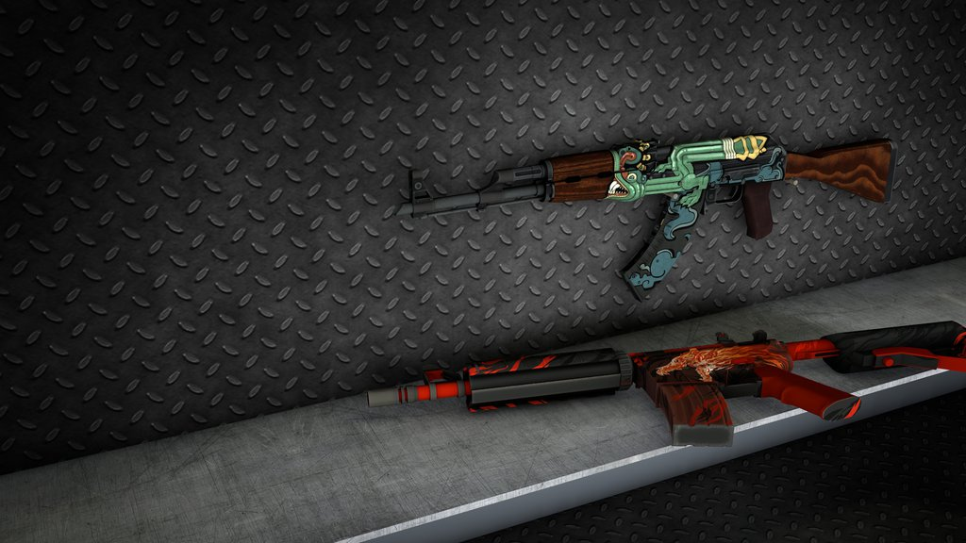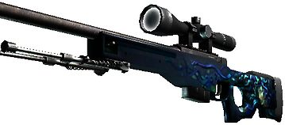
Characters: 5 Lemons [counter-carrotists a.k.a. GIGN Lemons]
5 Carrots [carrotists]

It was a hottest day on place named Dust 2.Carrotists came from terrorists country. We did not know from which to destroy Dust 2. GIGN Lemons noticed the signal about terrorist attack. They tried to protect a city named Dust 2 from terrorist attack.

Terrorists were on the place, But GIGN Lemons only came from France to Dust 2.
Both of team bought weapons. The battle began. It was 15/15. Final round. 2 of GIGN Lemons were on B. Others were on A. Carrotists rushed B. GIGN Lemons smoked the B tunnels. Carrotists fired random to smoke and fortunetly hit the enemy It was a headshot and John Lemmon died. One of Carrotists rushed GIGN Lemons from middle and killed Llleeemmmooonnn. He died too. It was 3 versus 5 situation. One of GIGN Lemons walked out of B site. Carrotists killed Los Lemonos . It is very hard situation . 2 versus 5. From GIGN Lemons left only: Lemon Norris and Professional NOOB Lemon, but one of carrotists rushed B tunnels and killed ProffesionalNOOBlemon. Second hardest situation. 1 versus 5. Lemon Norris checked the midle and saw 2 enemies. He shot and killed 2 enemies with 1 bullet. This wasn’t hardest situation but still better than 1 versus 5. Puf! Headshot! 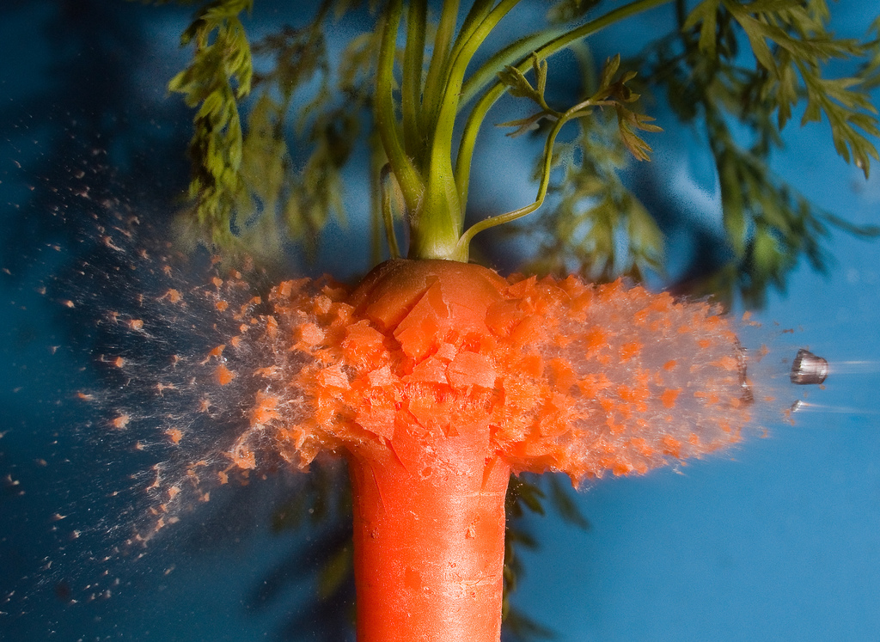
Lemon Norris killed third enemy. 2 enemies left. One of Carrotists came to B from middle and hit Lemon Norris, but Lemon Norris killed him. He got only 1HP. But: Bomb has been planted“. It was planted on A. Lemon Norris threw HE [high explosive] grenade to A site and with it hit the last carrot standing. Carrotists had a half of HP. Lemon Norris rushed A from GIGN Lemons´ spawn. Enemy missed him with SSG08, and Lemon Norris killed him with the last bullet in round. Lemon Norris found the bomb and started to defuse it. 5-4-3-to explosion-2-1.,, Bomb has been defused“
And Lemon Norris protected Dust 2 from carrotists attack.
Written by: Martin Janči

Story by: Martin Janči (mainly)
Nicolas Melioris

Concept by: Martin Janči (mainly)
Nicolas Melioris

Special thanks for: VALVe
Gaben Newell
And all authors of CS:GO (mainly authors of Dust 2 map)

Q:
- Which country is GIGN from?
- How many grenades are thrown in the fight?
- How many people are there in the fight?

