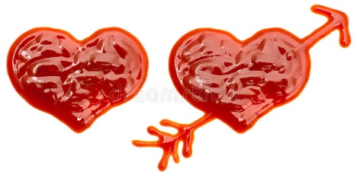
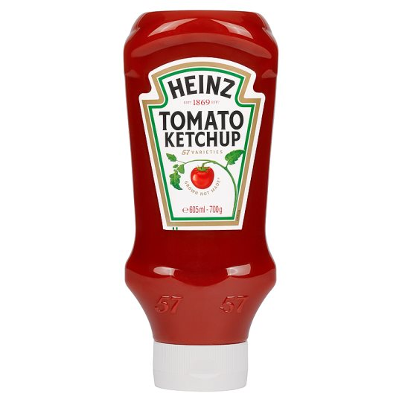
LOVE STORY
( romantic drama story )

Main characters:
Tatar sauce, Ketchup, Eggplant, Sausage, Mr. Spaghetti

Once upon a time there were three friends: Ketchup, Sausage and Tatar sauce.

Sausage with Tatar sauce were in relationship. Ketchup was jealous of Tatar sauce because she wanted to be with Sausage since he was very tasty and beautiful. She was so in love and she thought that Sausage was in love with her too, but he didn´t want her.
. . .
Later Ketchup, Eggplant and Tatar sauce were on the school toilet:
Ketchup talked to her friend Eggplant: ´ I love him, Sausage is so beautiful and kind.´ But Tatar sauce heard it!!! Tatar sauce walked out of the toilet and she had a very red face. Tatar sauce yelled: ´I hate you, stupid Ketchup!´ Ketchup yelled too: ´You are stupid! And you´re so ugly! ´ Sausage loves me!!! Tatar sauce started to bite her and she made her a blue eye. They had a very big fight. This time the teacher Mr. Spaghetti walked into the hall and he heard that noise. But when he opened the door of the toilet, he was so scared. The Ketchup died.
Then Tatar sauce had to go to prison, because she killed Ketchup.

The end
Q:
- Why was Ketchup jealous of Tatar sauce?
- Who was killed?
- Who was in relationship at the beginning of the story?

