FOOD WARS

Main characters: Popping corn, Sour lemon, Wild beef, The Fast coffee in the world, Screaming egg
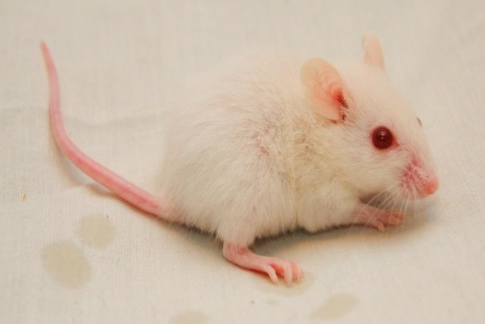
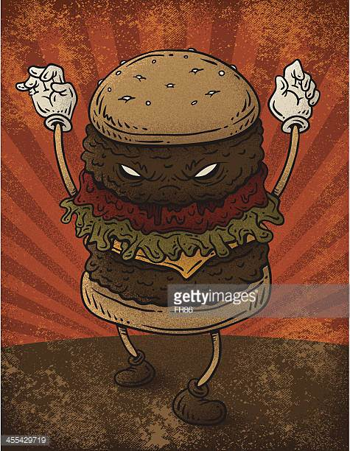
Once upon a time in a supermarket called: „The FoodSpace“.There were many galaxies or said in different words „shelves“. Every galaxy had a different name: Creepy vegies, Bloody fruits, Deadly meat, Evil Drinks and other deadly murderers. They all had an endless war named FOOD WARS!
One day, leaders of every galaxy in FoodSpace went to the most dangerous place to fight: THE FLOOR. Leaders who arrived there were: Popping Corn, Sour Lemon, Wild Beef, The Fastest Coffee in the World, and a Screaming Egg.
When they all met at the same place, they realized that they´re trapped! They could not go back. Five biggest rivals were trapped at the same place. Wild Beef turned around and screamed: „Beware! There are Red-eyed mice!“ „Oh no!“ yelled Screaming Egg. Everyone ran to the nearest shopping cart. They thought that they are safe but then they realized that there is no way out, because mice tried to get them. Then Sour Lemon said: „Why are we fighting each other? We should help each other and try to fight the mice. We will make a war between mice and us!“ Everyone thought about it for a minute. Than all of them shouted:
FOOD WARS!
(Of course, mice ate them all.)
Q:
- What colour were mice´s eyes?
- Who won the war?
- Where did they want to fight?

