PRAGUE
Prague is generally regarded as one of the most beautiful cities in Europe. The historical center of the city, with shows unique panorama of Prague Castle, the largest castle complex in the world, is a UNESCO heritage site.
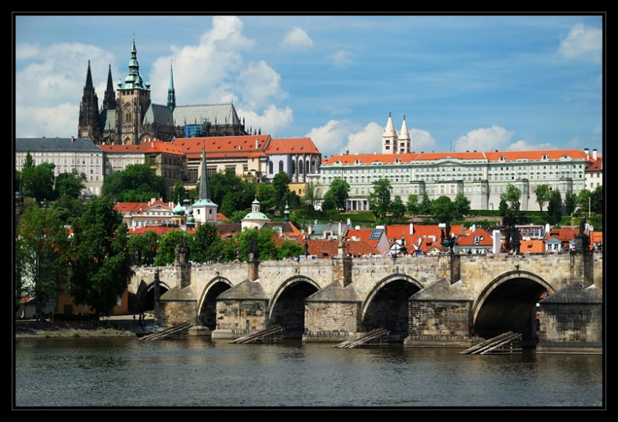

The Old Astronomical clock
The Old Town Astronomical Clock or the Prague Astronomical Clock are medieval astronomical clocks located on the southern side of the Old Town Hall Tower in Prague. For the first time, the astrology is documented historically in the charter of 9 October 1410.

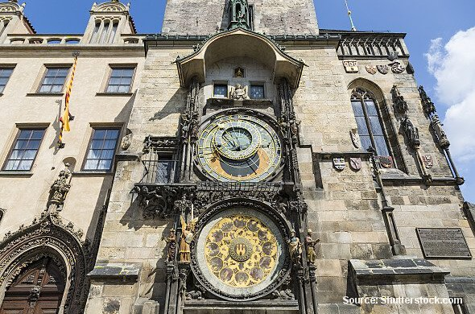
Pankrác
Our region is placed in Pankrác. Its a region where are the highest buildings in Prag.

