https://www.praha-kunratice.cz/sites/default/files/soubory/uvodni_rozvaha_mc_metropol.plan_.pdf

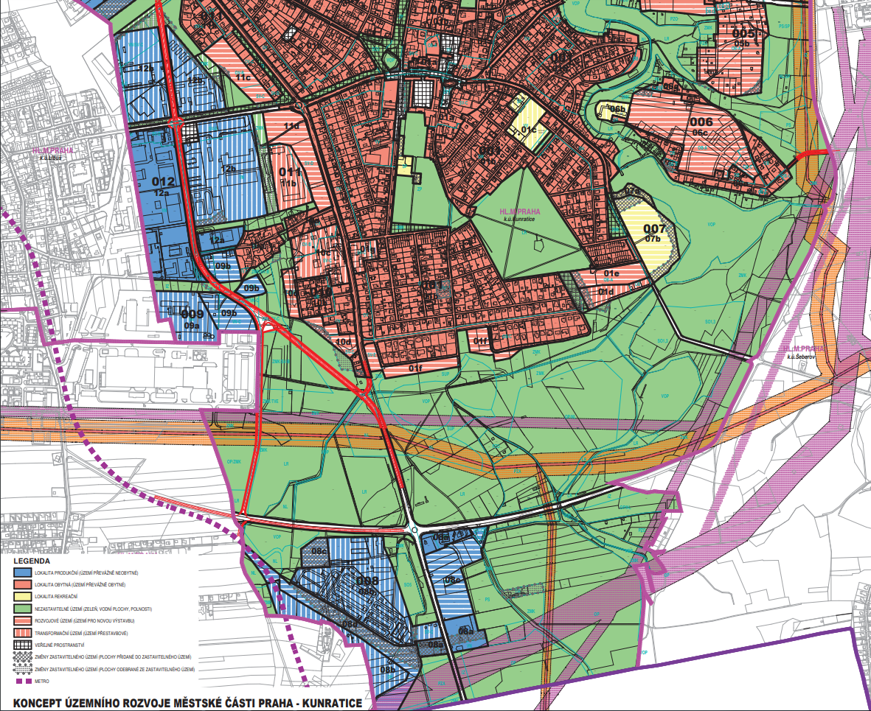

http://app.iprpraha.cz/js-api/app/vykresyUP/

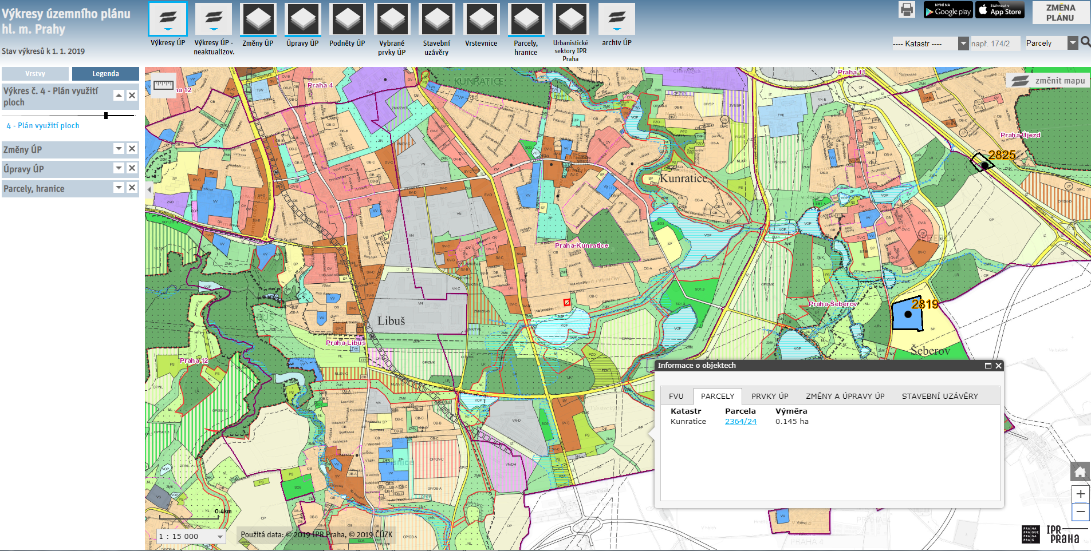

*Our plot is marked red

http://app.iprpraha.cz/js-api/app/vykresyUP/
region 01b

https://www.praha-kunratice.cz/sites/default/files/soubory/uvodni_rozvaha_ochar_uz_mc_p-ku.pdf
01b – KUNRATICE OBEC
- region description: mostly family houses, with basic administrative buildings and services. Most houses are separated by private gardens.
- height limits: maximum of 2 stories per structure
- region progress: the area is mainly filled with new insulated family houses, the older ones are undergoing repairs and reconstruction. The current noise and traffic at Vídeňská street will be soon resolved and will lead to a very quiet and peaceful neighborhood

01f – KUNRATICE NA JAHODÁCH
- currently empty with no soon expected construction
- might be used for more family houses with wiew of the greens below
- max. expected height 1 or 2 floors
- a natural passage will be kept

