We, the students from Technical school of Nikola Tesla Vukovar, Croatia, participated in the first mobility to Malaga, 18th-25th November 2018 within Erasmus+ project "More than the sum of its parts : Our diverse cultural heritage as building blocks for European unity ". Even before we knew the details of the programme, we were more than excited because for all of us it was the first time to visit Spain.

The programme itself amazed us as well. At the very beggining, the host organised an innovative ice-breaker which helped us relax, somewhat get to know each other and show what we are like and what we enjoy. Then each country got the chance to present its culture, monuments, industrial achievements, etc., which made us learn a lot about each other's background and tradition. It was very interesting to compare the rich diversity of all countries in mixed international groups afterwards. Finally, we participated in making a creative sculpture of Modern Art hoping to win the competition.

The most breathtaking experience was of course, visiting Alhambra. We didn't expect such a spectacular piece of architecture. Moreover, we were delighted by well-kept gardens as well as incredible view from one of the highest altitude points nearby. We also enjoyed Antequera Dolmens Site where we witnessed the fascinating settlements of ancient civilisation. Nevertheless, we learned a lot about Spanish history in Musem of Malaga although we appreciated Russian Museum, too.

To cut long story short, we had very interesting schedule and we enjoyed the programme. Still, most beneficial and rewarding experience was meeting other students and getting to know more about their culture, tradition, habits and lifestyle. The host families put a lot of effort to provide accommodation, food, transport and free-time activities for us and they did a great job, too. This was an amazing week and unforgettable experience that resulted in creating new friendships and memories that we will cherish for a very long time.
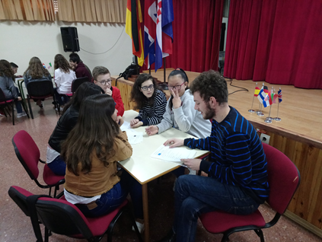 | 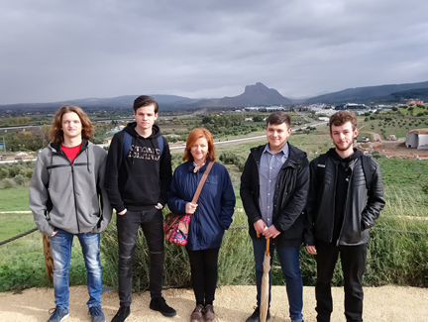
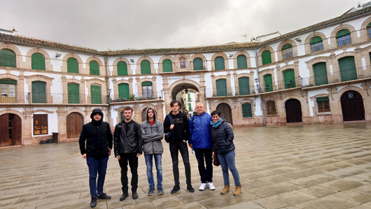 | 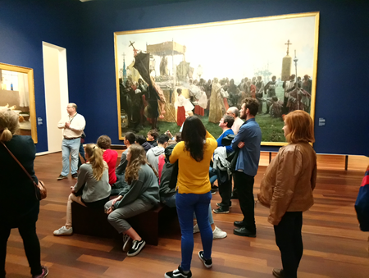
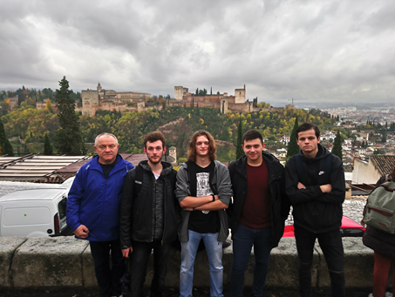 | 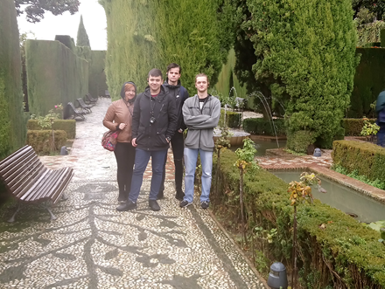
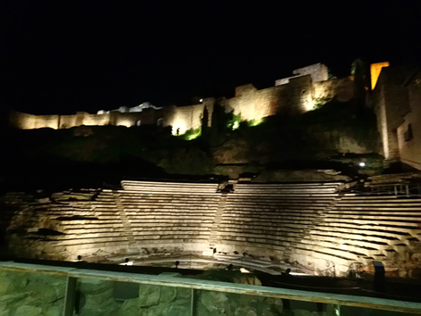 | 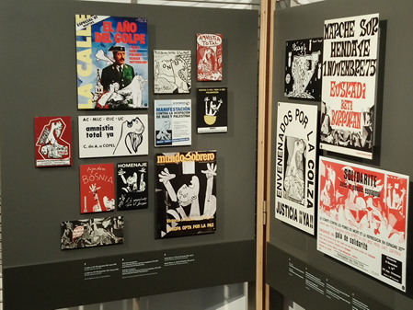
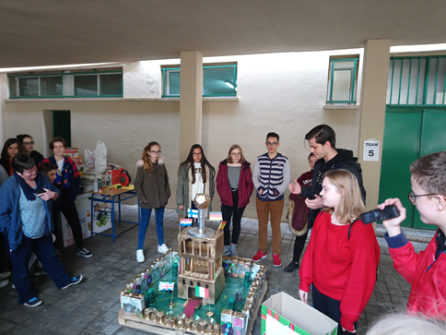 | 