Erasmus+ 2018-1-DE03-KA229-047353
More than the Sum of its Parts- Our diverse Cultural
Heritage as Building Blocks for European Unity

Truro Teachers’ Meetings (Minutes)

28th October 2019

Update on progress of the projects and requests:
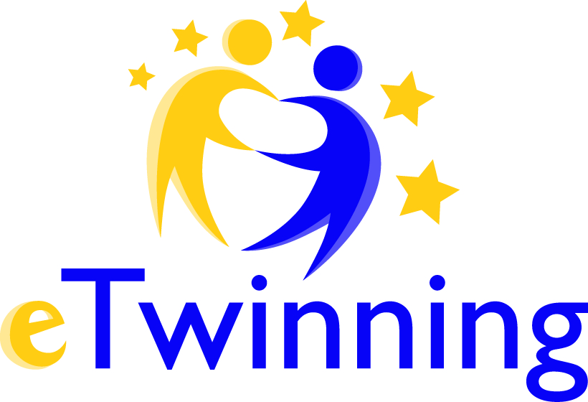
- The TwinSpace is set up, but only the material from Spain has been uploaded so far - the other pages are still empty. So please upload to eTwinning, especially since the feedback on the Interim Report has been very positive on the work done so far. Emilio is going to provide concise instructions.
- The website is supposed to be updated frequently, so please send all your work to Jasmina
- VALOR: In the end, all the material produced during the project is going to have to be uploaded to the European project result platform VALOR. This has to be done by the coordinator. So please make sure that everything you produce (surveys, presentations, reports, video diaries, newspaper and website articles, documentation of dissemination activities) is sent to me (kristin.haltermann@cato-achim.de).
- Dissemination and other non-mobility activities: the more you do of those (and document, of course!), the better. Just make sure the results are posted on eTwinning, the project website (via Jasmina) and the European project results platform (via me).

1st November 2019

- General project information by coordinating school (Achim, Germany)

- Europass Mobility: I’ve looked into the application progress and it is not possible for me to order the passes for all of you. Every country has to apply for them at their respective national agency. The application process itself though is really easy. Once you’ve found the correct website (in Germany it is a site called “Europass Germany”) you can order the passes for all your students at once. Participants of Erasmus+ school projects qualify automatically, you just have to give the project number and put the start and end date of the whole project. Apparently at some point you’ll be asked for the names of the participants and after you’ve received the passes you can fill in the date of the mobility the individual students took part in. I will tell you more once we’ve completed the process.

- Interim Report: All in all we received very positive feedback on the Interim Report and the project so far from our national agency. This was basically what was said:
- Work on the project is good and active and we are expected to have met our proposed objectives by the end of the project.
- Our TwinSpace has received a very positive mention with regard to the documentation of the course of the project and the presentation of the first project results.
- We are reminded to mention on each and every publication (and this includes the internet) the financing of the project by the EU and the legal disclaimer. The following sentence should suffice (thank, you, Emilio!):

This project has been funded with support from the European Commission. This publication reflects the views only of the author, and the Commission cannot be held accountable for any use which may be made of the information contained therein.

- Detailed To Do –list: This is a (more or less) comprehensive list of all the documents and you are supposed to send to Jasmina (for publication on the website) and to me (for publication on the European Results Platform). Additionally you yourselves are supposed to upload them to eTwinning to be posted on the relevant pages.
- Survey Before (the start of the project)
- All the presentations and materials prepared for each mobility
- Student reports / video diaries of each of the mobilities
- Documentation of the final work / result of each mobility if you have it (i.e. the stories / folk tales from Truro, etc.)

- Next mobility: Croatia (23rd March - 27th March 2020)

Programme:
Topic - How food and history influenced our culture

What to prepare:
1. Presentation on eating habits, food, national dishes, changes due to different influences (= traditional local dishes and “new“ popular dishes), influence of climate on ingredients / food grown, traditional holiday food and drink
2. There will be a cooking evening on which to prepare the individual recipes, so each country brings one simple recipe that can be prepared then; please send list of ingredients beforehand to check for availability in Croatia; students bring more recipes of traditional dishes to include in the final product
3. Final product: recipe book

Flights and accommodation:
- Information about hotels and prices to be sent on by Jasmina
- Flights: Zagreb, Belgrade (closest, but here you need passports, not identity cards!), Budapest (closest) are possible airports, Osijek (from German destinations); email arrival time and place, the Croatians will then organize transportation to Vukovar

- Final mobility: Germany (11th - 15th May 2020)

Hotel: We made reservations for 10 single rooms at “Gieschens Hotel“ to the agreed price of 77,00€ per person per night (breakfast included). You need to confirm your booking until the end of January at the latest.
The address is Gieschens Hotel
Obernstr. 12
28832 Achim
Tel. +49-4202-88480
https://www.gieschens-hotel.de/

reference: CATO
10 – 16/5/20

This work is licensed under the Creative Commons Attribution-NonCommercial-ShareAlike 4.0 International License. To view a copy of this license, visit http://creativecommons.org/licenses/by-nc-sa/4.0/.

