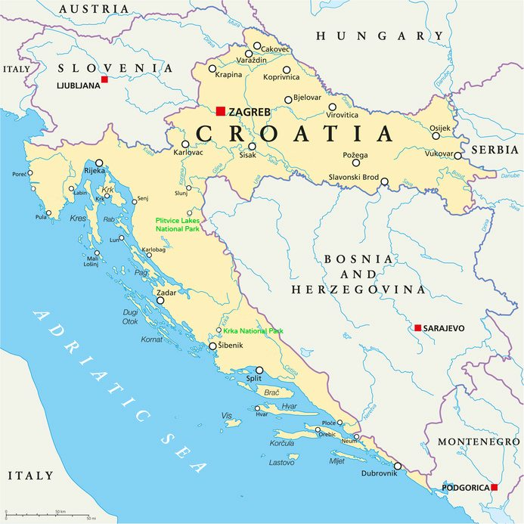
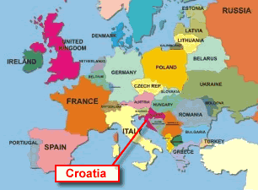
Landscape, Weather, Climate in Croatia
There are two climate regions in Croatia - Continental and Mediterranean. Mediterranean climate covers Croatia's coast and islands, from Istria in the north to Dalmatia in the south. In the summer, the average temperature along the coast is between 24°C and 26°C. In winter it is 2°C in the north and 9°C in the south. Summers are dry and hot and winters are rainy. Snow is very rare anywhere along the coast.
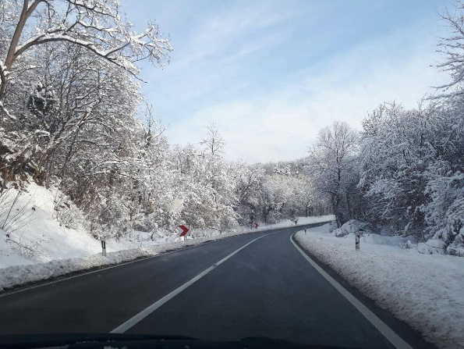
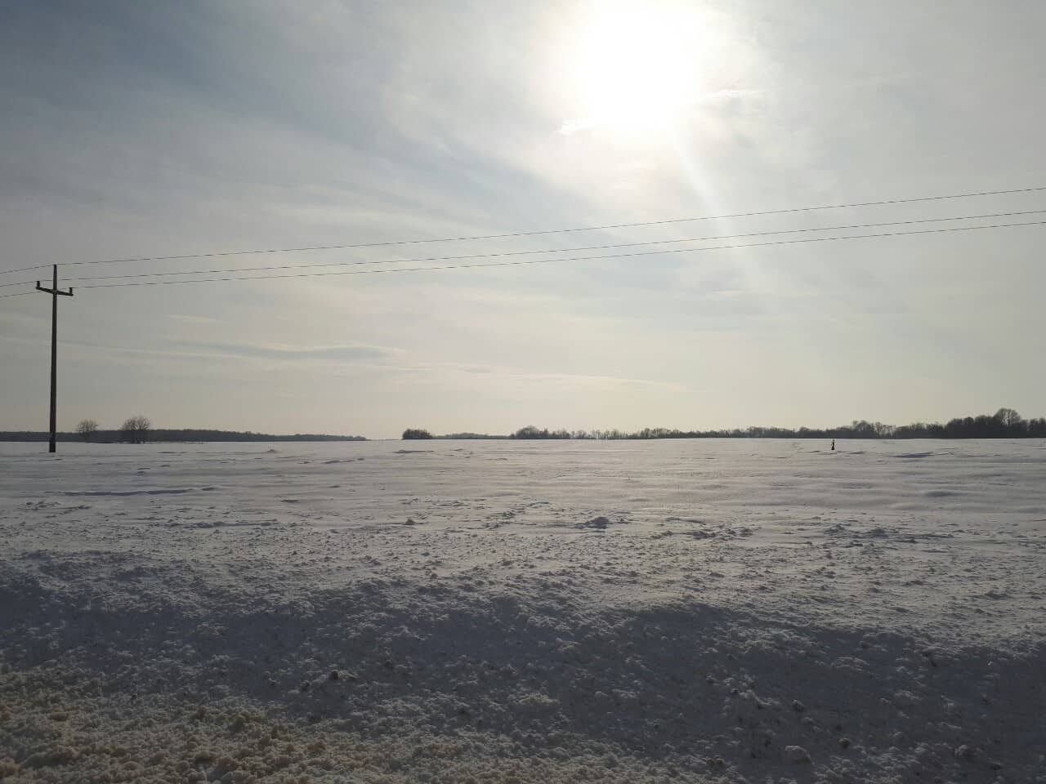

Continental climate covers the Croatian interior, which includes Zagreb and Slavonia. Winters are cold with snow, with the average temperature in January ranging from 0°C to -2°C. Summers are warm with strong heat waves. When it comes to Slavonia, it has a moderately warm and rainy continental climate. The warmest month is July, averaging around 22 °C. Summers can get hot and humid. The highest temperature of 40.5 °C was recorded in July, 1950 in Đakovo.
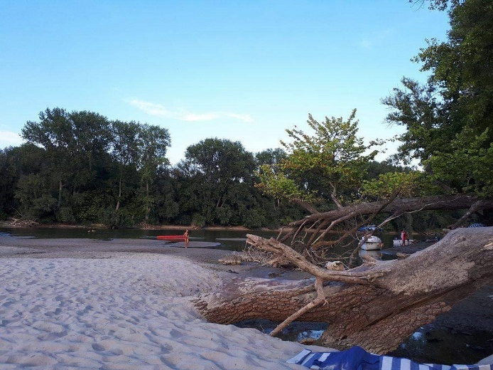
Winters are cold and snowy at times and temperatures around 0 °C. However, temperatures can go below 0 °C, as well. In January, 1963 in Slavonski Brod, the temperature reached −27.8 °C. Rain falls mostly during the growing season, which helps farmers grow crops. Slavonia receives more than 2,000 hours of sunshine per year on average. That would be around 166 days or even more. This helps us stay positive and keep smiling.

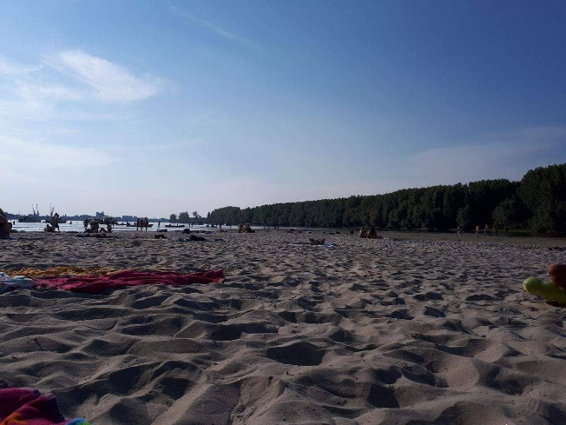

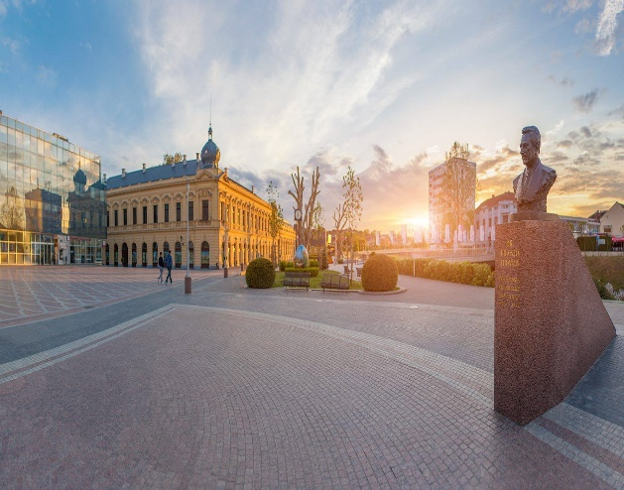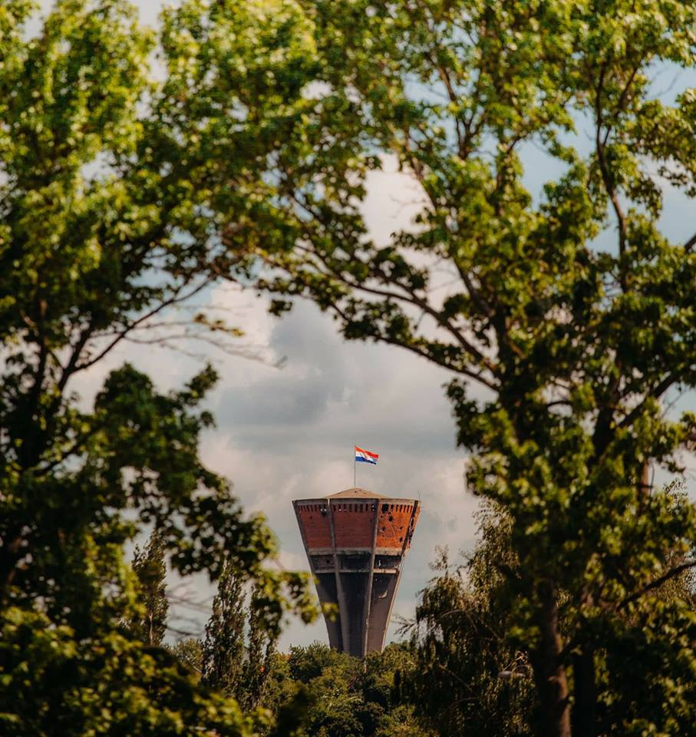
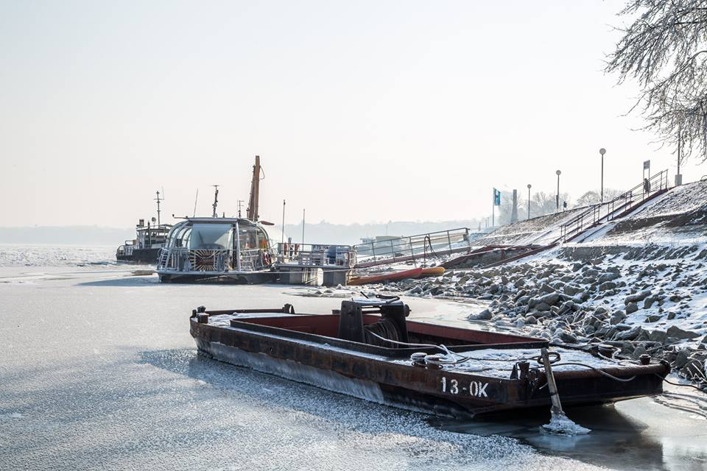
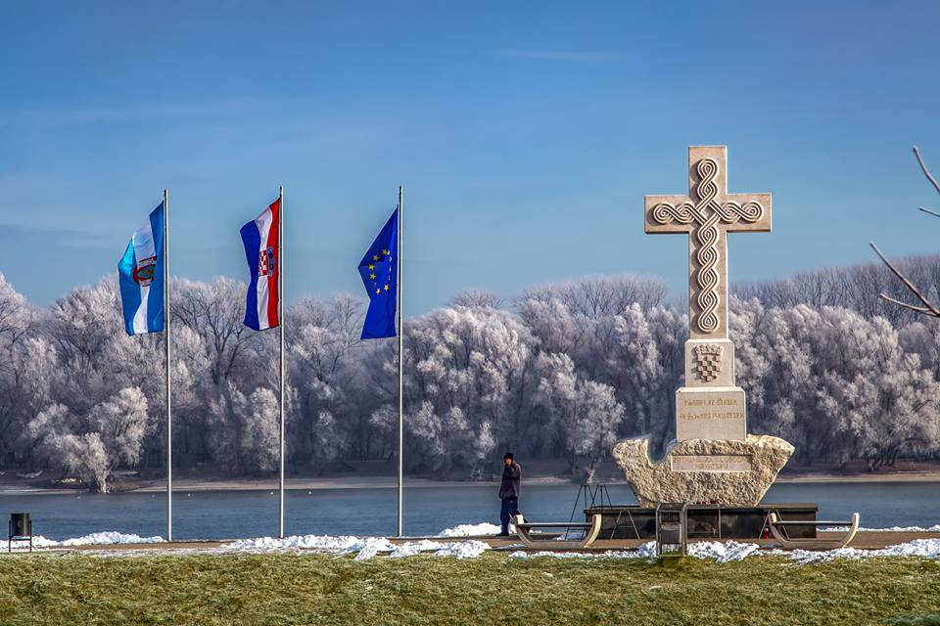The inland climate with its cold winters and greater precipitation resulted in a more compact house, steeper roofs, greater overhang of eave. In Gorski Kotar the particularly long winters with a great deal of snow meant that most of the features had to be under the same roof, with the byre on the ground floor, the fodder in the attic. On flat lands we had a primarily horizontal development of the house, particularly in the Pannonian region, where up the end of its development the house remained on the ground floor only and the steading was relatively regular. A sloping ground fostered the vertical development of the house.
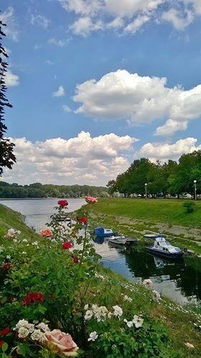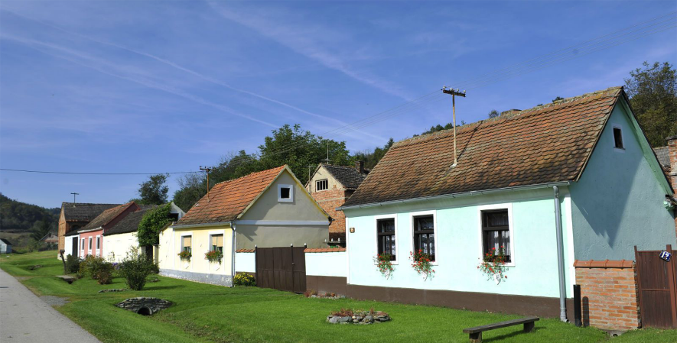

Croatia has three types of terrain: plain part (or Pannonian), mountain part and coastal part.
Coastal part
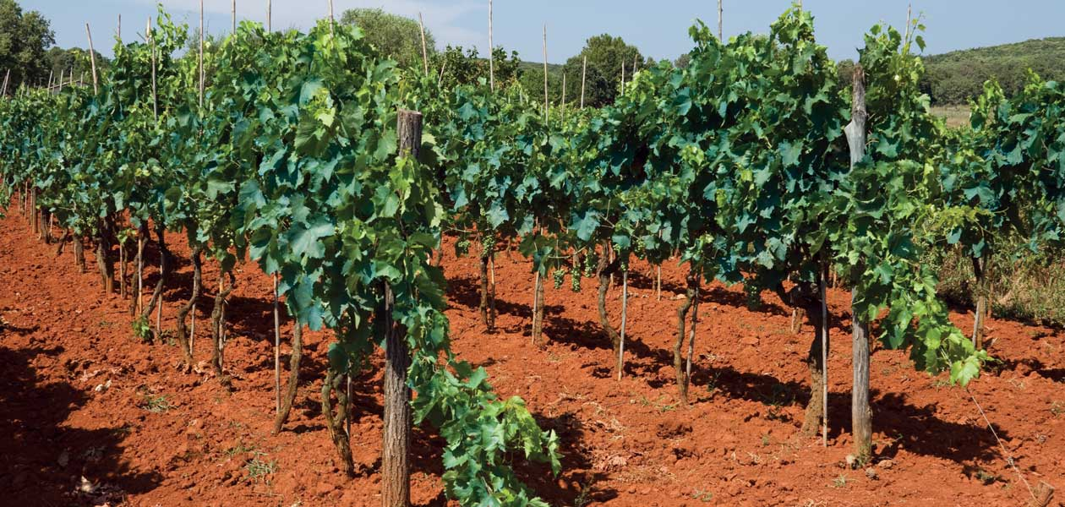
In this part of Croatia we include: all Croatia's islands, one part of Dalmatia and coastal part of the Adriatic sea. The interesting thing about ground is that it is red, because of some insoluble minerals.

Mountain part
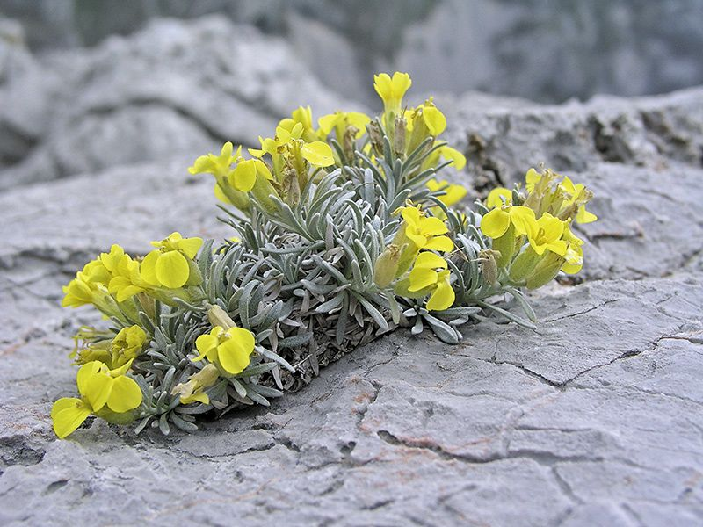
Mountain part of Croatia occupies the northwestern part of the Dinaric mountainous area. Parts of it are: Gorski Kotar, Lika and Ogulin - Parcels (or Potkapelska) valley. Some mountains are: Velebit, Učka and Ćičarija.

Pannonian part
This part of Croatia is located between Croatia’s three main rivers: the Danube, Sava and Drava. It is the most fertile part of Croatia. Old mountains that are located in the Pannonian part(closer to Slavonia) are: Papuk, Psunj, Krndija and Požeška gora.
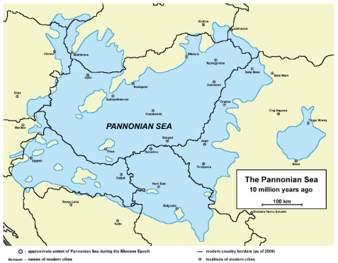
These old mountains are the remains of the old Pannonian mainland, from the time when Pannonia was covered with the Pannonian sea. Later, the sea disappeared and turned into a lake, then into the swamp and finally to the Pannonian basin, where we live today. And finally, the land in Vukovar is called loess. This is the clump of tiny dust that the wind has brought.

Vukovar’s geographical position at the Danube River determined the development and importance of the city throughout its history. As it was at Roman’s limes (border), it had to be fortified. Since the Romans had plans to stay there, agriculture in the area was improved and viticulture developed at drained marshes. The wine attracted Avar and Slavic tribes. The area was part of the Kingdom of Croatia in the 11th and 12th century. Vukovar was first mentioned at the beginning of the 13th century. Later came the Kingdom of Hungary, Turkish domination, then the Habsburg Monarchy. After the Ottoman dominion, in 1736, a large part of the Vukovar area was bought by the German Counts of Eltz, who will have a significant influence on the economic and cultural life of Vukovar in the following two centuries and even to our times.
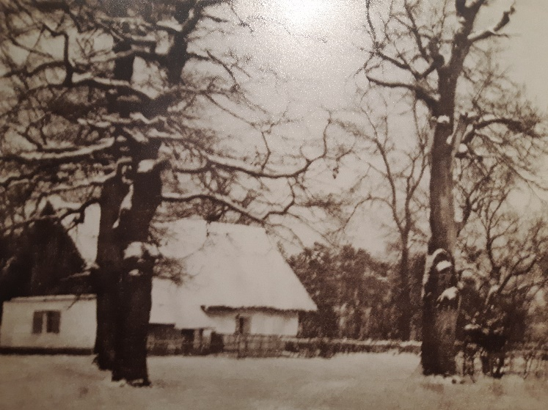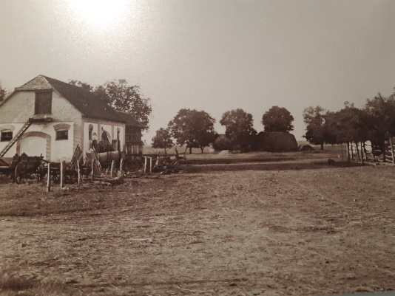
The Pannonian cultural zone has been characterised by the growing of grain, flax and hemp, and breeding larger domestic animals (horses, cattle). The people lived in single-storey houses made of wood or mud and wattle (in the west), or of compacted clay or unfired bricks (in the east), with straw roofs. In the Dinaric cultural zone (highland Croatia and the Dalmatian hinterland), sheep and goat breeding was dominant. Shepherds spent the summers in the mountains with large flocks of sheep, and in winter, moved them to the coastal areas, using mobile pens and huts. In highland Croatia, houses were mostly made of wood, often with a stone ground floor section, and the tall, steep roofs were covered in wooden slats. House in most parts of Croatia have a sloping roofs because they shed water faster than flat roofs which is highly beneficial during hard rain and snow.

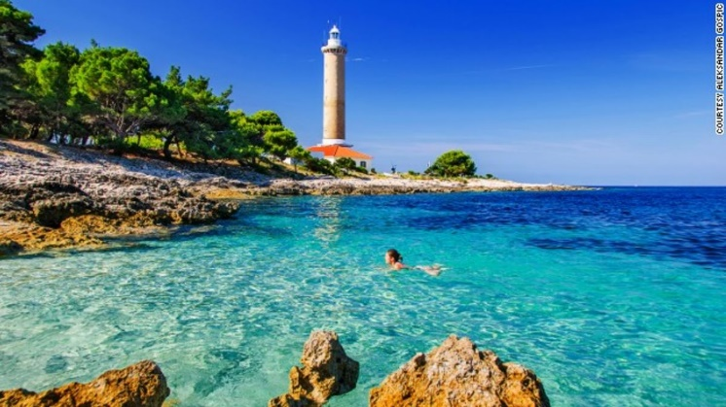
Within Europe, Croatia is considered to be one of the classic karst countries. Almost all formations have developed. The karst region includes the largest reserves of underground drinking water, which require special protection from the dangers of pollution. Since the level of preservation is high, the Croatian karst region is of exceptional natural value in European terms.

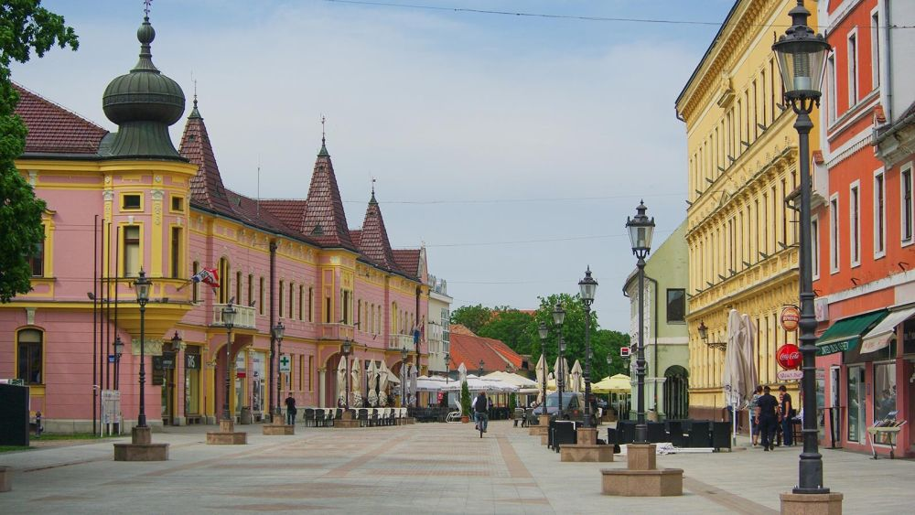
City of Vinkovci is the oldest continuosly inhabited city in Europe – over 8000 years inhabited

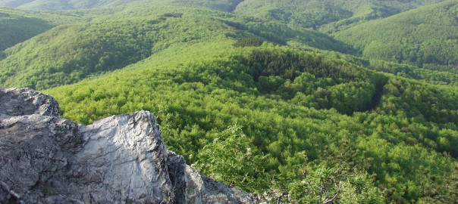
Dinara at 1831 meters (6,007 feet) is highest Croatian mountain and summit
One-third of Croatia is covered in forest.

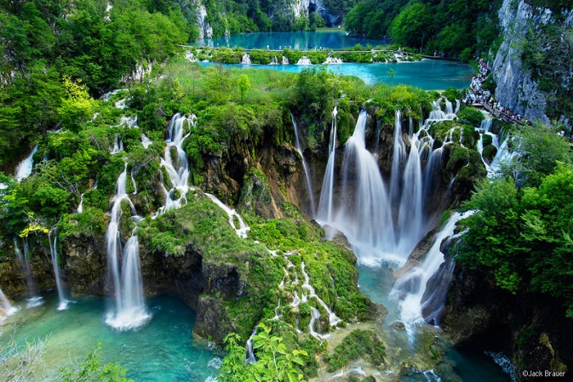
Croatia has 8 national parks, 2 strict reserves and 11 nature parks.
The most famous protected area and the oldest national park in Croatia is the Plitvice Lakes National Park, a UNESCO World Heritage Site Kopački rit Nature park in eastern Croatia is Europe’s largest and best preserved wetlands and floodplain forests.

Croatia’s Adriatic Sea mainland coast is 1,777.3 kilometers (1,104.4 miles) long, while its 1,246 islands and islets (only 66 inhabited) encompass a further 4,058 kilometers (2,522 miles) of coastline—the most indented coastline in the Mediterranean.
The most famous beach in Croatia is in Bol, which is on the island of Brac.
Cres and Krk are the largest islands of the country.
Vis, is the farthest inhabited island from the Croatian mainland
Out of the numerous deep caves in Croatia, at least three are deeper than 1,000 m.
The country also has a system of lakes with distinctive colors including mint green, grey or blue.
47% of Croatia’s land and 39% of its sea is designated as specially protected areas and areas of conservation.

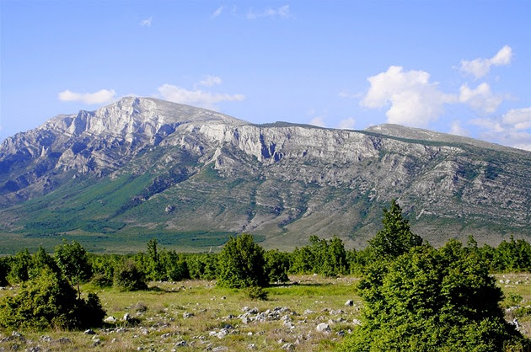
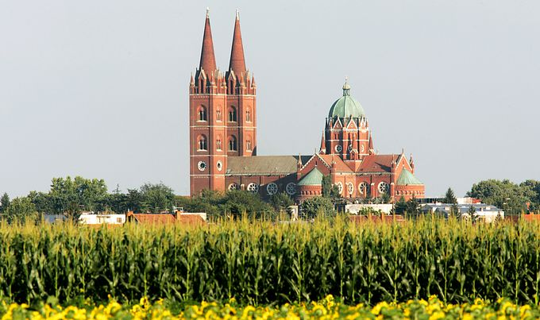 Djakovo
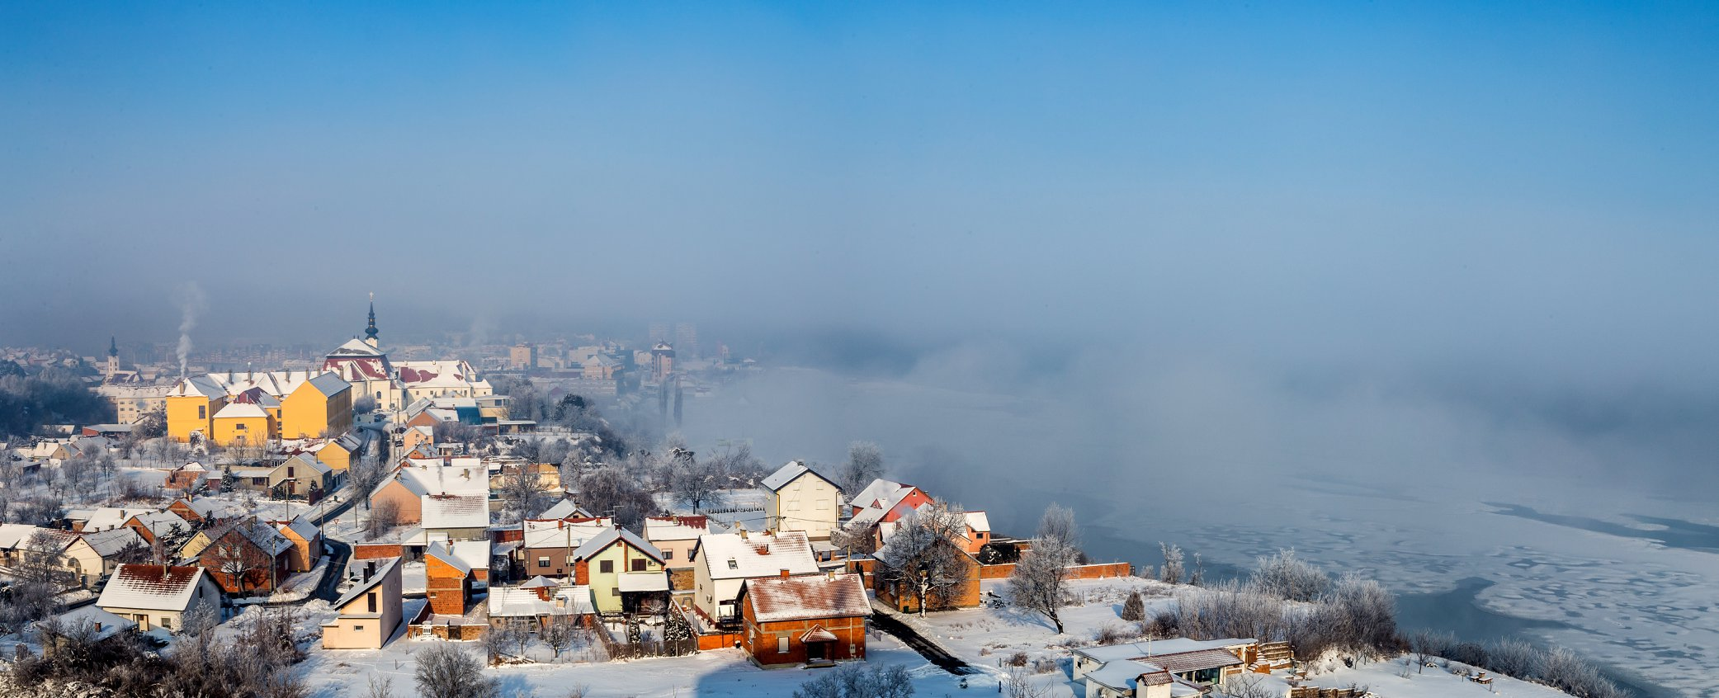 Slavonski Brod

