Chess
World Chess Championship

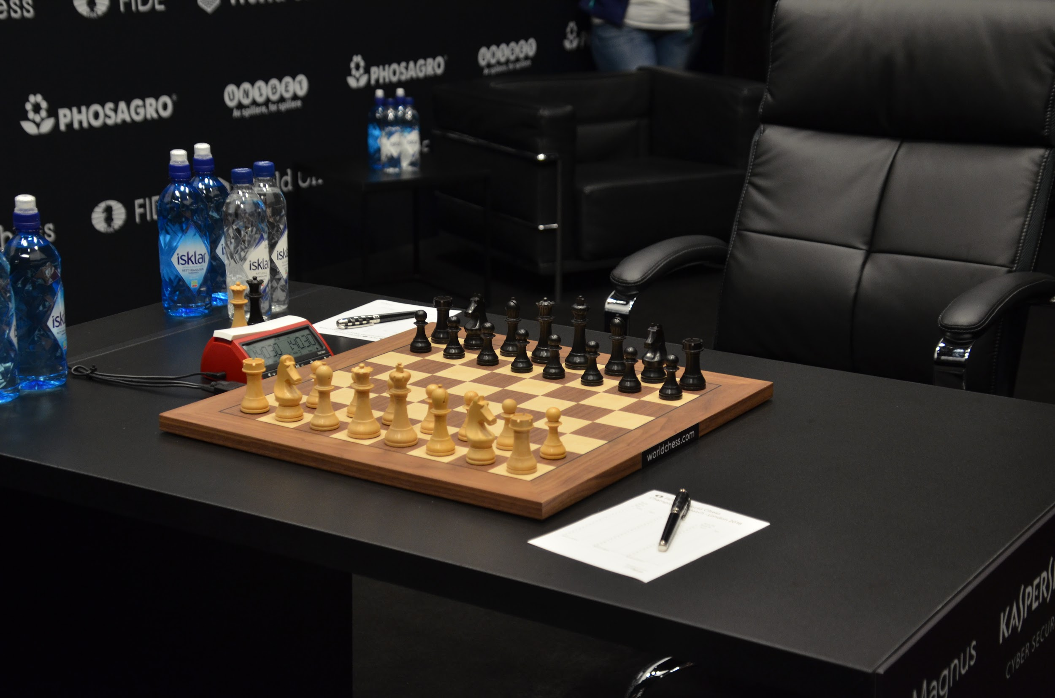
The first football World Cup was held in 1930 and the modern Olympic Games in 1896. The World Chess Championship is one of the competitions with the longest historical tradition, having been held since 1886. The World Chess Championship recognizes the first world champions of this sport officially from Steinitz (1886) who proclaimed himself world champion, up to the current world champion, the Norwegian man Magnus Carlsen.

Emanuel Lasker (friend of Albert Einstein) was the one who won the title of world champion for the longest time (26 years and 337 days). In 1985 Garry Kasparov became the youngest world champion in history (22 years and 210 days).

During World War II some of the best chess players were also codebreakers.

Marshall was the first American to defeat a Soviet player in an international tournament (New York, 1924).

In the chess world championship, the current world champion and the winner of the candidates' tournament (a tournament between the best chess players in the world, selected for their scores in national and international tournaments) face each other. 14 games are played at classic rhythm and in case of a tie, 4 games are played at a rhythm of 25 minutes and 10 seconds increment (the increment is the time that is added each time a player hits the clock).

Swiss system
The Swiss system is the most popular competition system in the world for chess tournaments, both in individual and team tournaments. It is also used in petanque, bridge, checkers, Scrabble, mus, go, Magic: The Gathering, Pokémon, Yu-Gi-Oh!, Myths and Legends, Urban Rivals, League of Legends, KeyForge, Pokemon Go, etc. It has been used in table tennis with remarkable effectiveness. Also, it can be used in other sports or games defined by points. In the Swiss system the players are paired in each round according to the points of the players. The idea is to produce a effect so that each player faces players of their level. The total number of rounds is decided before the tournament starts and there are almost always relatively few rounds. Swiss tournaments with more than 100 participants and only 7 or 9 rounds are the most common. The number of participants will dictate the minimum number of rounds. The formula says that the minimum number of rounds is equal to the base 2 logarithm of the players.

