Hopscotch

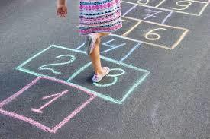
Hopscotch is a popular playground game in which players toss a small object, called a lagger, into numbered triangles or a pattern of rectangles outlined on the ground and then hop or jump through the spaces and retrieve the object. It is a children's game that can be played with several players or alone. The first player tosses a marker, also called a "lucky bean", onto the court. The player then hops through the course, skipping the marker's square. Single squares must be hopped on one foot, except for the first single square, where either foot may be used. Side-by-side squares are straddled, with the left foot landing in the left square, and the right foot landing in the right square. Optional squares marked "Safe", "Home", or "Rest" are neutral squares, and may be hopped through in any manner without penalty. The player stops in the square before the marker and reaches down to retrieve the marker and continue the course as stated, without touching a line or stepping into a square with another player's marker.
Upon successfully completing the sequence, the player continues the turn by tossing the marker into square number two, and repeating the pattern.
If, while hopping through the court in either direction, the player steps on a line, misses a square, or loses balance, the turn ends. Players begin their turns where they last left off. The first player to complete one course for every numbered square on the court wins the game.

