Mood Chart
Fill in a mood chart for 4 weeks beginning from today.
- write the date on the left side
- tick the mood
- write down a key word/phrase that influenced your mood that day (e. g. too much homework, news: end of lockdown, I went running, etc.)
We can plot your results in about 4 weeks when we are back in school (see picture below). It is important that you track your mood and movement every day to have solid results.
 | 1 | 2 | 3 | 4 | 5 | Keyword
Date
1.2.2021 |  |  | + |  |  | I went walking with my friends
2.2.2021 |  |  |  |  | + | It was my birthday
3.2.2021 |  |  | + |  |  | I was exhausted
4.2.2021 |  |  |  |  | + | Received really exciting news
5.2.2021 |  |  | + |  |  | Too much homework
6.2.202 |  |  |  |  | + | It was Saturday finally
7.2.2021 |  |  |  |  | + | Saw my grandmother for the first time after a long time

Movement Chart
Date | Type of Movement (e.g. running, Yoga, dancing, etc.) | Length (e.g. 30 mins)
1.2.2021 | - | -
2.2.2021 | - | -
3.2.2021 | Running | 30 mins
4.2.2021 | - | -
5.2.2021 | Running | 30 Mins
6.2.2021 | - | -
7.2.2021 | running | 30 mins

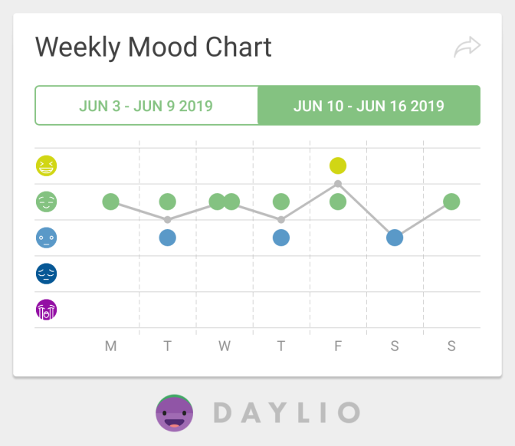

 | 1 | 2 | 3 | 4 | 5 | Keyword
Date
8.2.2021 |  |  |  |  | + | Spent time with my family
9.2.2021 |  |  | + |  |  | I was sick
10.2.2021 |  |  | + |  |  | Still sick
11.2.2021 |  | + |  |  |  | I found out that I’m going back to school
12.2.2021 |  |  |  |  | + | I had a game night with my friends
13.2.2021 |  |  | + |  |  | I had a lot of things to do for school next week
14.2.2021 |  |  |  |  | + | I was a little bit excited about seeing all of my friend again tomorrow

Date | Type of Movement (e.g. running, Yoga, dancing, etc.) | Length (e.g. 30 mins)
8.2.2021 | Running | 30 Mins
9.2.2021 | - | -
10.2.2021 | - | -
11.2.2021 | Running | 30 Mins
12.2.2021 | - | -
13.2.2021 | Running | 30 mins
14.2.2021 | - | -

 | 1 | 2 | 3 | 4 | 5 | Keyword
Date
15.2.2021 |  |  |  | + |  | I went to school
16.2.2021 |  |  |  |  | + | It was a really good day
17.2.2021 |  |  | + |  |  | Had a math test
18.2.2021 |  |  |  | + |  | It was a solid day
19.2.2021 |  | + |  |  |  | I had a headache
20.2.2021 |  |  |  |  | + | It was finally Saturday
21.2.2021 |  |  |  |  | + | I had a little trip with my family

Date | Type of Movement (e.g. running, Yoga, dancing, etc.) | Length (e.g. 30 mins)
15.2.2021 | Running | 30 mins
16.2.2021 | - | -
17.2.2021 | Running | 30 mins
18.2.2021 | - | -
19.2.2021 | - | -
20.2.2021 | - | -
21.2.2021 | Running | 30 mins

