https://www.newsbuzau.ro/cultura-media/36649-foto-elevii-colegiului-economic-buzau-au-fost-gazdele-unei-sezatori-dedicate-marii-uniri
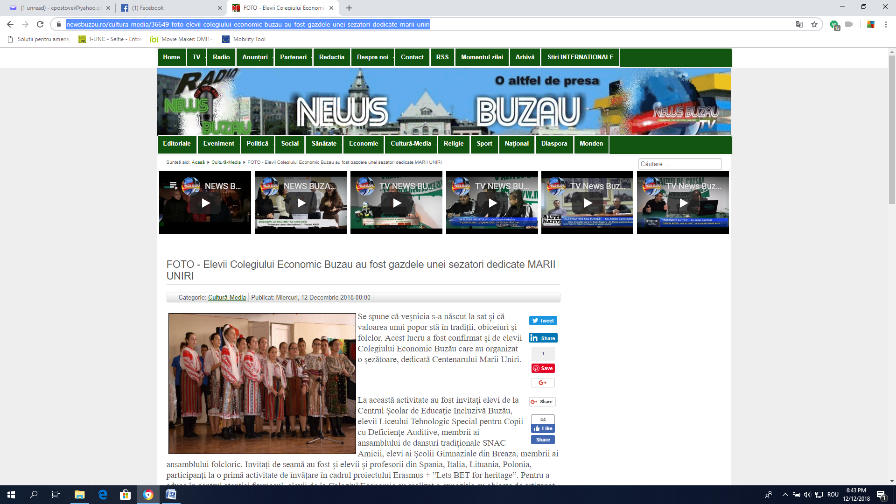
https://www.buzau.net/stiri-buzau/elevii-colegiului-economic-gazdele-unei-sezatori-dedicate-marii-uniri-23071.html


