Greek diary
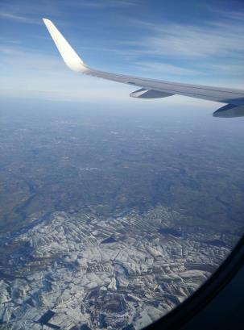
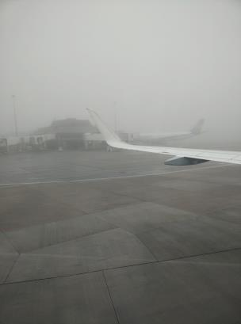
The first day started in the early morning. We woke and began our journey to Manchester Airport to board our plane to Frankfurt. Once in Frankfurt we transferred flights to Athens. When we arrived in Athens we met up with the other student delegations and introduced ourselves. We got a coach to Tripolis, and when we arrived we were greeted by a crowd of

The next morning we met at the hotel and travelled to the new, as yet unfinished, school. We then went to the current school where we were serenaded by violins! We met the family and friends of the hosts, and did our presentations along with all of the other delegations.
Whilst in Tripolis, we visited the theatre, performed our song we created and also the song the Greek delegation had wrote, and ate lots of local food! My favourite food was Pita Gyros!
It snowed very heavily which was amazing, I’d never seen snow so thick before! We visited many local attractions in Tripolis and the local areas, such as the Ampitheatre, the Acropolis at Mycenae, and the various different museums. We ate lots of Gyros and souvlaki on the way.
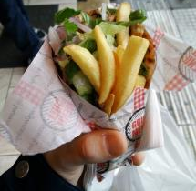
On the last day in Tripolis we joined in a traditional Greek Holiday which involved eating lots of meat – my personal favourite day. We went to a party where we did lots of greek dancing and ate even more souvlaki.
On the Friday we began our journey to Athens. It was a long journey and I slept through most of it.
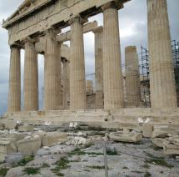
Athens was amazing, the atmosphere of the city was great! The Acropolis was just mind blowing, being stood so close to something so old! All I could imagine is how many others have stood there before me. We had a final meal in a lovely restaurant, I again had pita gyros!
The next day, tearful goodbyes were said as we departed for the airport. I met a lot of people in Greece and I’m sure I’ll keep in touch with them!.

