MEETING IN ISTANBUL
22 - 28 NOVEMBER 2015

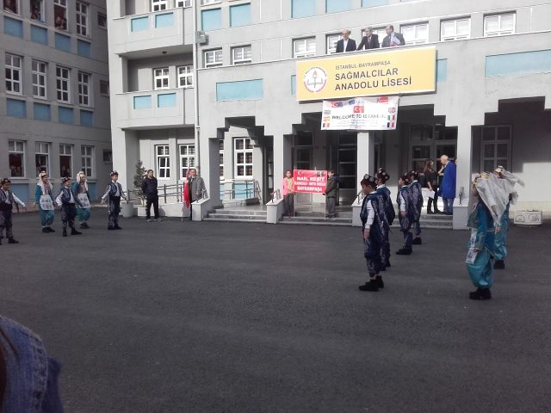
The first day they welcomed us to their school and they showed us their folk dances that reminded us some elements from the greek culture.
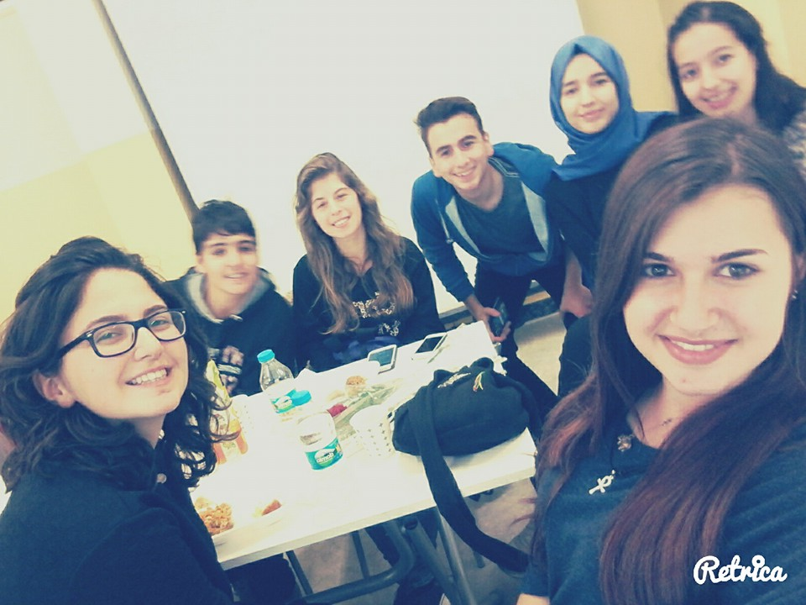
Then, we had break for lunch and we met our Turkish friends. All foods were perfect. After lunch some students met the headmaster of school and in the evening some others visited one of the mayors of Istanbul.
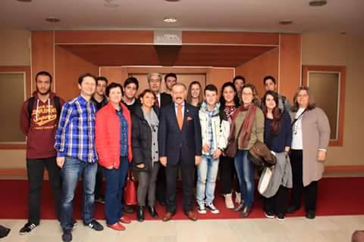

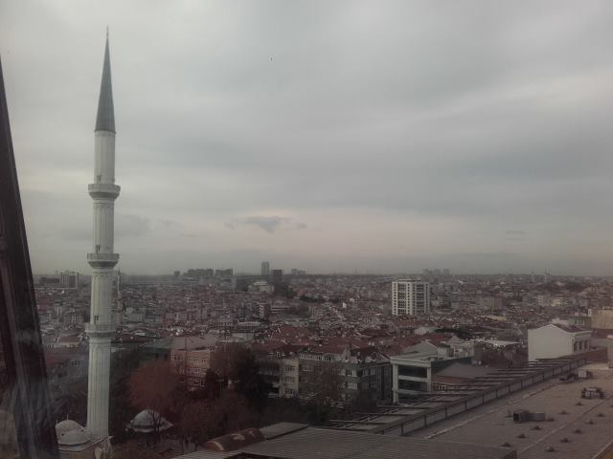
The view from mayor’s office was incredible.
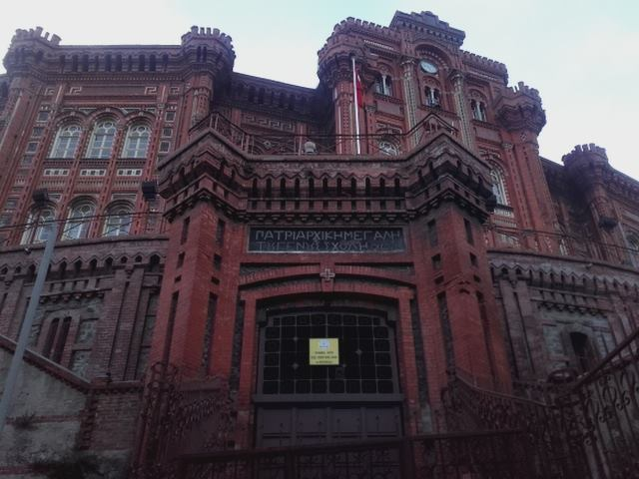
Then, the greek students visited the Ecumenical Patriachate of Constantinople. It was a very familiar surrounding for us and we felt glad for our visiting there.
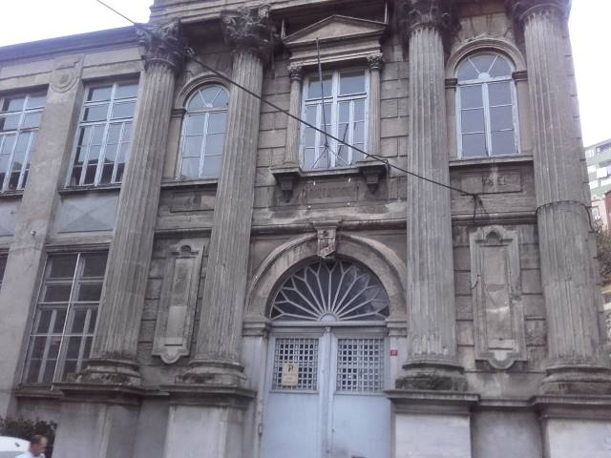
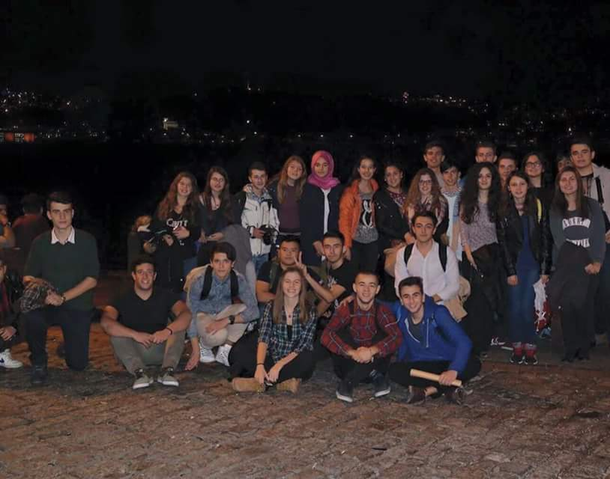
At night, all students went a walk in Bosphorus to drink or eat something.

On Tuesday morning we went to the ULKER Chocolate Factory where we tasted the perfect taste of Turkish chocolates and after lunch we arrived in their school for the logo contest.
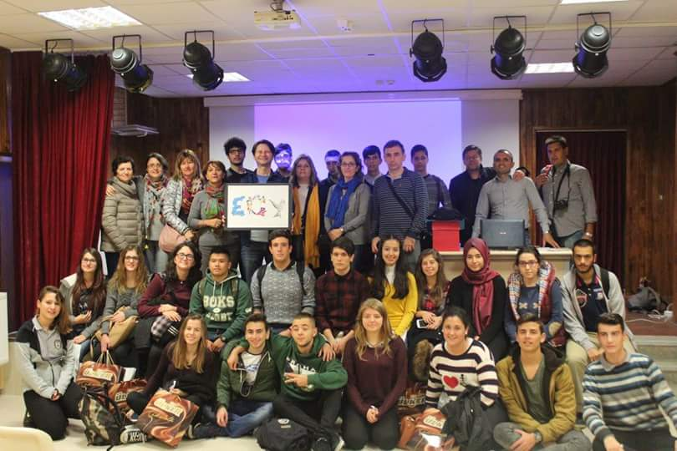
Voting we decided that the Turkish logo was the most beautiful and suitable to represent our program.
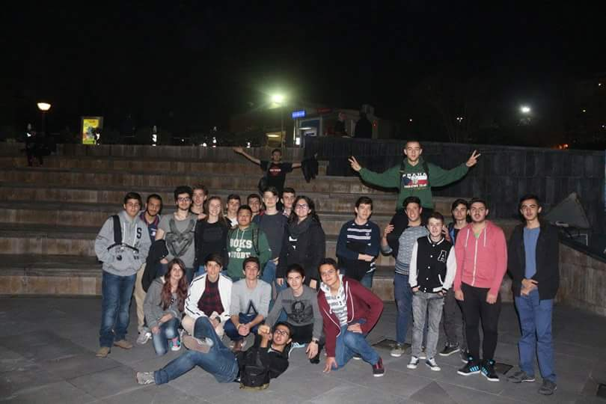
In the evening, we went to play bowling and we knew each other better.
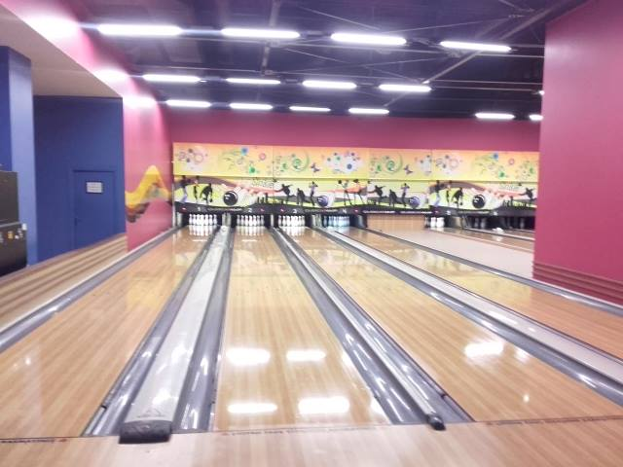
On Wednesday, we had to showed the drama play .So we met in the school to prepare it and then we were ready to play it. All countries had done a very good preparation .
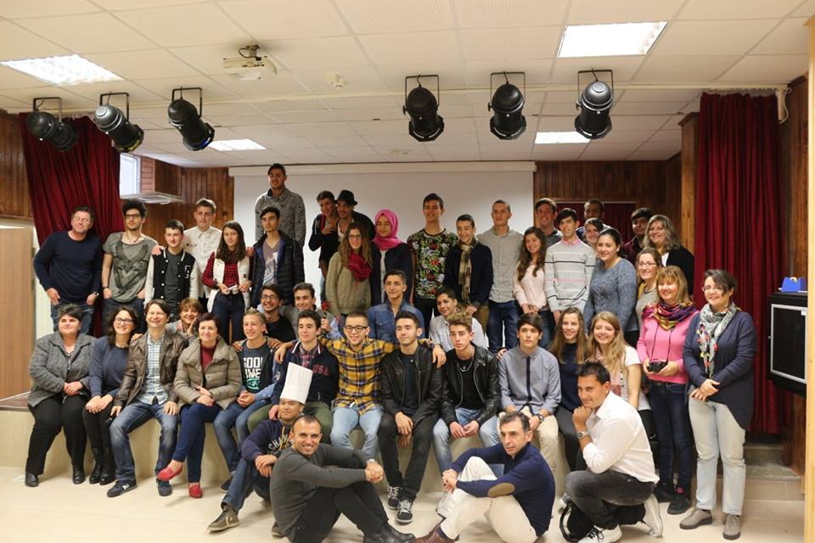
Then, we visited Panorama and at night we went for a walk to Atakoy .
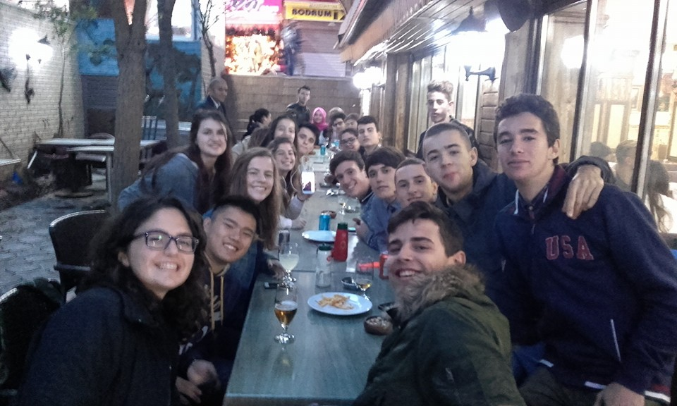
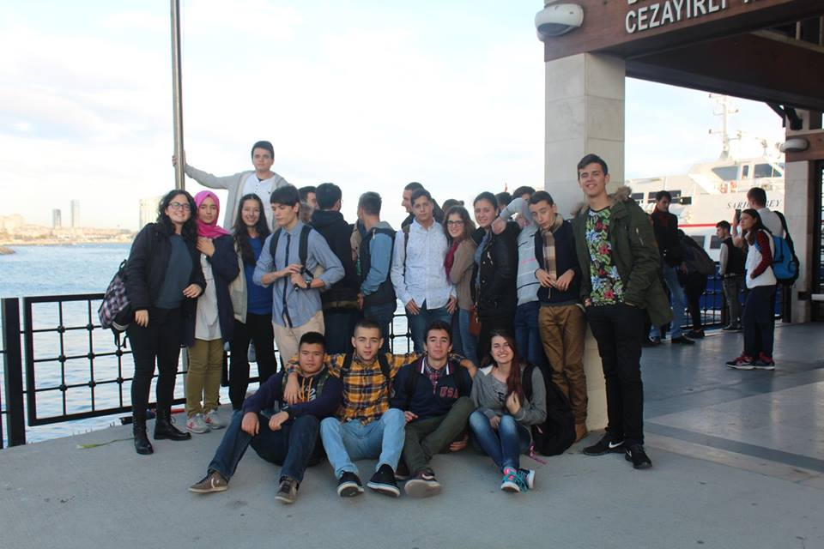
Thursday was the guided day. Firstly, we visited the Sultan Ahmet Mosque where we wore scarfs in our head to go inside and Hagia Sophia which was an indescricable place and we enchanted for her wealth and her beauty.
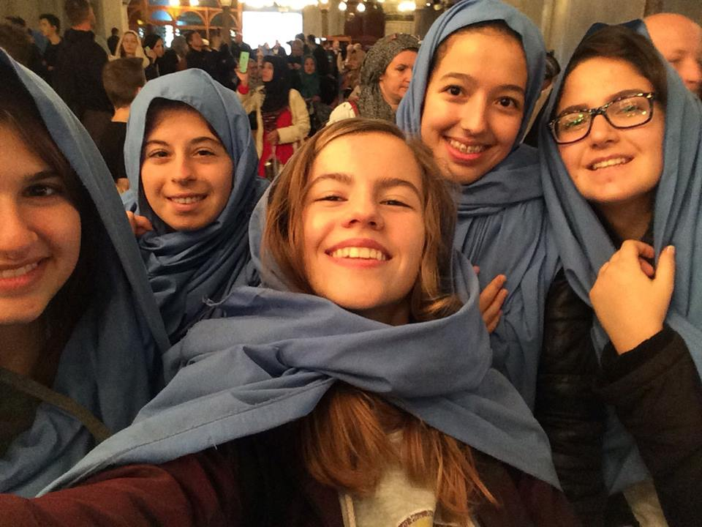
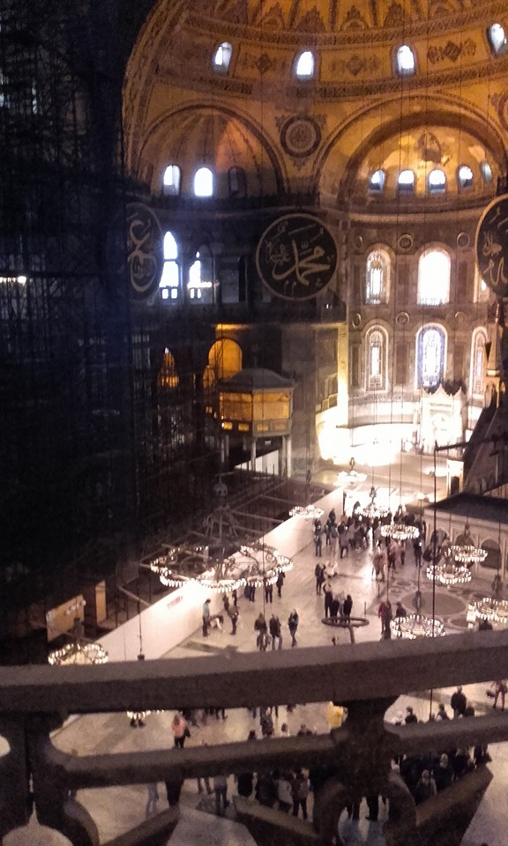
Then, we went in Topkapi Palace and in Basilica Cistern where we saw Medusa and we heard for her history.
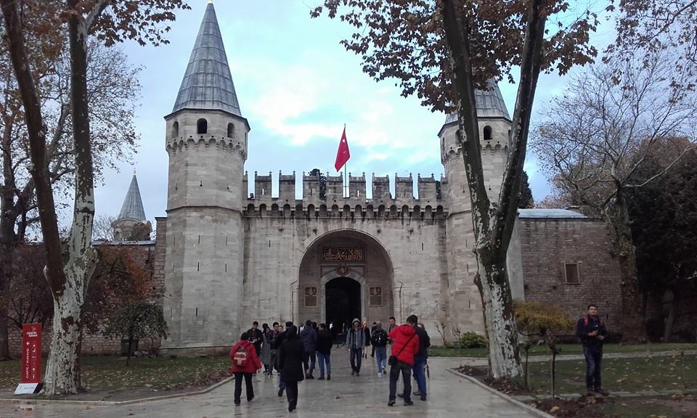
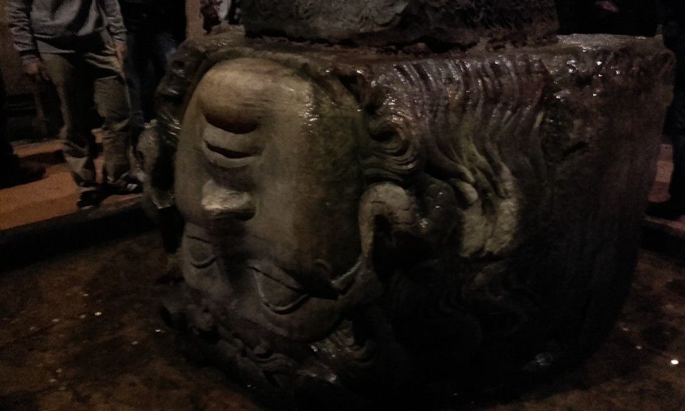
The last day morning, we departure from school and we went in Maidens Tower and Camlica Hill where we went to eat something to continue our tour.
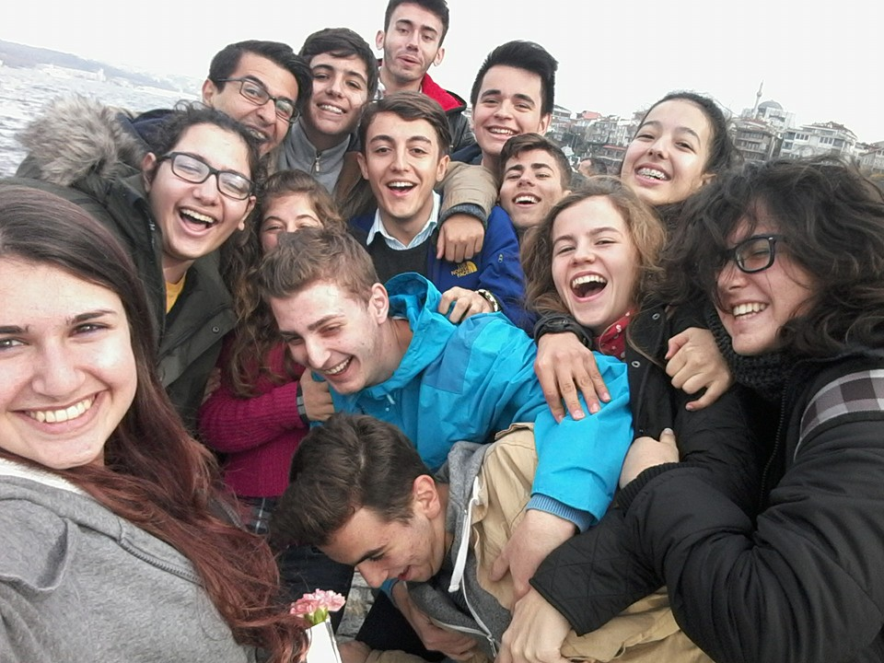
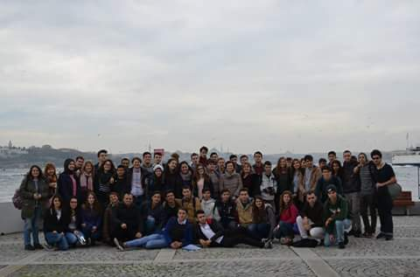
In the evening, we went for a walk in Taksim square where we had free time for shopping souvenirs for our families. It is so beautiful square and all shops had many interesting things for a tourist.
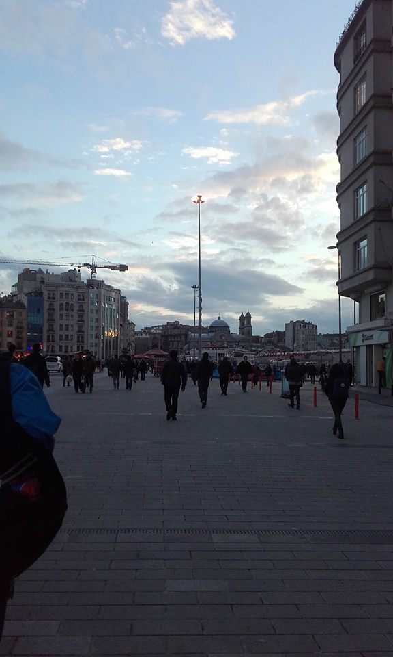
At night we arrived at school for the last party to goodbye our friends
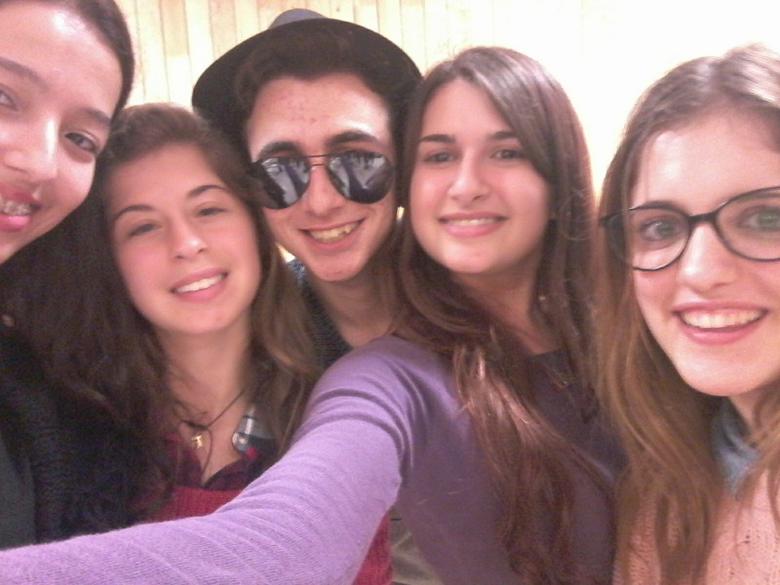
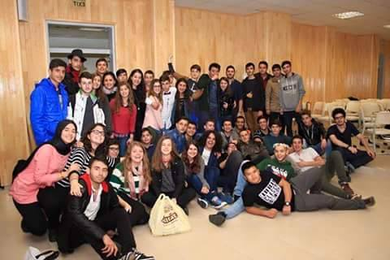
Saturday morning we gathered in Turkish school to say goodbye and go to airport. It was an unhappy moment and all we were sad because we should have abstracted each other. I miss you all ,
Thank you for this perfect week.
