1st day- Monday
(18-1-16)
On the first day we had the reception by the headmaster and the presentation of the Spanish school… 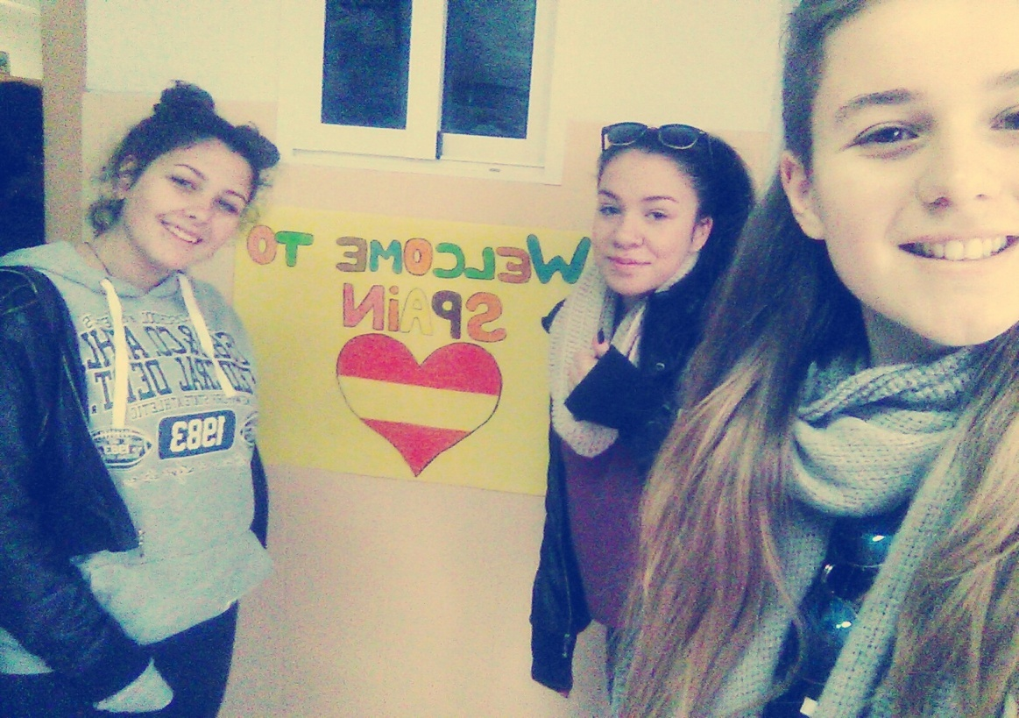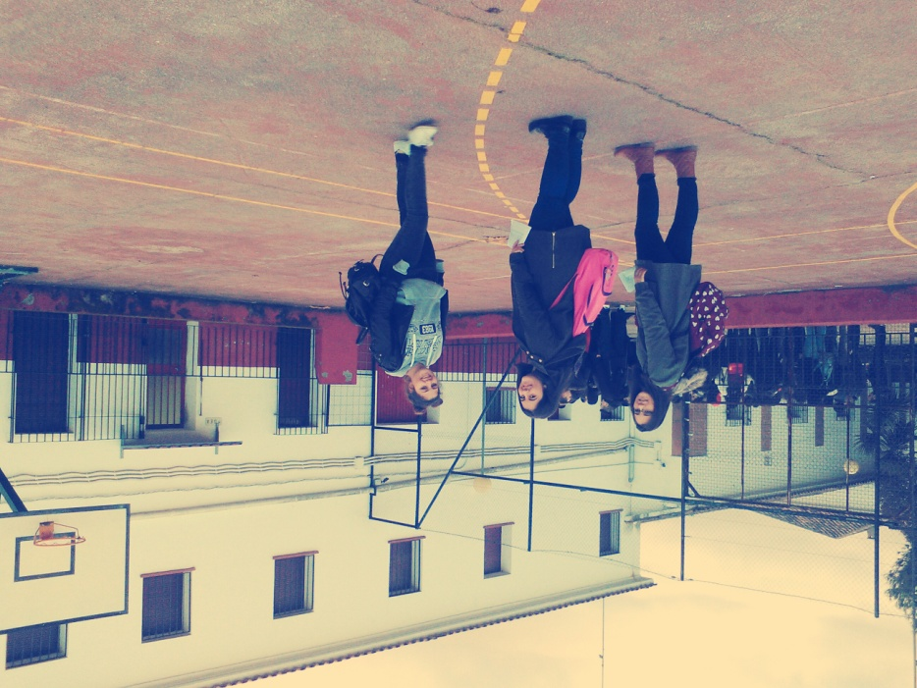

Then we had a typical breakfast all together at a local churreria …
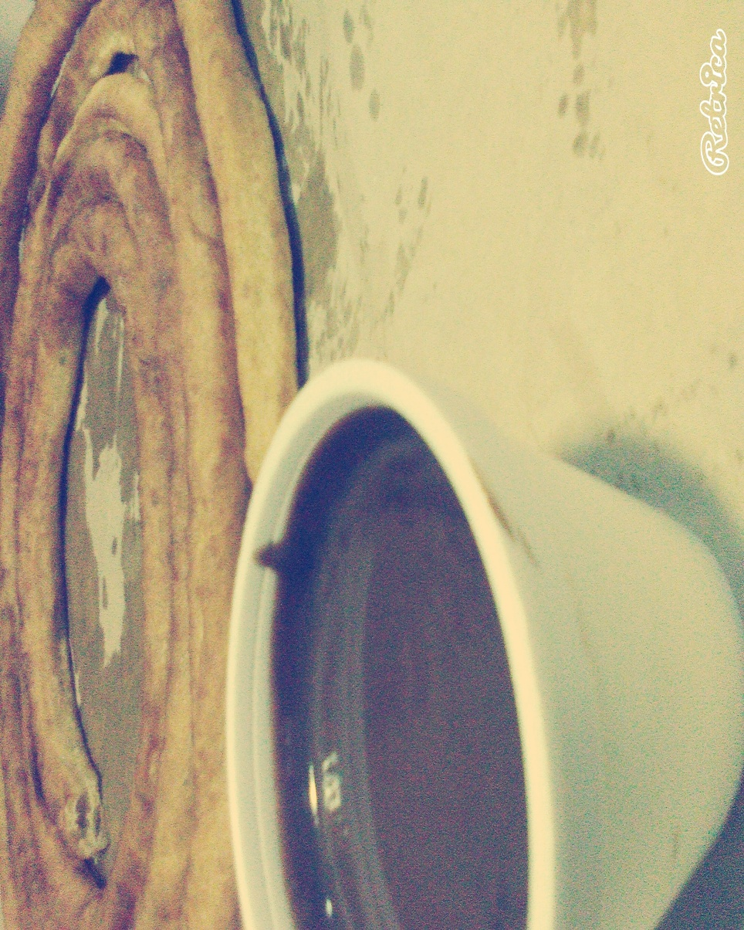

After our breakfast we had a walk arround the village and the reception by the Mayor of Marmolejo…
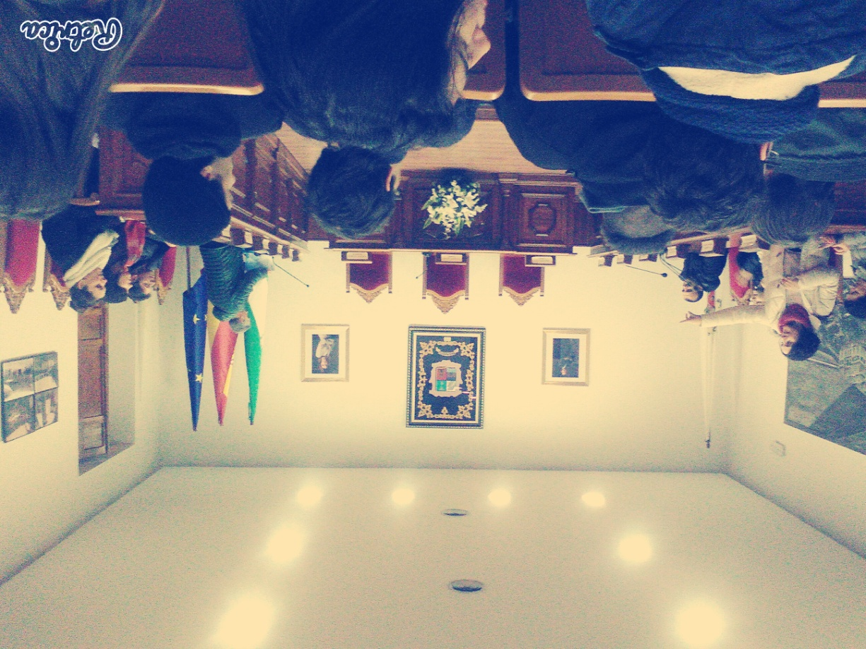

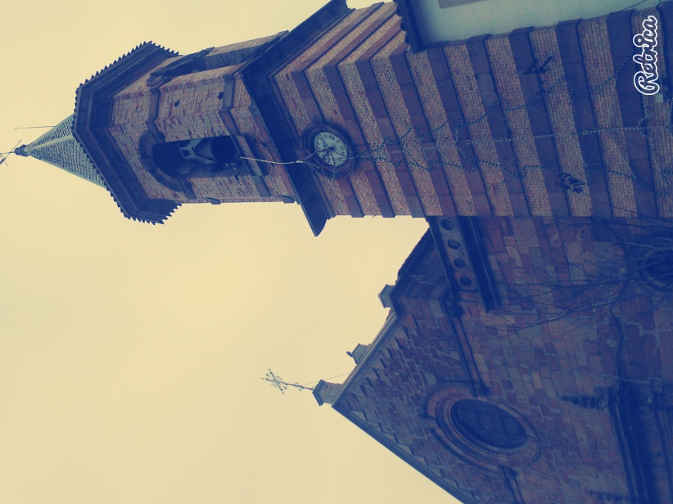
Then we returned home to have a meal with the families, in the afternoon we played some board games to get to know each other better. After the board games we returned to the families to have dinner.

2nd day-Tuesday
(19-1-16)
Early the next morning we got up and we went to the meeting point to get the bus and start our trip to the Oil Museum. One or two hours later we arrived at the museum…
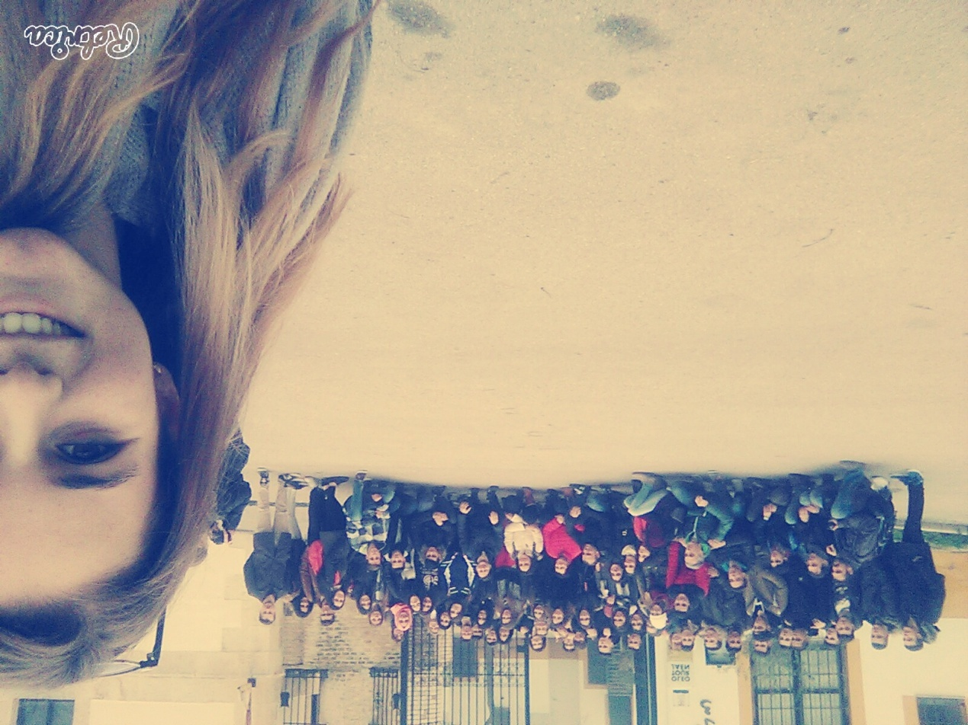

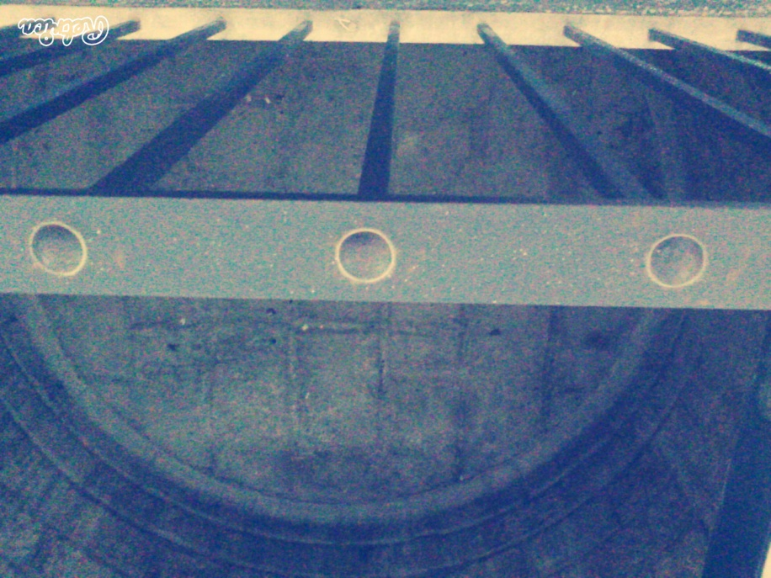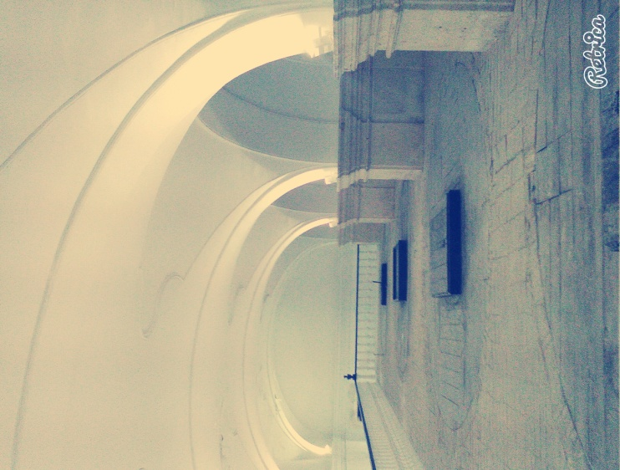
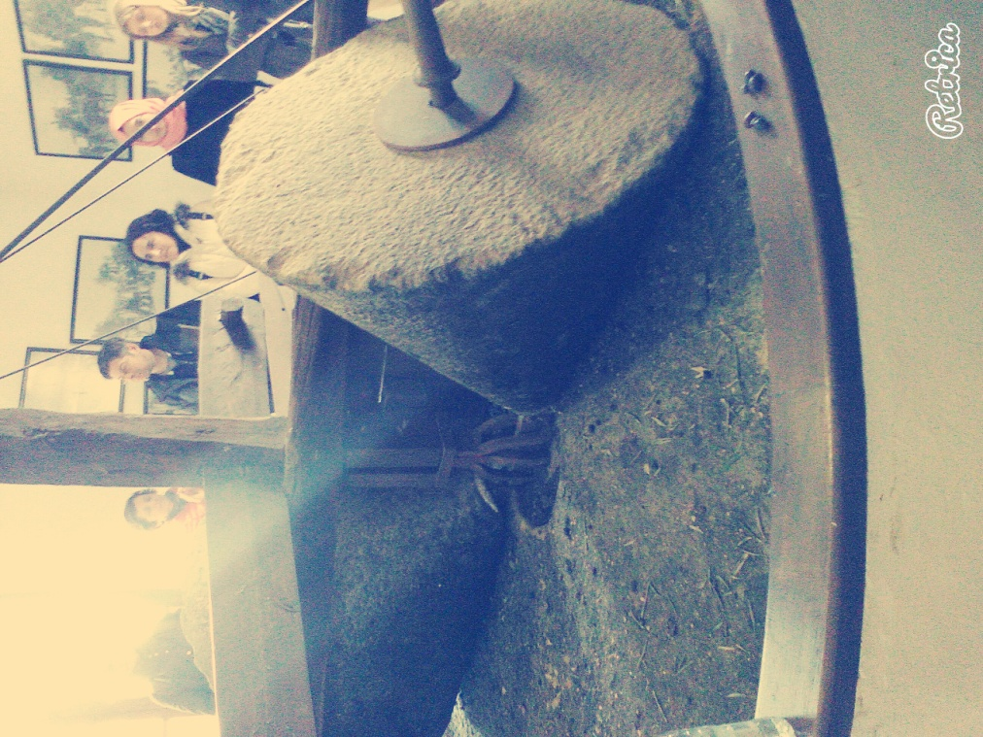
Then we went again to our meeting point, we took the bus and we visited Baeza. We learned everything about the local industry and we also had free time to visit the town. In the evening we got again into the bus and we returned to Marmolejo.

3rd day- Wednesday
(20-1-16)
On Wednesday we went to the school of Marmolejo and we did digital activities about our project. We had breakfast at the school’s coffee shop and then we took the bus to Cordoba… 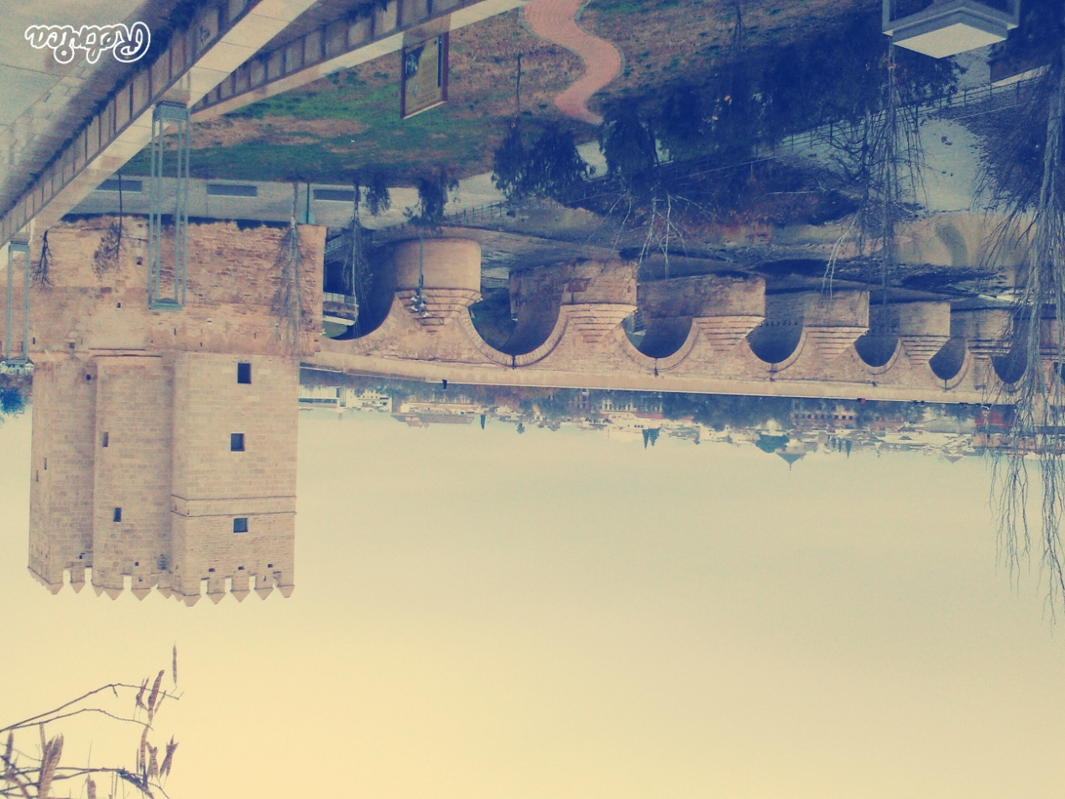
When we reached Cordoba we wandered around the town’s streets and visited the Cordoba Mosque…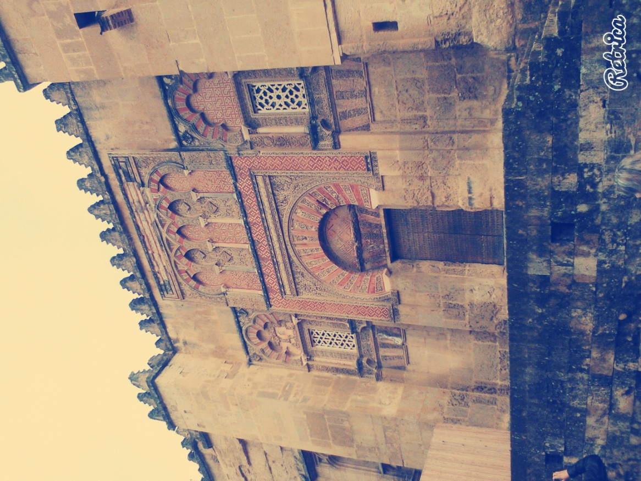
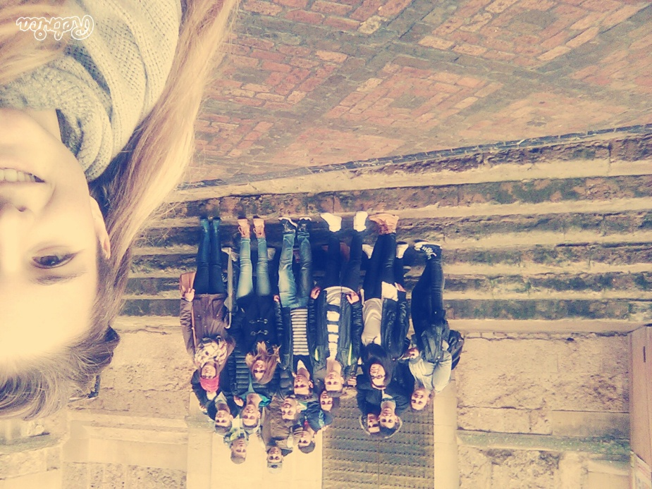
Then we had free time to have a meal, choosing among different local places, and later at night we saw a performance of the famous Andalusian horses. After that wonderful show, we took the way back to Marmolejo.
4th day- Thursday
(21-1-16)
On Thursday we got up early and went to school. We worked on a second digital workshop about our project and then we had free time to have breakfast at the school’s coffee shop. After our breakfast we went to a forest nearby to plant trees…
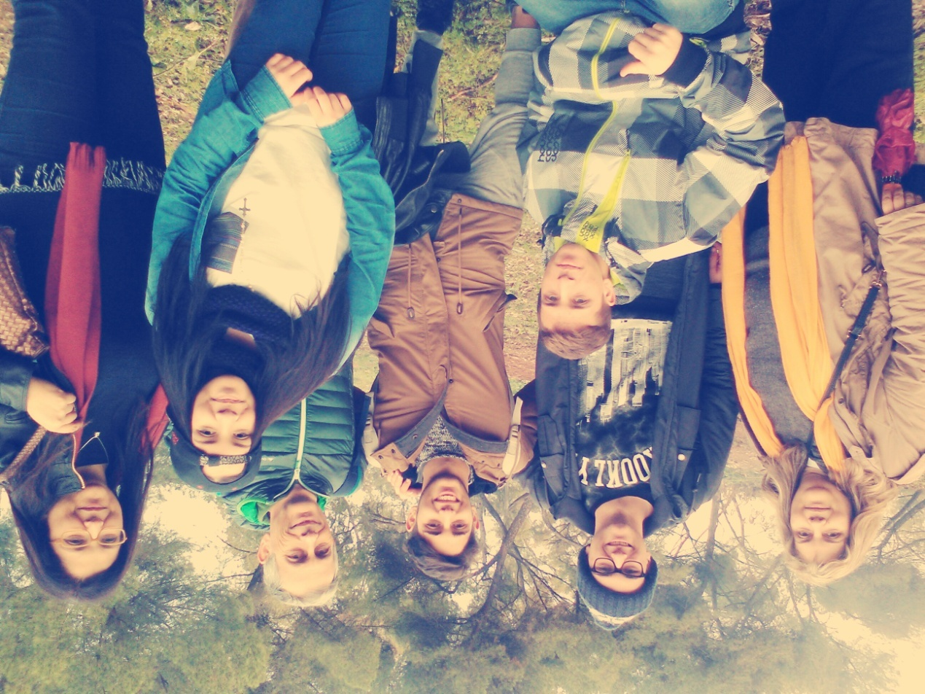
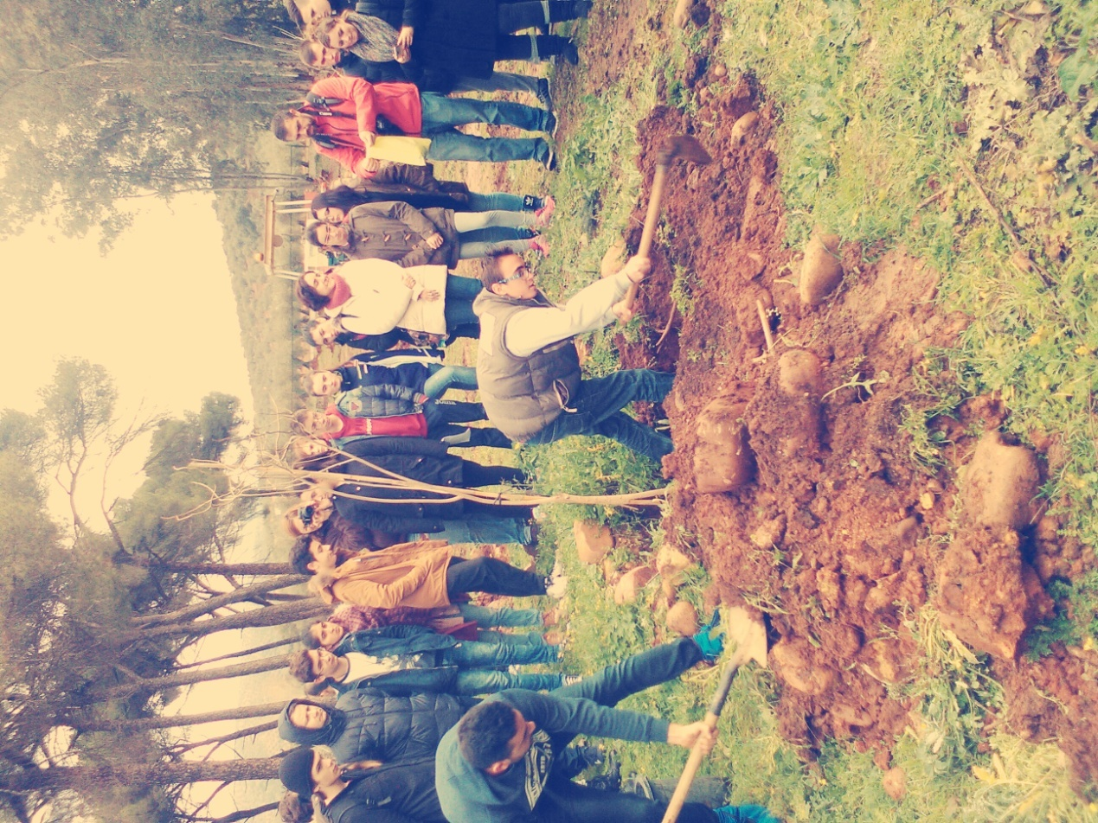
After that we had plenty of time to spend time with our Spanish friends. And in the end we had dinner at home with the families as always.

5th day- Friday
(22-1-16)
Last day. Friday… we departure from Marmolejo to Granada…
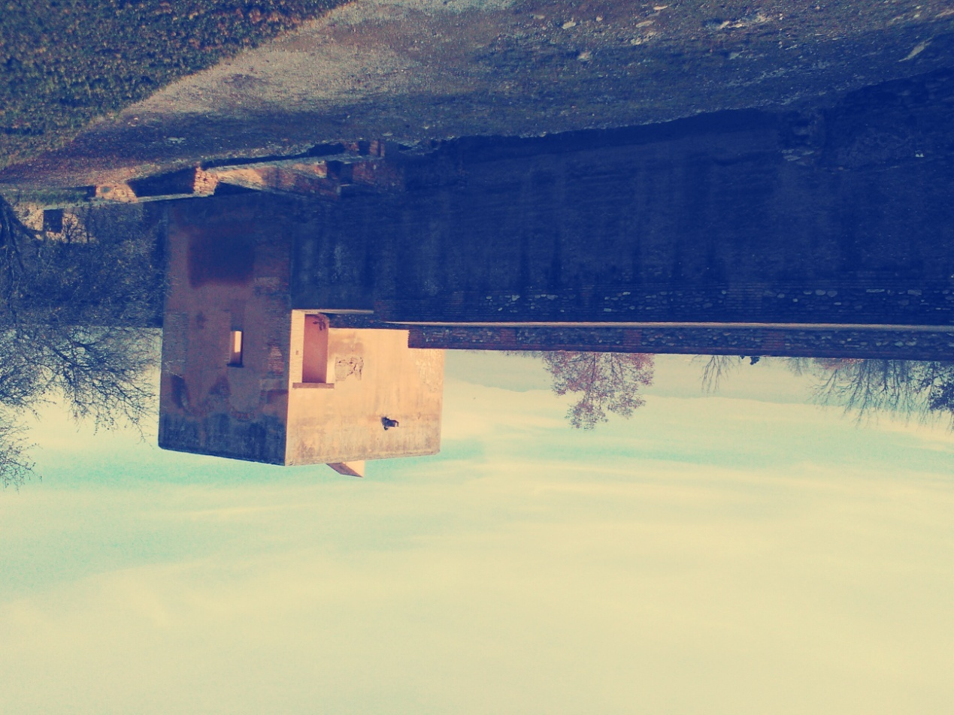

We visited the Alhambra Palace and many different places of it…
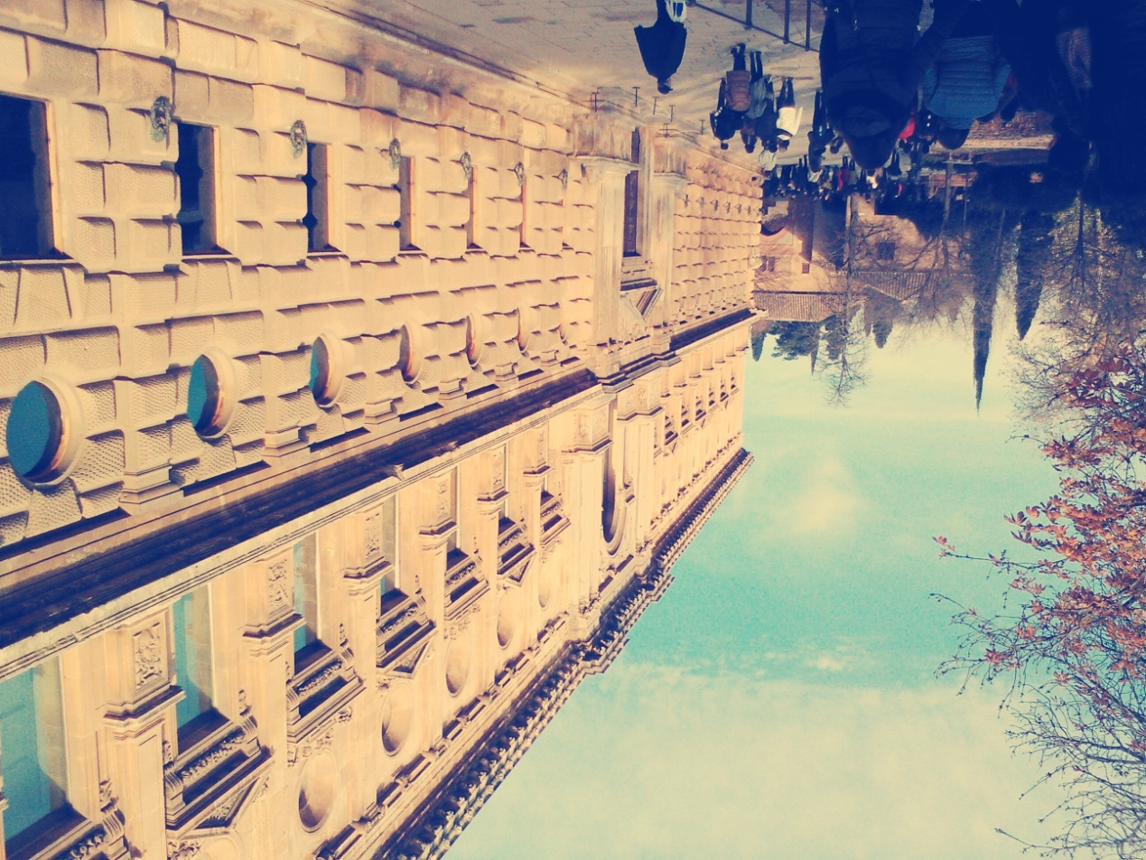

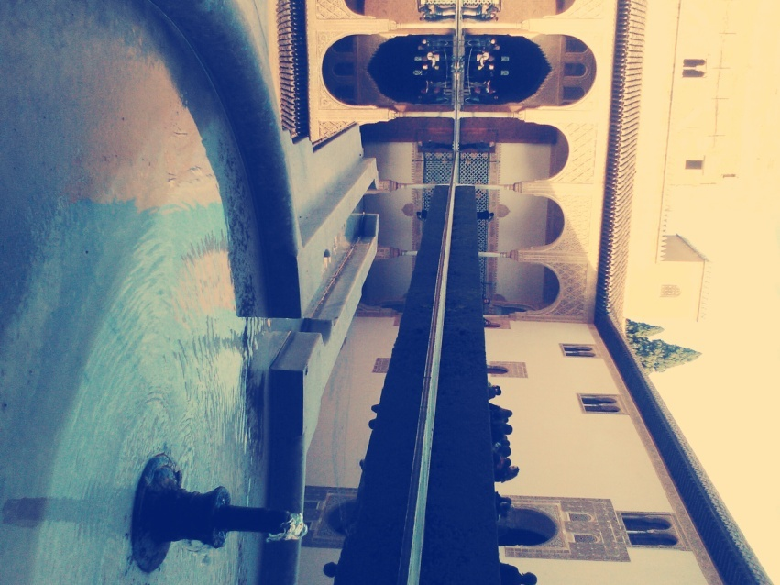
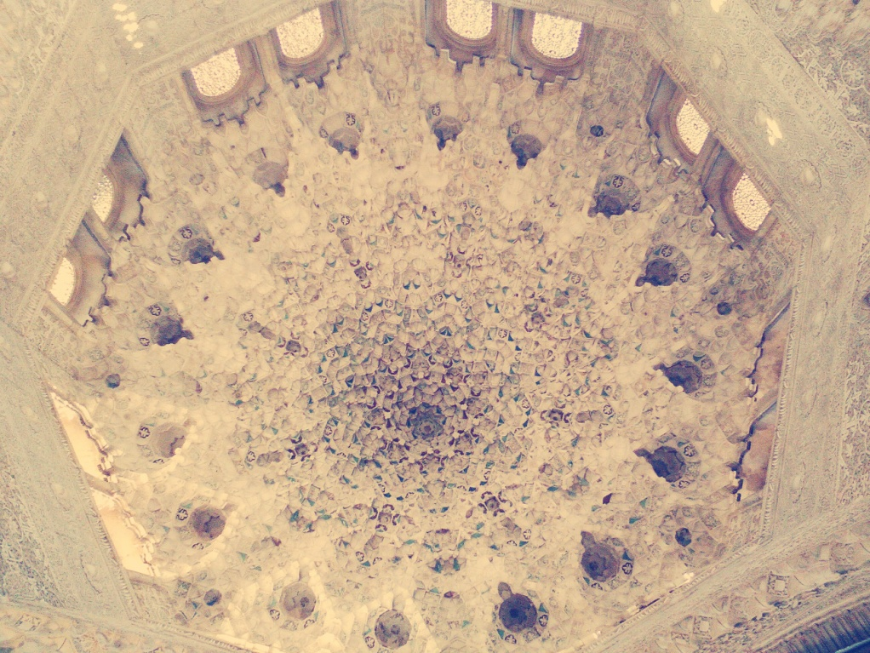
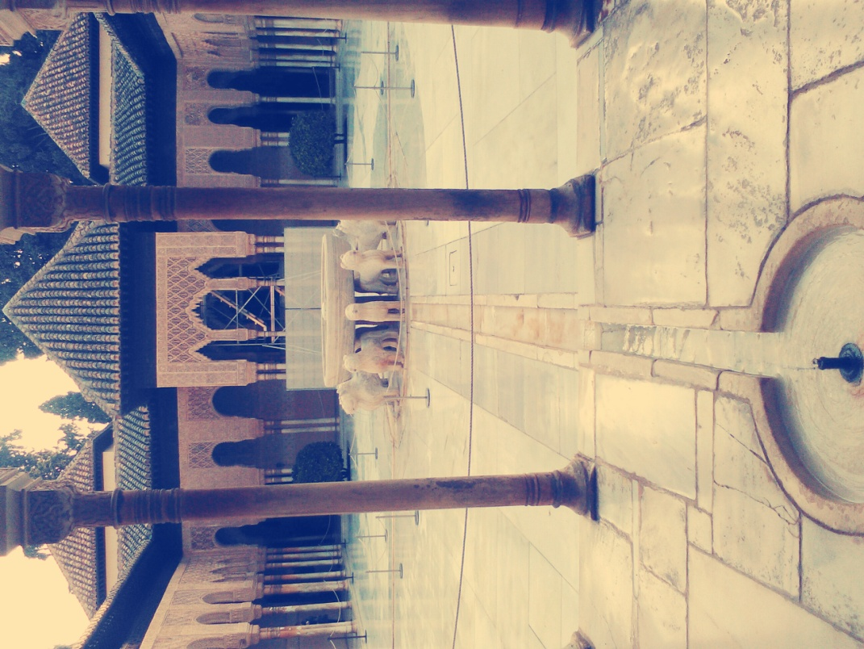
After our visit to the Alhambra Palace we had some free time to have a meal and then we had a tour around the streets of Granada…
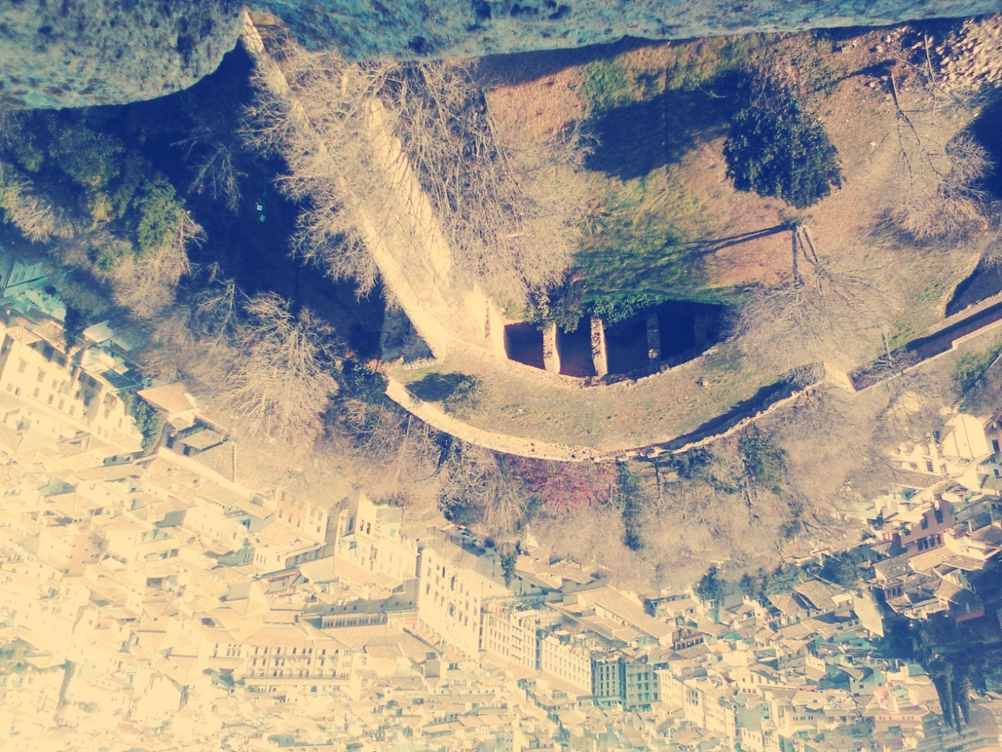
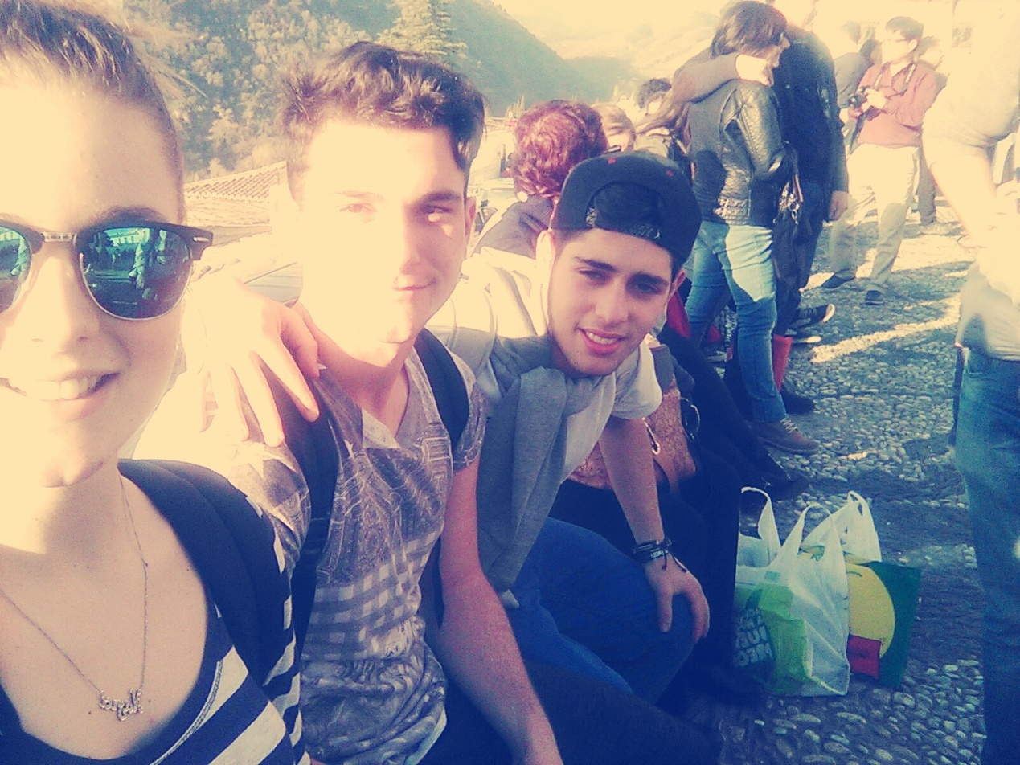
A few hours later we departured from Granada to go back home to Marmolejo for our last night at this beautiful village, with the most beautiful people I have ever met…

Thank you all, I will never forget you!!!

Erasmus+ … Spain… 2016

Naya Sotiropoulou.

