February 12, we get up at 8 o´clock of the morning to go to the hotel.
When we came to the hotel, we had to divide in two groups, to do different activities.

The first group we went away with a percusionist of typical music in Greece. Others, went with a clarinetist, who played tipical music of Greece.
First, we was in the group with the clarinetist,he played a weird music, very different from the spanish music. While he played the clarinet, a girl explained the history about the music.

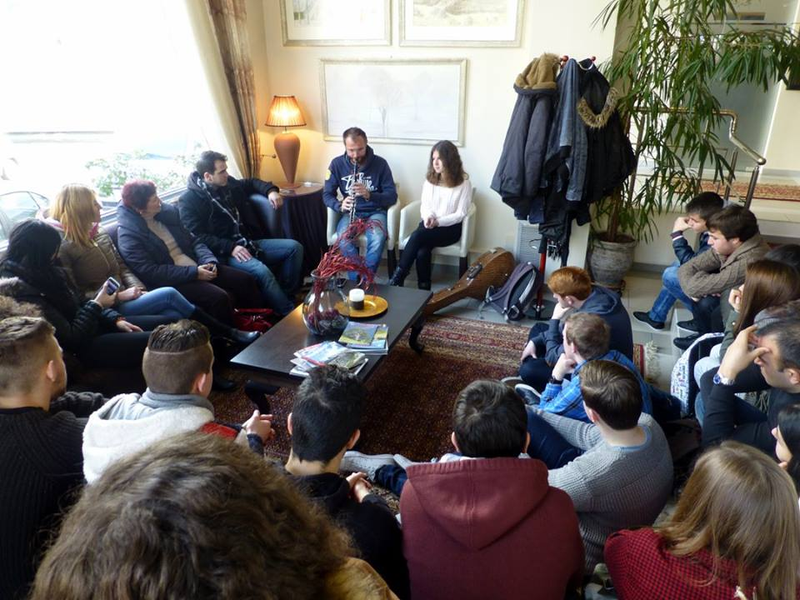

In the other group, after the men explained the history about the drum music, we played the instrument too. There were more or less five different instrument and we choose the instrument that we wanted to play.

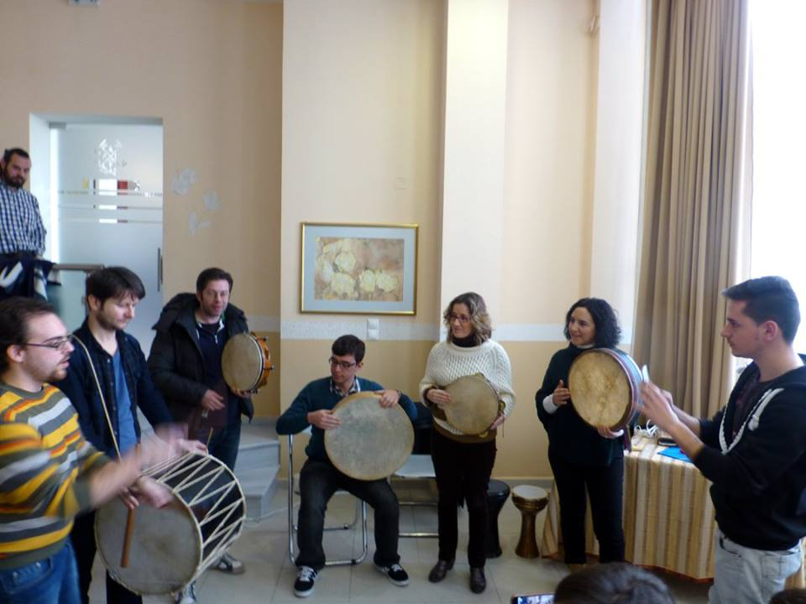

After, we want to a restaurant all together, because it was the last day in Tripolis and moreover, it was the greek carnival, the Tchniknopemti. whe arrived there at 12o´clock and we ate a soulaki, a tipical food.

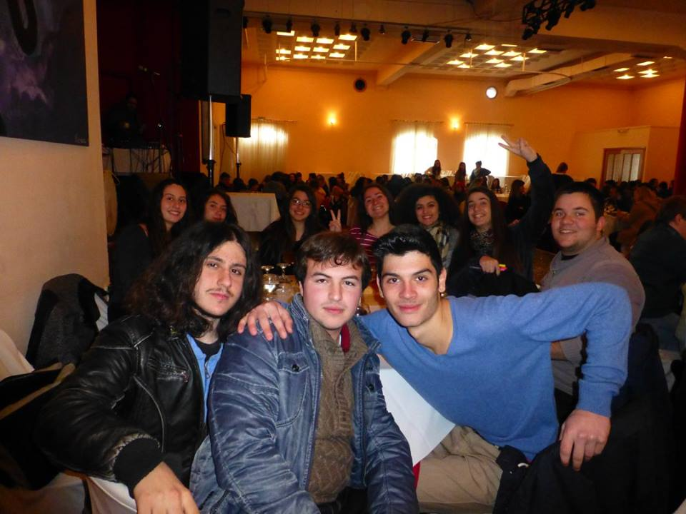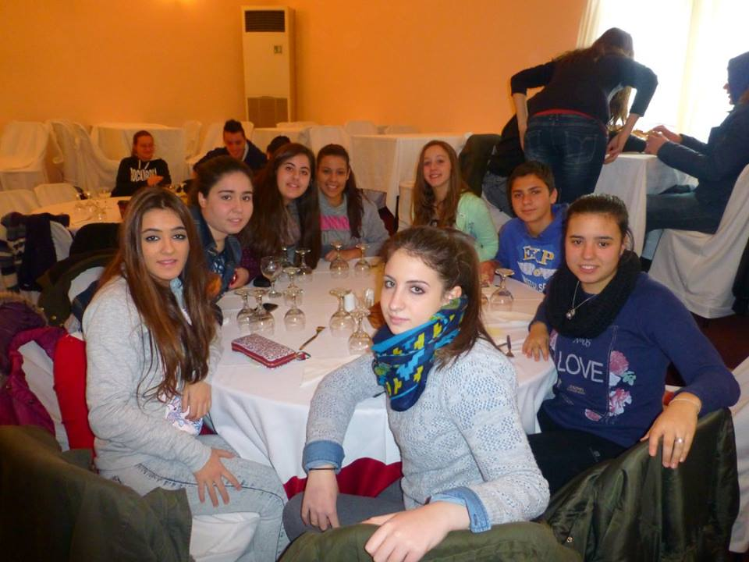
​
​
There, there was a stage where Jose luis, delighted us, with his magic.

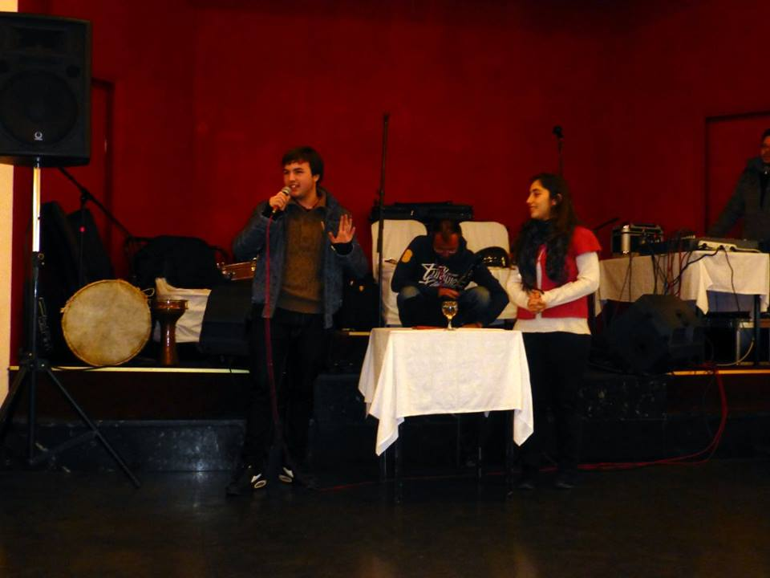

Moreover, we could to dance the tipical dance. we had the chance of to have a good musicians and good singer to us. We enjoy a lot dancing with our greek friends, because it was the last day with them. We didn,t want to return to Spain.

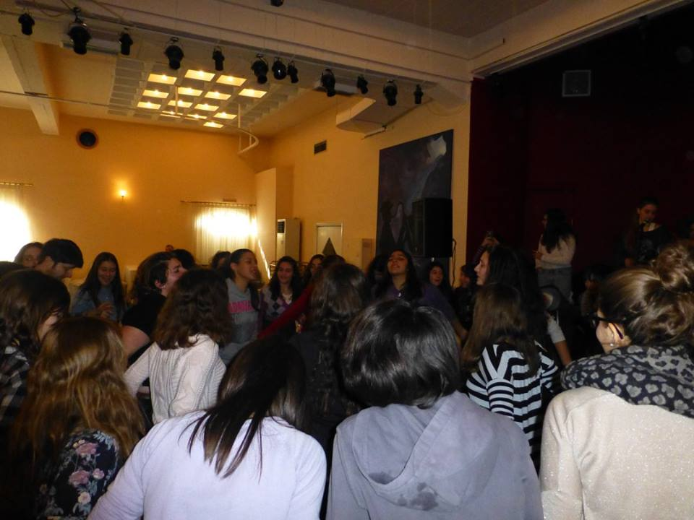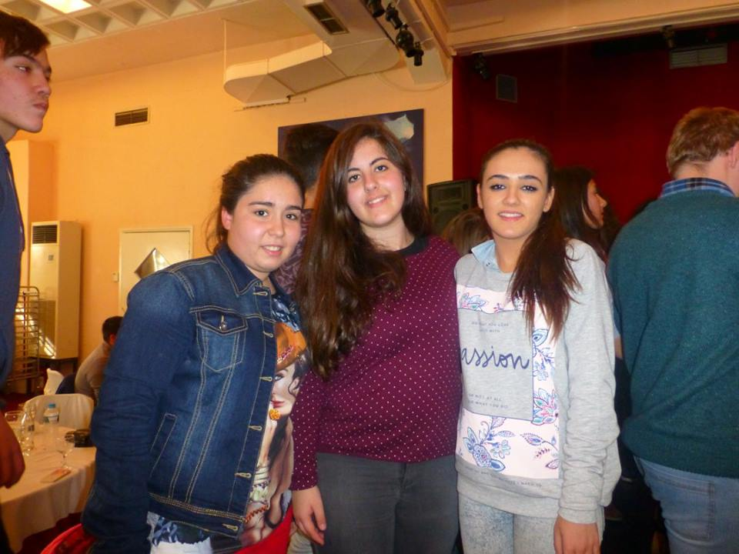

We were very pleased to discover the Greek carnival. we learnt about tipical instruments and music but also about tradition throght music, dande and food.

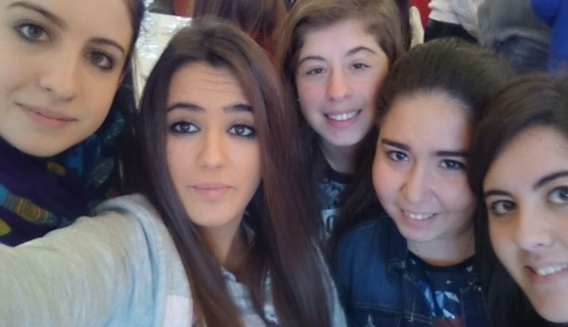

In the afternoon, we went to our houses to do the bag, and to be with our families. When i did the bag, my family wanted to give me a present, and we went to the shop to see what i wanted for me. I choose a little brazalet, and they give me a vine and a pasta, whose are made in tripolis. After,we went to a cafe with other people of erasmus too, and we enjoy a lot remerbering some things that we had done. Moreover, we walked around tripolis seeing the clothes shops and souvenirs shops too.

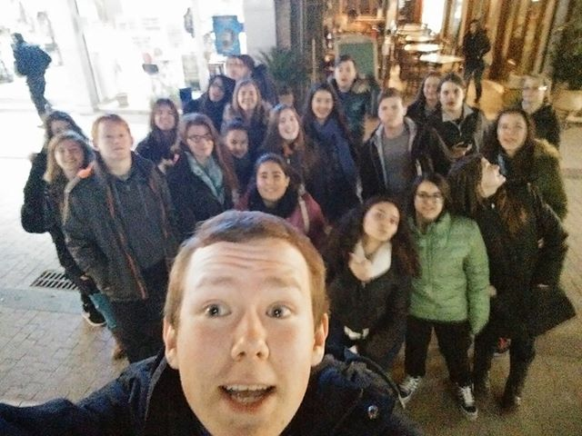

Finally, my family and me, went a restaurant with my family´s friends. These restaurant, was the job of the other family, and we ate there. we ate chips and soulaki again. when we ate, we danced and song.

When it was the half past nine, we went to house to sleep to be refreshed to go to Athehs to the next day.

