Erasmus +
Meetingin Italy(04.10. -10.10.2015)
Greek delegation
Mr. Sotiris Kostouros
Mrs. Betty Kouskouli
AggelikiGiannopoulou
DionisiaGeorgelou
Dimitra Roumelioti
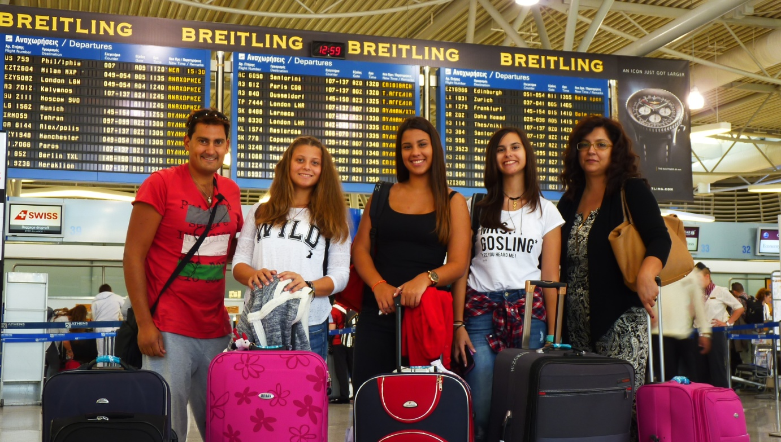

1st day
On Sunday we left Tripolis in the morning, at 9:30 and then we went to the airport of Athens, EleytheriosVeniselos, where our flight was at 15:25. In Italy, we arrived 2 hours later and next we had to take the train that would transfer us from Roma to Pisa. At Pisa we arrived approximately at 11:30 p.m. The families that hosted us were at the train station to go with us at home.

2nd day
On Monday we woke up early and our excursion started at Polo Piagge,a University of Pisa where we met the other groups from Turkey, Spain, France, Romania, Italy and England and there we attended a conference in English. Then we were free to go with our new friends to walk and to eat lunch in Pisa. At 15.00 o' clock we went all together Pisa sightseeing.
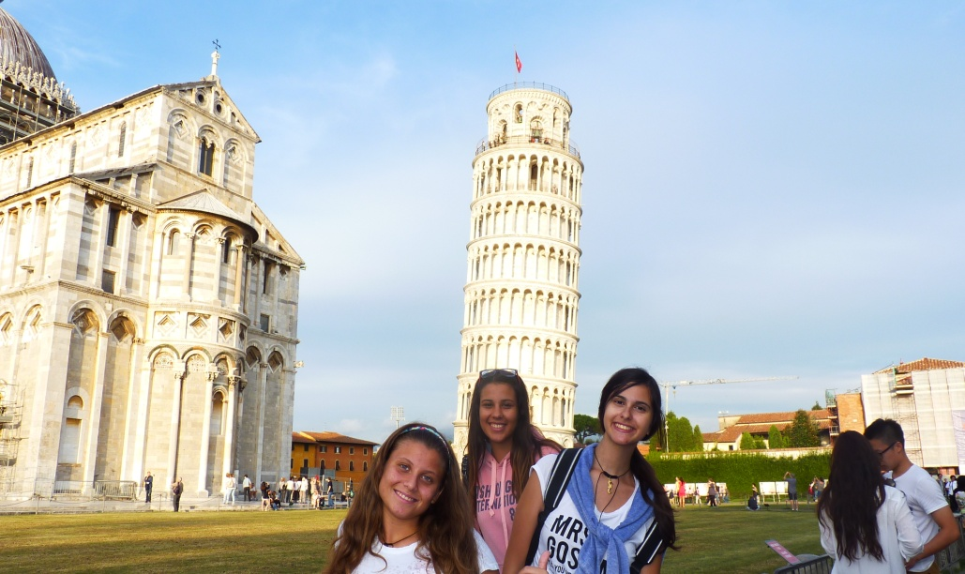
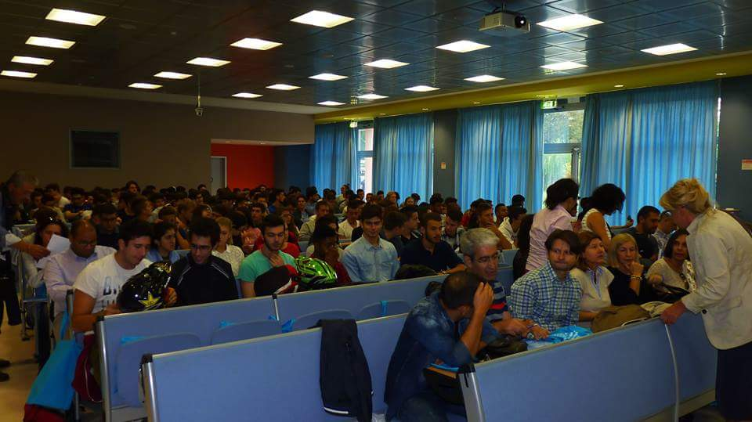
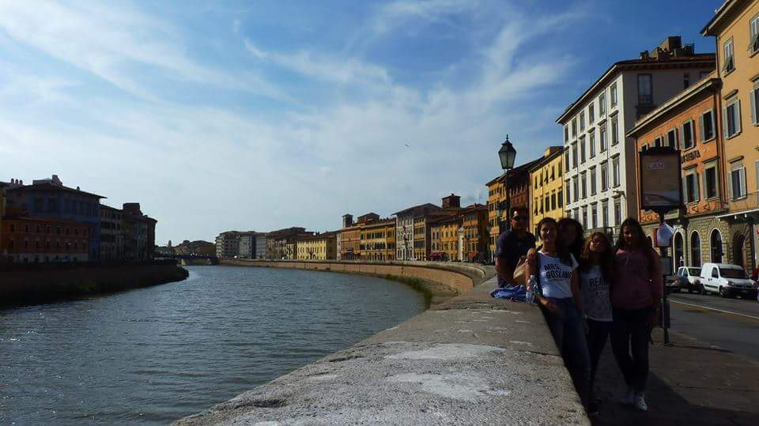
3rd day
On Tuesday, in the morning we went at Leonardo Da Vinci I.T.I.S, the Italian school, where teachers and students welcomed us. It was a huge school with many laboratories and other equipment. Next we did a break and 1 hour later all countries presented the working identity in their local area. Afterwards in the program followed sports(football, basketball,dodge ball etc.) that the aim was the cooperation and contact between our teams' members.
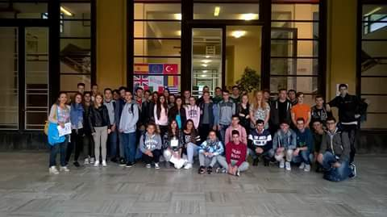
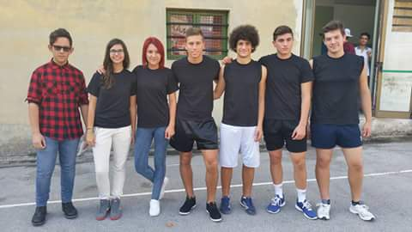
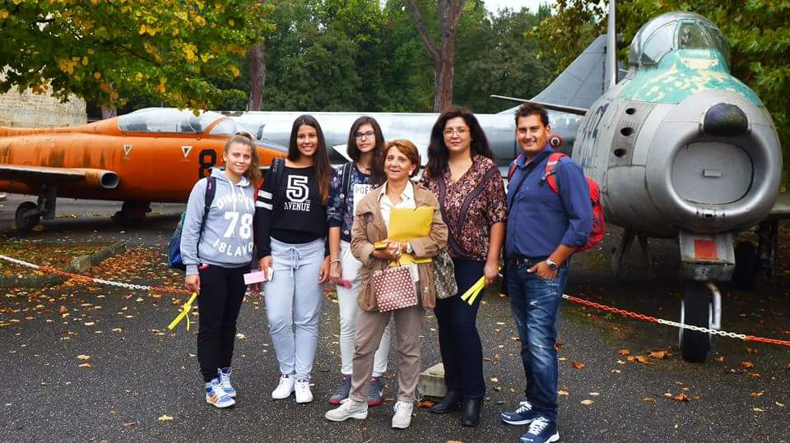
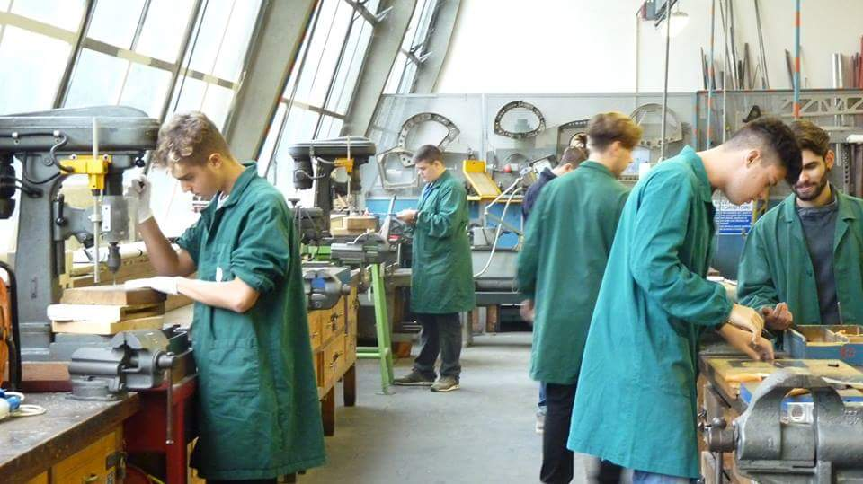
4th day
On Wednesday, we took the bus to visit Piaggio and the European Gravitational Observatory in Pontedera. The Observatory was about hunting for Gravitational Waves by using Light, Mirrors and Pendula. Then we visited Piaggio, where there was a huge Vespas' exhibition with Vespas from all over the centuries. At 13.00 o' clock we returned back to Pisa to eat lunch with the families, who hosted us and to relax.

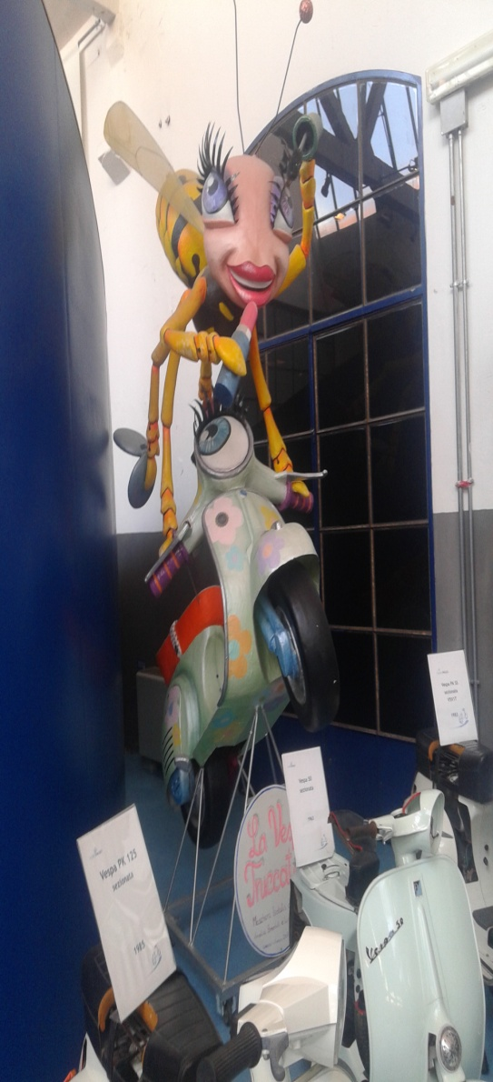
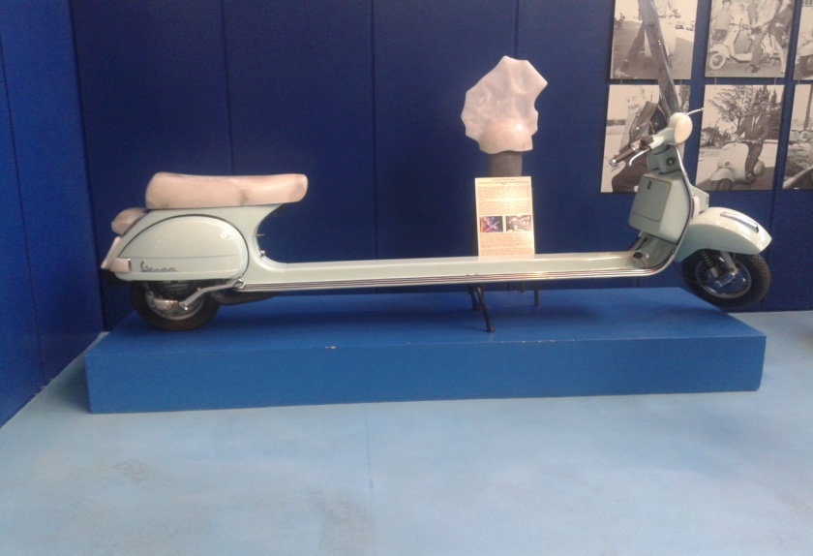
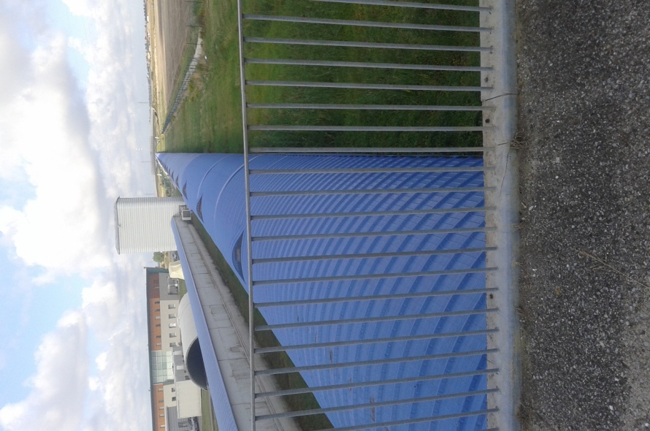

5th day
On Thursday, we met each other at the train station, where our destination was Florence. In Florence we saw many notable buildings. We visited Medici Champels, an art museum, which was designed by Brunelleschi in the fifteenth century and built by Michelangelo and Buontalenti. Furthermore we went to Boboli Garden, a park in Florence, that is home of a collection of sculptures dating from the 16th through the 18th centuries and then we walked in Florence admiring the stoned buildings.

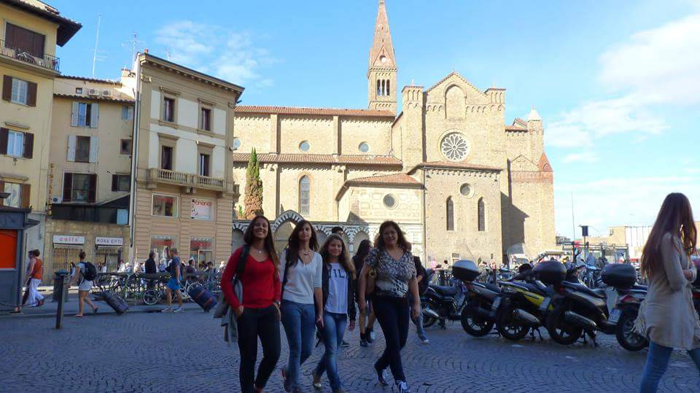
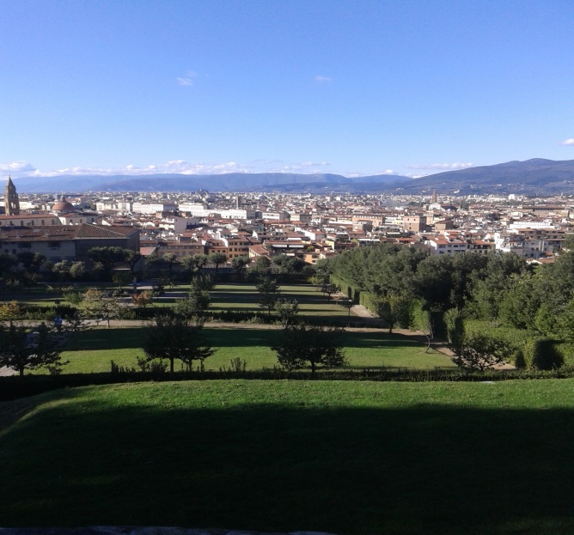
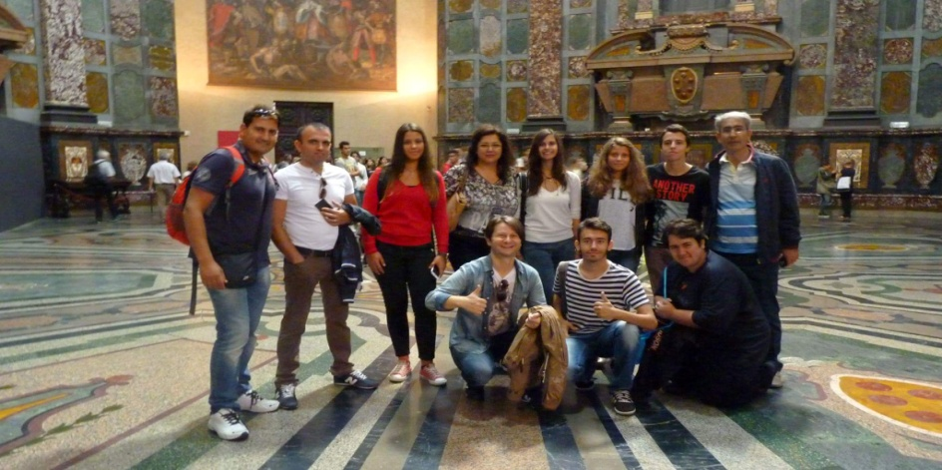
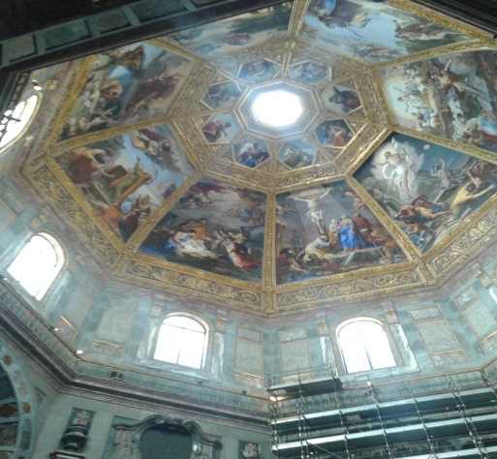
6th day
Friday was our last day in Italy. We woke up in the morning and we went by the train to Lucca. At Lucca we saw a great green landscape, where we were guided and took photos. Continuously, we went to a museum, where we learned how old people were using the loom. When we finished our guided tour we walked in Lucca for a while and then we returned in Pisa. In Pisa we had to do the Workshop (students work through the data collected on the economic situation in their countries, in mixed groups). Finally we returned at homes to prepare ourselves for the farewell party.

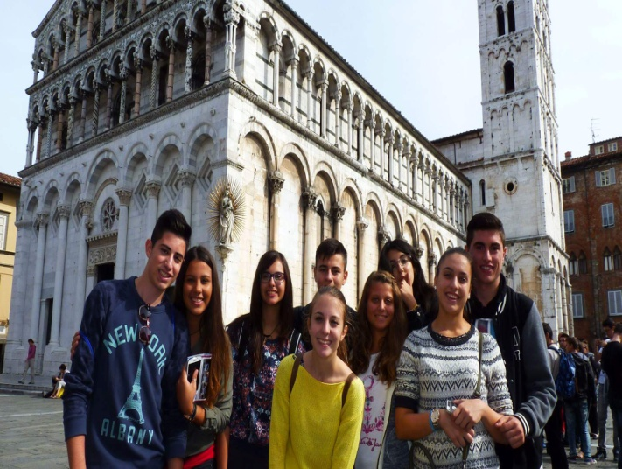
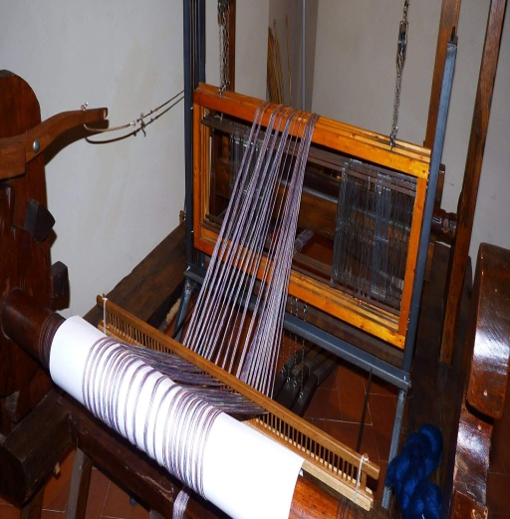
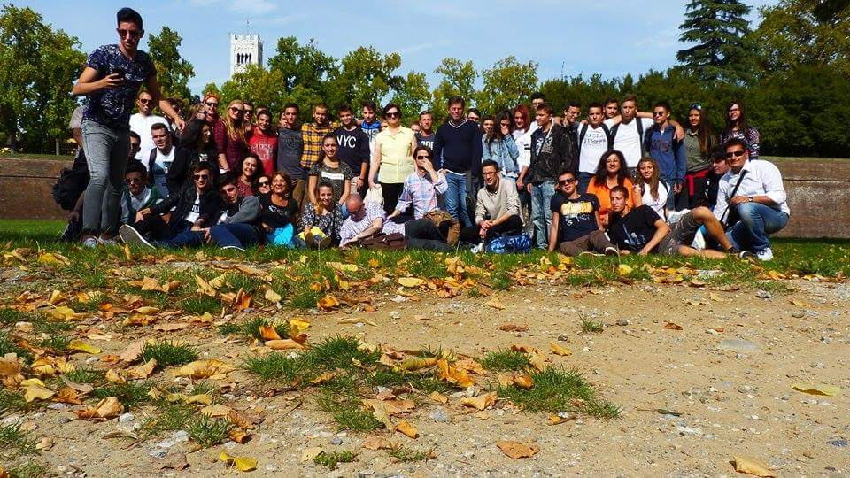
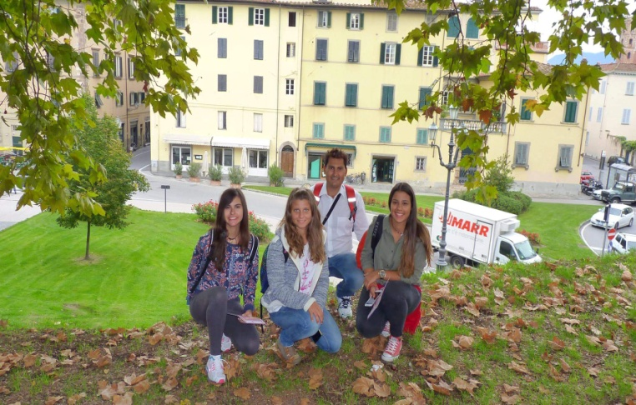

7th day
On Saturday we left Pisa at 7.30 a.m. Our host families accompanied us to the train station, where we took the train to go to Roma. Approximately 4 hours later ,when we arrived in Roma there was a bad weather with a lot of rain. However we watched Colosseum and we walked there to admire this beautiful town. Our flight was at 17:30 ,so we went to the airport and approximately at 20:40 we were in Athens, where our beautiful trip finished, leaving to us unforgettable memories to remember.
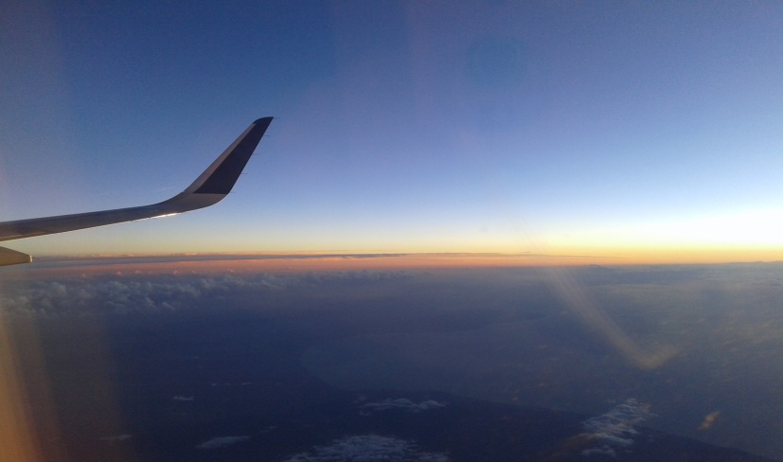
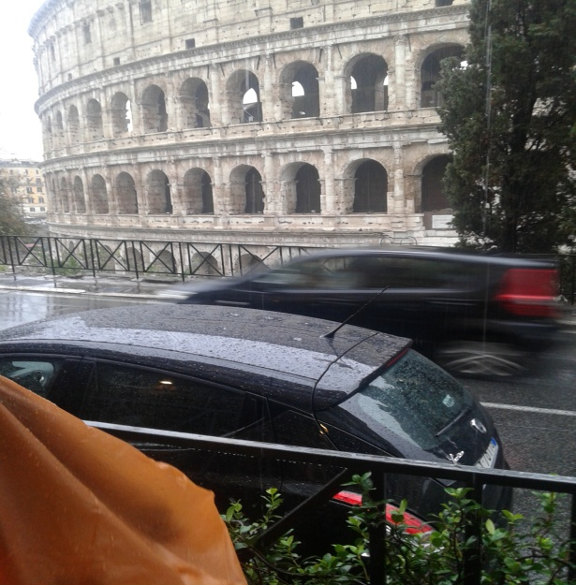
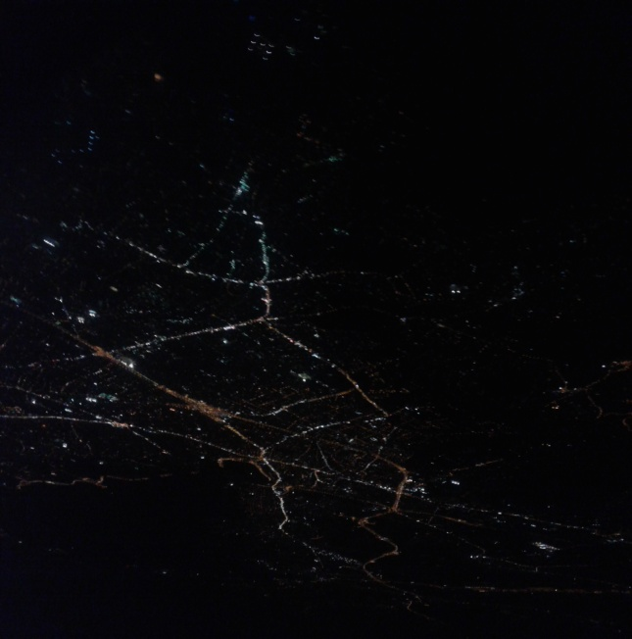
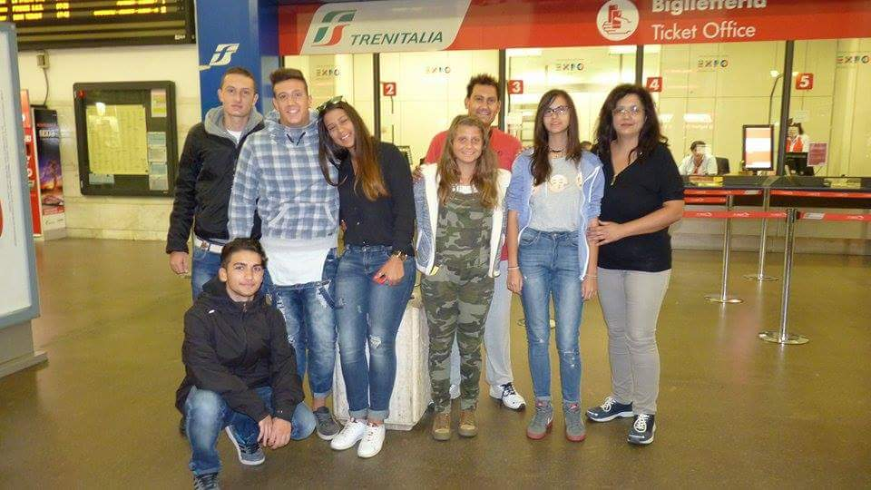

DionisiaGeorgelou

