Erasmus+ Activity jurnal Turkey

Tene Adriana-Mirela

First day 22 november 2015
I arrived at school,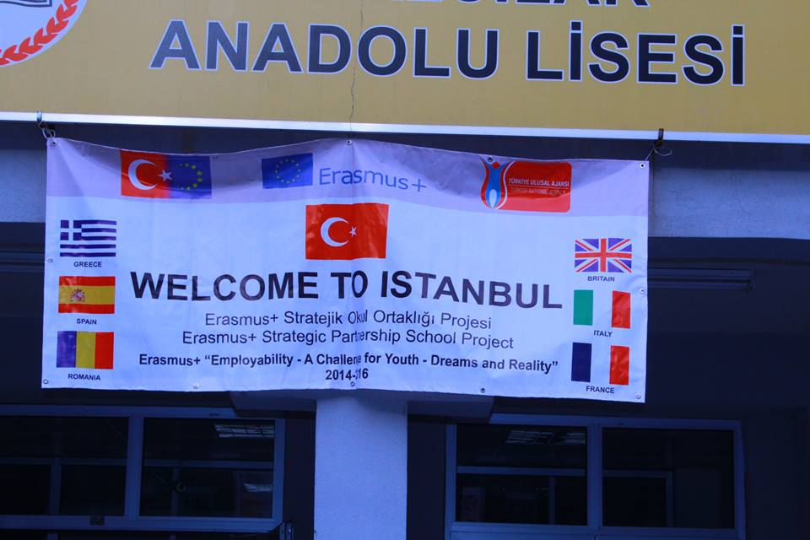 with anothers , I met my host and went to home.
I met his family ,I spoke a little with them and after we go in Forum.
Day 2 : 23 november 2015
We wake up and go to school . At 9:15 we saw Turkish Folk Dances
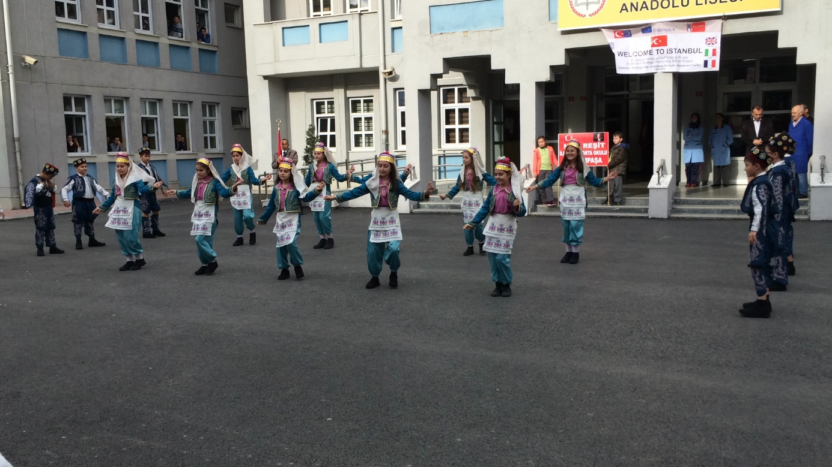
At 9:45 we go to conference room ,there we saw the presentation about school.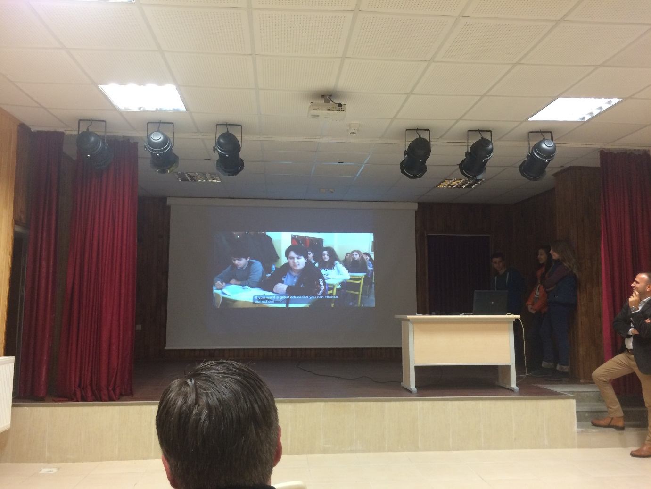

After this we had a coffee break
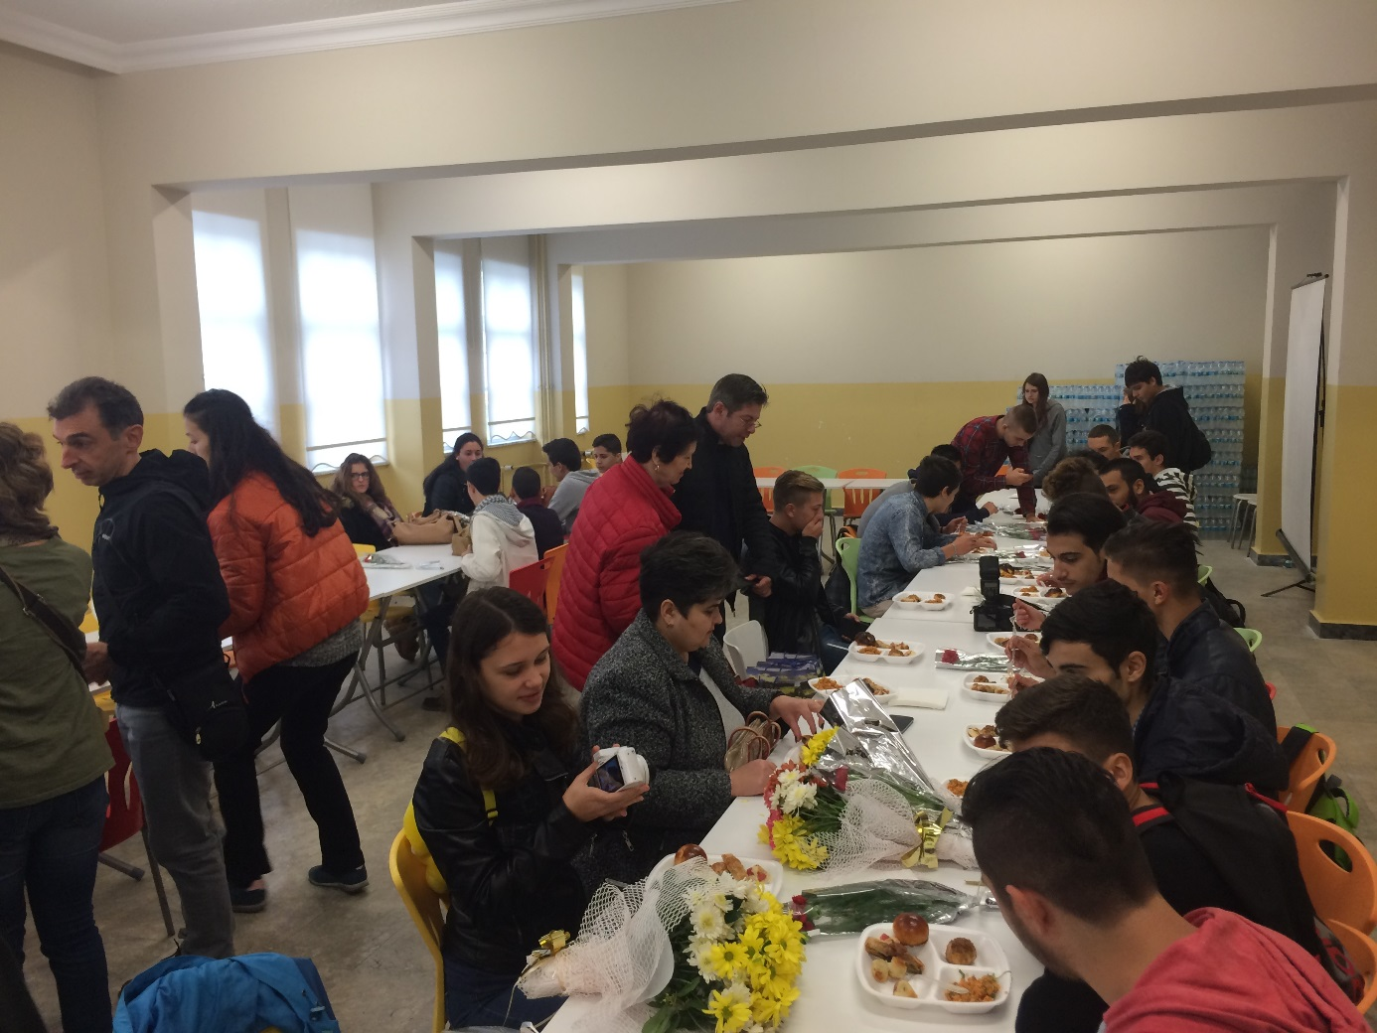 until 12 when we went to Mihnver Restaurant.
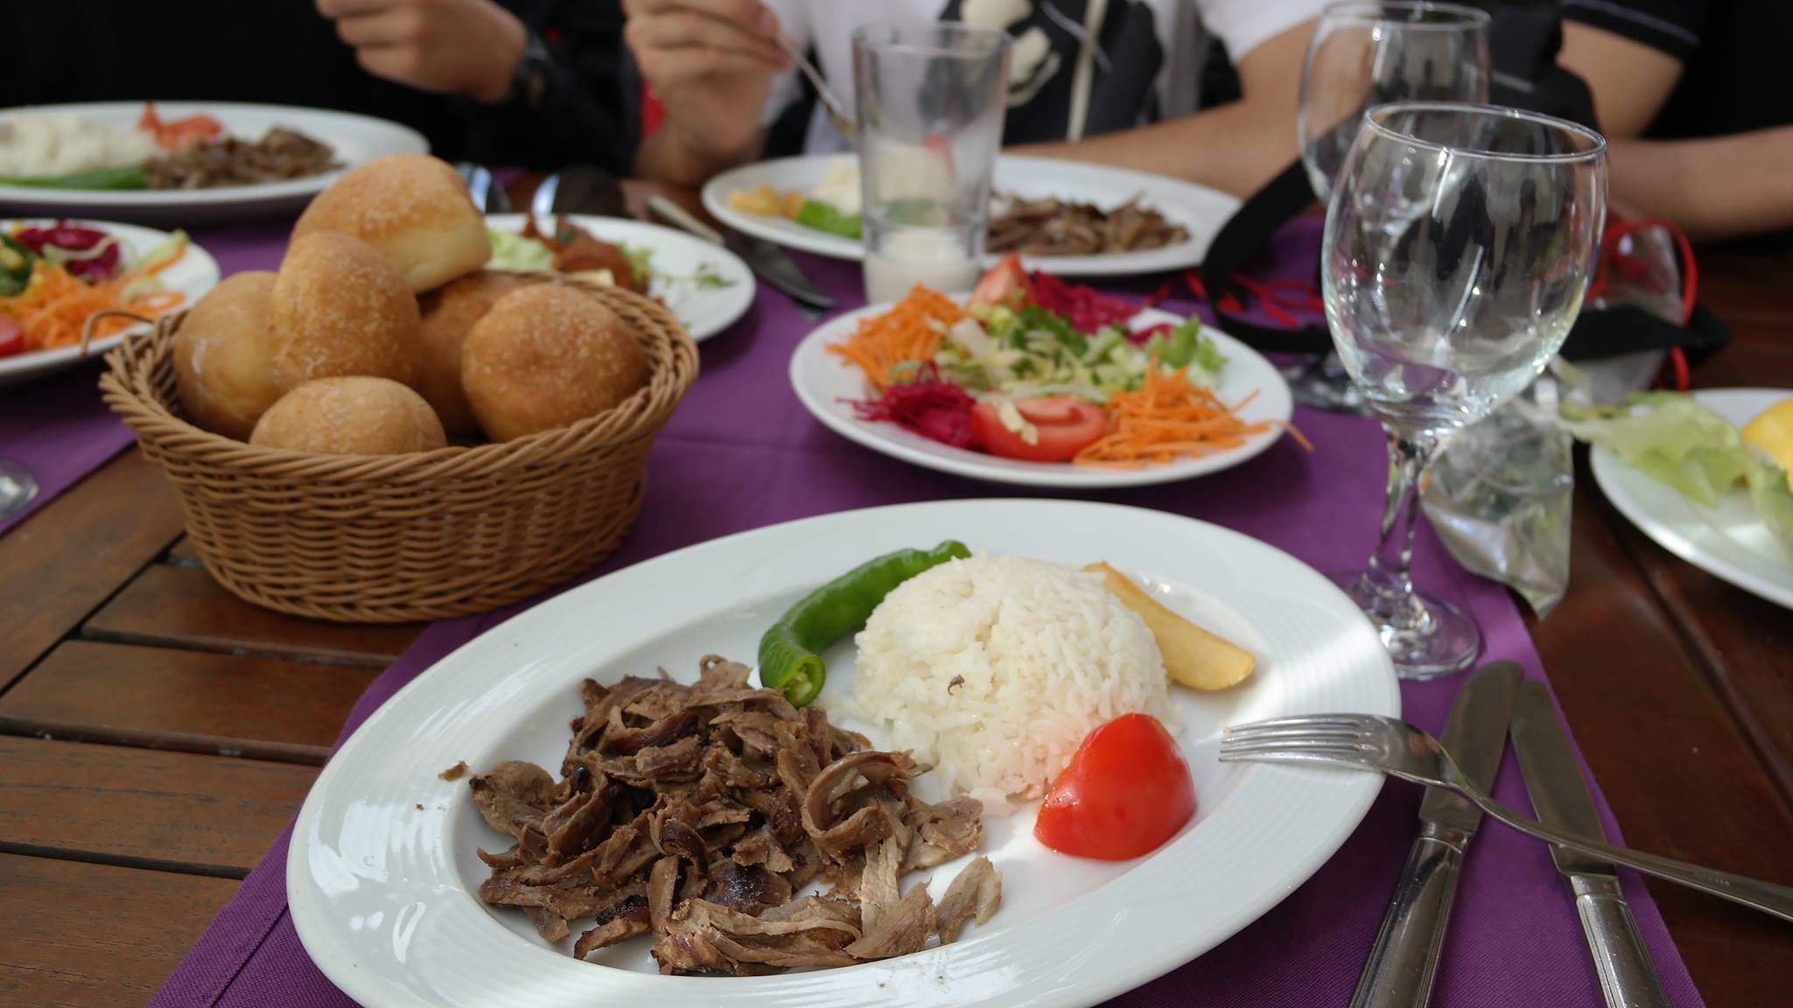
After this we visited Baygem(Workshop) at 1 o’clock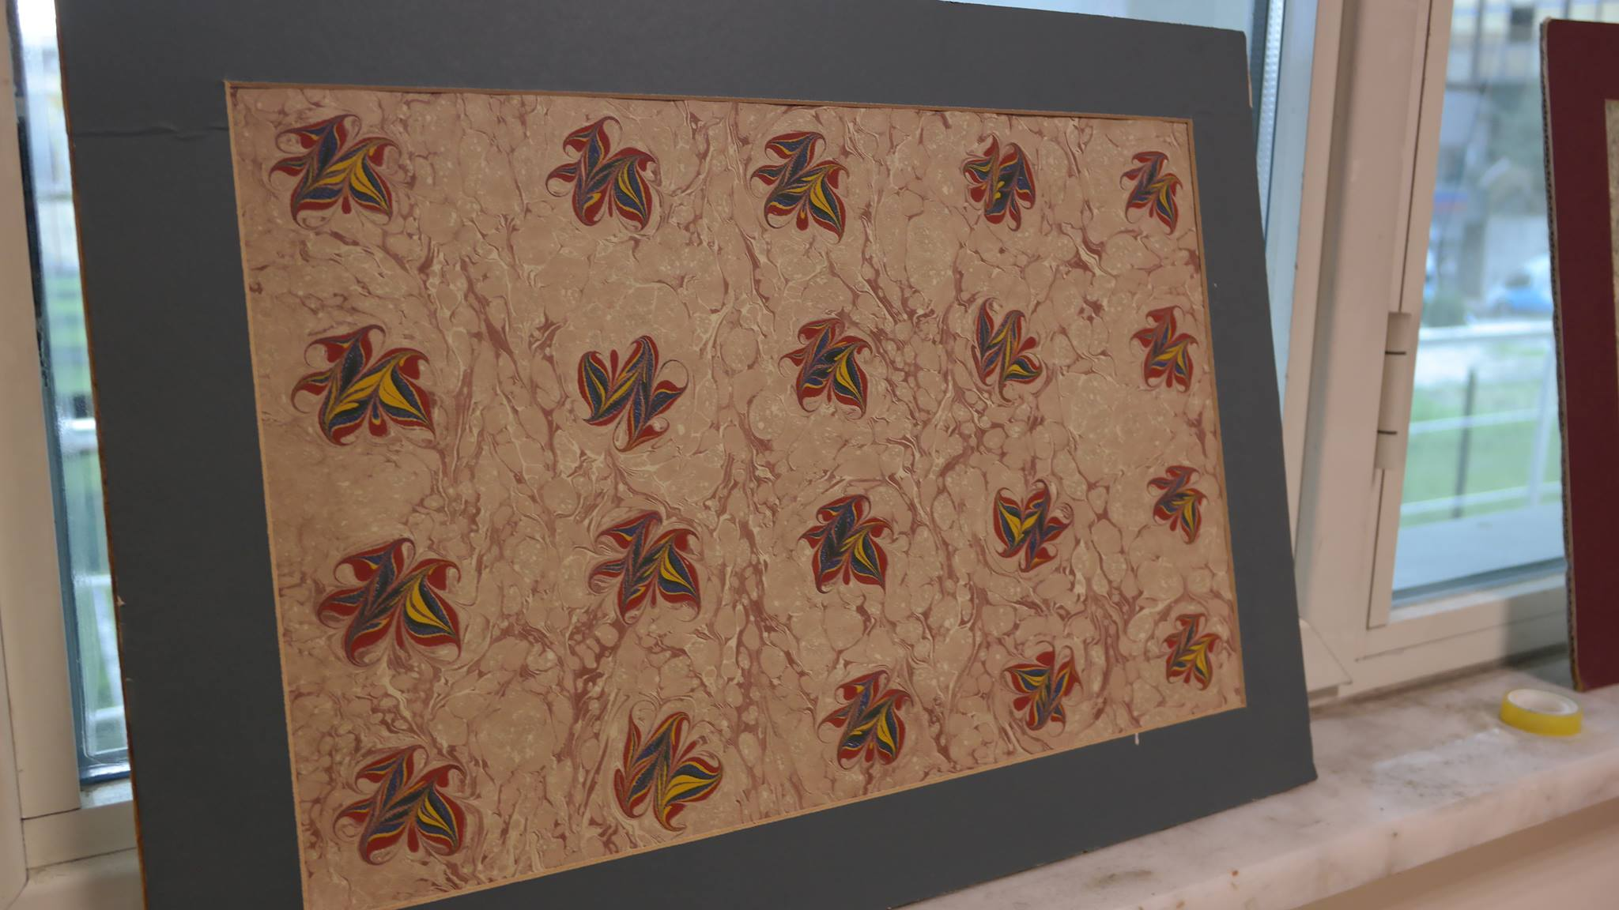
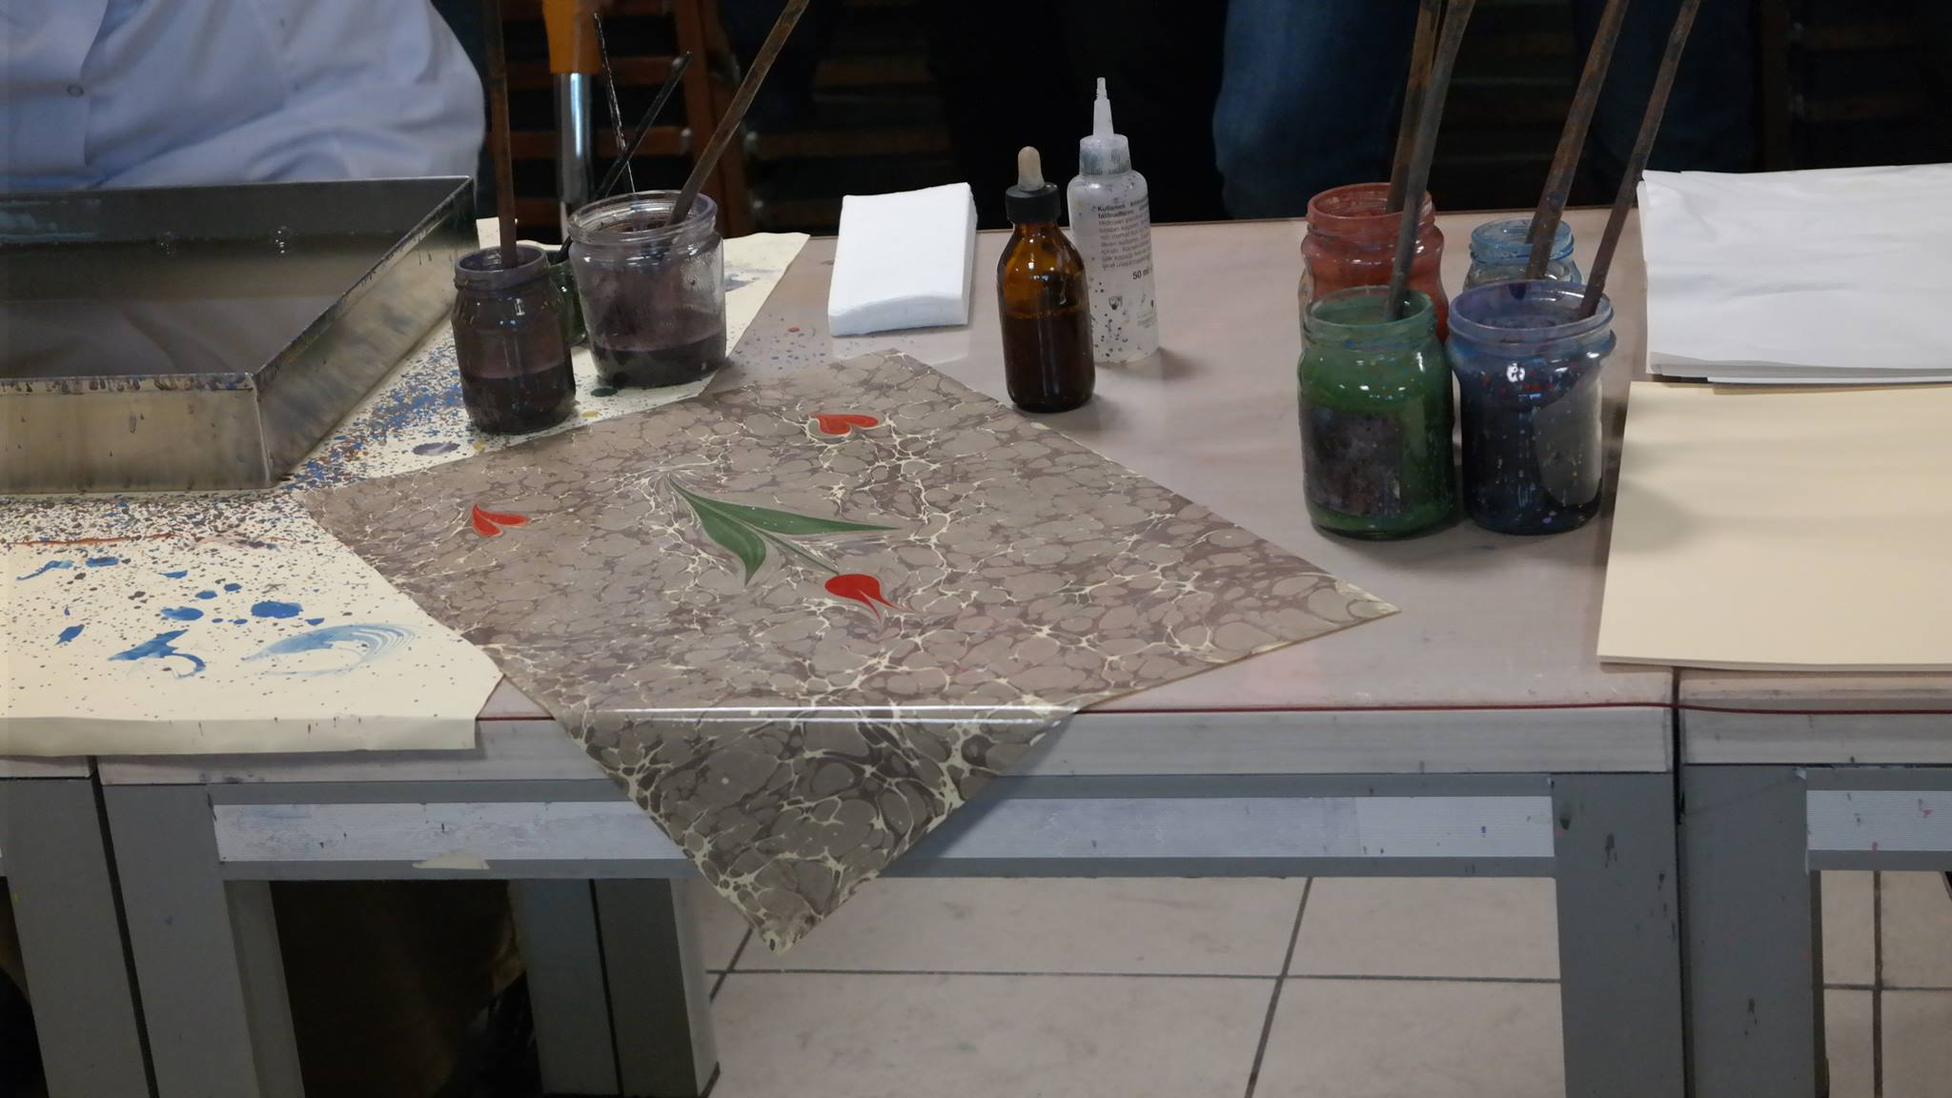
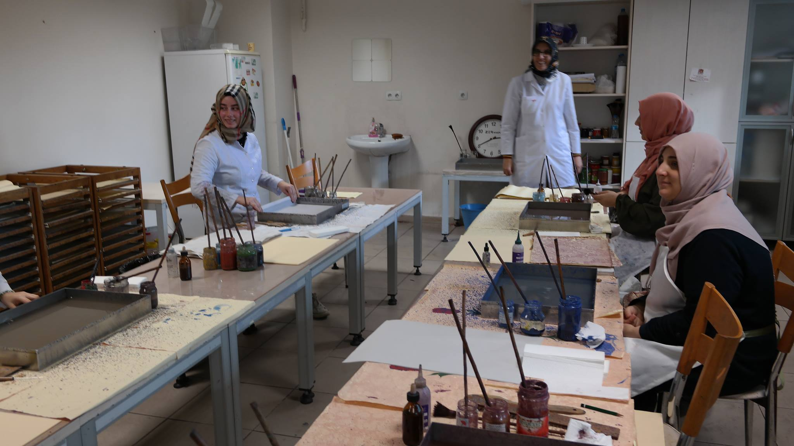
After this we went to school at 16 o’clock
Day 3 : 24 november 2015
At 9 o’clock we went to ULKER Chocolate Factory the thirt biggest chocolate company in the word.
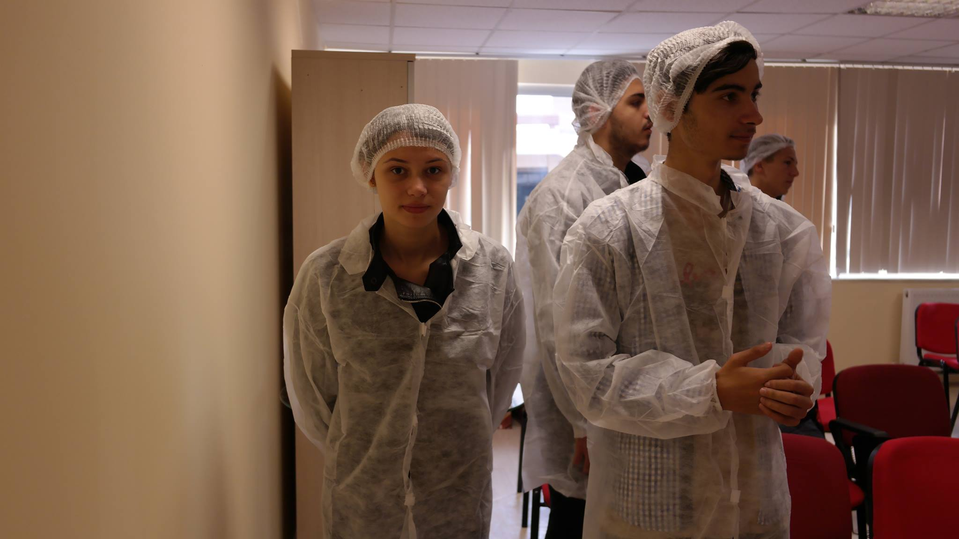
After this we had some free time to shopping at Forum Instambul 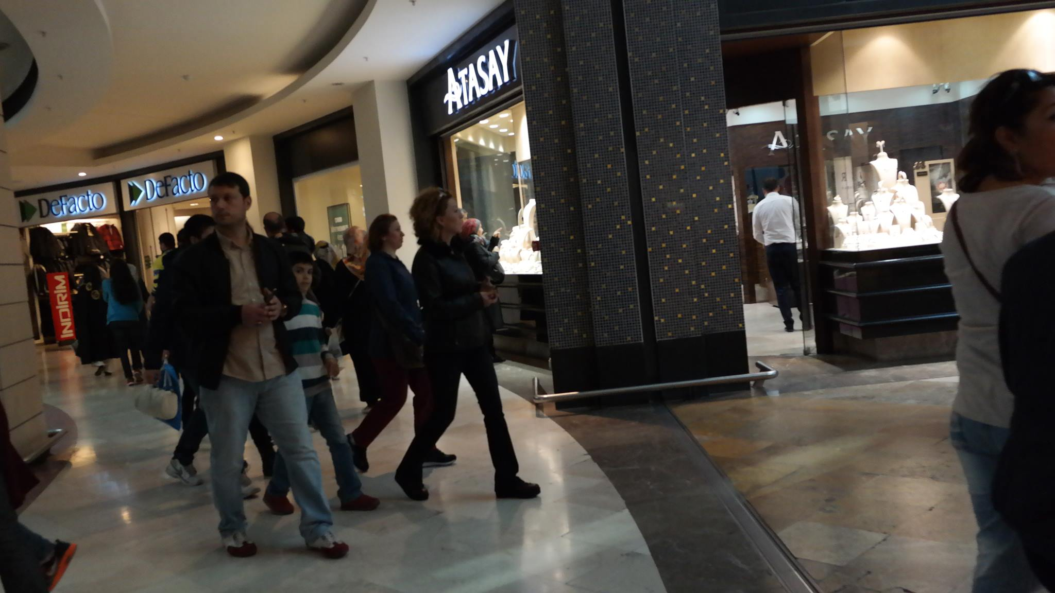

Later at 15 o’clock we had logo contest to decied why logo gona be the official logo of the project , and Turkey is the winner (all countries )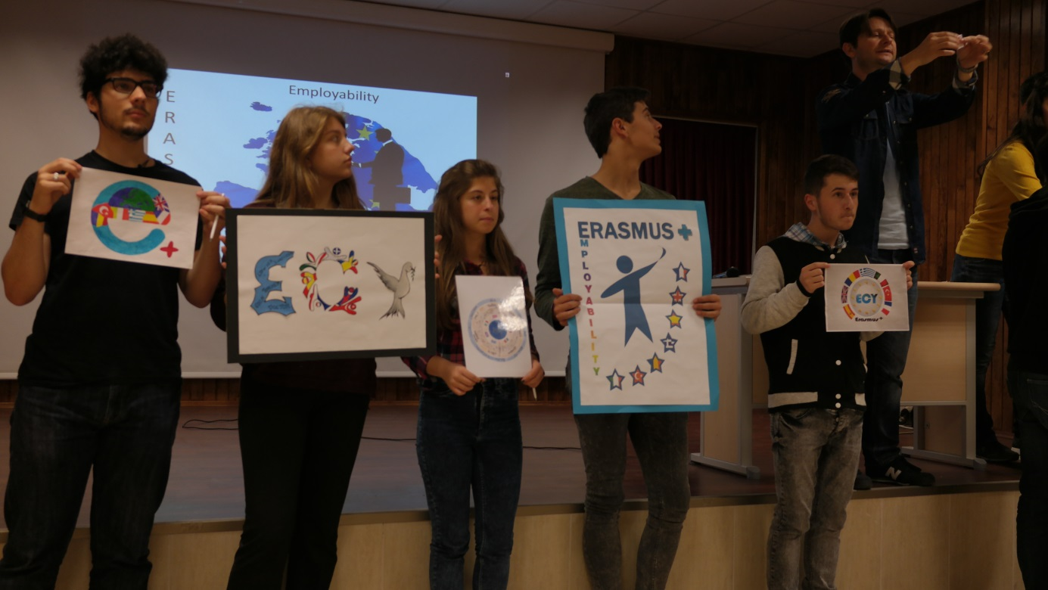

Day 4 : 25.11.2015
This was the big , the day when we had Drama Activity and here are some pictures:
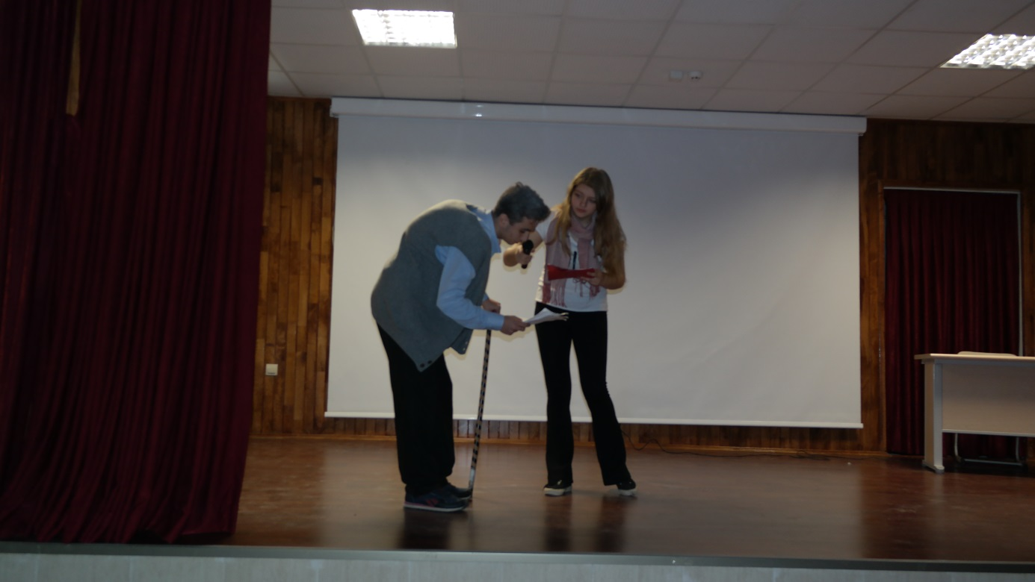
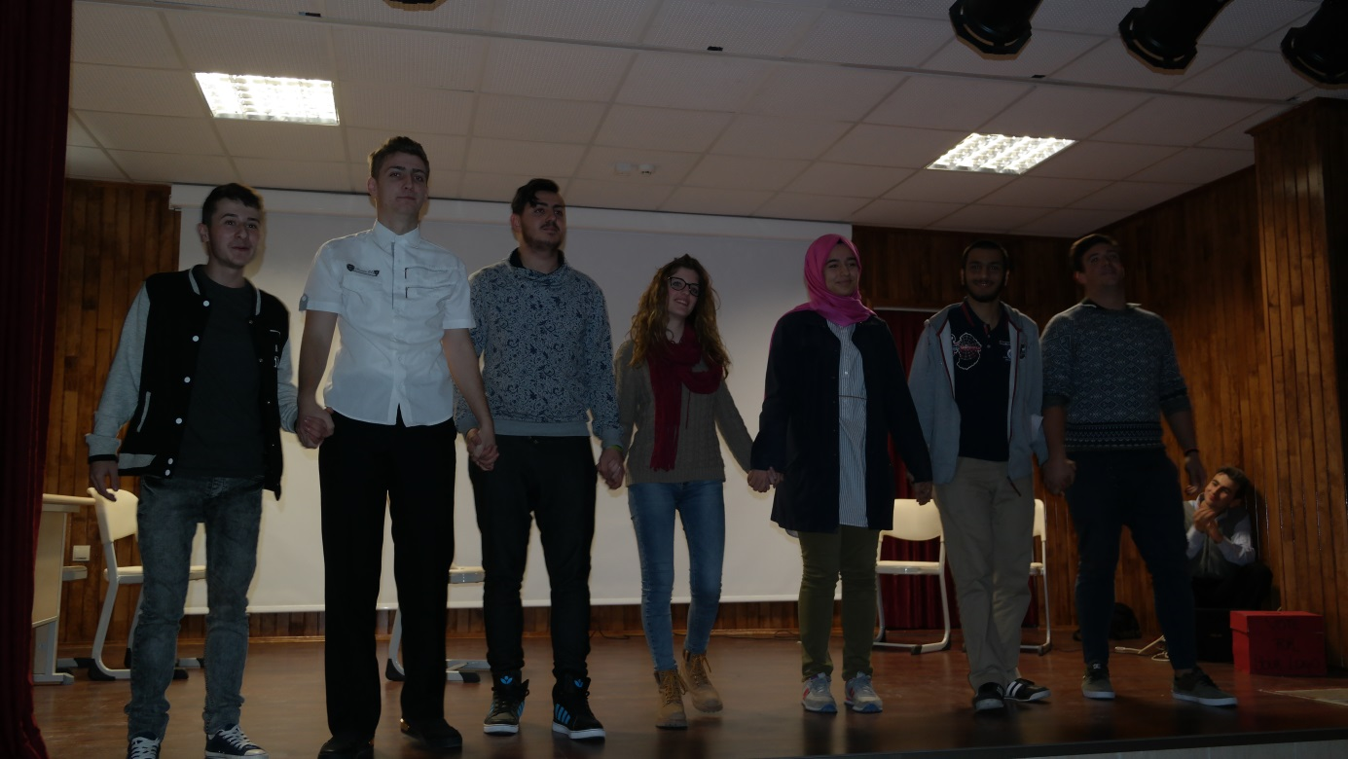
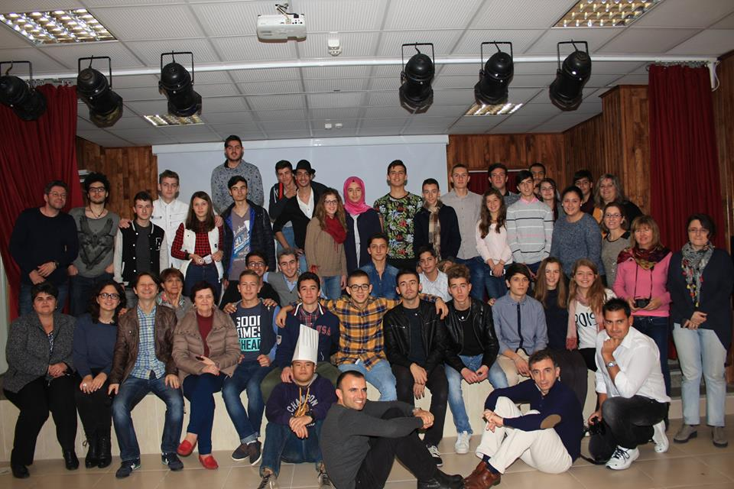
And after this hard work we went to Ramazan Bingol Restaurant and the dessert was so delicious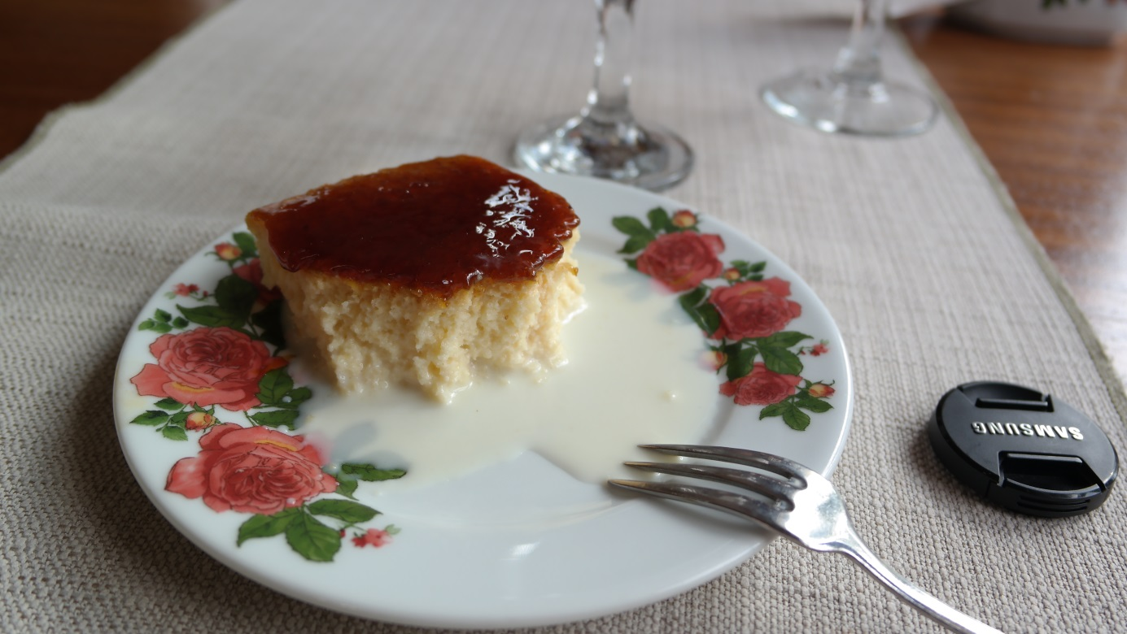
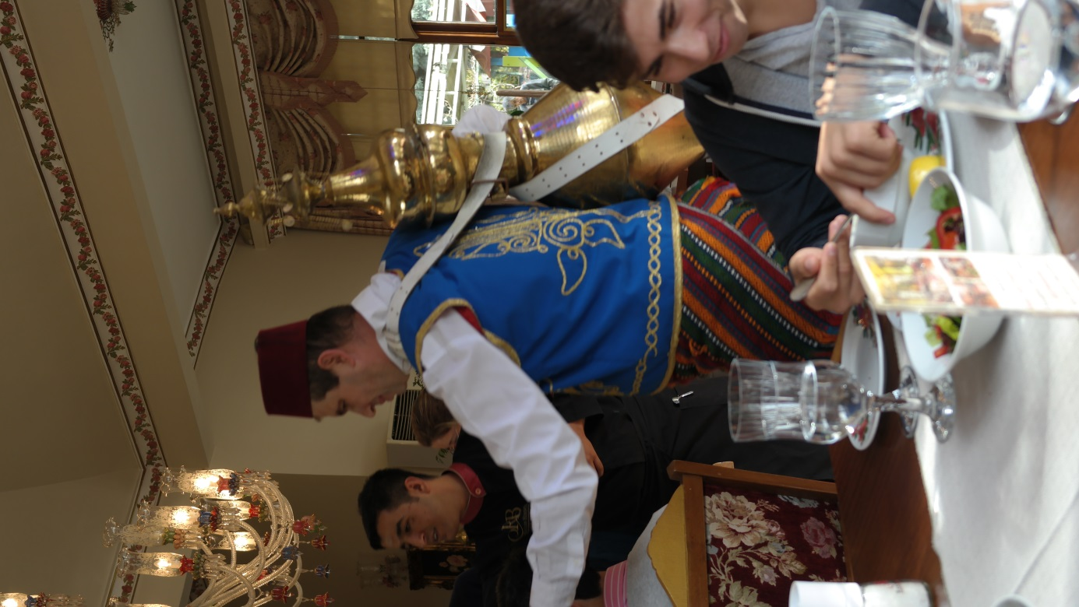
At 14 o’clock, we visited Panaroma Istambul 2015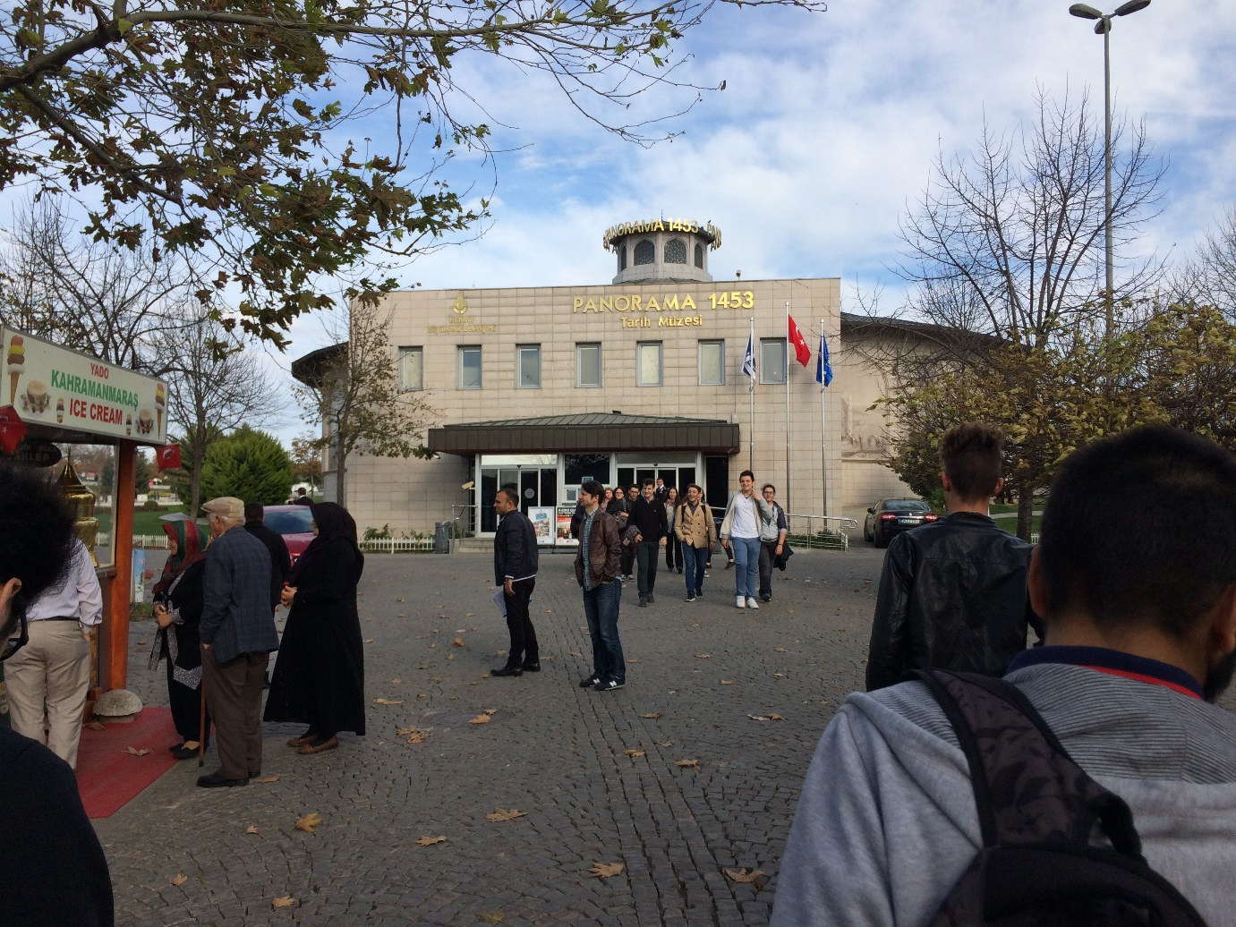
I saw there a lot of interesting things about war
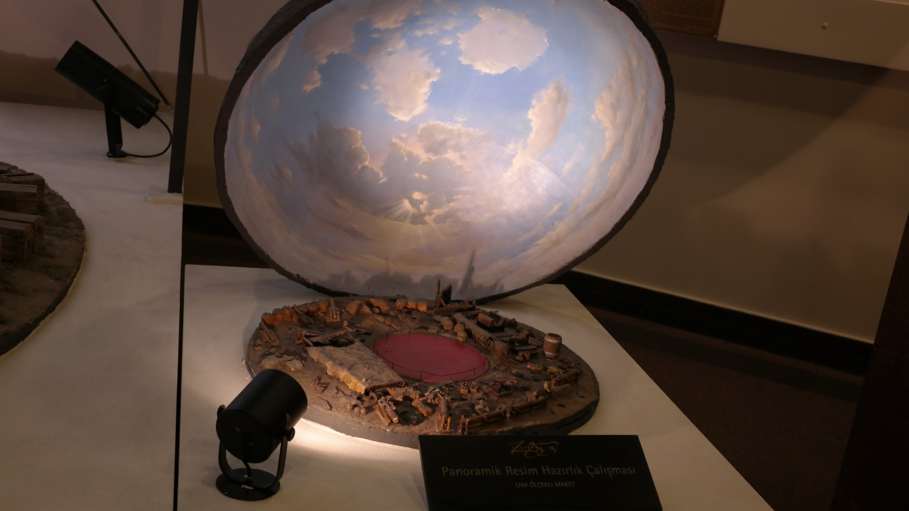
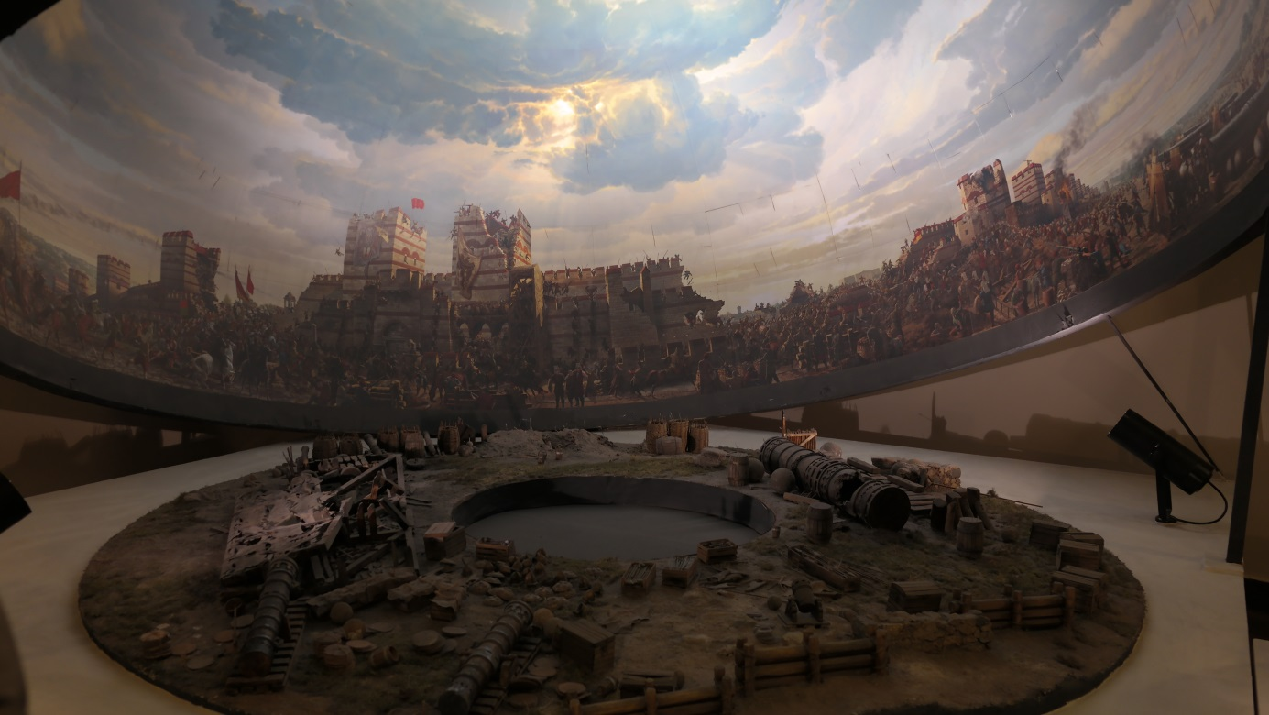
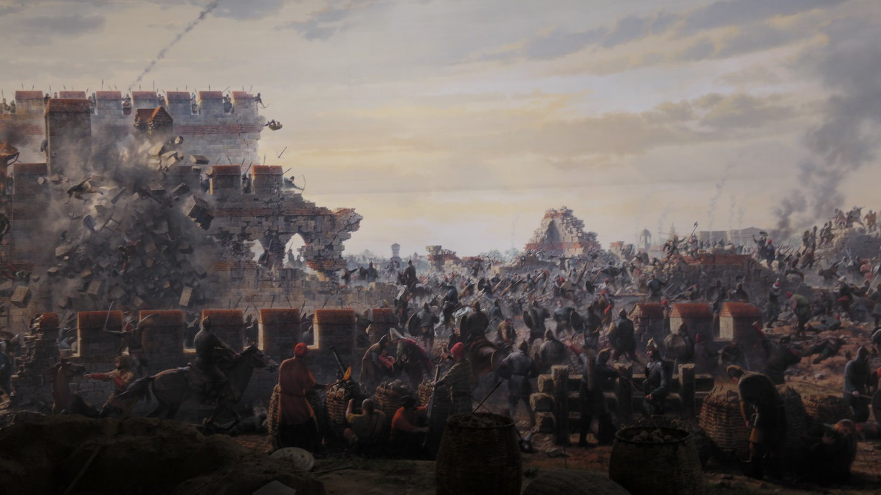
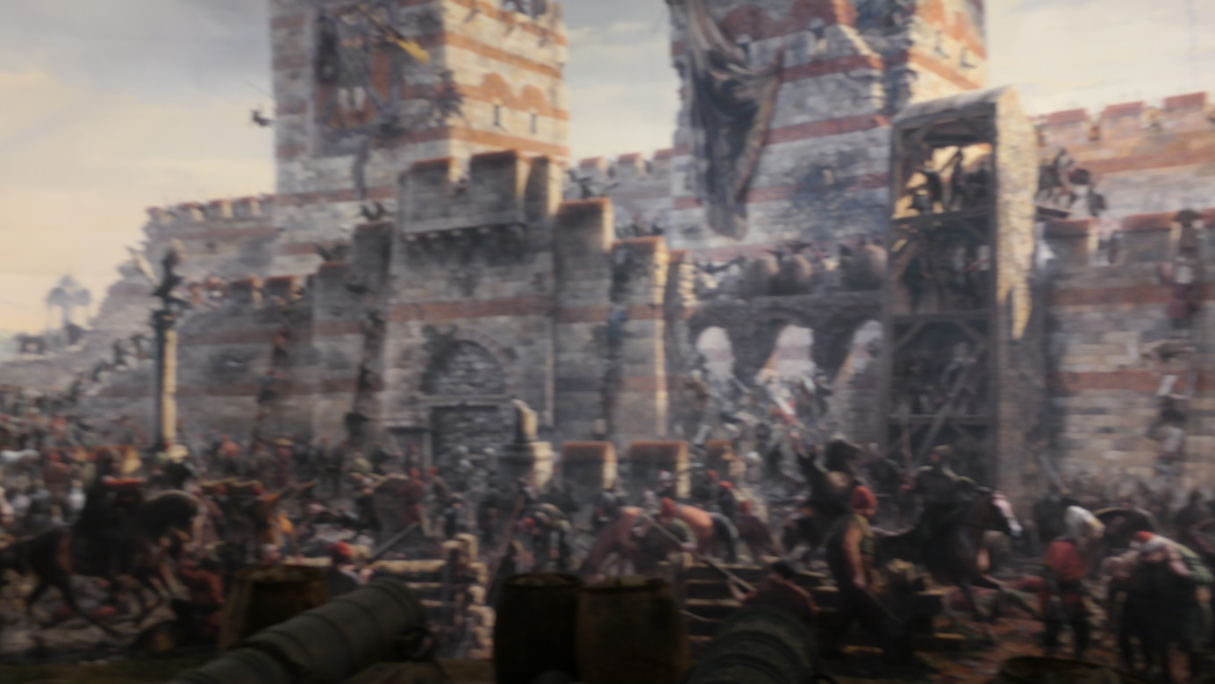

Day 5 : 26.11.2015
This was Guided Day , we visited Topkapi Palace.
This is gate of salutation 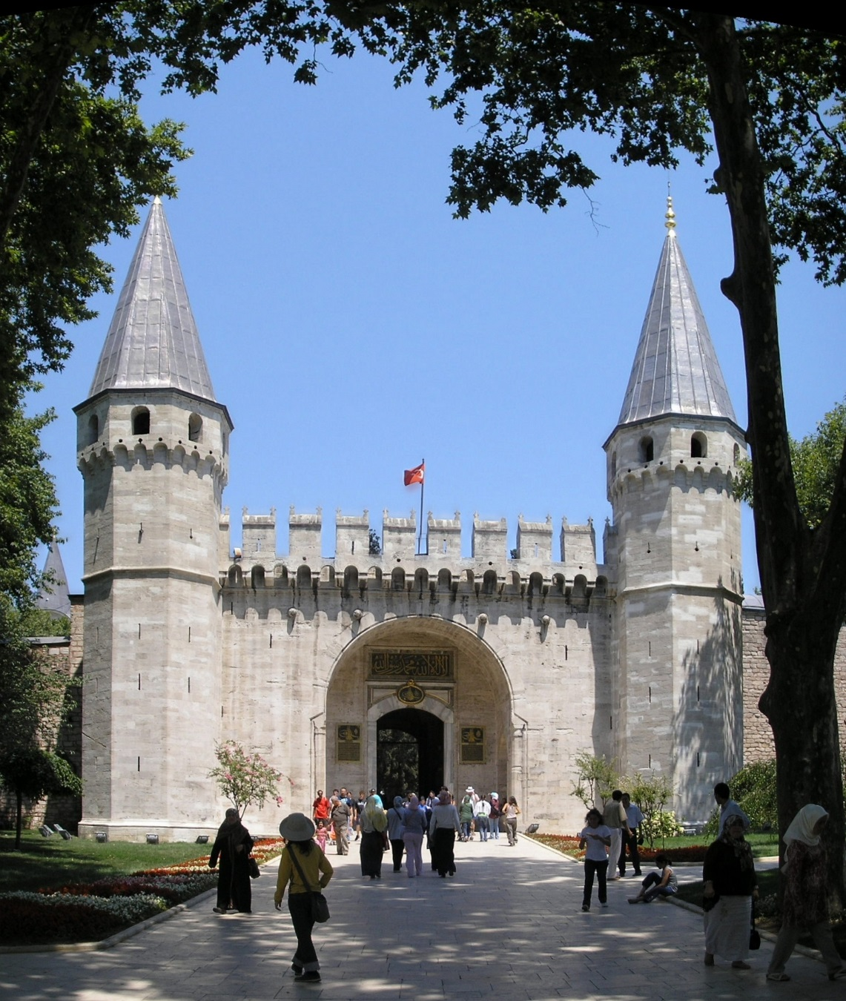
And this is from topkapi palace garen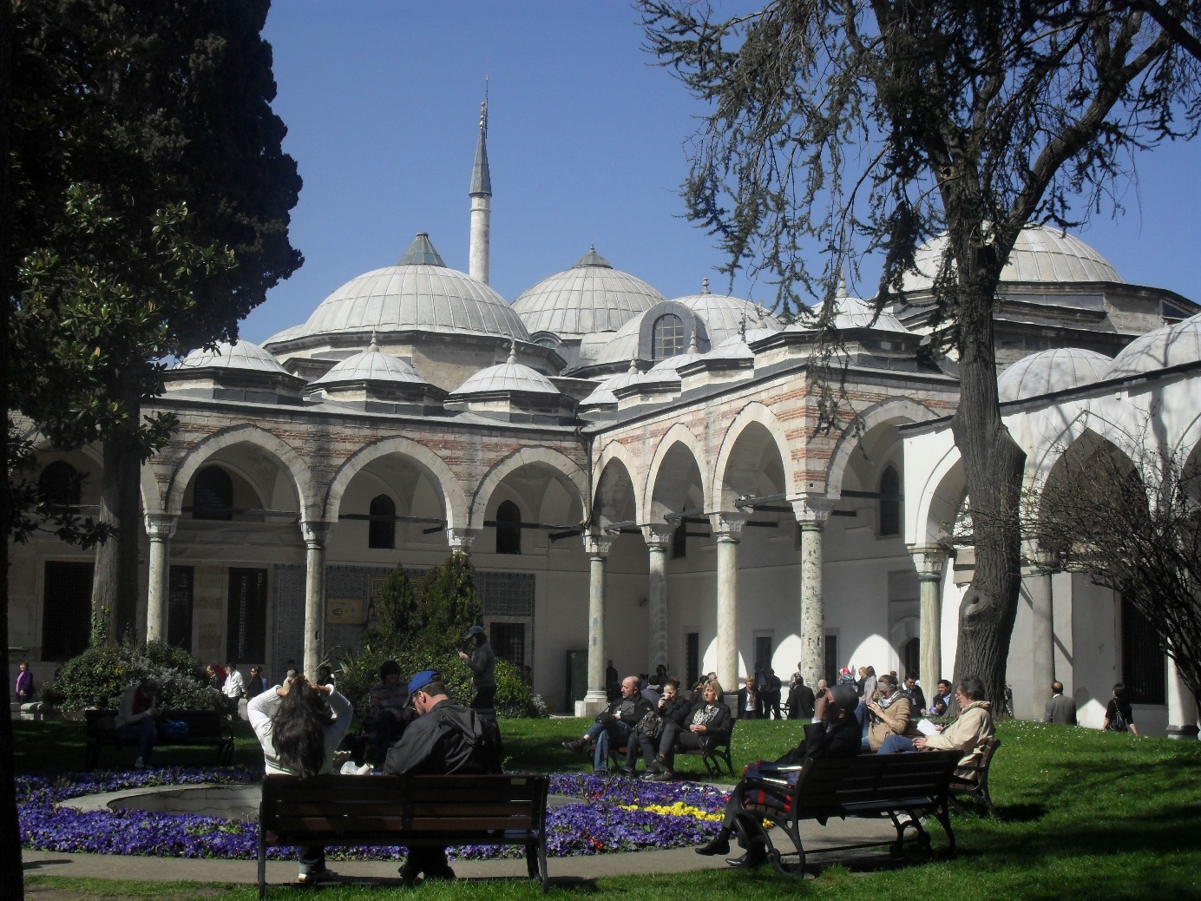
After this we saw Sultan Ahmet Mosque
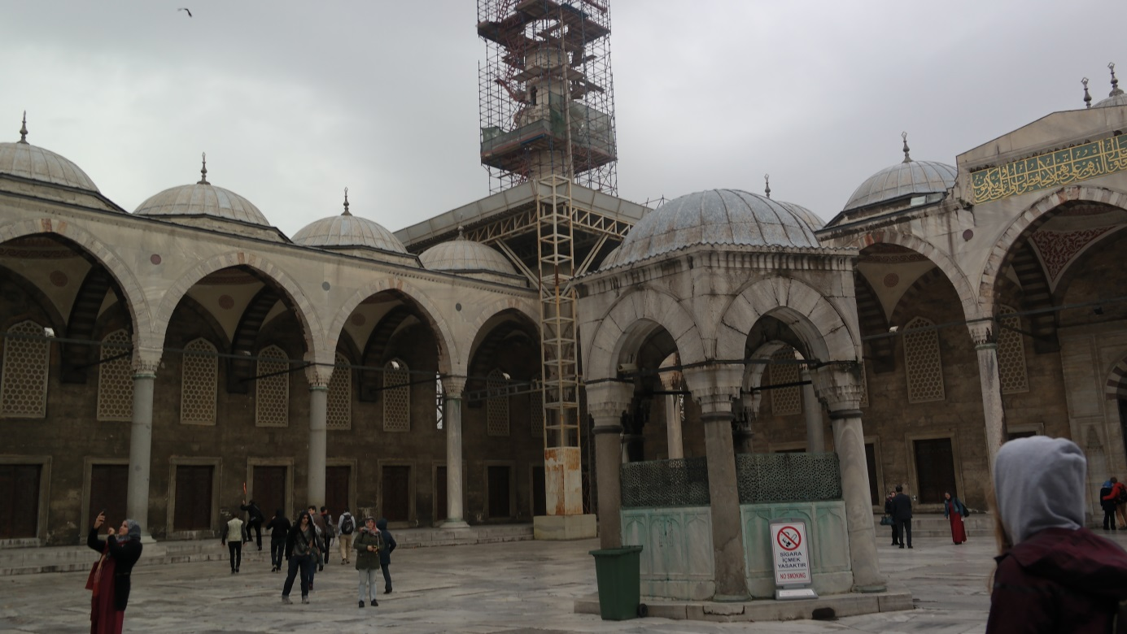
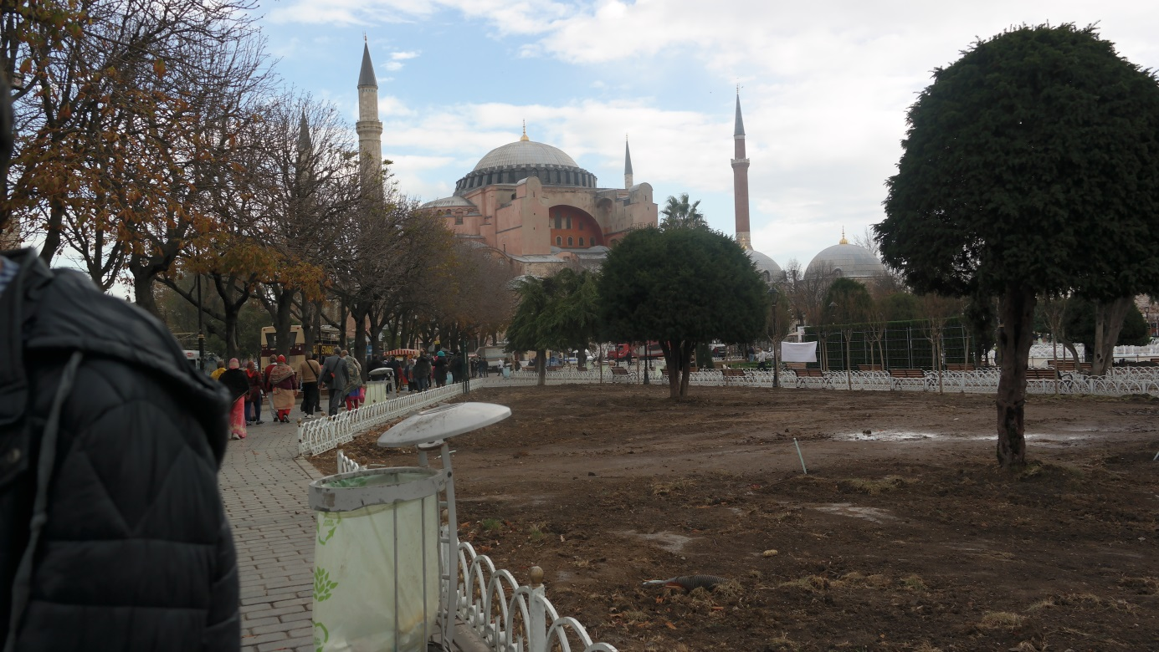
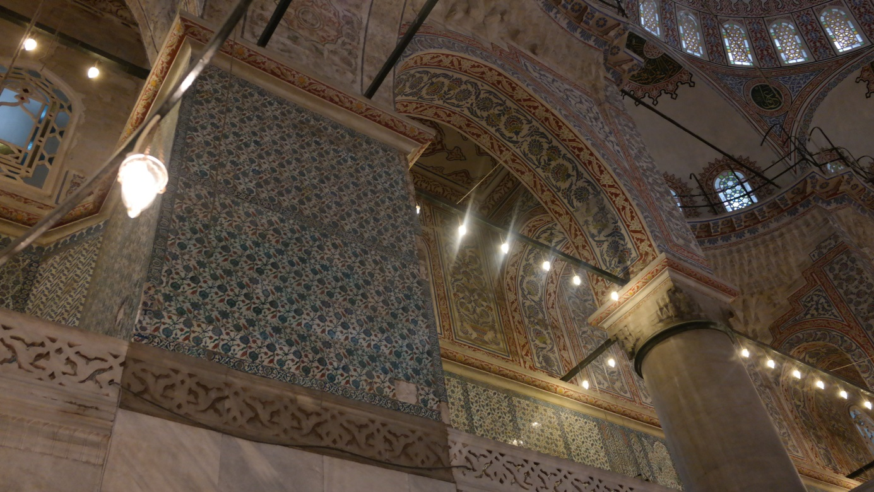
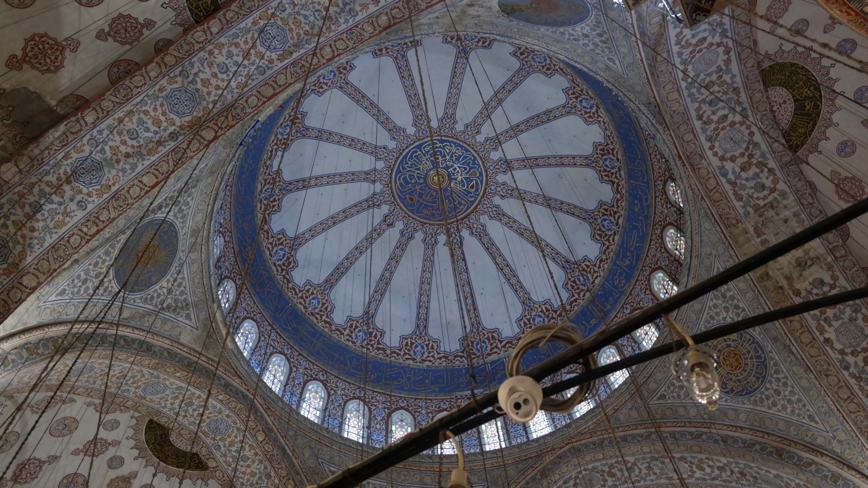
Codename knowed like Blue Mosque.

We visited Hagia Sophia a really beautiful building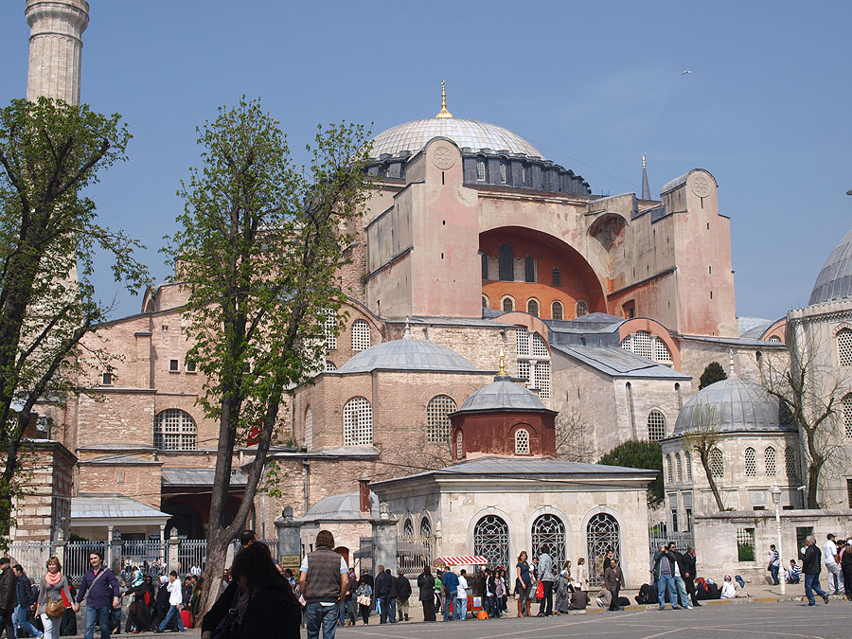
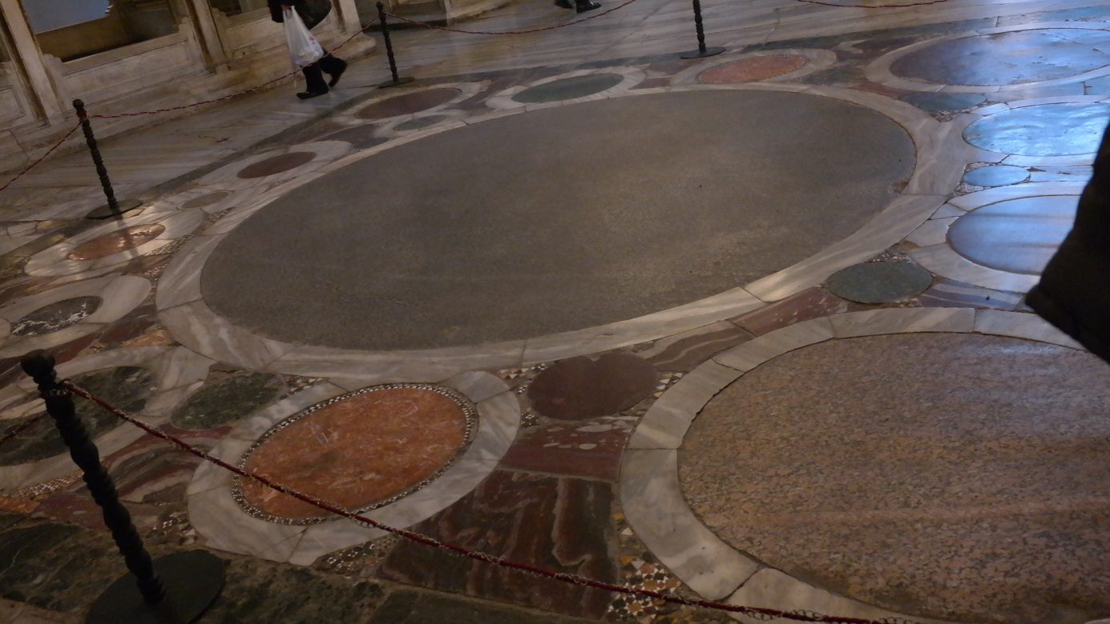
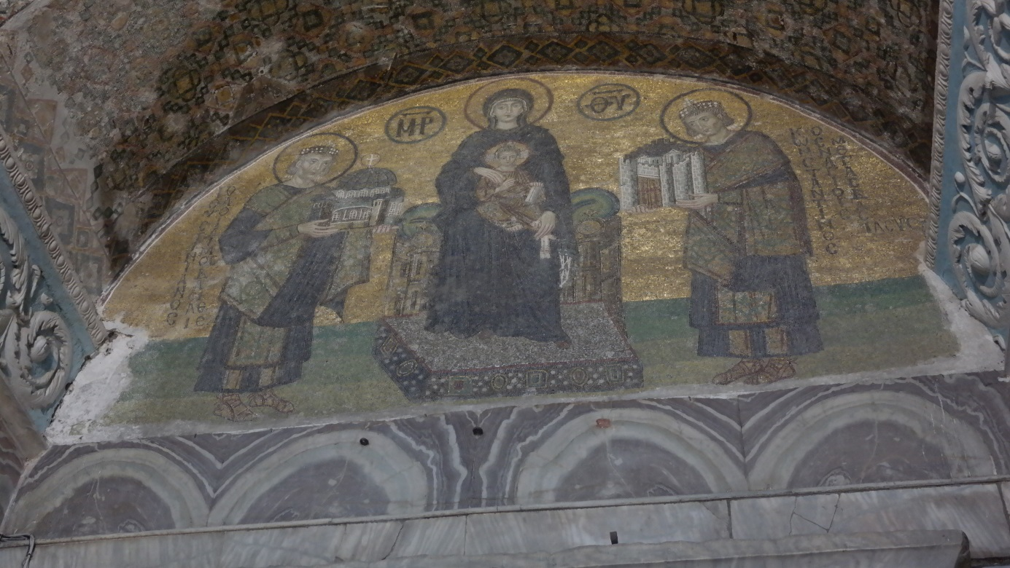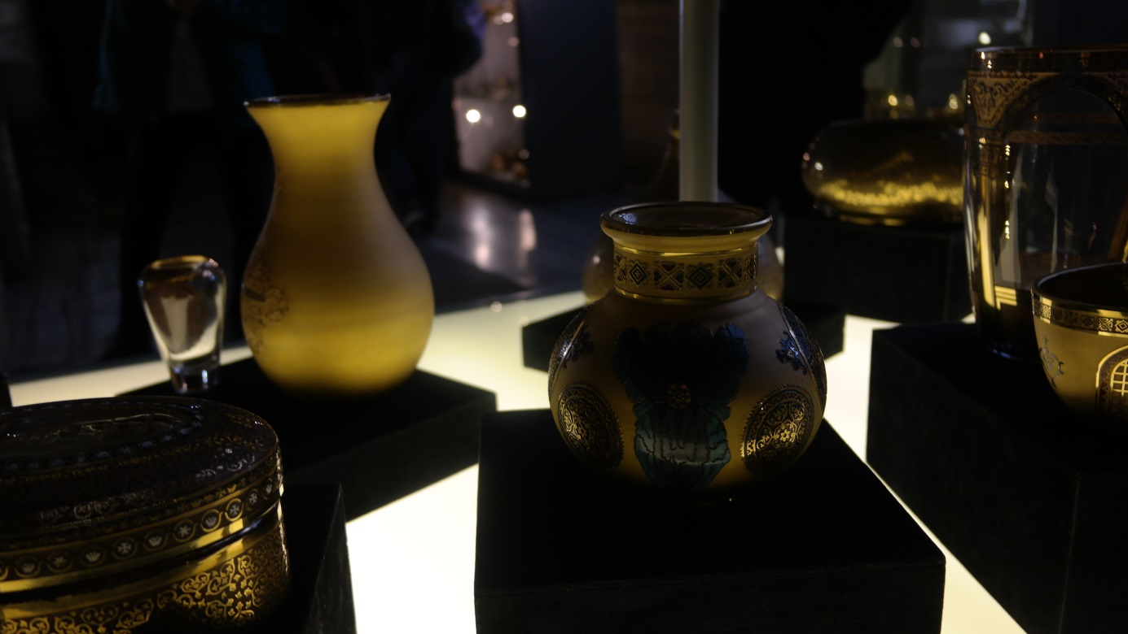

We saw some swords and armours from Suleyman Magnificent time.
This was his sword :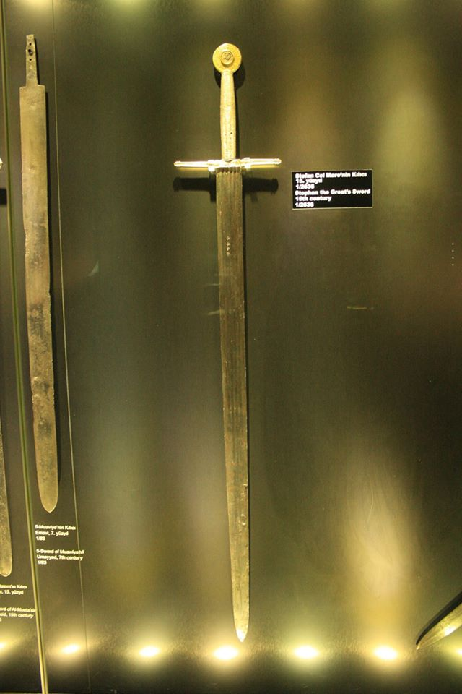
And one of his armours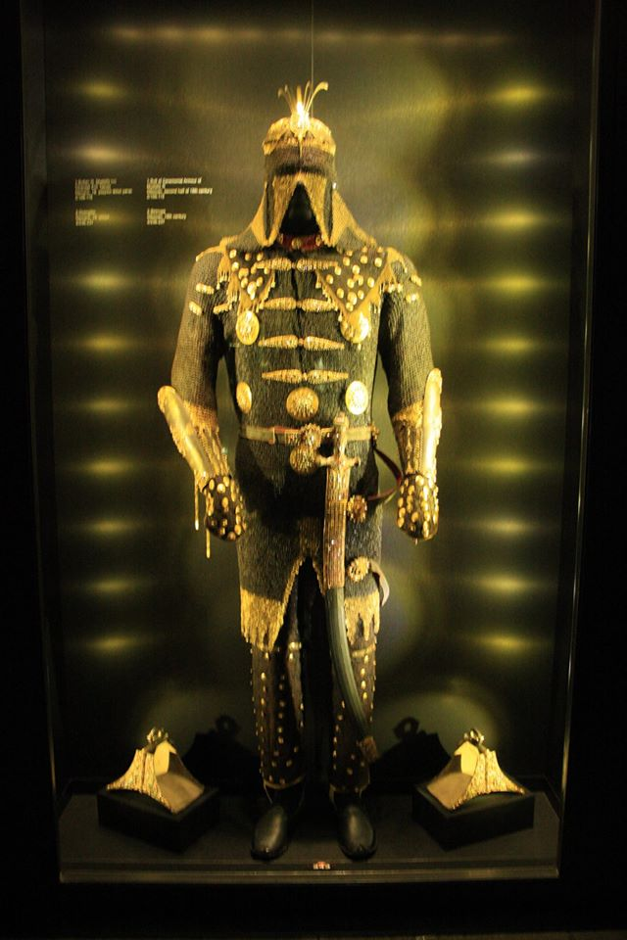

This beautifull day end with a visit at Basilica Cistern in the subway , a place used to storage a lot of water in old wars and there I learned about Medussa legend and I saw her head used to scare peoples and population.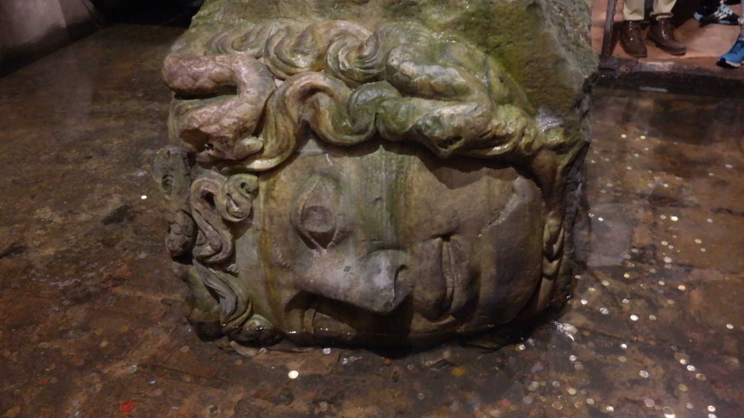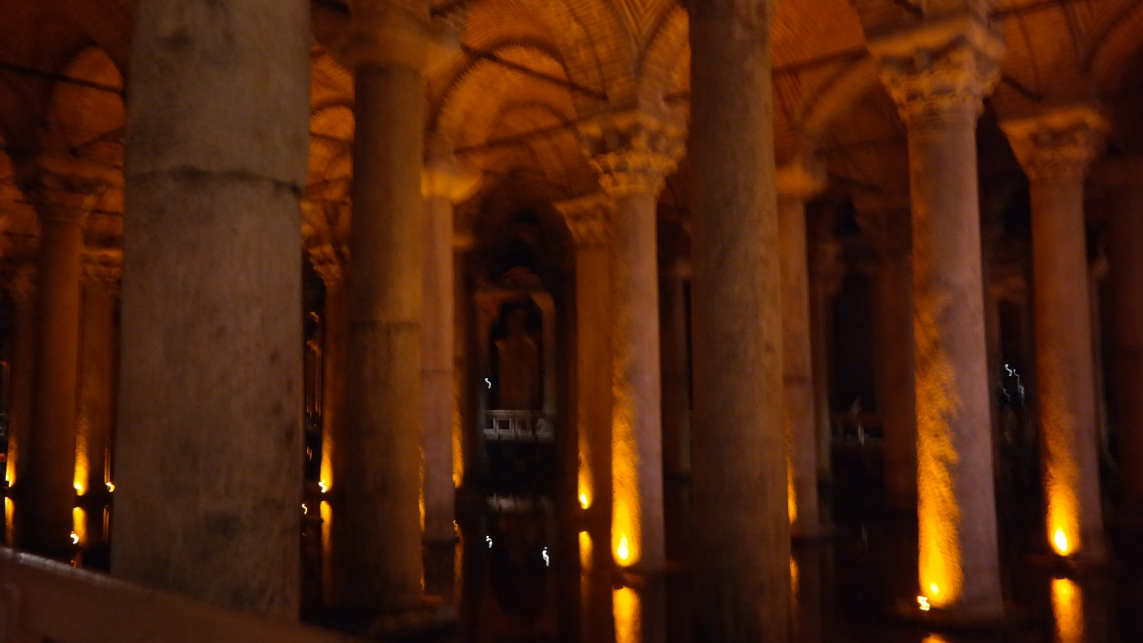

Day 6 : 27 november 2015
We depart from school and went to Maiden’s Tower 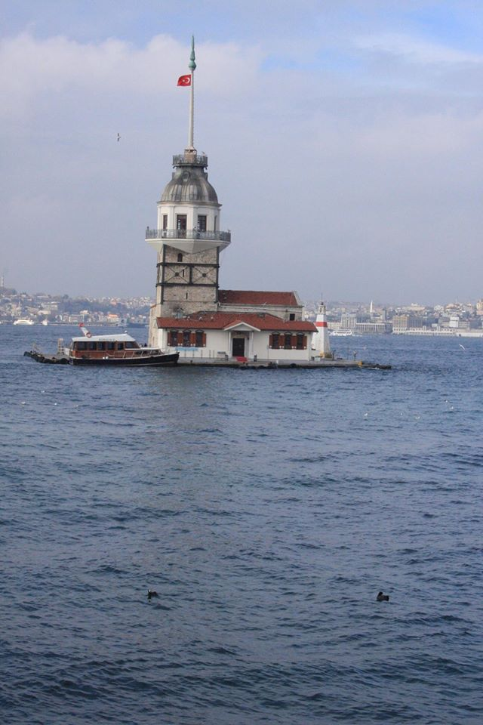
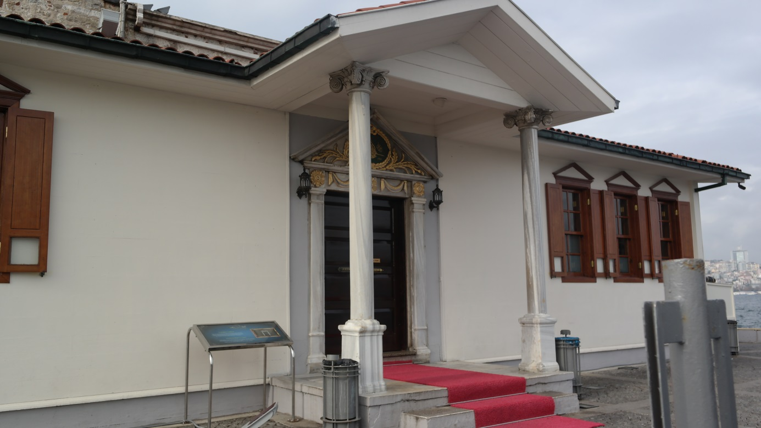
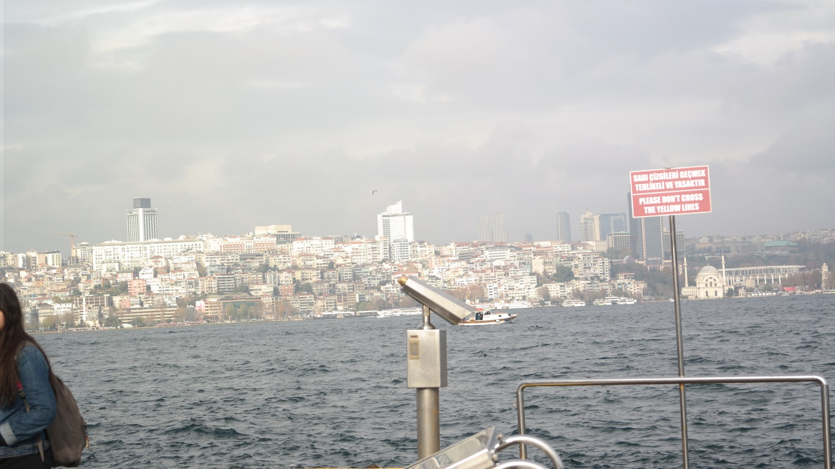
A really beautifull view After this we went to Camlica Hill there we eat. 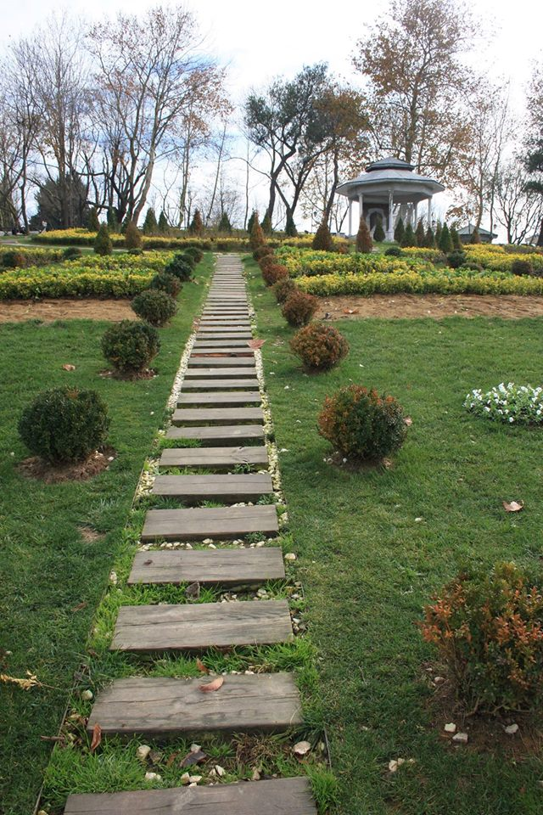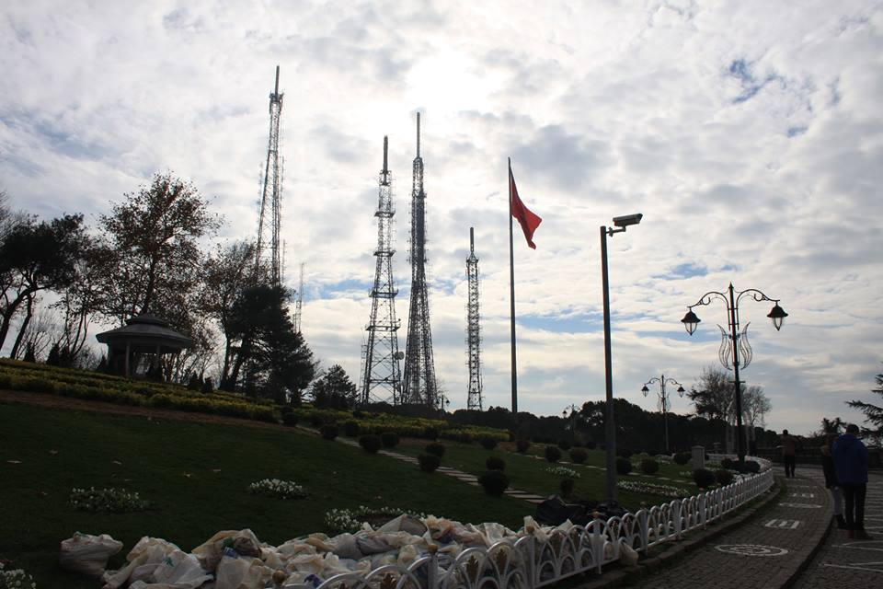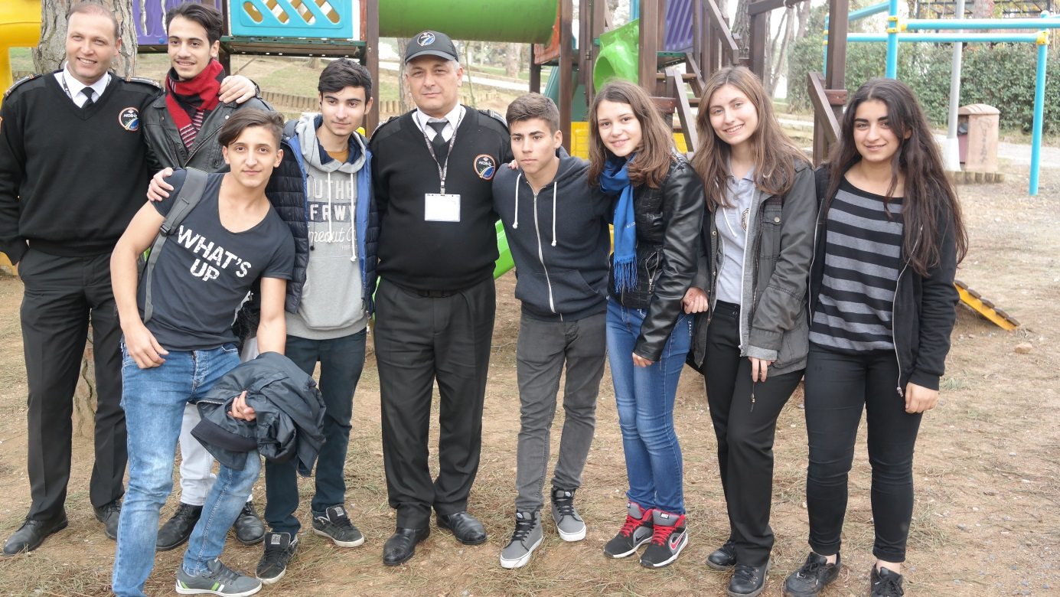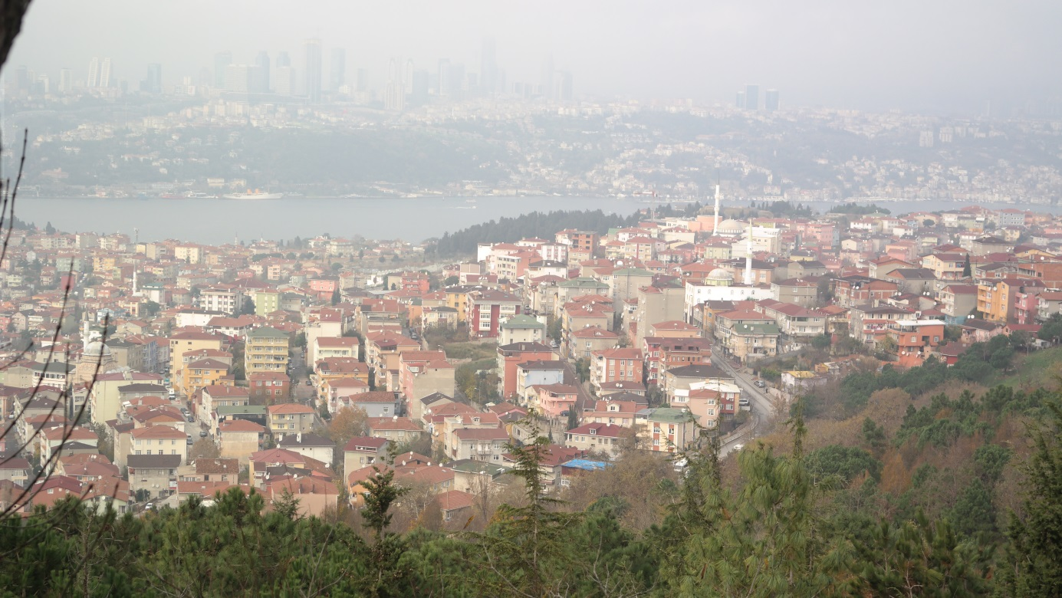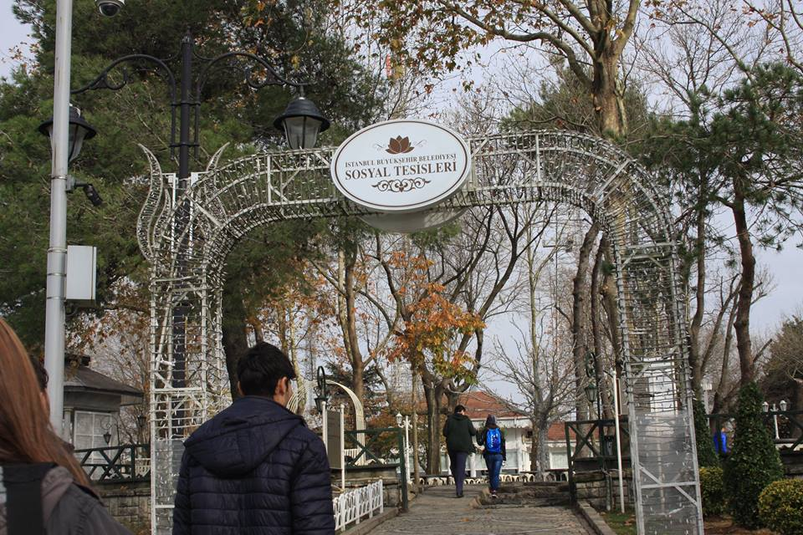

After this we went to Harbiye Military Museum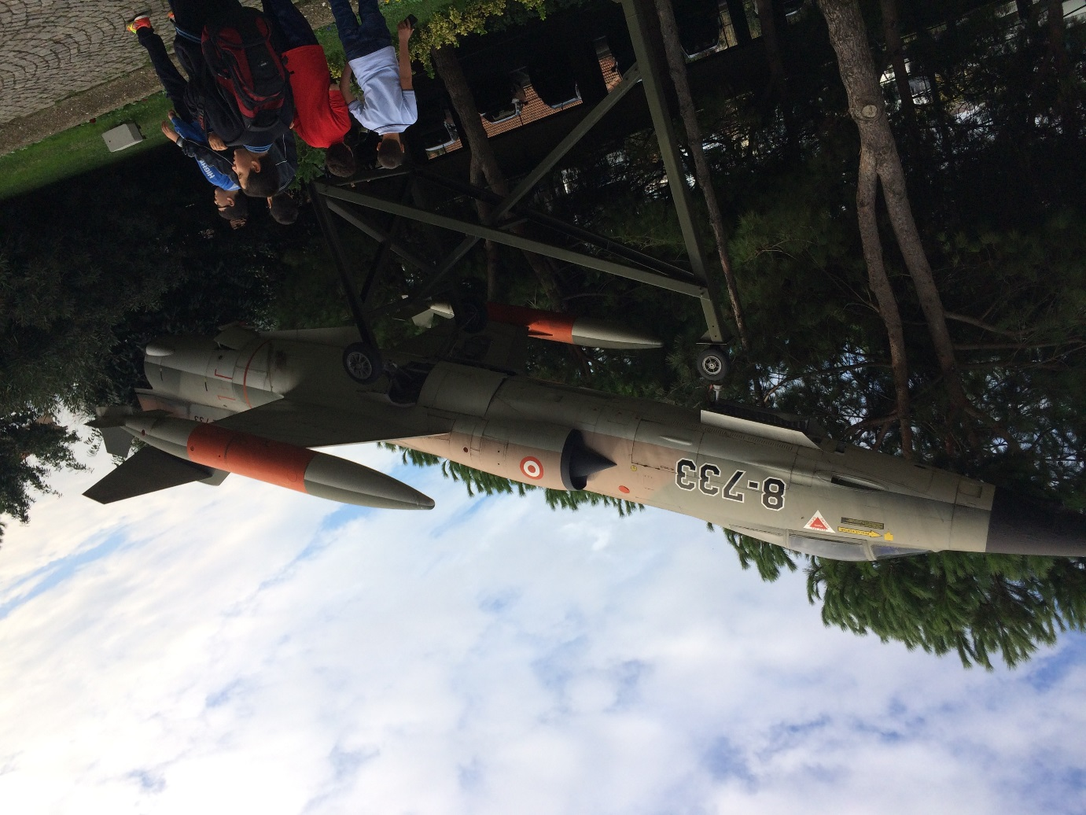
There we saw a lot of guns ,armours and a beautifull show in the end .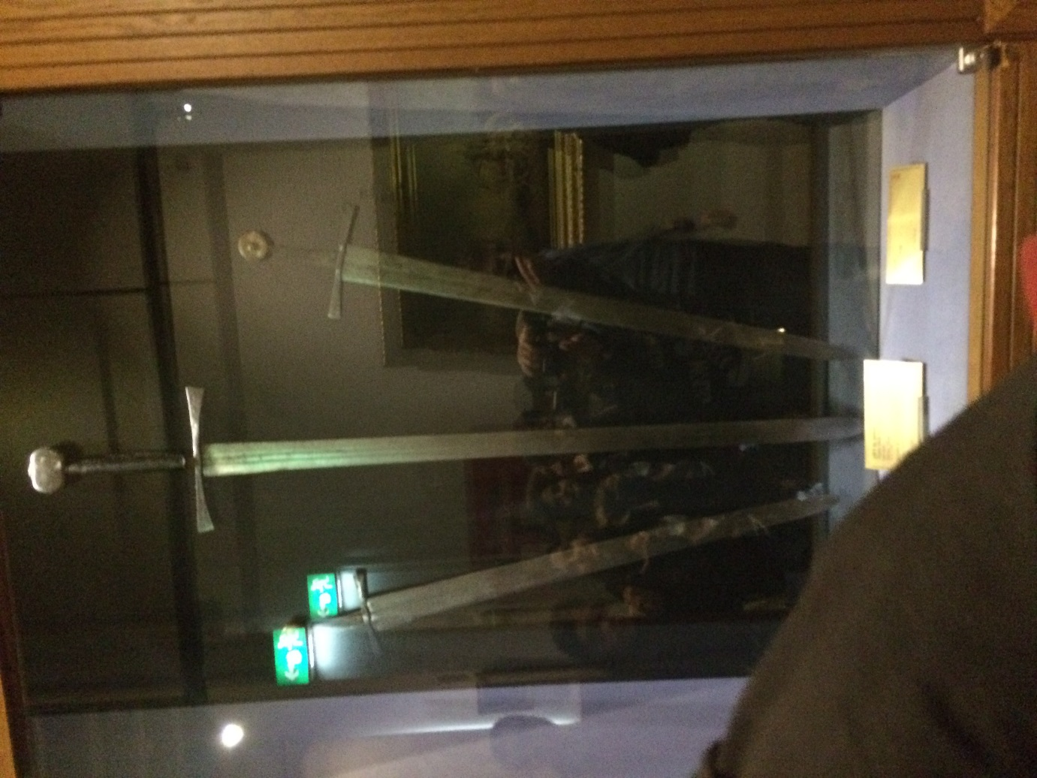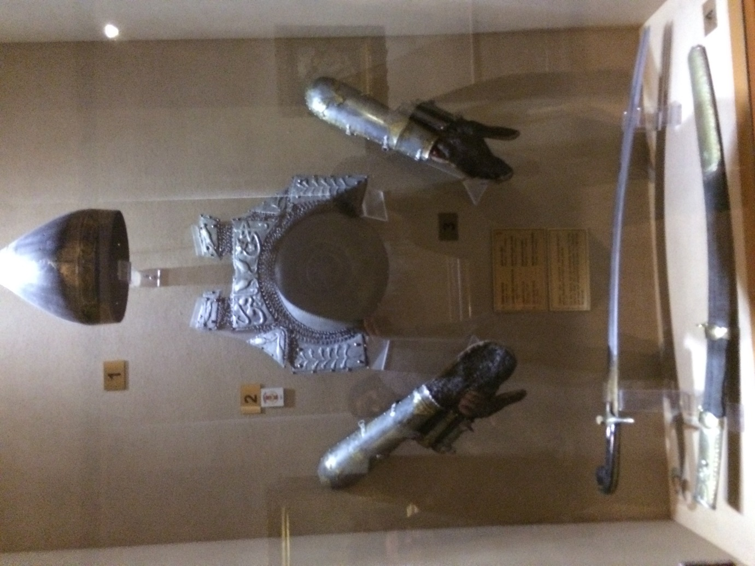
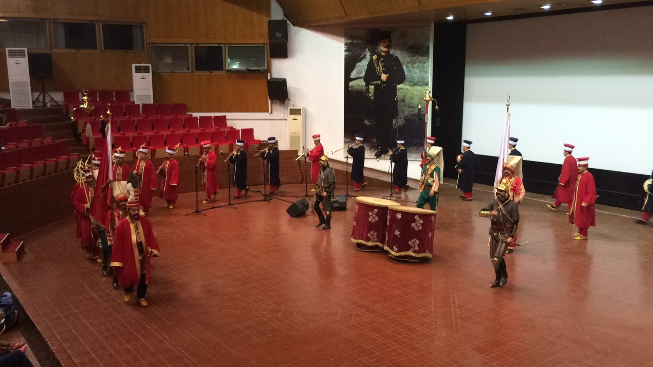
After this I went with erasmus group to Taksim for shopping .
Was a great week with many beautifull memories.

