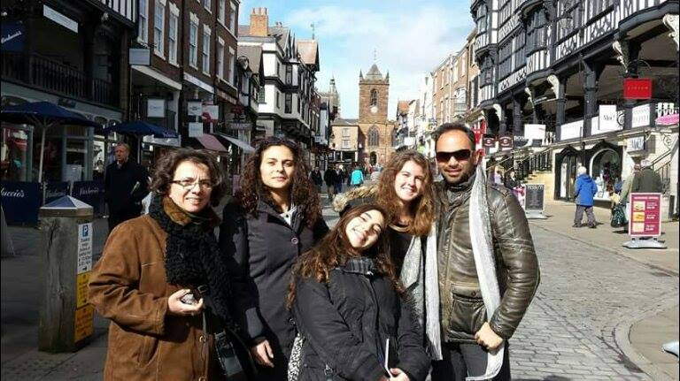
Meeting in the UK
Greek delegation:
Ms Kalliroe Argyropoulou
Mr. Thanasis Mourlas
Mania Kafetzi
Anastasia Papadimitriou
Maria Plessia

22-28 / 03 / 2015

1st day:
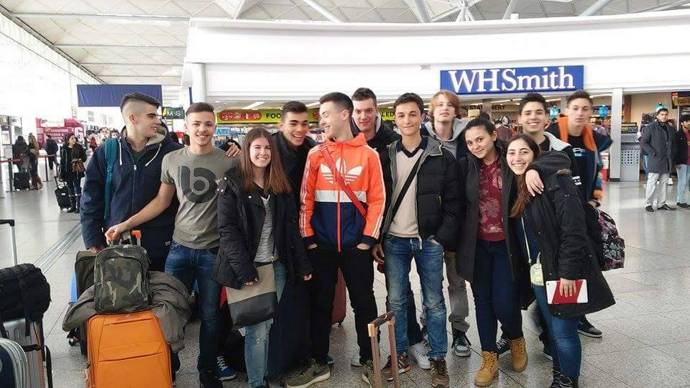
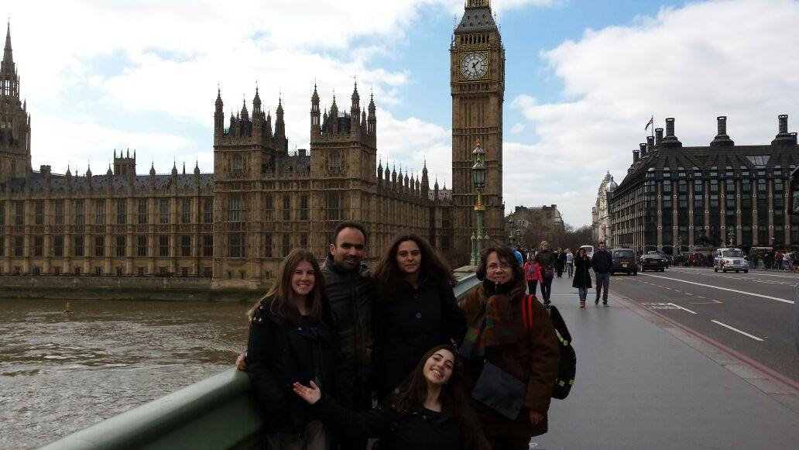
Our trip started on early Sunday morning. When we arrived at Stansted Airport, we met and greeted the Italian delegation and then we took the coach to London. In about 2 hours we arrived and once there, we went sightseeing at the Big Ben and the London Eye, having explored the centre of the city by the Underground. In the afternoon we took the train to Liverpool and after our arrival there, we met with two of the English teachers and went by a mini-bus to Wallasey, were we were greeted by our host families. They took us to their house, were we had dinner and got some rest until the next morning.
2nd day:
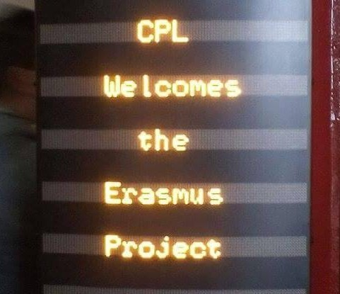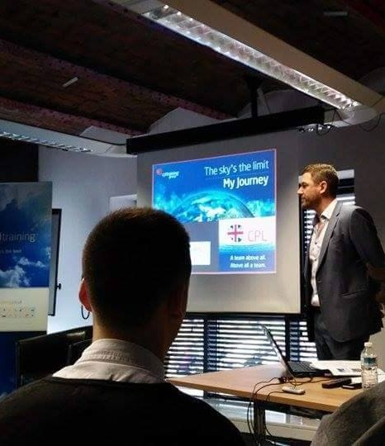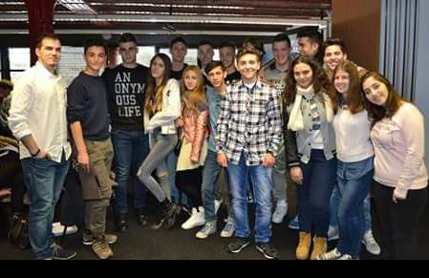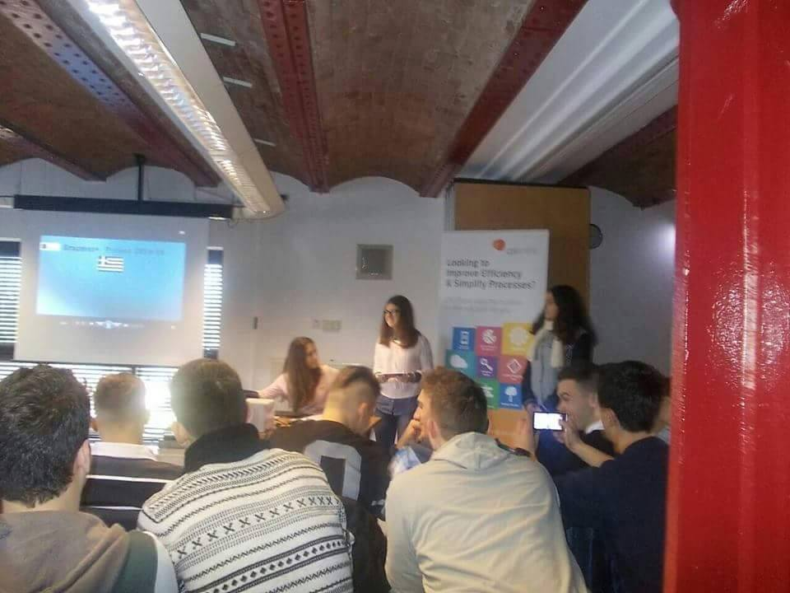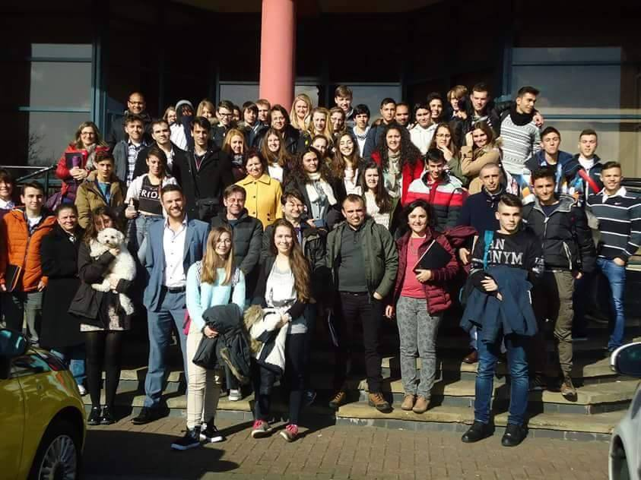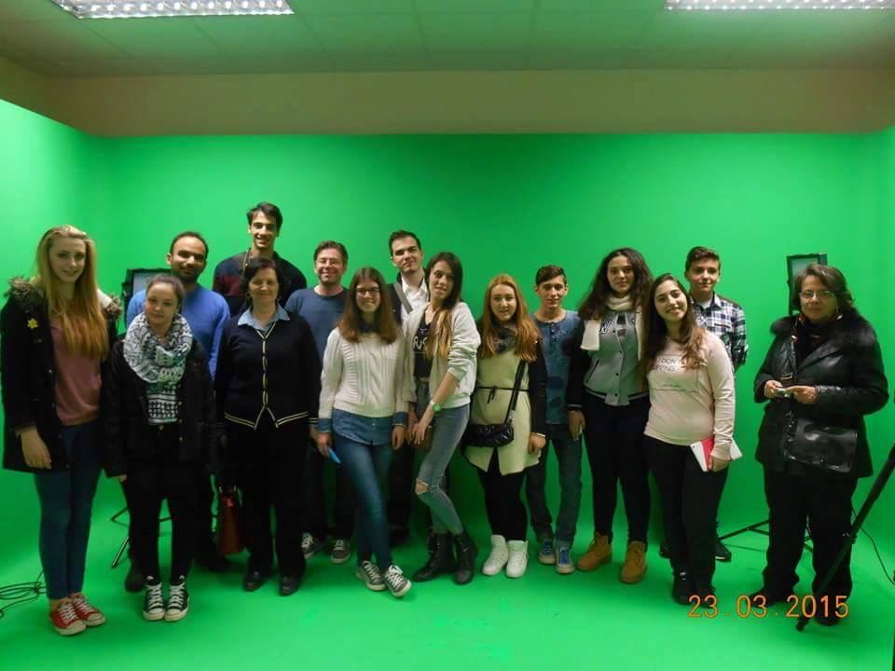
The second day we went to the Oldershaw Academy, where we were greeted by the headmaster. Then we visited CPL, a British company which consists of several teams, all of which are dedicated to training employers and delivering business solutions. There, the CEO of the company presented us CPL’s vision and goals us a company and after that we had a tour of the offices and the departments. We went on to present each county’s project to the rest of the delegations and have some lunch. At noon we went back to our hosts’ houses to get some rest and in the afternoon we all met at a bowling centre and spent time together.
3rd day: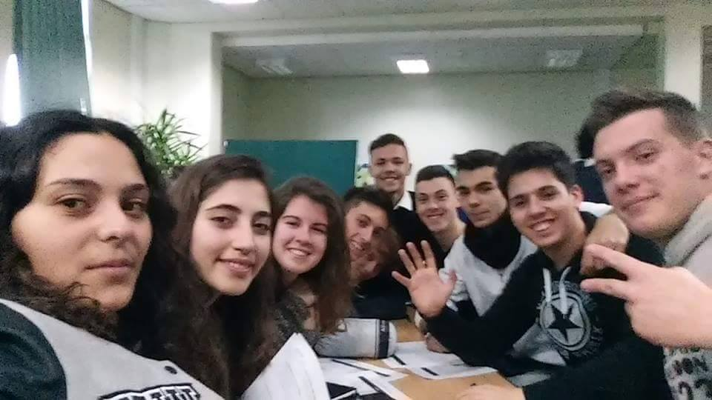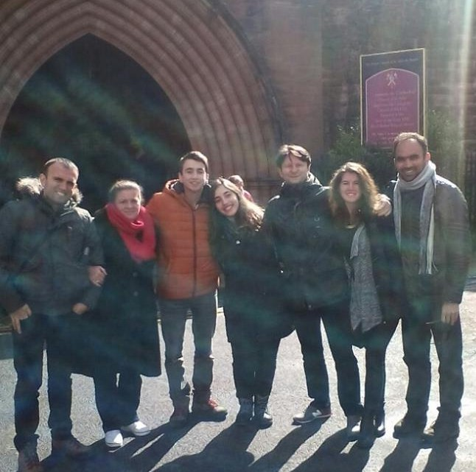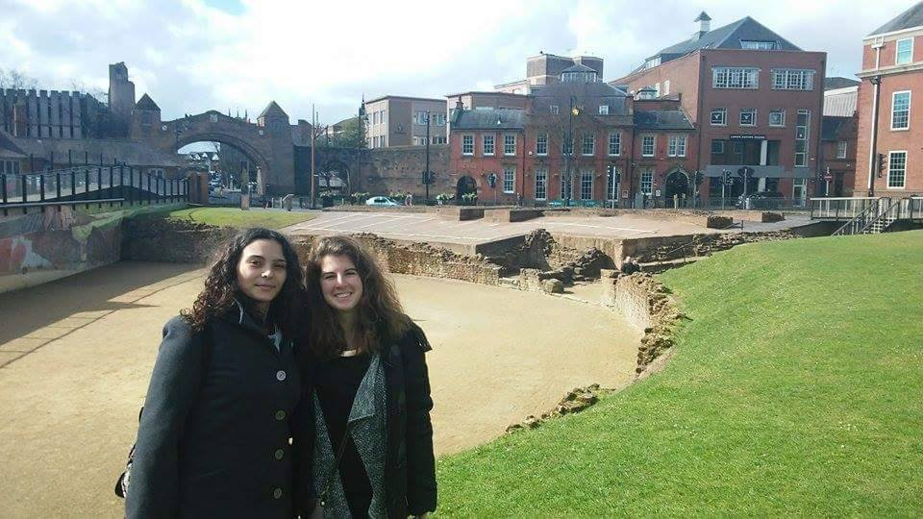

The third day was full of activities. Firstly, a tour of the school took place. Then we had a personality test at the Oldershaw Academy and discovered a lot of things about our character. Then we took the bus to the Ancient Roman city of Chester. There, we had the chance to do a lot of sightseeing at interesting places and monuments –the Roman Walls, the Roman Gardens, and River Dee to name but a few. In the afternoon, we spent time with our host families.

4th day:
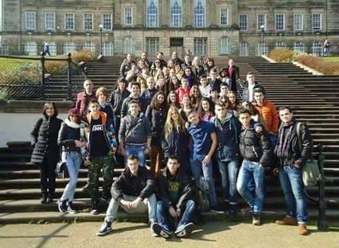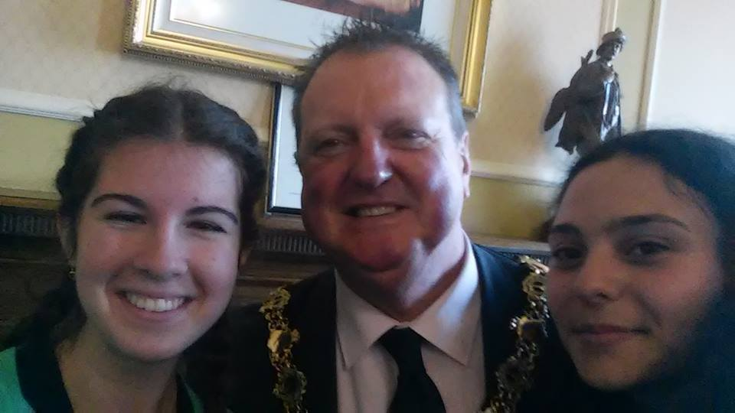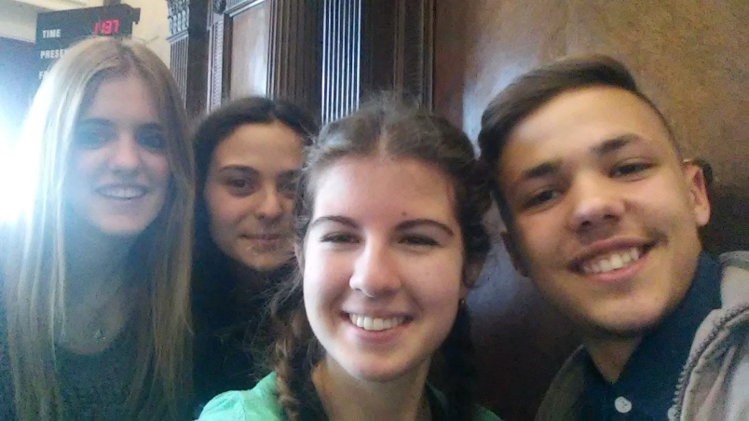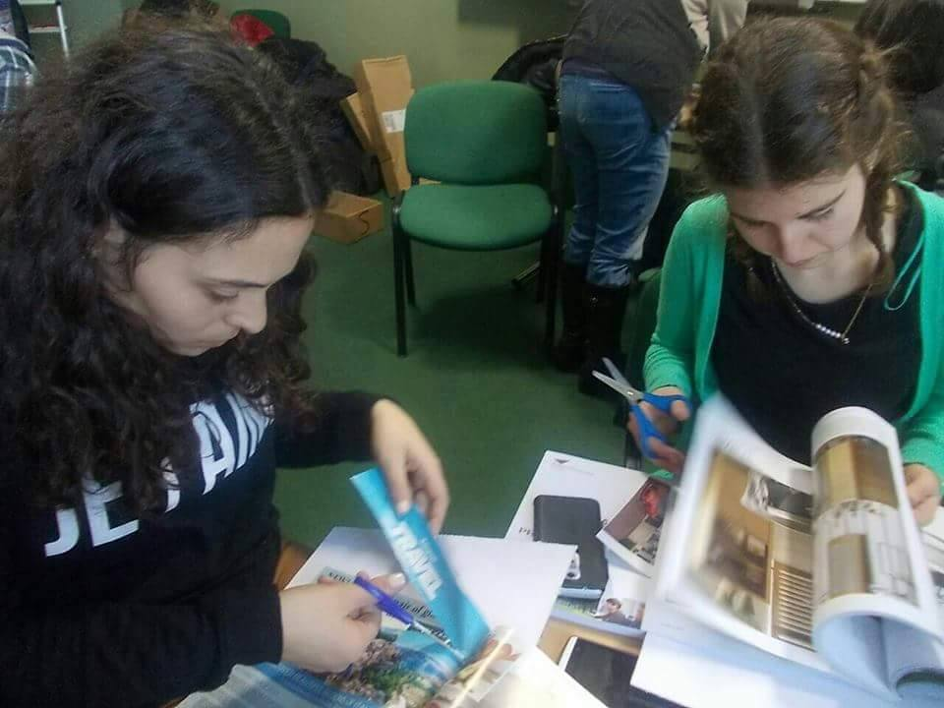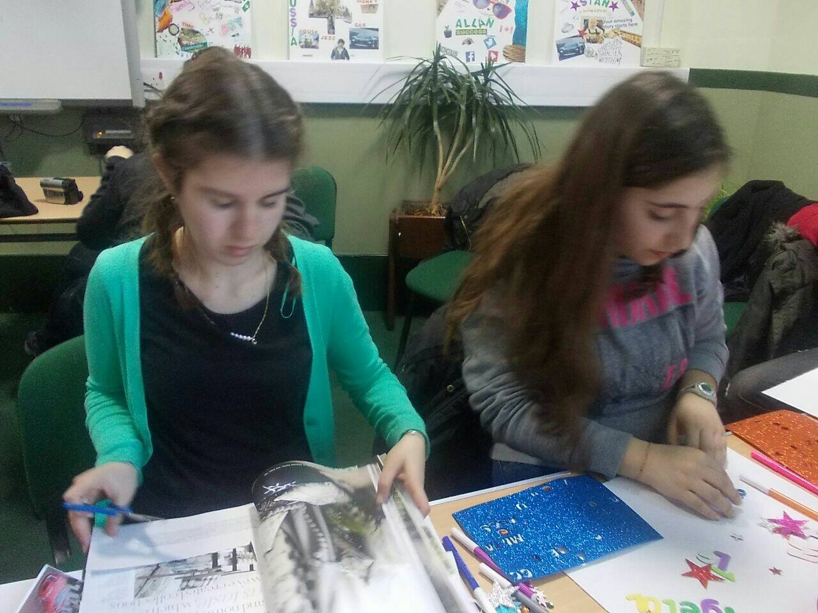
On Wednesday, we attended lessons with our hosts and then we visited the Wallasey Town Hall, where we met the Mayor and were given a tour of the building. After that, we walked by the beach, enjoying the sunny weather, and had chips for lunch in New Brighton. Returning at the Oldershaw Academy, we created our vision boards. In the afternoon, we went by train to Liverpool, to watch Andrew Lloyd Webber’s musical “Jesus Christ Superstar” at the Empire Theatre.

5th day:
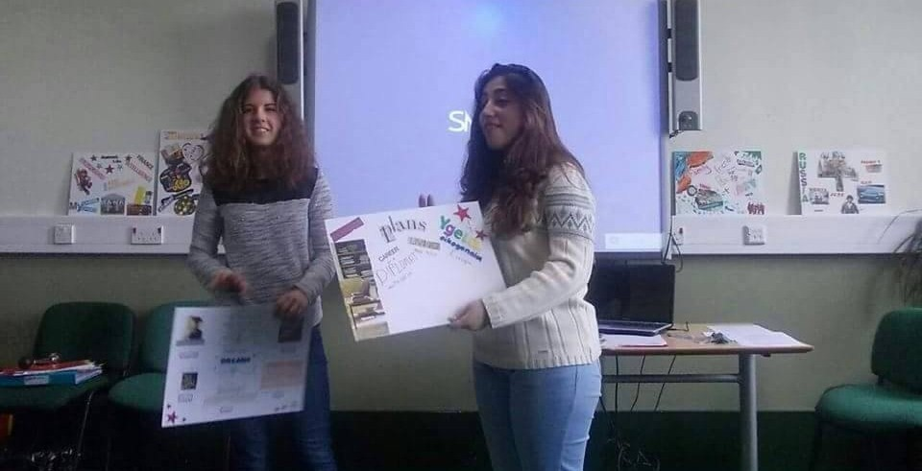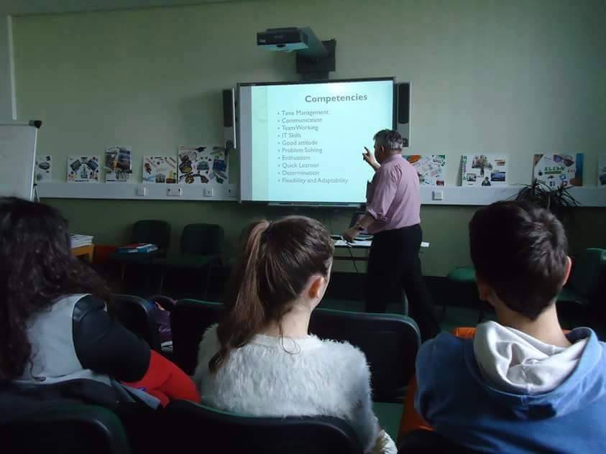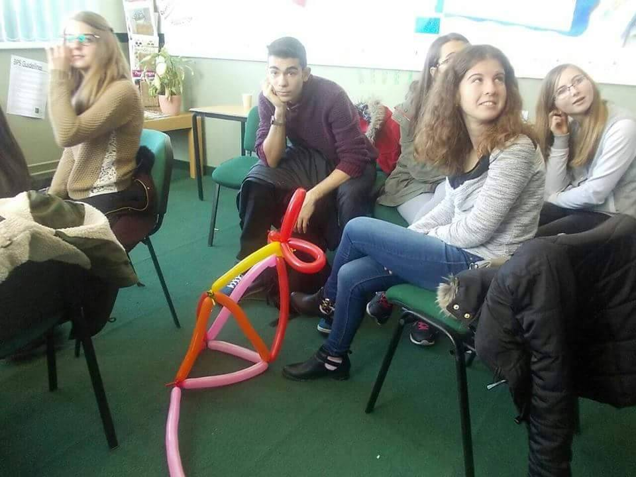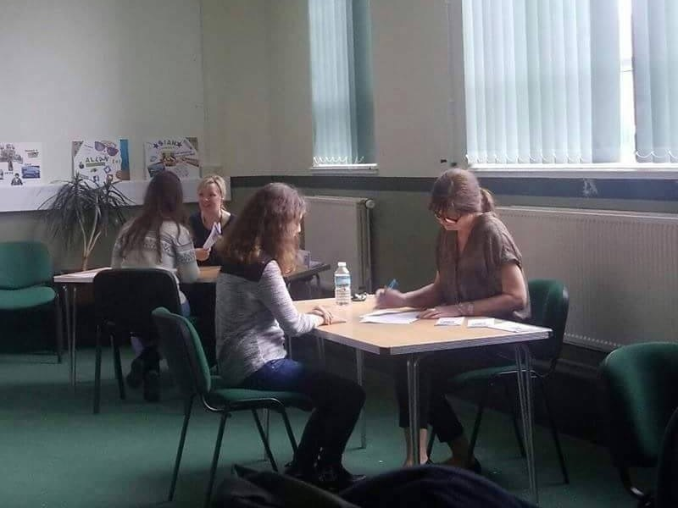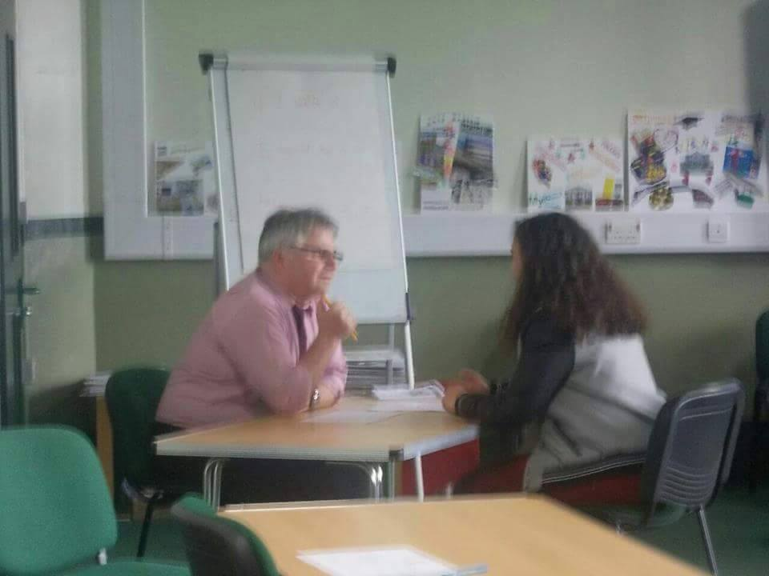
On the fifth day, we started by presenting our vision boards to the rest of the group. Then we were split in two teams and two workshops about our team-building skills and job interview took place. At noon we had fish and chips for lunch in the school cafeteria. After that, we were talked about the advantages of preferring an apprenticeship to University and then we were given time to prepare ourselves for the mock interview, which took place some minutes later. Our delegation left the interview room having made some of the best impressions to the interviewers. This day we spent the afternoon at the bowling centre again, enjoying ourselves and the company of our friends.
5th day:
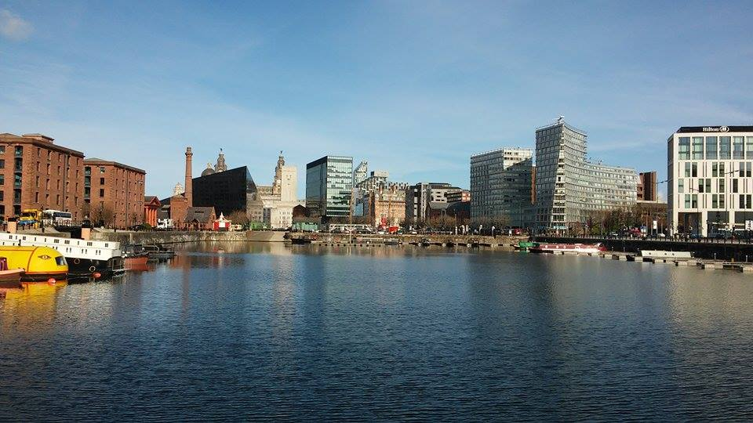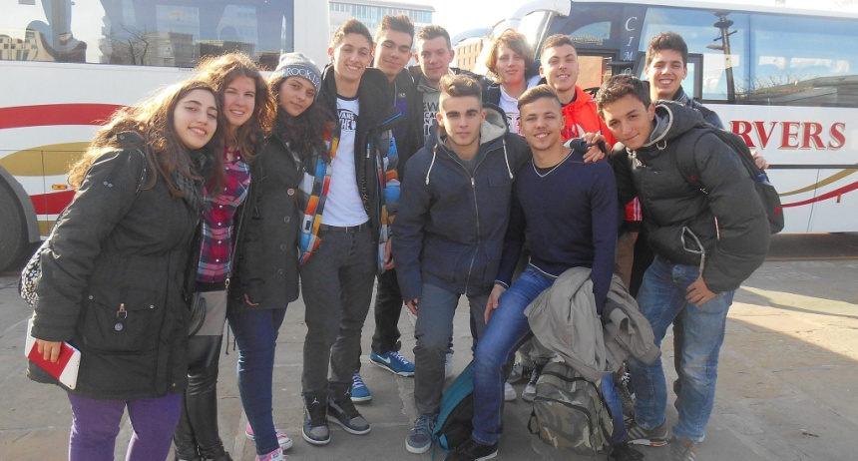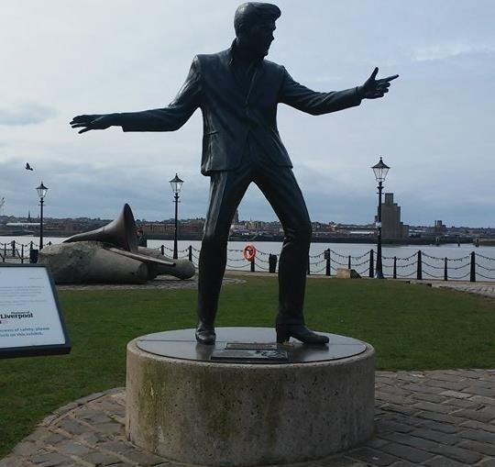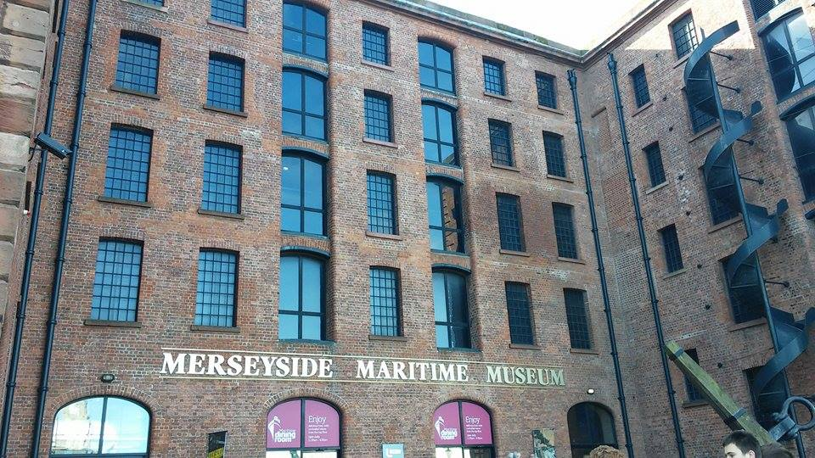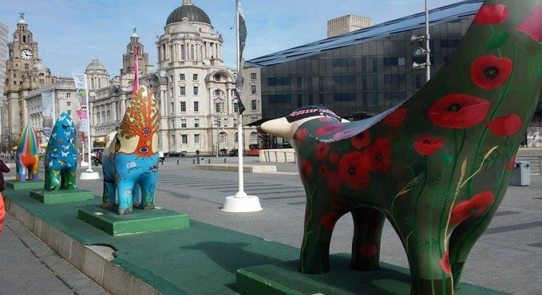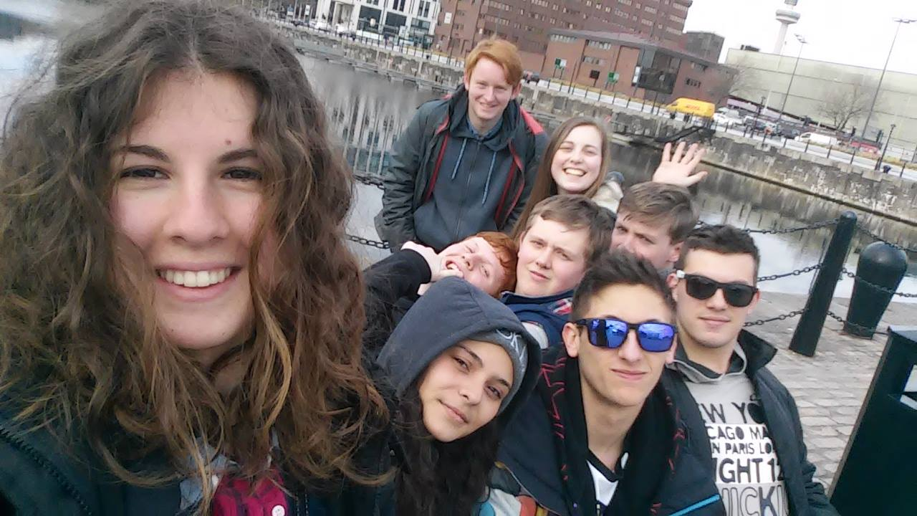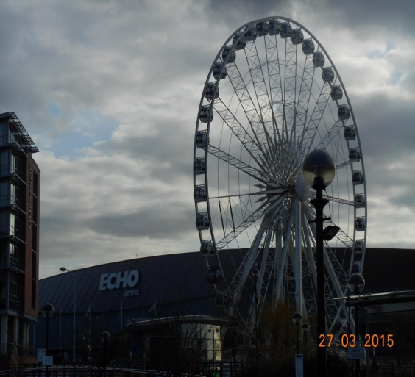
Friday was all about Liverpool! At first, we were given a tour of the Albert Dock, and then we visited the Maritime Museum. After this, we spent some time in the Liverpool Museum and then we had free time for shopping, wondering in the town and having lunch. At the same time, the Treasure Hunt gave us the chance to explore a great variety of Liverpool’s sights. Back at Wallasey, our afternoon was free and some went ice-skating, some others bowling, and others just stayed home.
6th day:
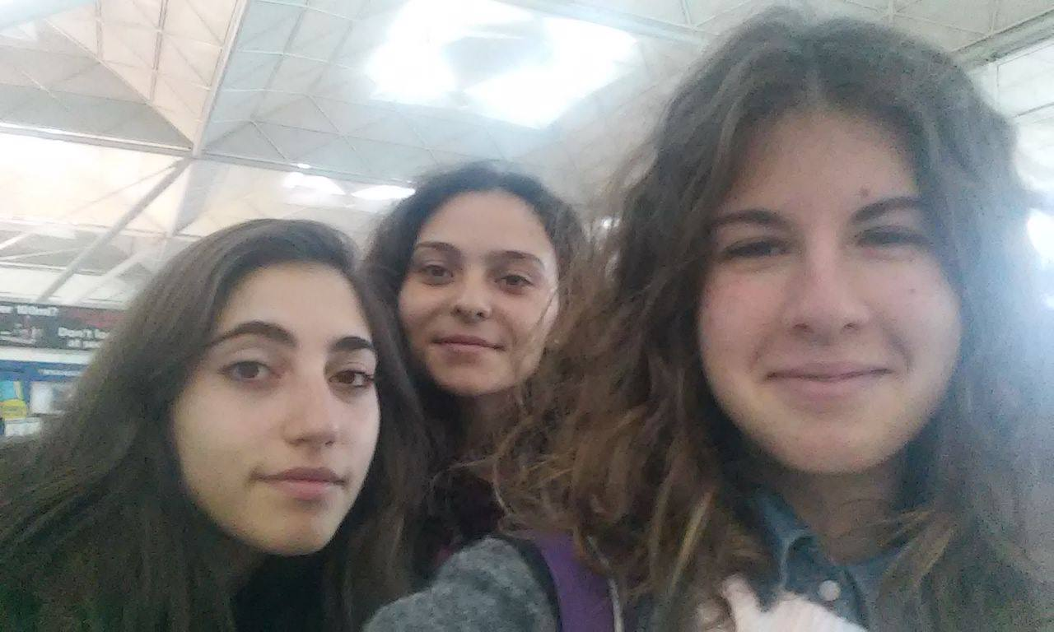
On early Saturday morning, we departed from New Brighton to by train Liverpool, were we took another train to London. Once there, we took the coach to Stansted Airport and after about two hours we were there. Our flight was early in the afternoon. We arrived at Athens at 12a.m. and two hours later we were at Tripoli.

