Days 14 and 15.
The day 14 we decided to get up earlier than the previous days, because several countries had already gone, except Turkey that went in the morning and Italy in the lunchtime, so we decided to spend the last day for Athens but before we said goodbye to the Turks.
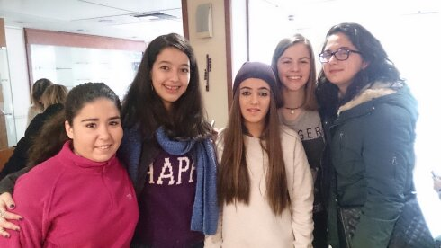

We were going for a walk and we saw a curious thing, the changing of the guard of Parliament, and there we said goodbye to the Italians. 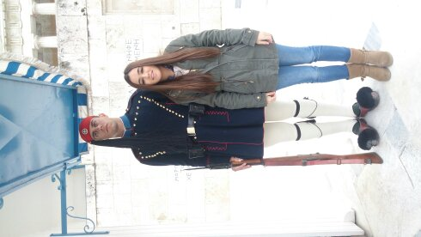

Then we caught a tram and we saw very beautiful scenery with the background acropolis and the beach.
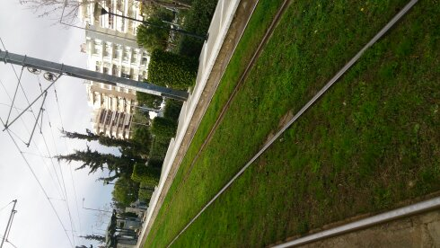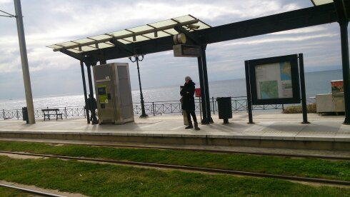
We stopped for lunch at a pizzeria and then we took a stroll in the beach until we took the tram in order to go to the center.
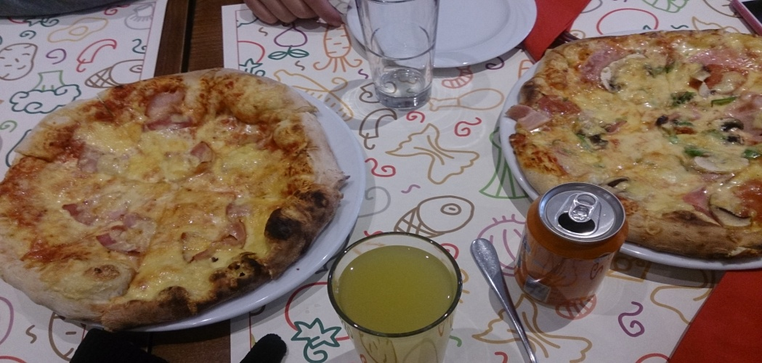
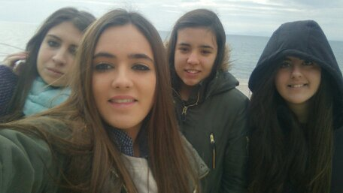

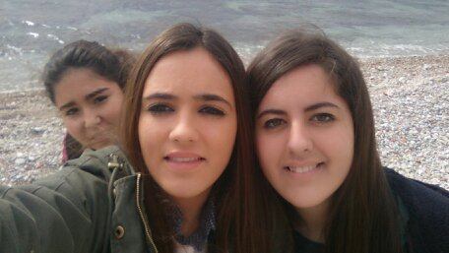

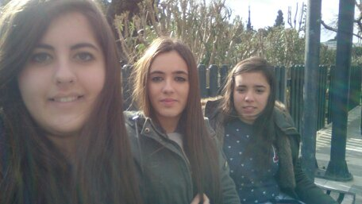
When we arrived the teachers wanted to show us a very interesting market but we really wanted to go shopping, after the teachers were tired and decided to return to the hotel in order to have a shower and dining out as it was last night. We were looking for a suitable restaurant for our budget and we entered a very simple restaurant but with lots of music but the food was horrible and very poor because the amount was insufficient and we decided only the students to eat a rich kebab after we returned to pick up the teachers in order to return to the hotel because we had to sleep because the next day we would come back to Spain. The morning of the 15th we had the breakfast and then we packed up.
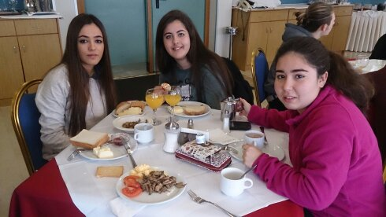

We had to take several metros to arrive the airport. The trip back on the plane was good because it was less time and some people ate there.

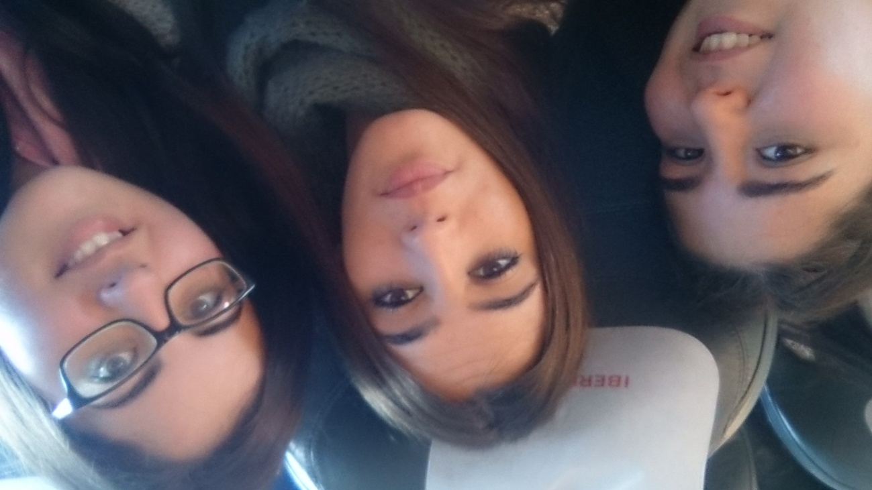

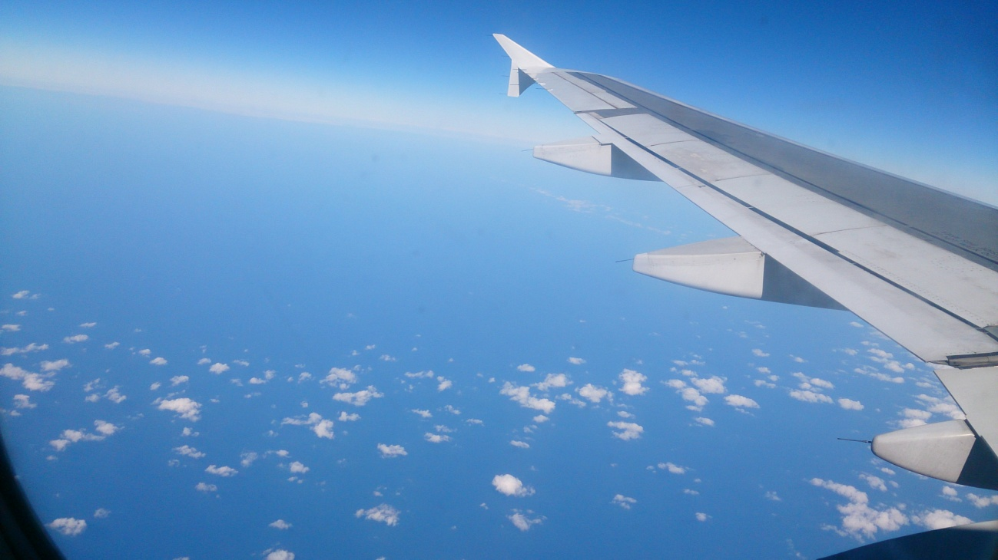
When we arrived to Madrid we took a bus and stopped in a bar in order to the teachers had to dinner while we waited on the bus. At 12 ó clock we arrived to our village.

