MEETING IN ITALY!!!!!
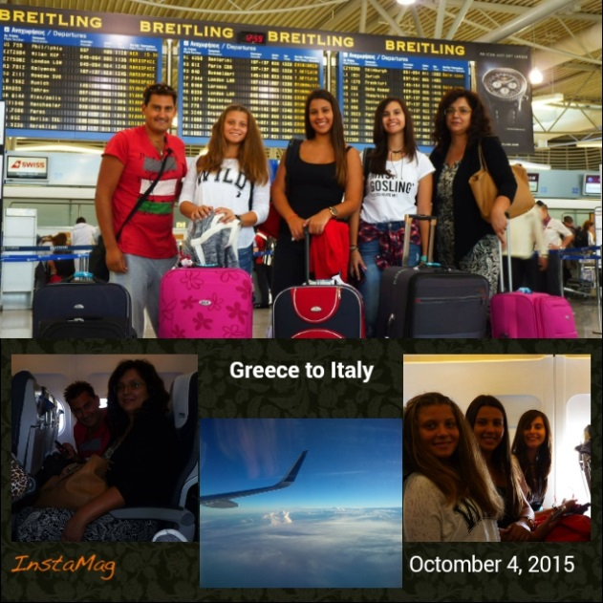

OnSundaymorningwestartedfromTripolibybus to go to Athens. And from there we take the plane to Italy! We were all excited because a new exciting experience was started for us!
When we arrived in Rome we took the train to Pisa where we arrived late in the evening. The families that hosted us waited in the train station and from there we went to their homes.
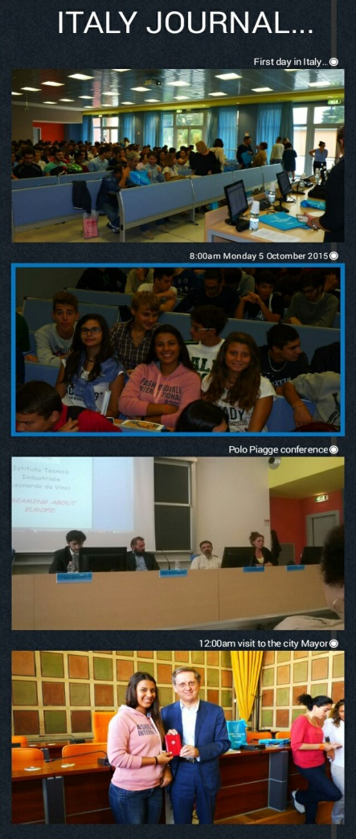

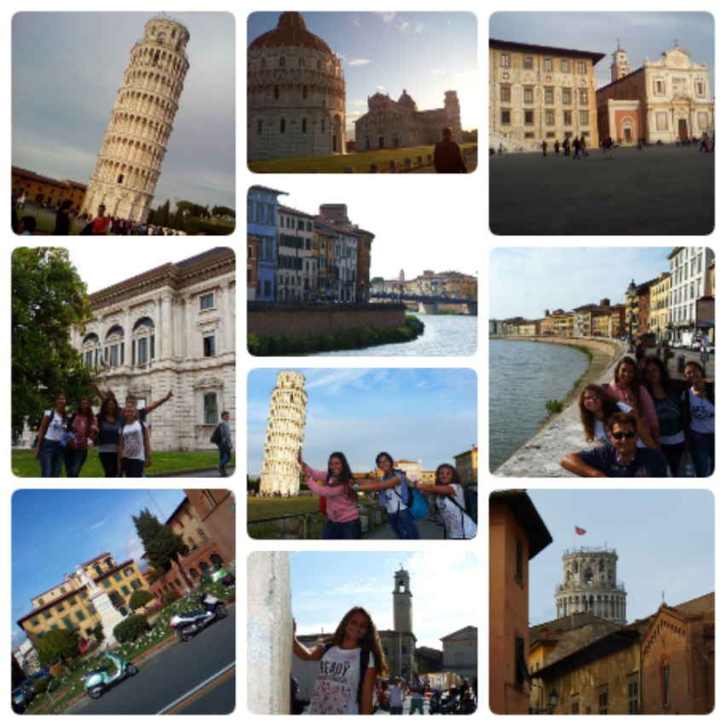
On Monday morning we went to the Polo Piagge to watch the speech experts had prepared for us. Later Angela and Mr. Kostouros from our group went to the Mayor of the city, while Alessandro,Flory (from Romania), his friends and I went to Pisa for food. Then we went home and we played together playstation. At 15:00 noon we went and found the rest of the program and our Italian friends guided us and showed us the sights of Pisa. When we finished the tour we returned home, we ate all together with the family.In the evening Alessandro and I went out stroll.

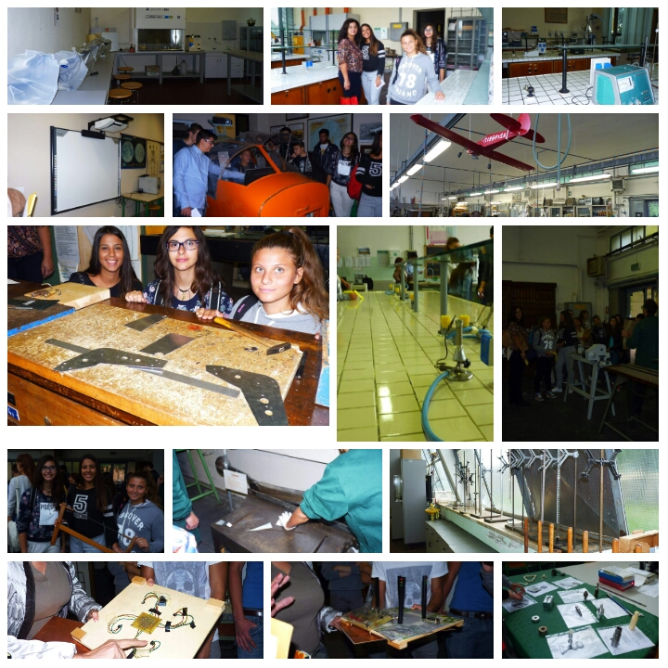

On Tuesday morning we visited the school, divided into three groups, there we saw biology labs, chemistry, physics, aerodynamics, woodworking and more. At 10:30 we took a break in the school cafeteria and there offered us brunch. Later we presented the work they had done with Mr. Melis.
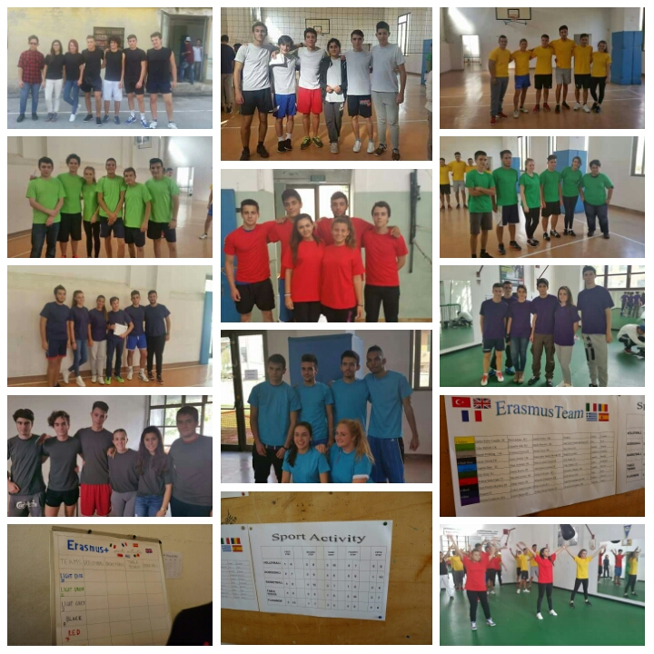

After we ate at the school cafeteria, followed by sports which parted to ten teams and we played volleyball, basketball, table tennis, dodgeball and flashmob. When we finished sports we returned home and played board games with the family, who hosted me, this wonderful week. Then in theevening we rediscovered in Pisa together, out and met the other friends from the program.

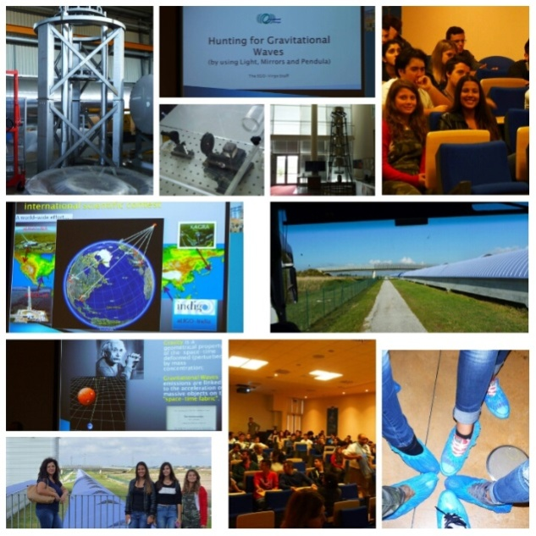

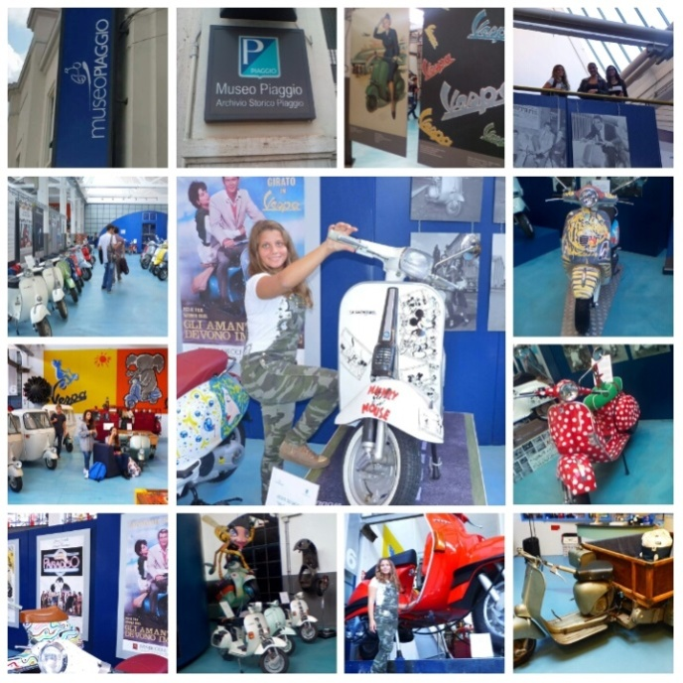
On Wednesday morning we visited to Virgo: The European Gravitational Observatory is a company dealing with the theories of Albert Einstein and astrology. Then we went and visited the museum of Piaggio, there our tour guide spoke of the vespas history of the first model and how it evolved until today. At noon we returned to Pisa, we went home and cooked all together!! Later the afternoon we went with the kids on the court and we played football. In the evening we came back home and we prepared to gone out for eating with other families who hosted children. One of them was the family of Giacomo who I knew him from last year. Because it was the child who I had hosted when he had come in Greece.
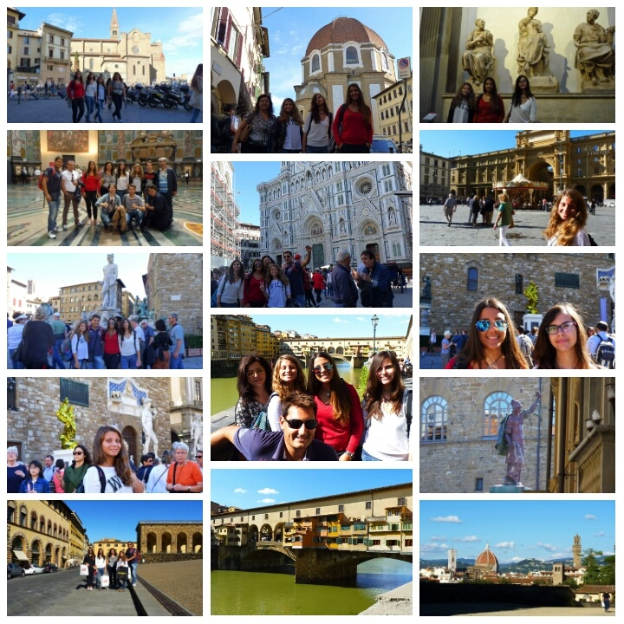
On Thursday throughout the mission we started from the station of Pisa to get to Florentia.There we visited to Medici Chapels and we saw the wonderful creations of Michelangelo. After they left us free time in Florence and saw the breathtaking landscapes such as the Basilica of the Holy Cross, the Piazza della Signoria, the David of Michelangelo in Palazzo Vecchio and other wonderful places while we exploited the little time we had we did some shopping. After we found the rest of the program in Boboli garden in which we toured separated into groups. In the afternoon to the evening we returned to Pisa and we go out for dinner with the family.

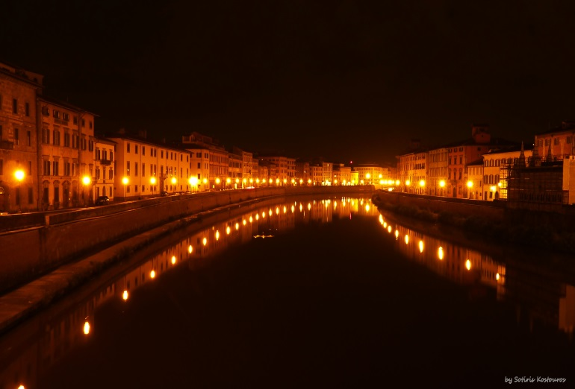
On Friday we met at the station and I went to the medieval Lucca, is one of the oldest town in Italy. Which is surrounded by high perimeter walls having a unique access from six gates "which when you cross to enter, into the city, you think spins and time together! There we dine in the company of our teachers and post we did a walk to see the city. After we returned to school and did the Workshop through the data collected on the economic situation in their countries, in mixed groups.To evening followed the farewell party and so was closed very beautifully this wonderful single week in Italy.
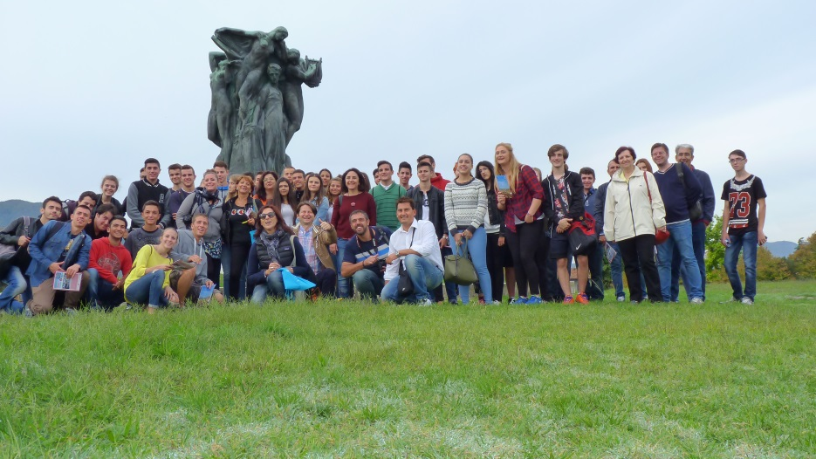

On Saturday morning we start from the station of Pisa to Rome, this time however we wereonly the greek group. When we arrived in Romewe visited the Colosseo and after we took the road back.

