ERASMUS+

MEETING IN ISTANBUL

1ST DAY 22 NOVEMBER 2015
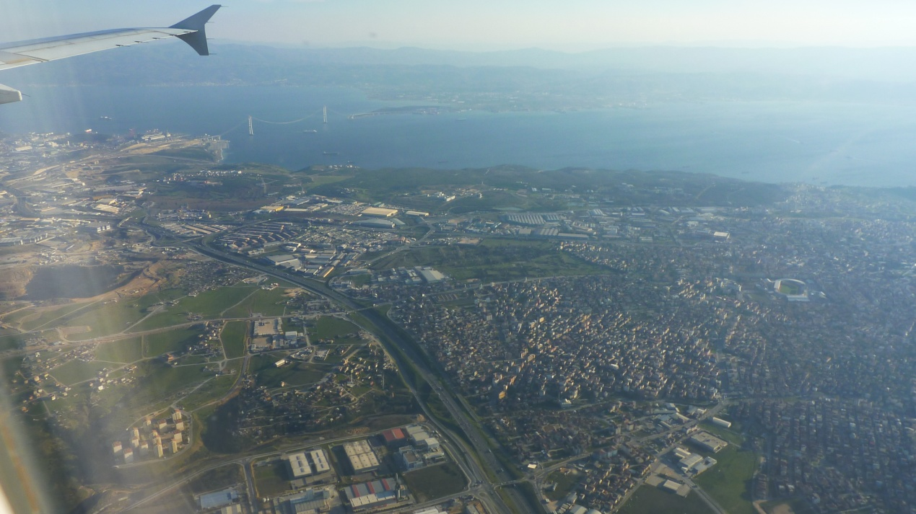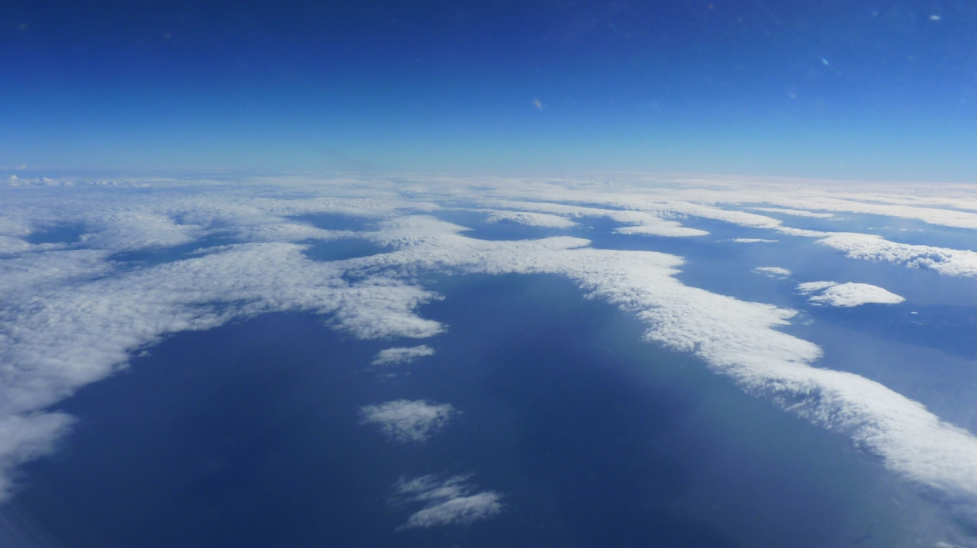
We left Tripolis very early in the morning of Sunday with our final destination the Istanbul.
It was a very unique experience especially when we first saw this amazing city from our plane. It was just a gorgeous view that somebody difficult can forget. Istanbul is one of the most famous cities in the world for its amazing temples, culture, traditions and sightseeings that someone can visit.
We reached at Istanbul at about half past 7 in the night of Sunday and we were very exhausted from our long trip. 2 students waited for us at the Turkish airport and took us to their school in order to meet for the first time our host families. (It is just an amazing experience to meet and stay with people from different countries into the same house as you can see new traditions and a new way of living).

2nd day 23 NOVEMBER
It was our first day in Istanbul!!!! (Just astonishing !!!!!!!!!!!!! ). We were going to see for the first time the Turkish school and it’s students, also they showed us some special Turkish folk dances that were just brilliant as they were very unique for the way of dancing . Then we went at a very nice park that had a very had lake with a lot of flowers sourounding it and many other beautifull things to see and do , we also took a lot of photos there with all the other delegations. After this we went to the mayor of the city in order to meet him and talk with him for our special program, at the end of our talk we took a lot of photos all together. After that we went to a special place named workshop were some women draw some very nice paintings on water with a special oil. It was just a very nice and unique experience.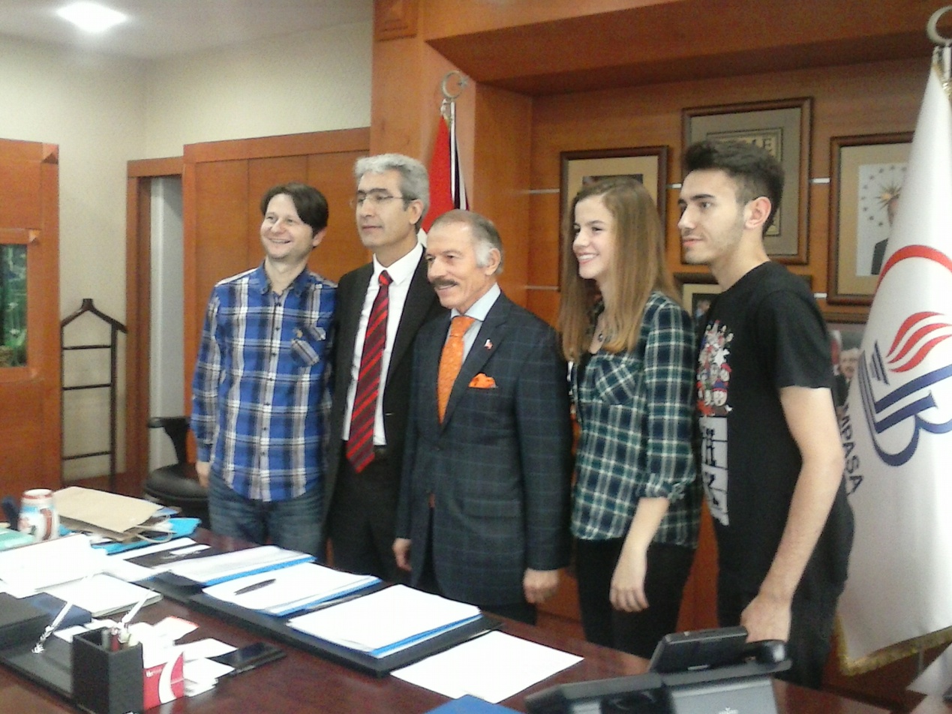 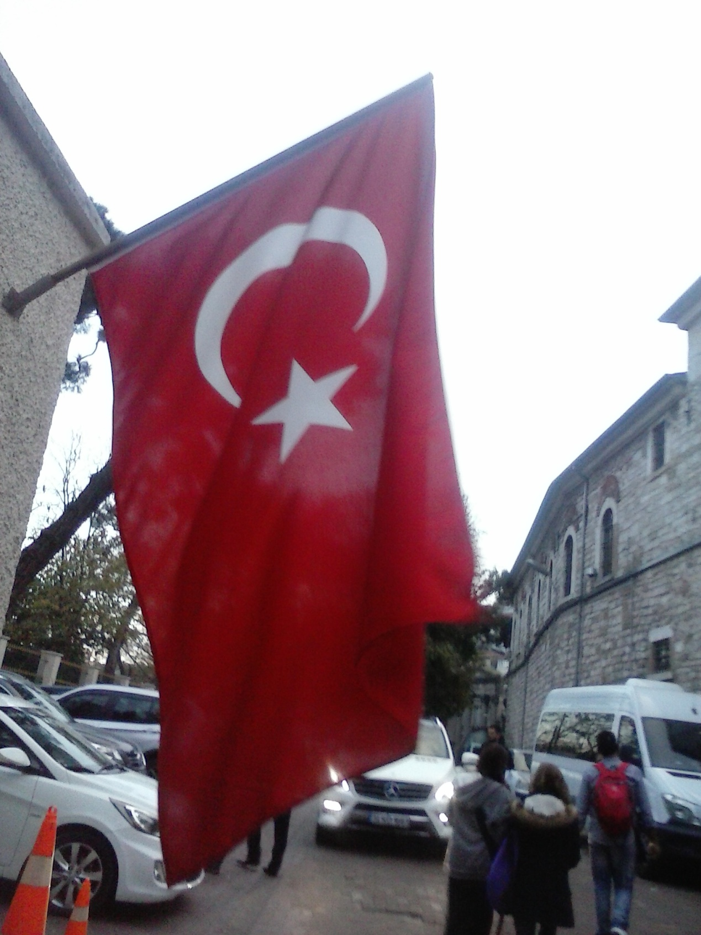

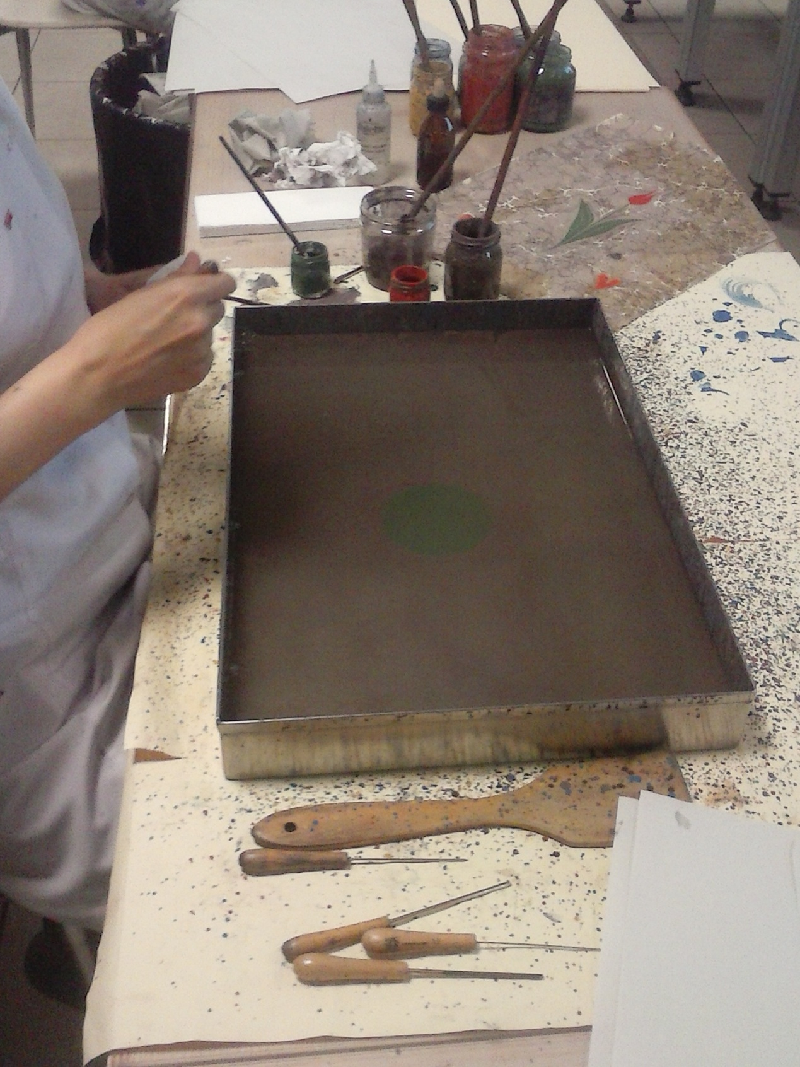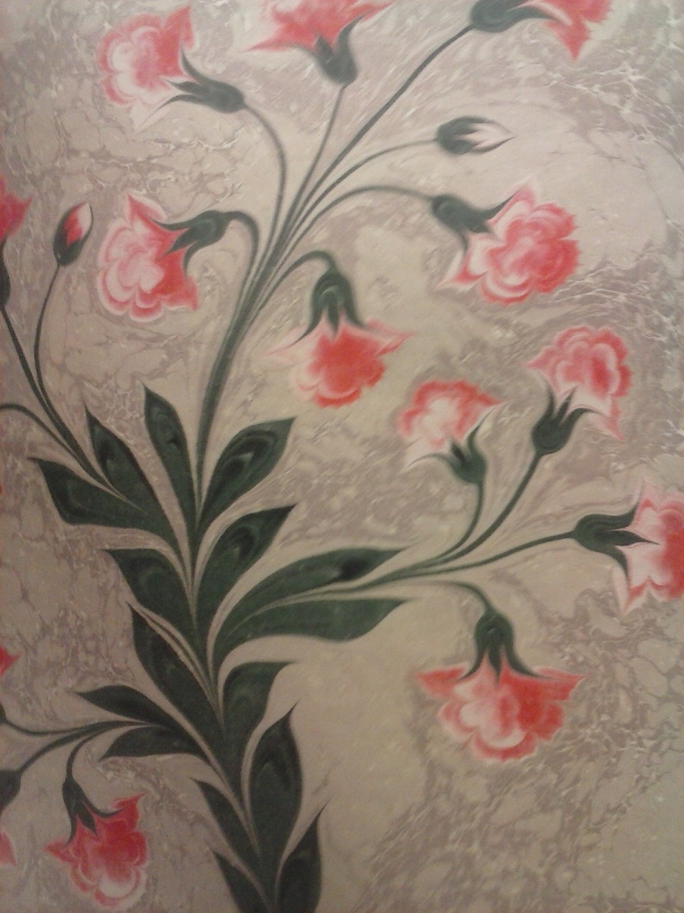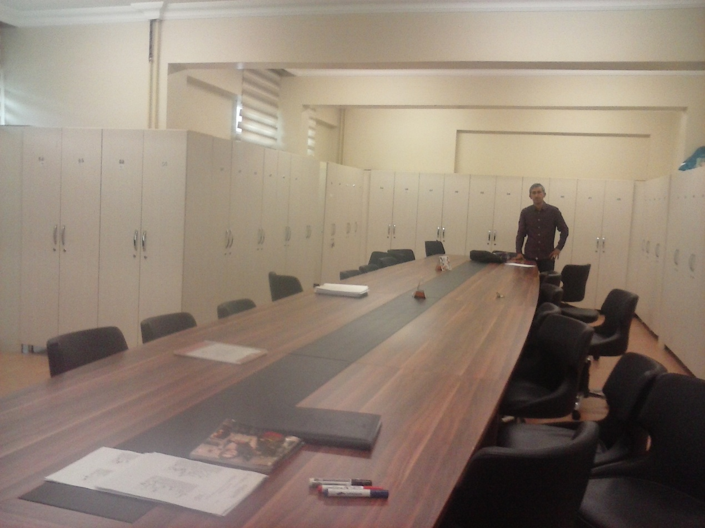

3rd day 24 November
WOW!!!!!!! Our 3rd day in Istanbul!!!! That day we went at the spectacular ULKER chocolate factory!!!!! It was a very unique and very organized factory in the way of producing chocolates and with the way that the workers who worked there introduced to us all of the factory’s utilities. After that we went at THE RAMAZAN BINGOL restaurant in order to eat and drink some Turkish special dishes and drinks. Later that day we returned at the school in order to see the logos of all delegations and at the end vote for them. It was a very unforgettable day as all the others. 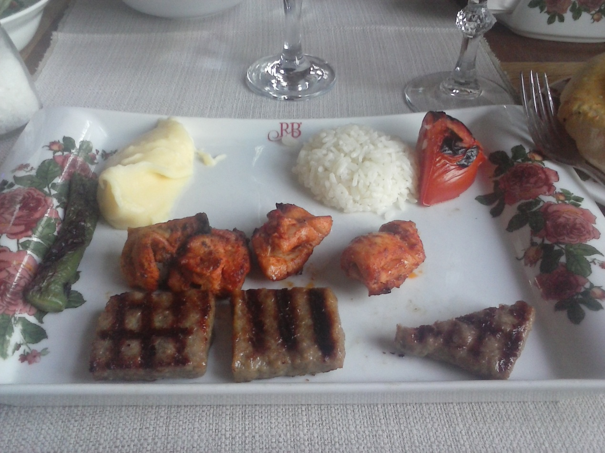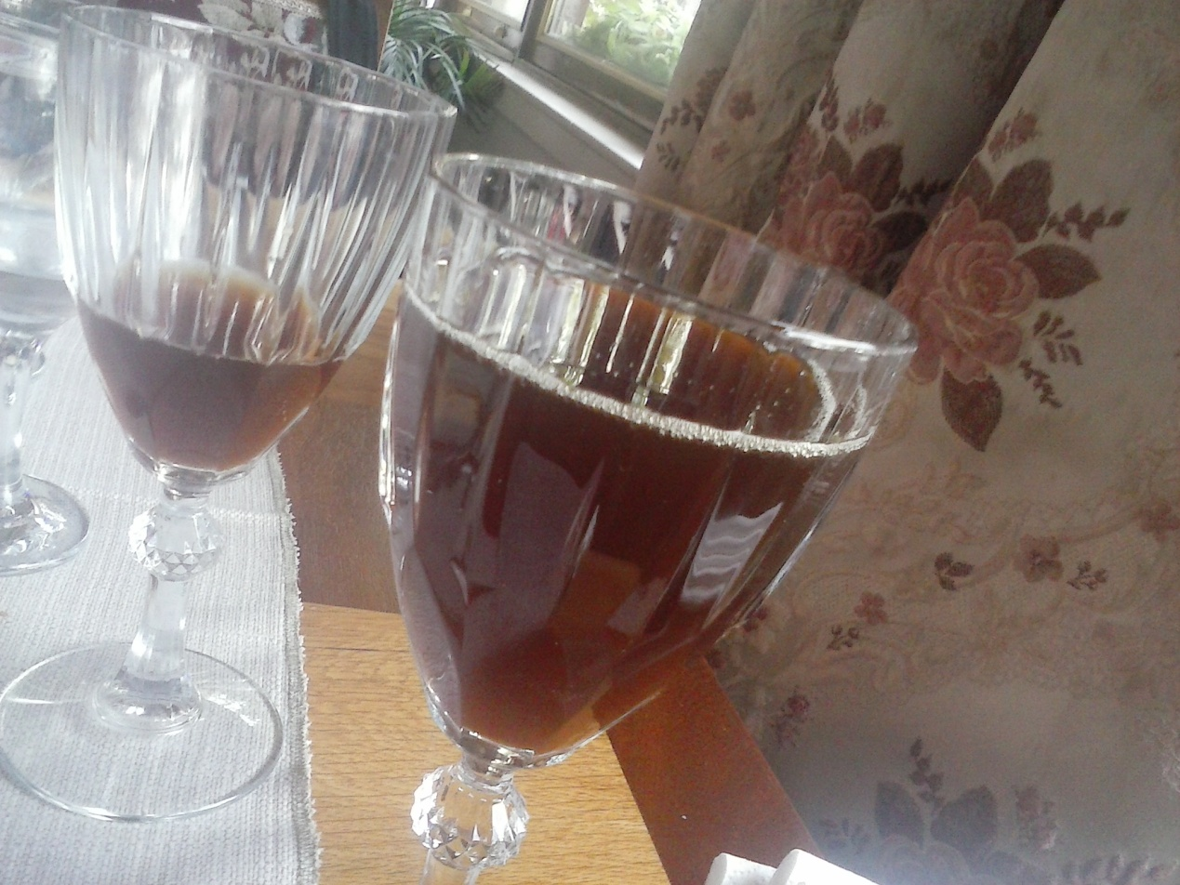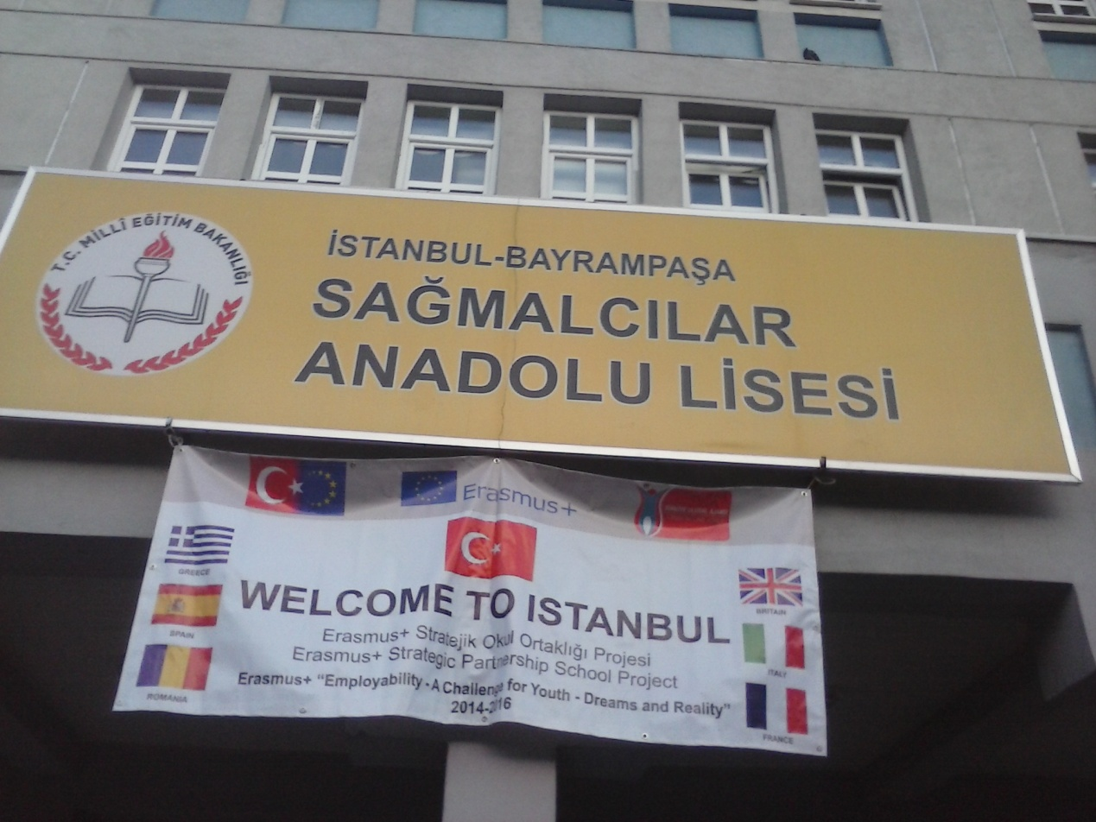

4th day 25 November

It was a very special day for every student of the program as we participated in a theatrical team and each kid played a role that a different country had created for him. It was a very special idea, as, by this way , people from foreign countries can work together and cooperate with each other. After that, we visited Istanbul forum in order to go shopping and to eat because we were starving from our full schedule. At the end of the day, we visited Istanbul panorama. 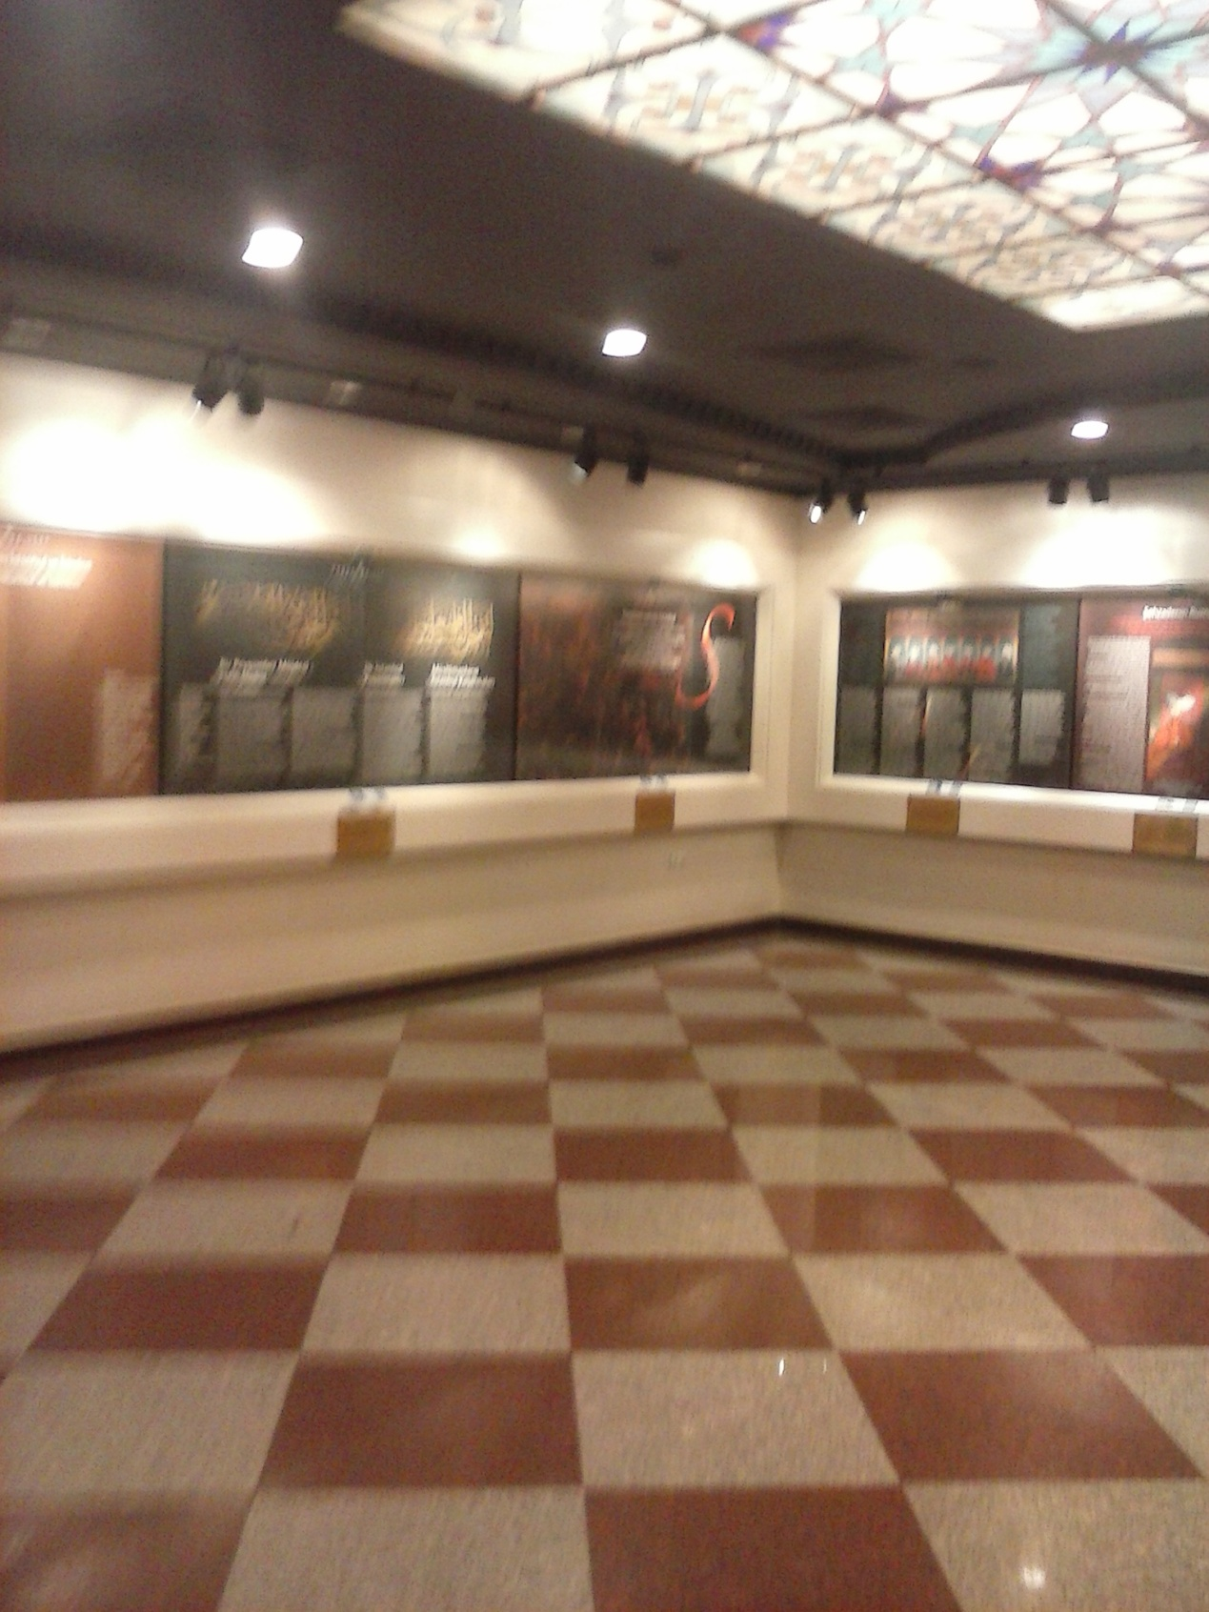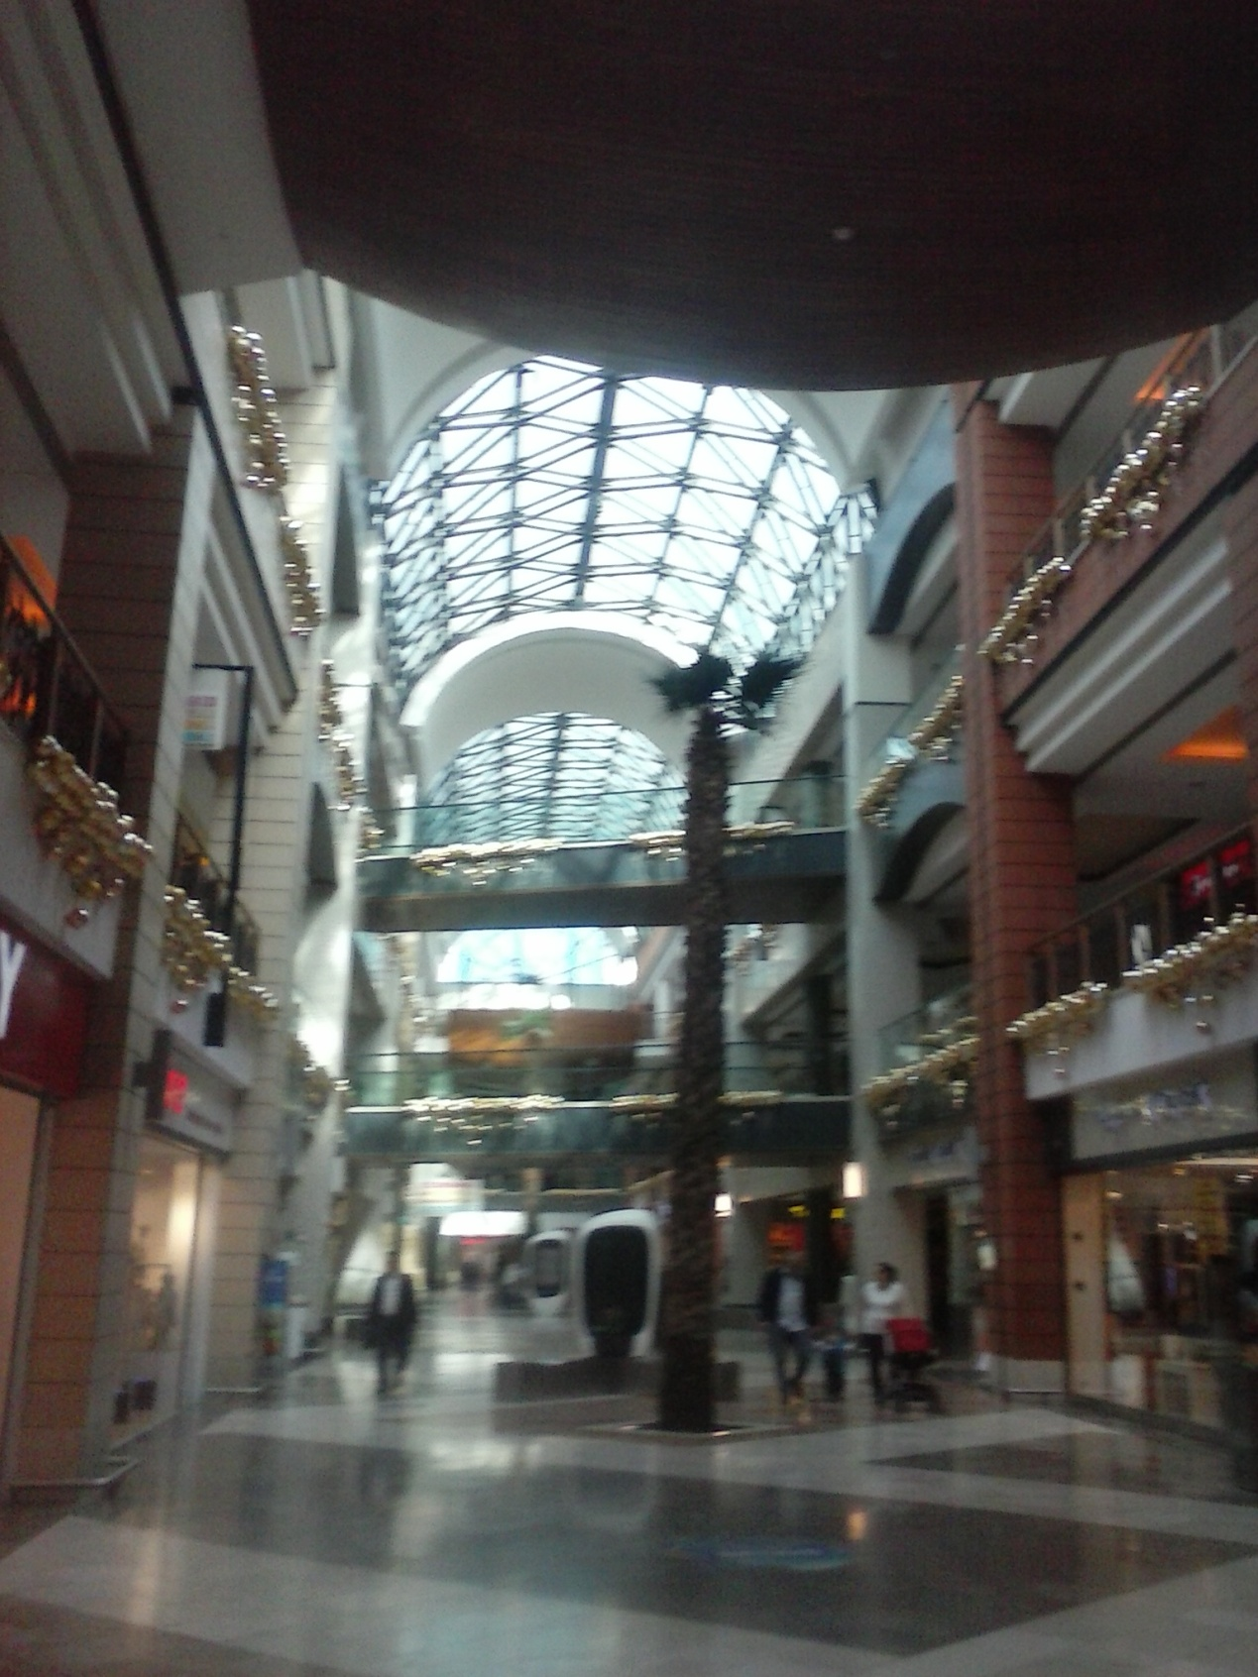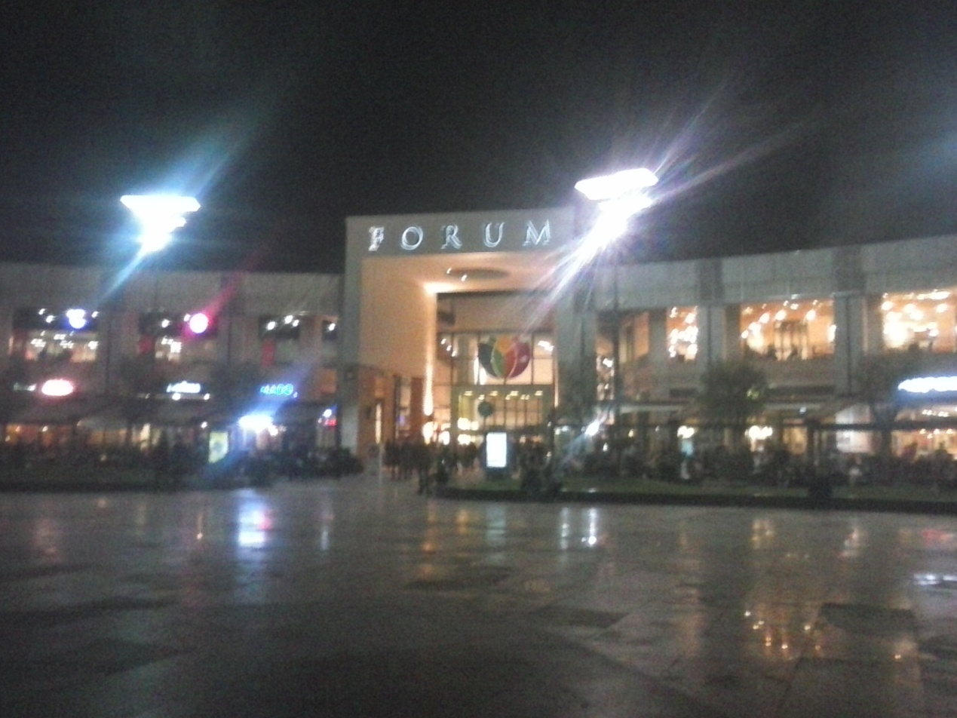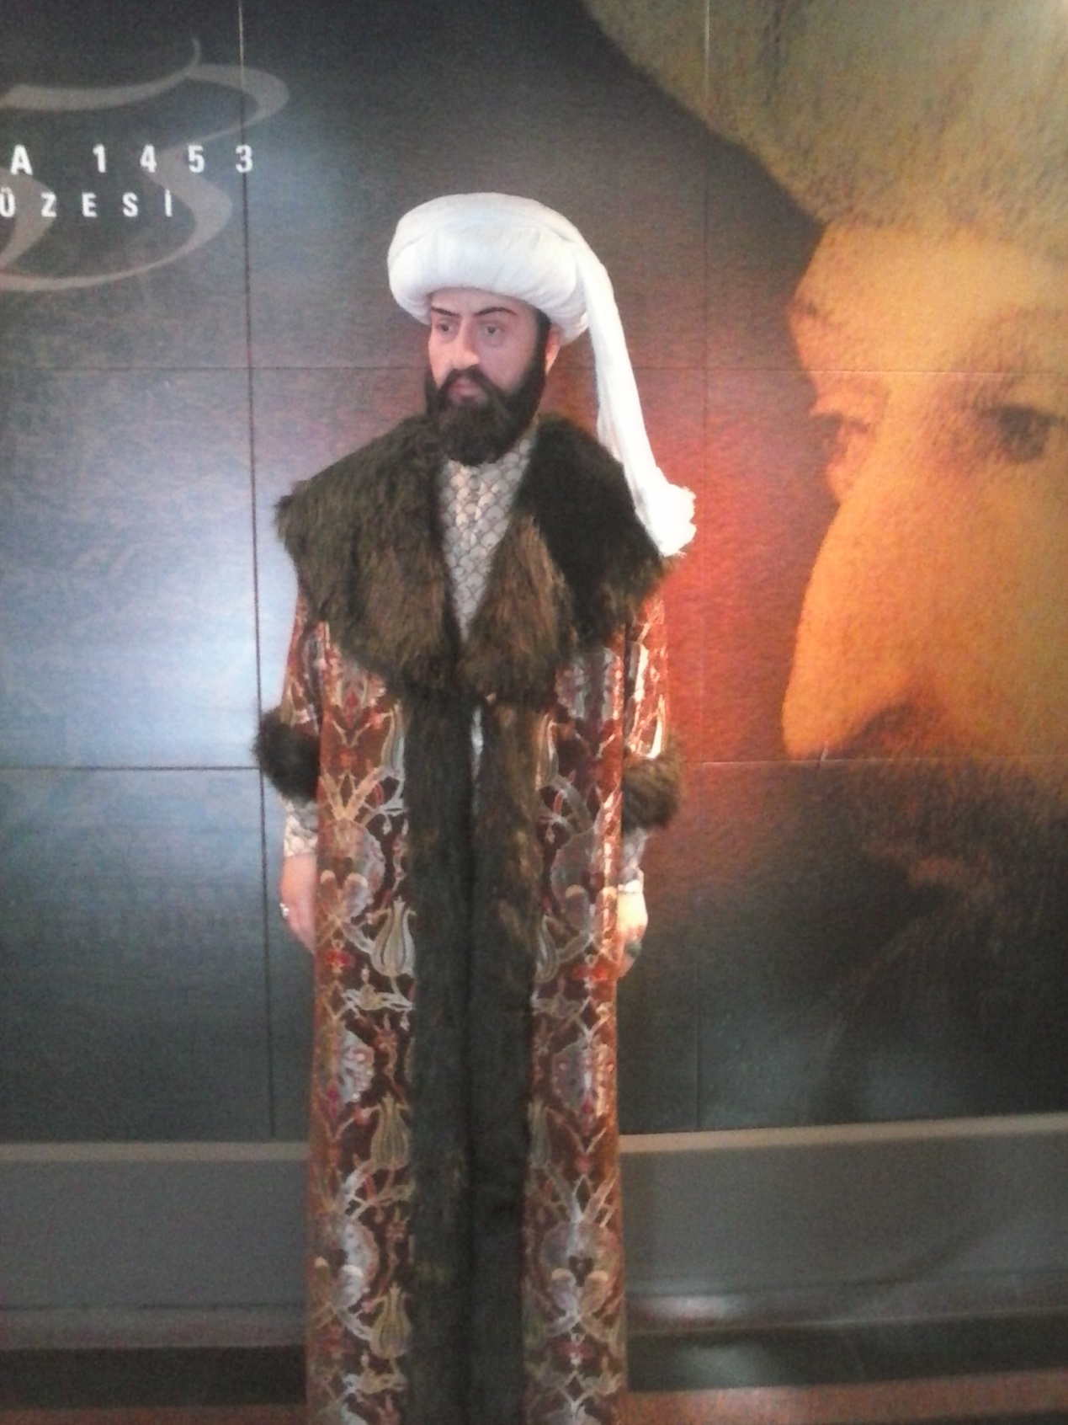

5TH DAY 26 NOVEMBER

Hahaah!!!! The guided day!!!! At that day we went at the sultan ahmet mosque which really was a very nice experience considering all the amazing sightseeings . After that we went at Hayia Sophia temple which also was a very nice and unique sight for somebody to visit. Then we visited Basilica sistern water facility to see some very unique sights of this underground facility. Moreover, after that we did an eating break to relax. At the end, we visited the famous topkapi palace to see the enormous gardens, the buildings and to hear some historical events that happened back at that ancient era.

f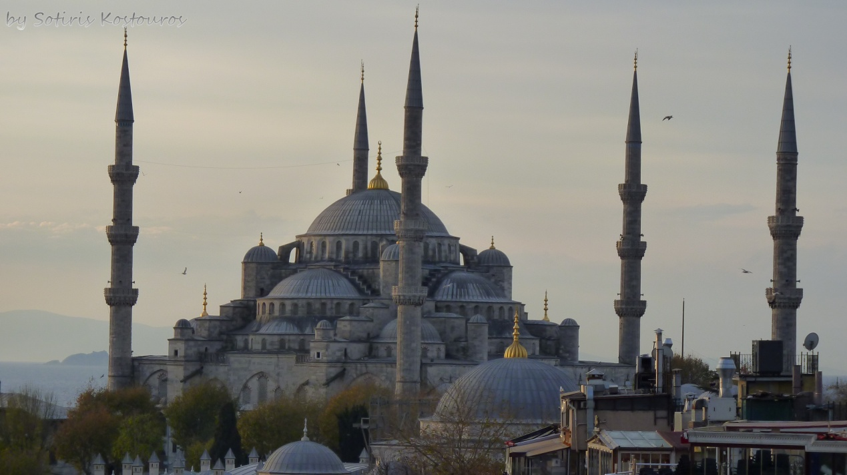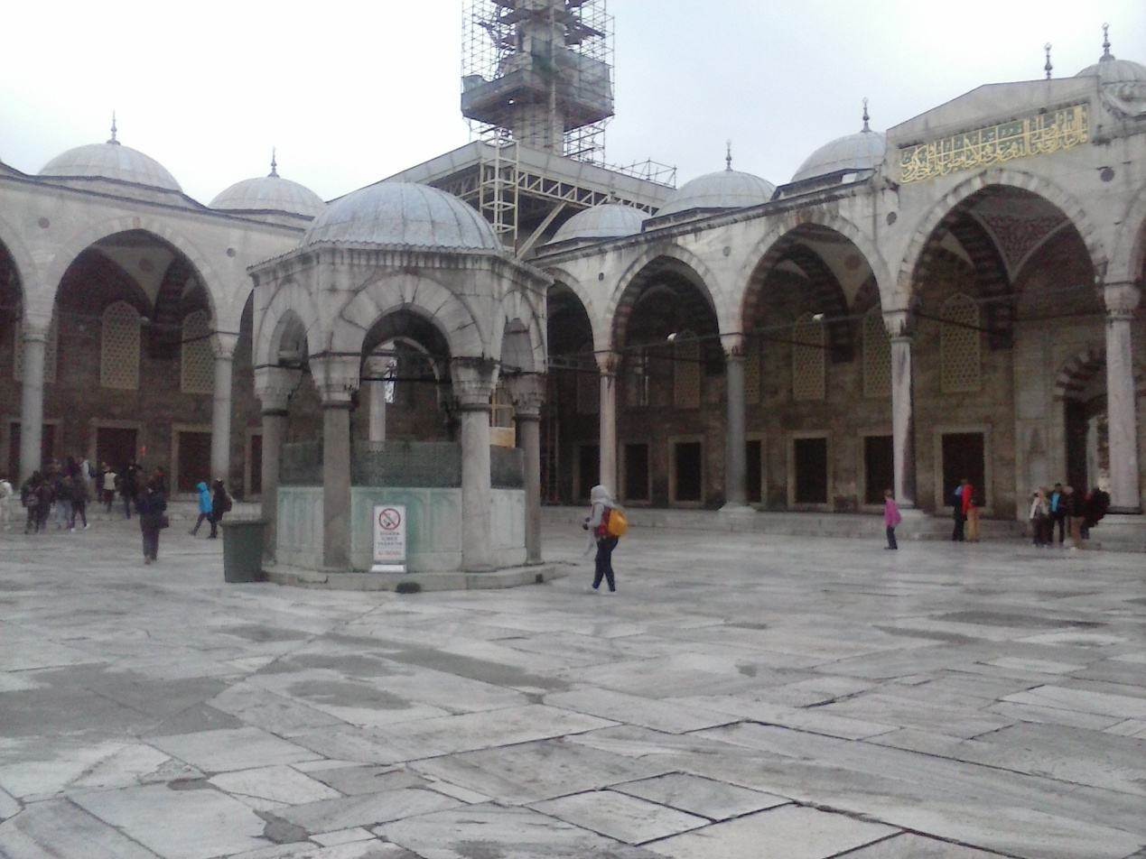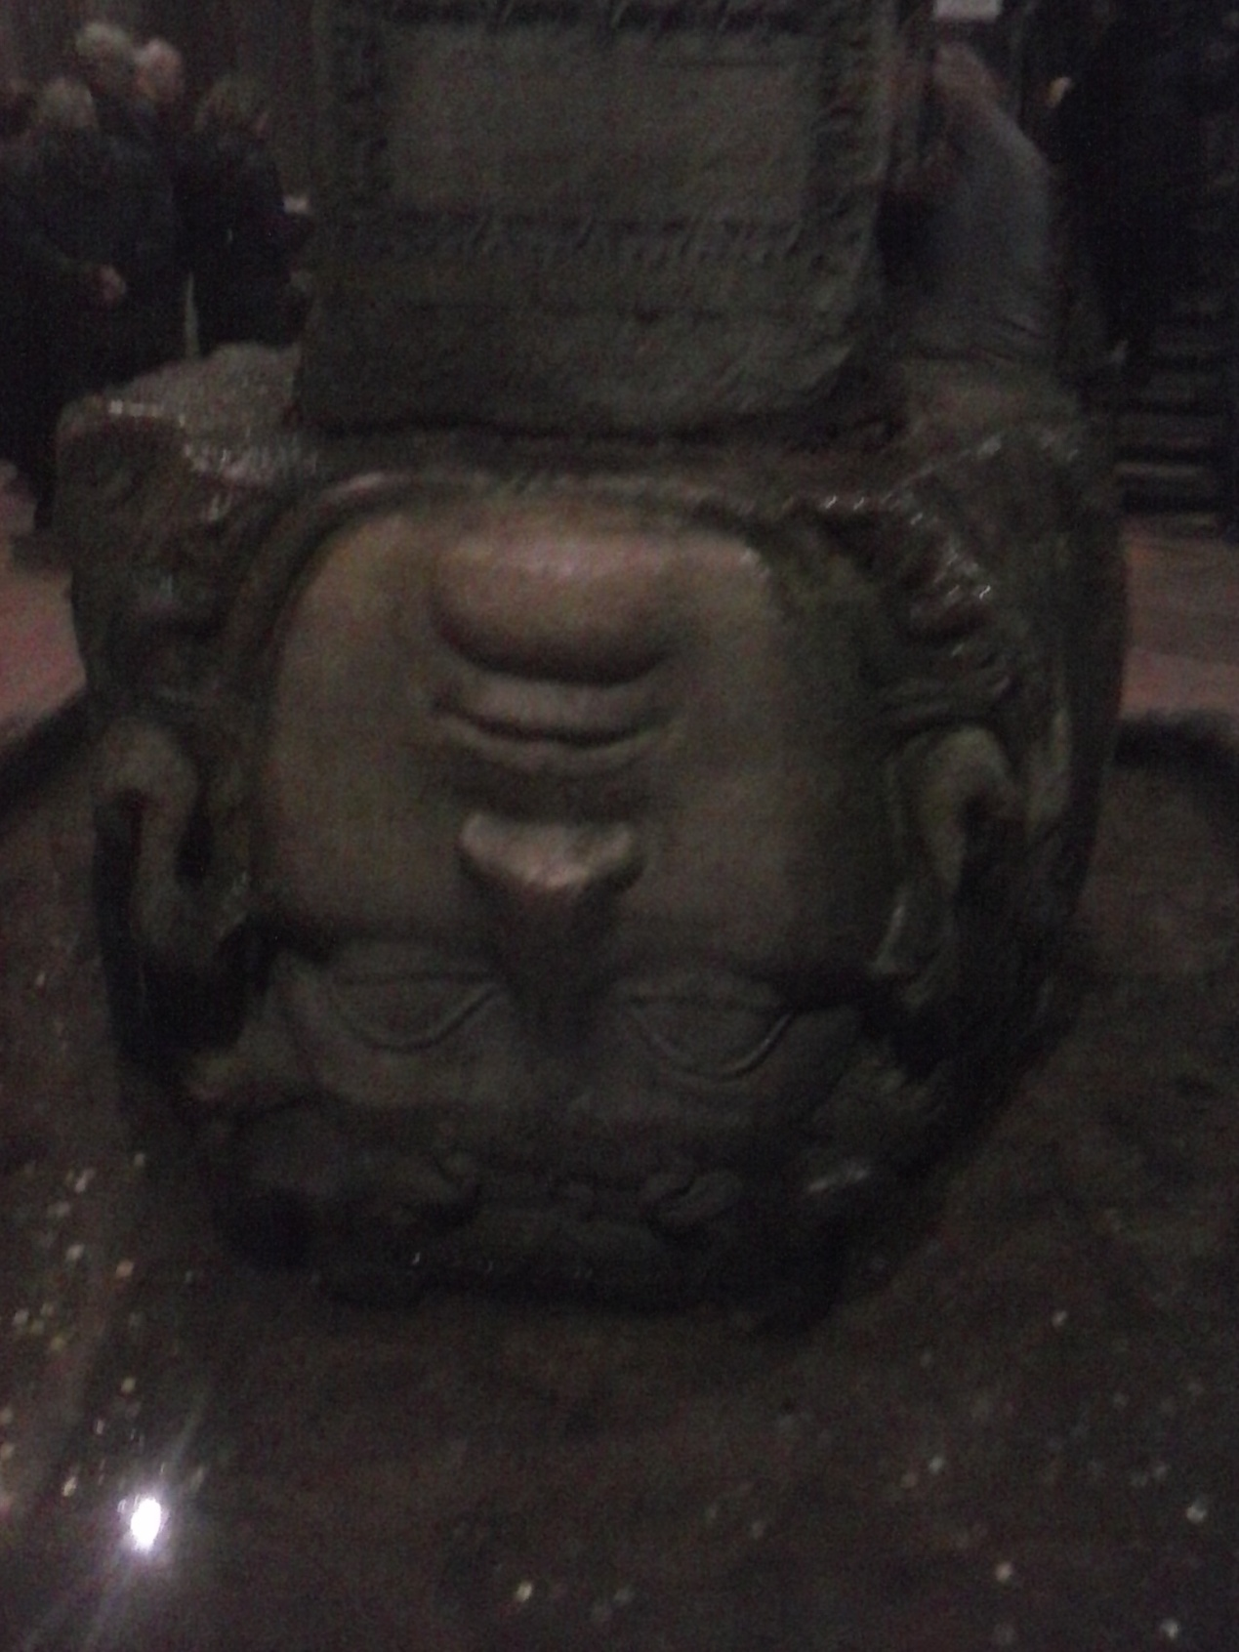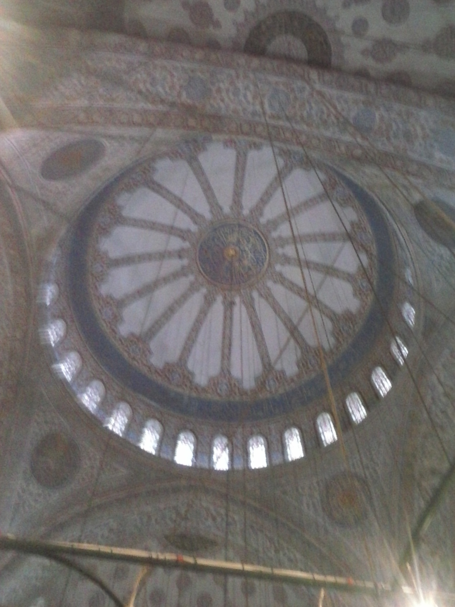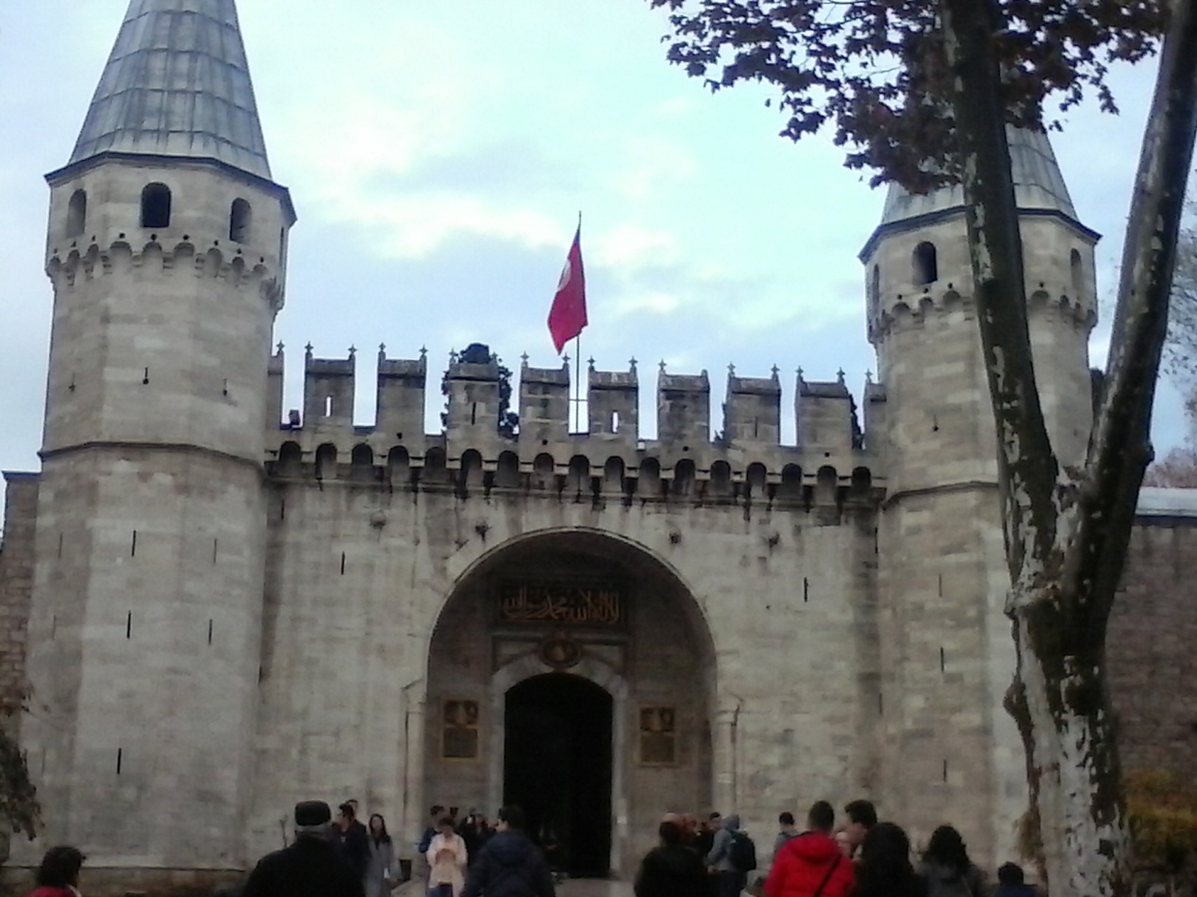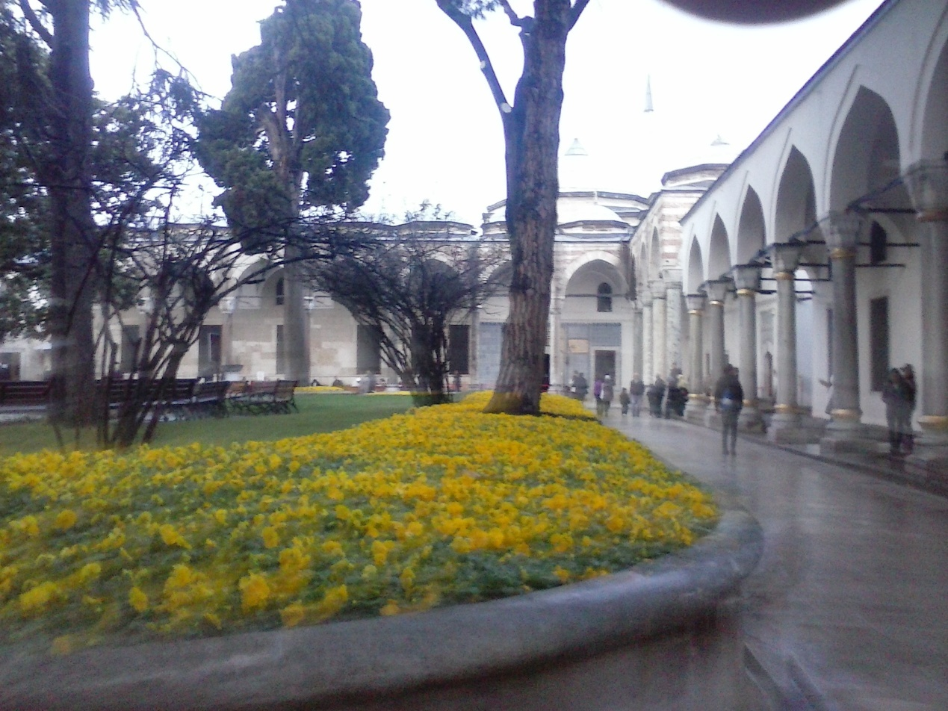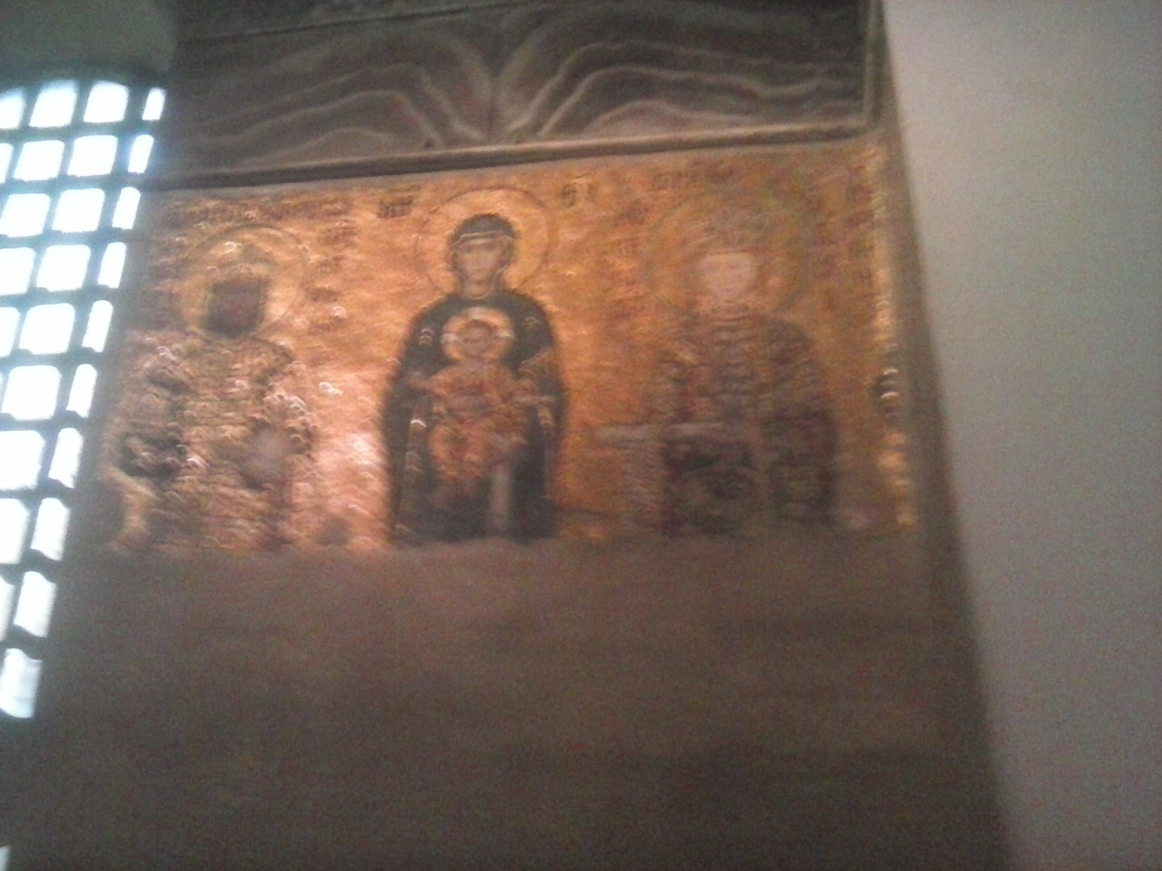
gggjjdjdjdjghg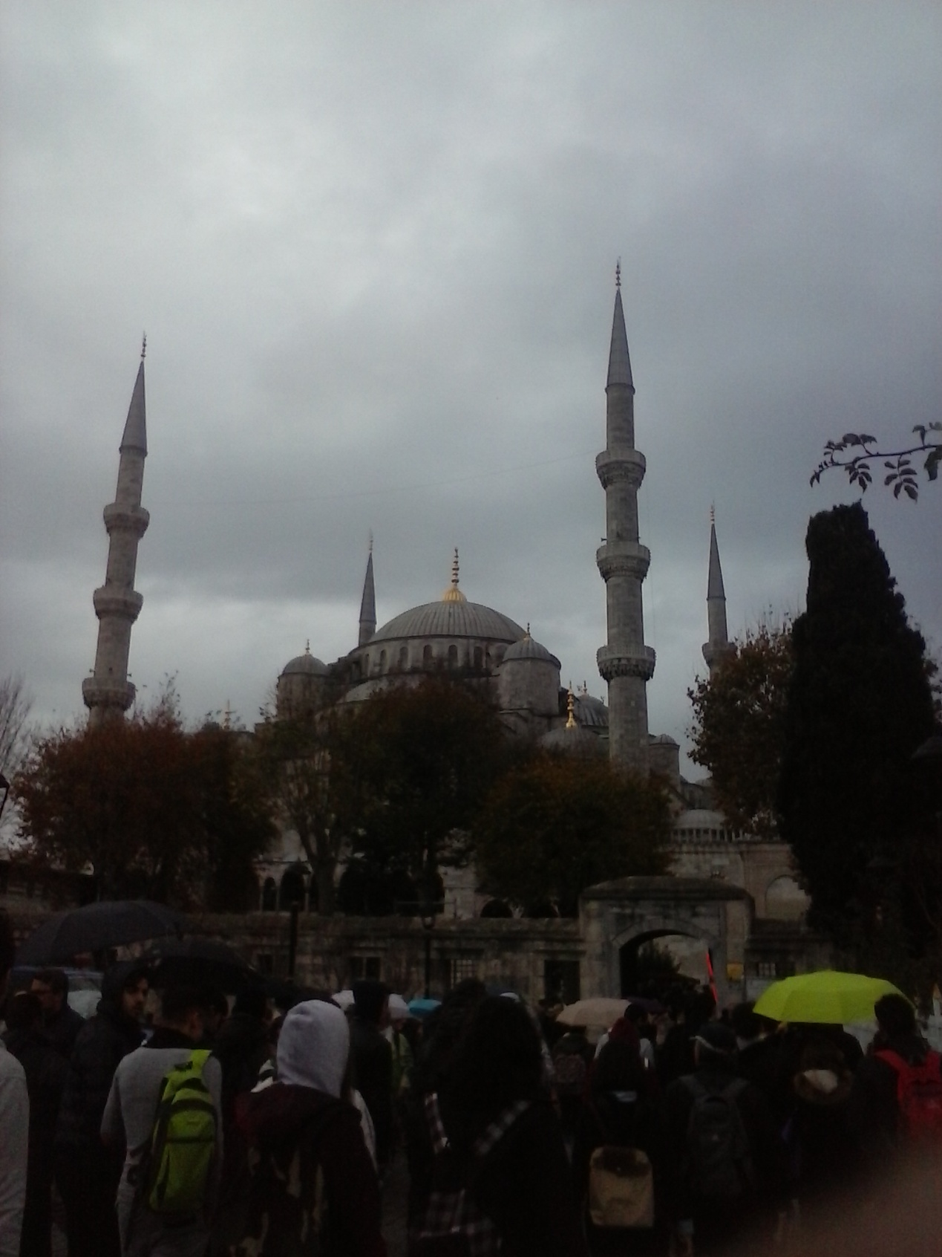

6TH DAY 27 NOVEMBER
At our 6th day in Istanbul we first visited very early in the morning the maiden tower which was a very special (observatory for the sea) and also had a very amazing view as it was in the center of the river. After that we went at camlica hills in order to see this spectacular view that faces the whole Istanbul as these heights are very high. We also ate there at some local restaurants in order to have energy for the rest of the day. Furthermore, we visited the war museam of Istanbul , then we visited TAKSIM square which is at the centrer of Istanbul and it is full of shops to buy whatever you want. At the end of the day, the Turkish students had prepaired a surprise party at their school which was just amazing for our last day in Istanbul. 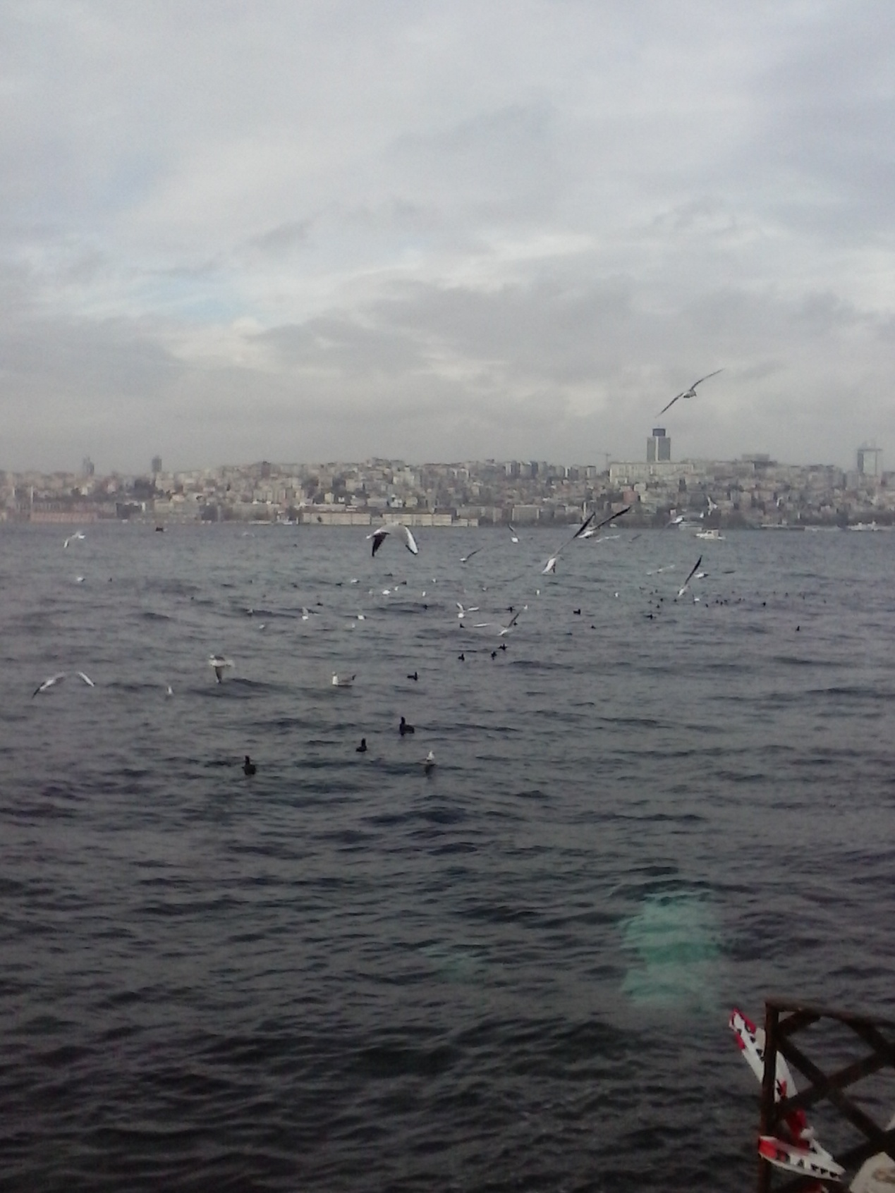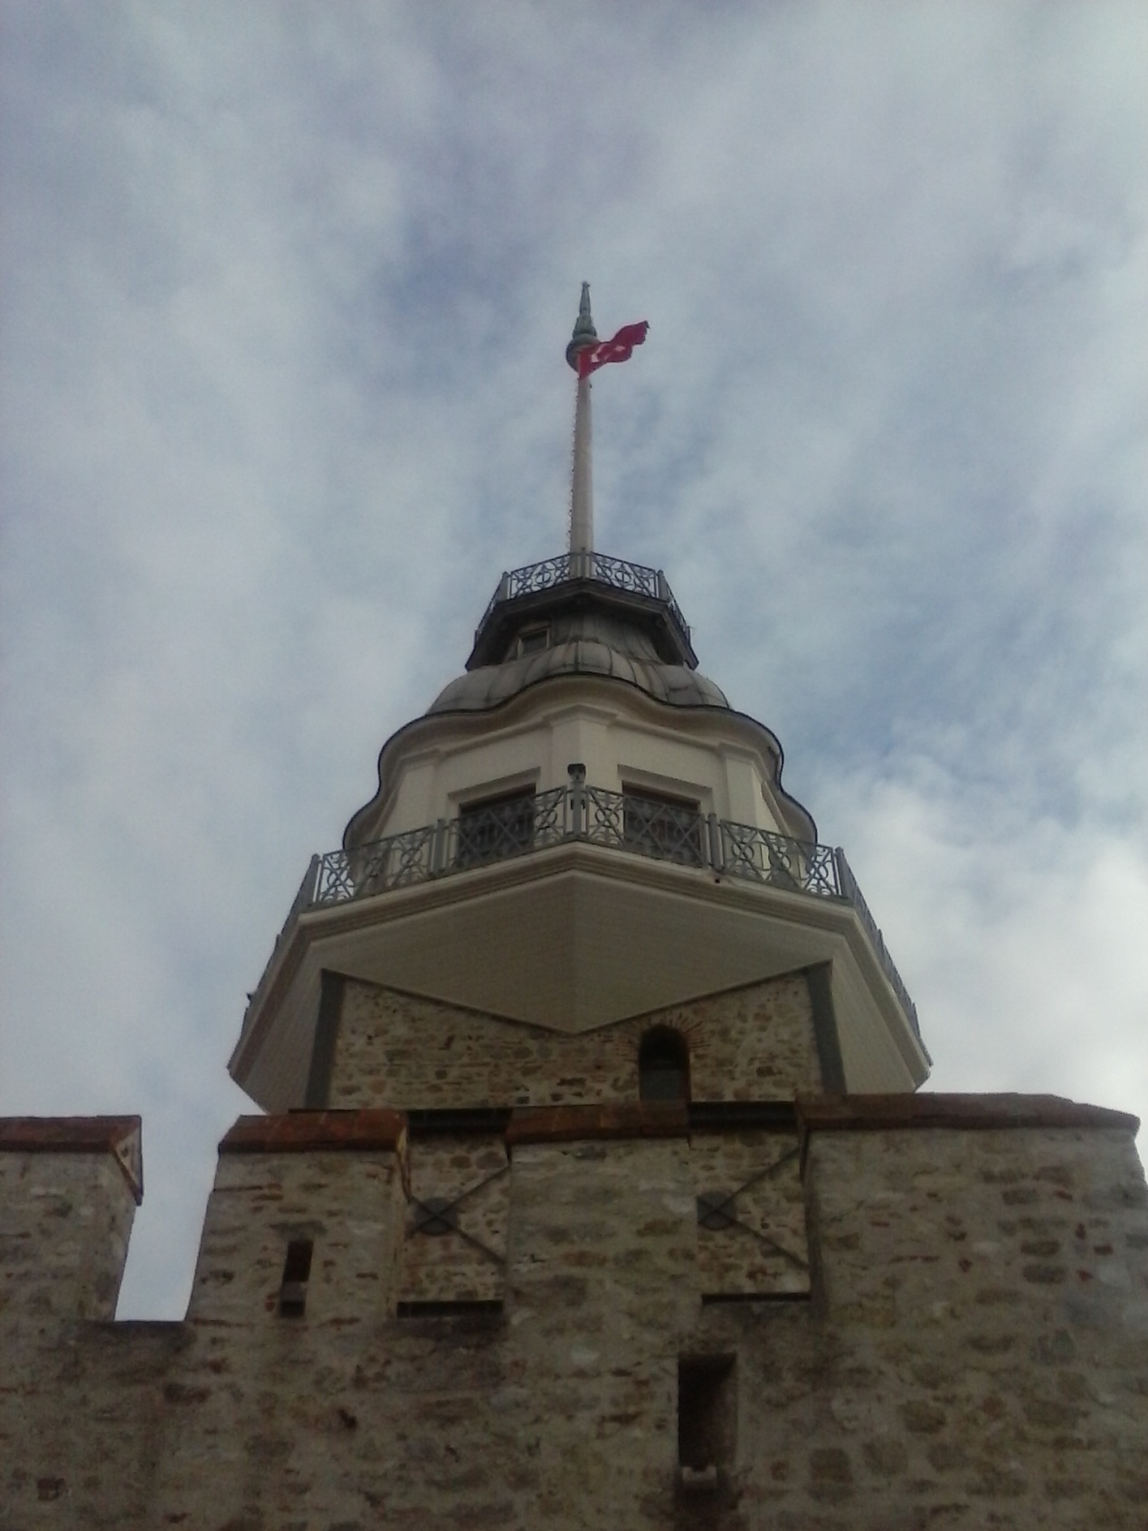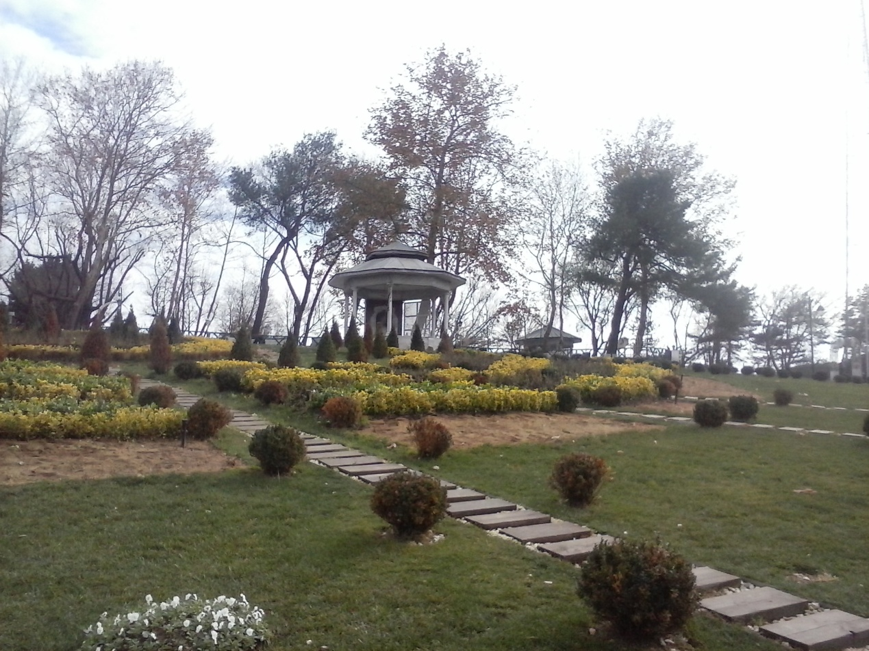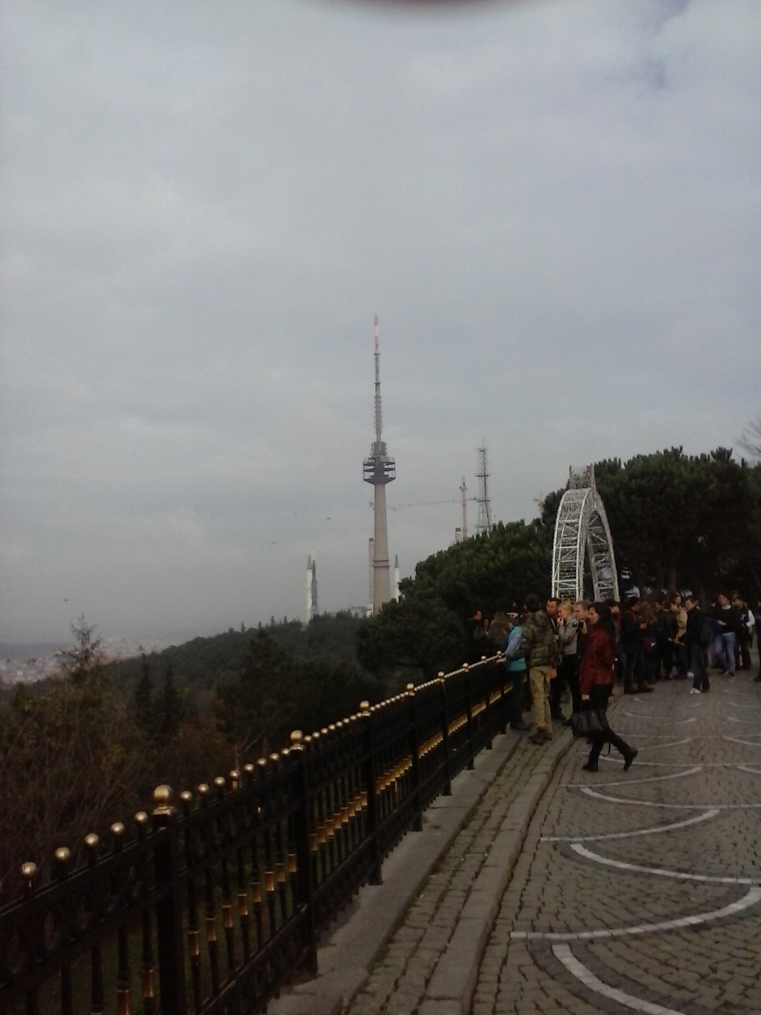 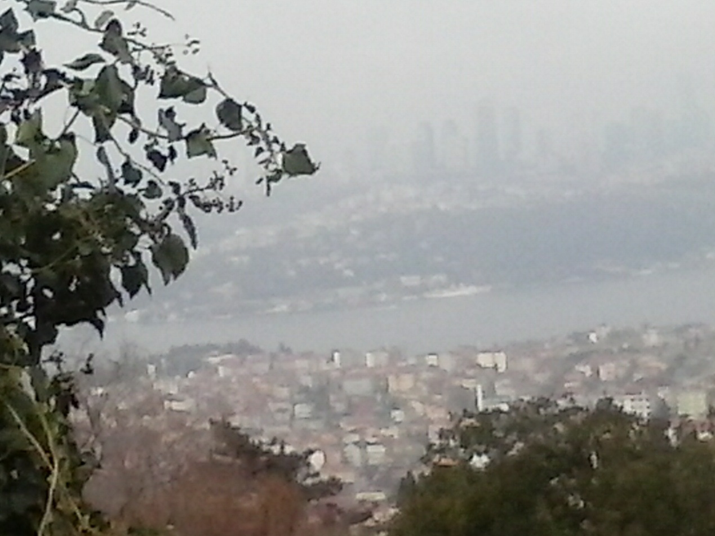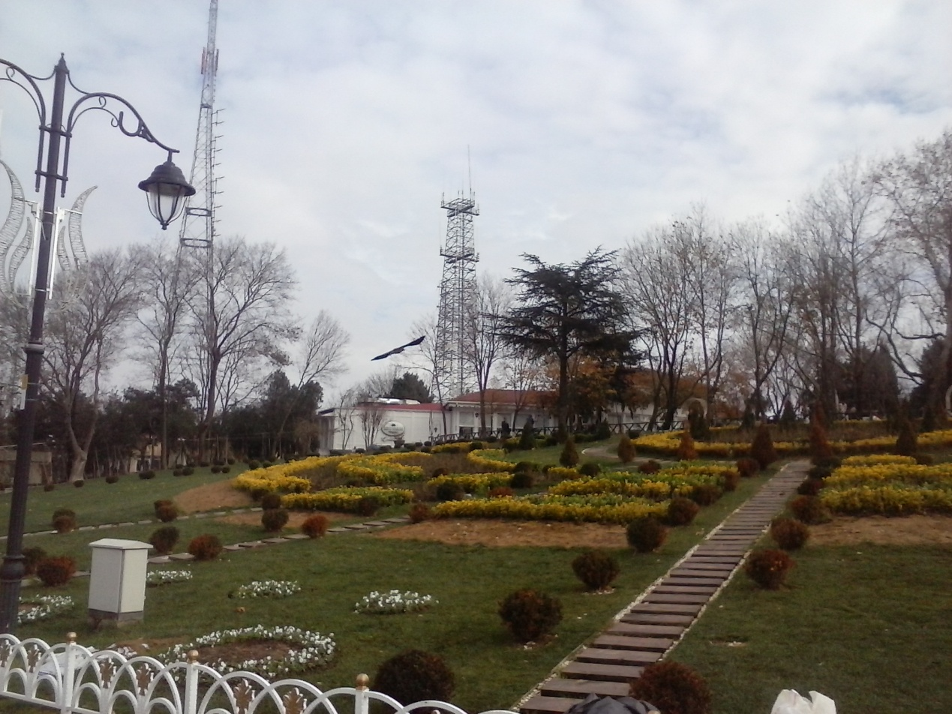

7th day 28 NOVEMBER
Our last day at Istanbul….. (we all were very sad) it was just an amazing week that will stay in our minds. We went at the Turkish school very early at the morning to see our friends for the last time and to say goodbye to our host families. THIS TRIP WAS JUST AN UNFORGETABLE WEEK FULL OF INTERESTING THINGS TO DO AND SEE THAT WE WILL REMEMBER FOR EVER!!!!!!!!!!!!!!  