Erasmus +
8 - 14 February 2015 : Meeting in Greece
Sunday was the first day of the meeting. We were waiting at the hotel for our friends to come.
My parents welcomed my friend and had cooked many special dishes for the occasion. I was very happy but embarrassed to see him.

After two days we had become good friends and we went together to Nafplio and Mykines. We had a great time there because we were all the groups together and we had fun.

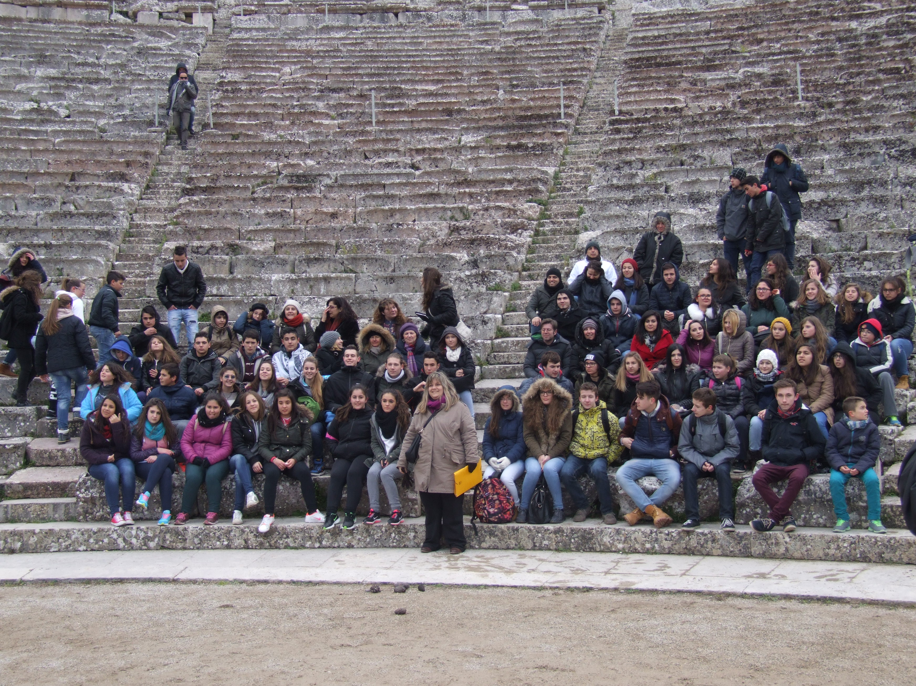

The best day was Thursday when we had a party with all the teachers and the delegations together and we were dancing and singing.

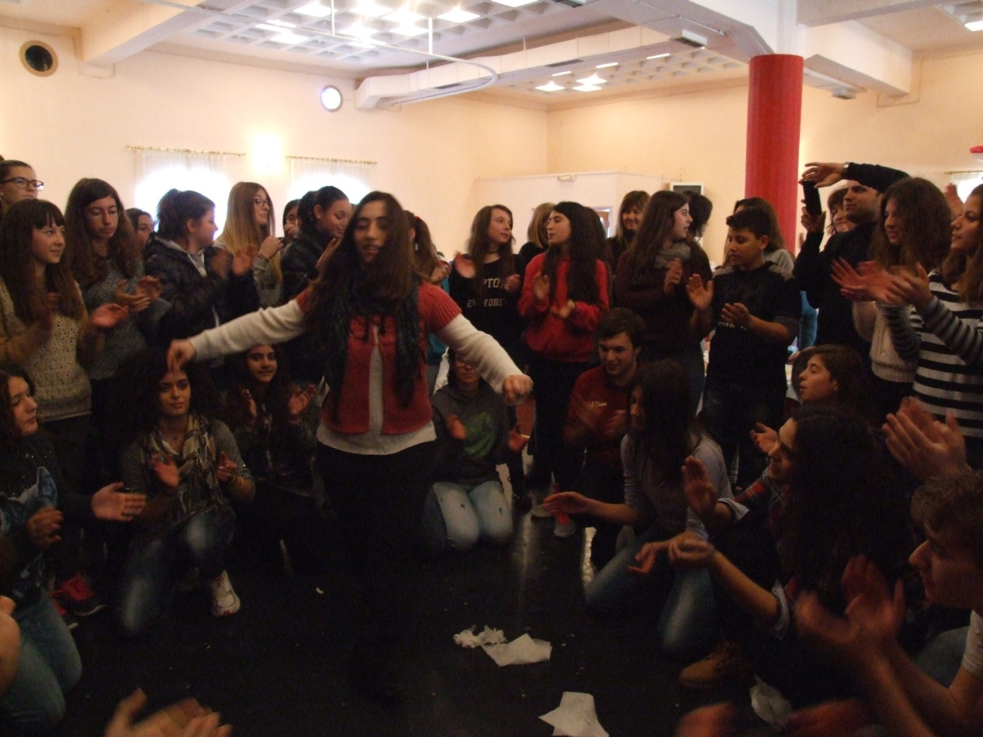

The last day was Friday when we were all sad and we were crying because our friends were leaving for Athens. We were unhappy and we didn't want to separate. Finally our friends left and we were standing there thinking our good memories.

Anastasia Papadimitriou, Greece

