Erasmus+ Activity jurnal Turkey
Daniilescu Costin Mihai
First day 22.11.2015
I arrived at school,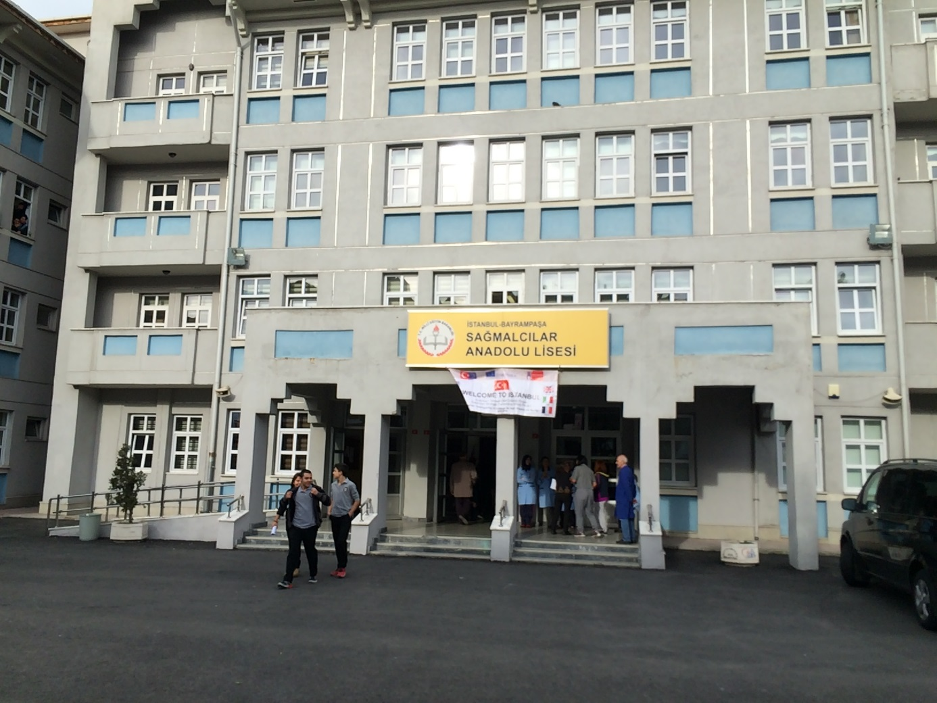 with others , I met my host and went to home.
I met his family ,I spoke a little with them and after we go in Forum.
Day 2 23.11.2015
We wake up and go to school . At 9:15 we saw Turkish Folk Dances
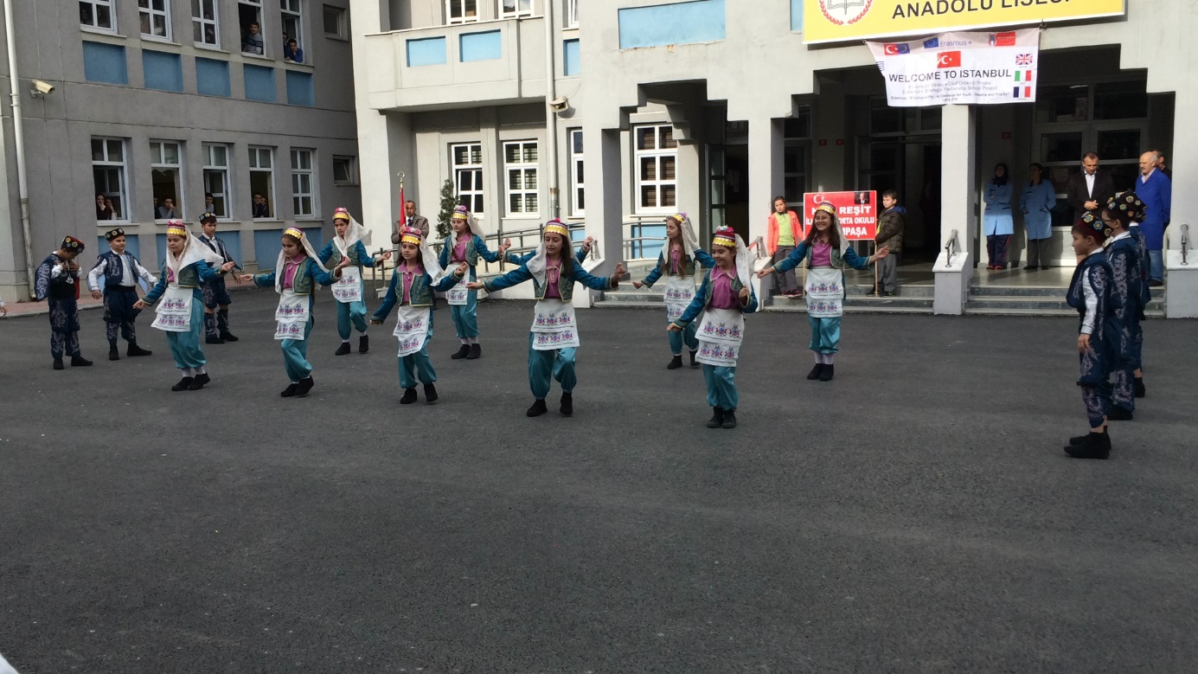
At 9:45 we go to conference room ,there we saw the presentation about school.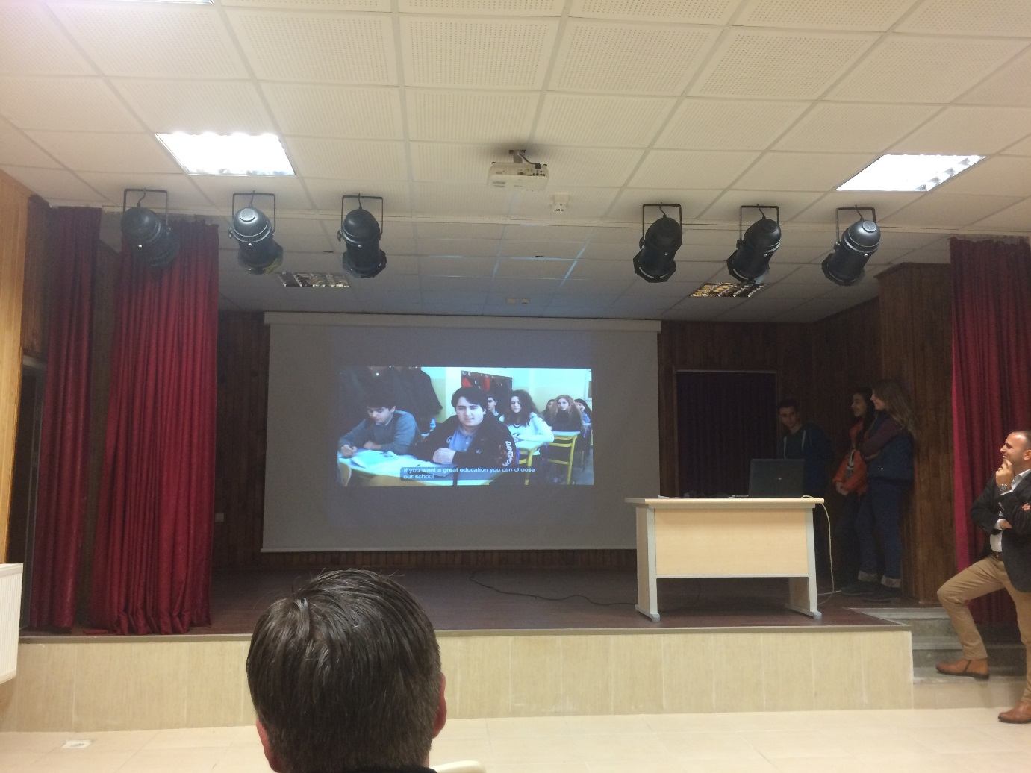
After this we had a coffee break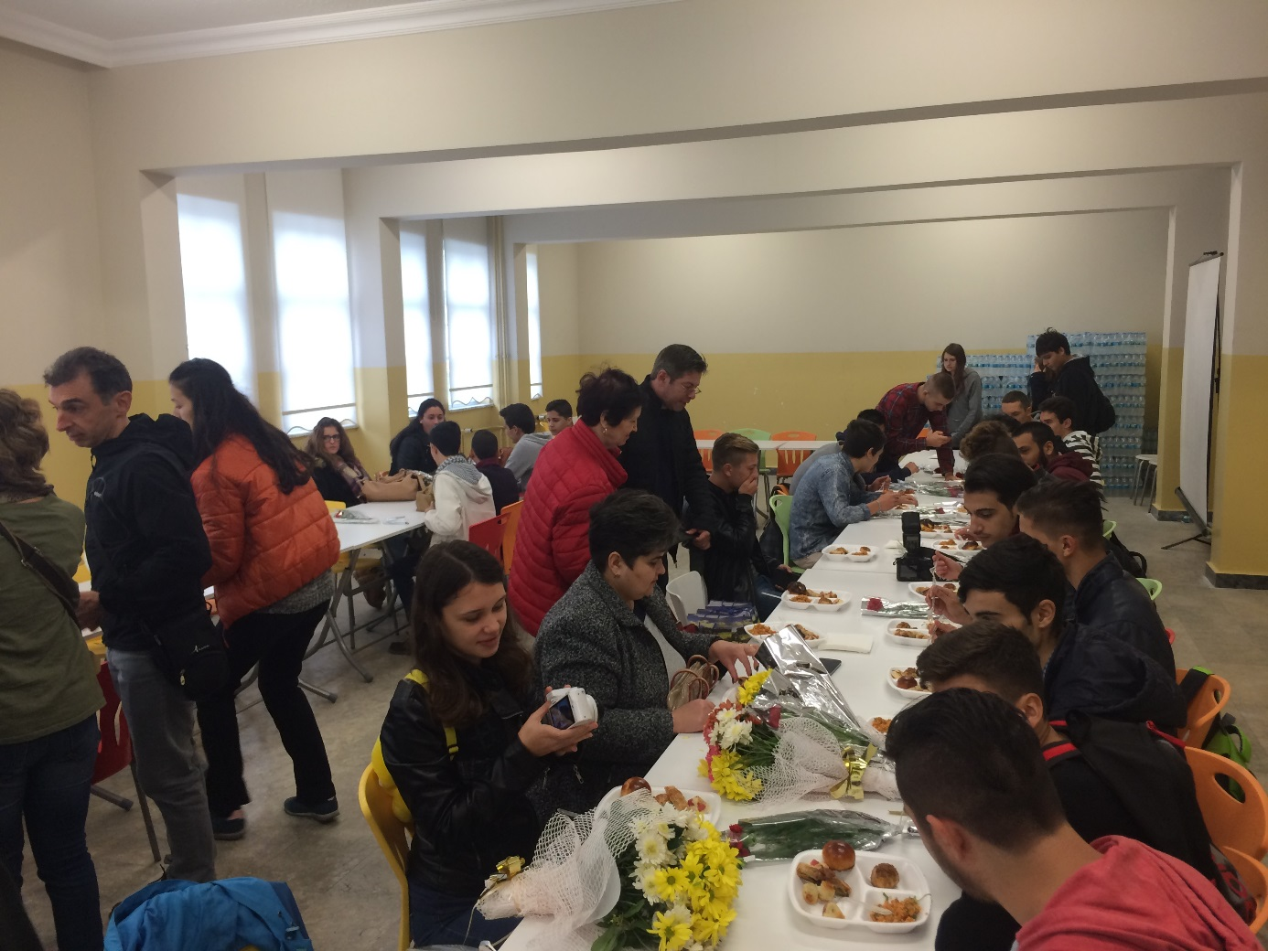 until 12 when we went to Mihnver Restaurant.
After this we visited Baygem(Workshop) at 14:00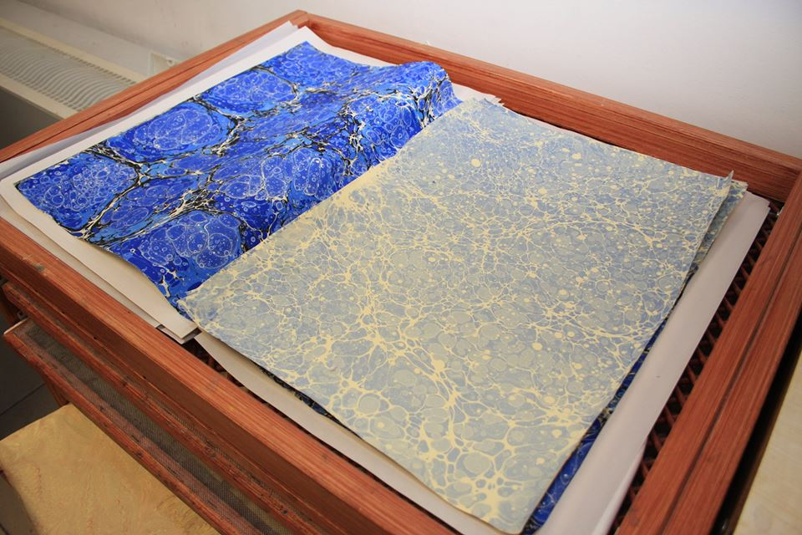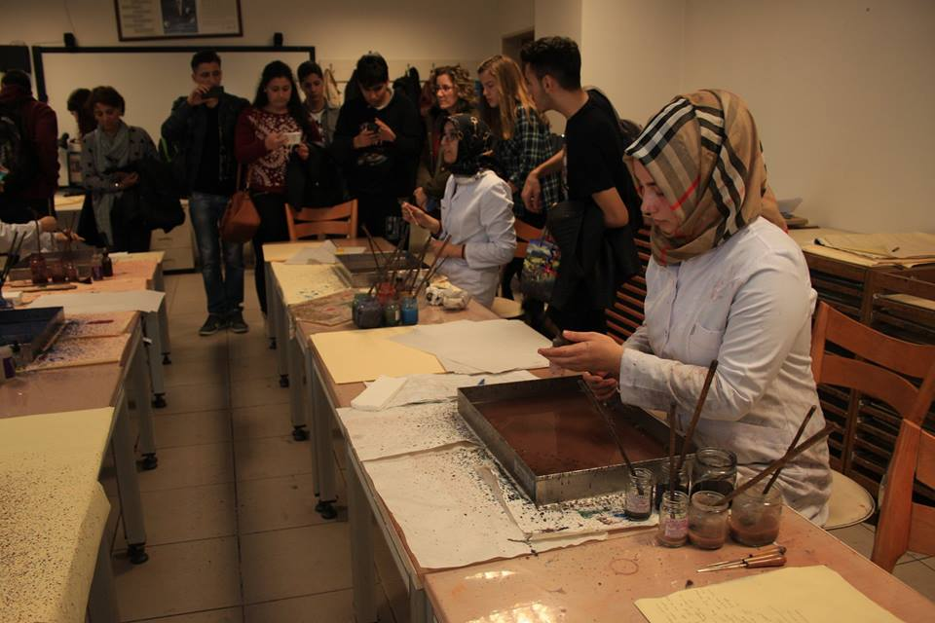
After this we went to school at 16:00
Day 3 24.11.2015
At 9:00 we went to ULKER Chocolate Factory the thirt biggest chocolate company in the word.
Unfortunately I couldn’t make pictures there …
After this we had some free time to shopping at Forum Istanbul 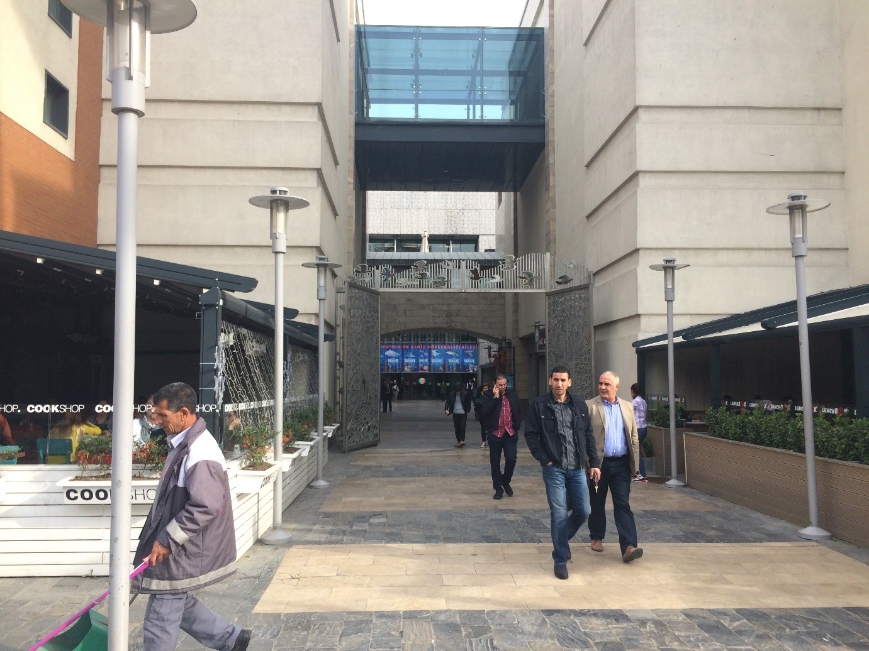
Later at 15:00 we had logo contest to decided why logo gonna be the official logo of the project , and this is the winner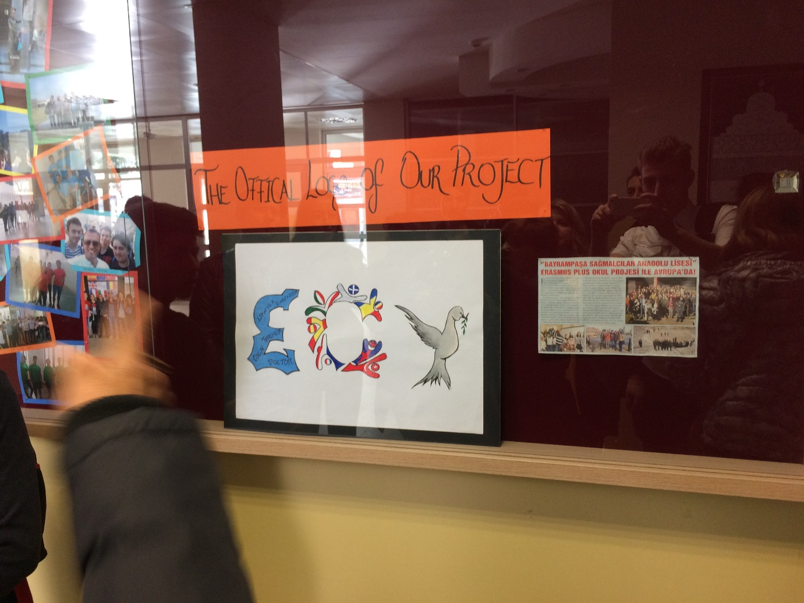

Day four 25.11.2015
This was the big day , the day when we had Drama Activity and here are some pictures:
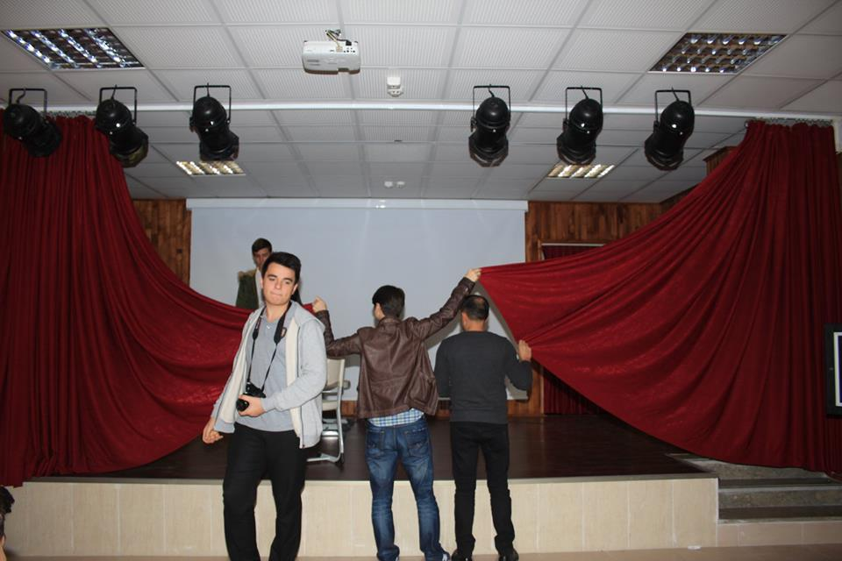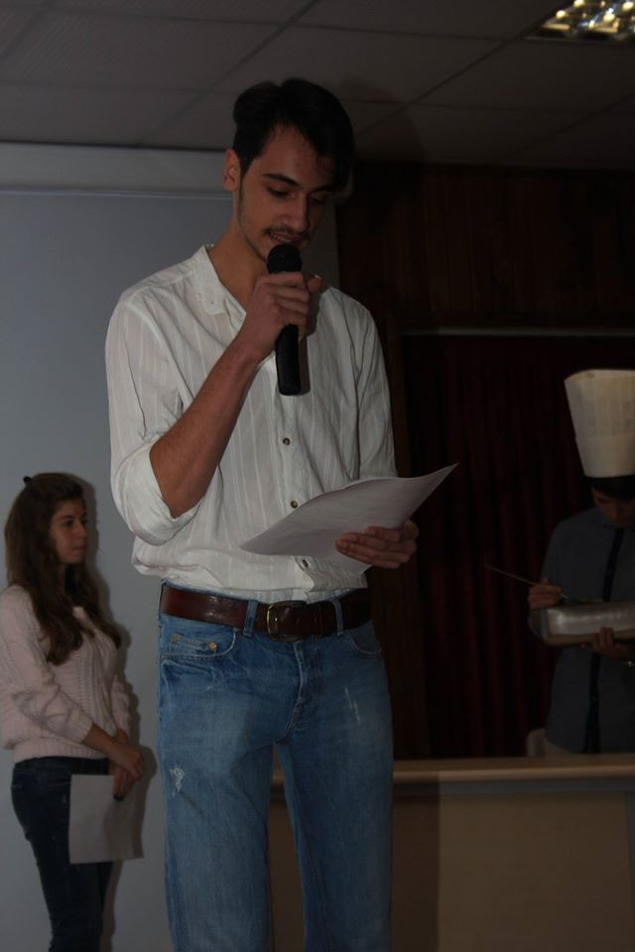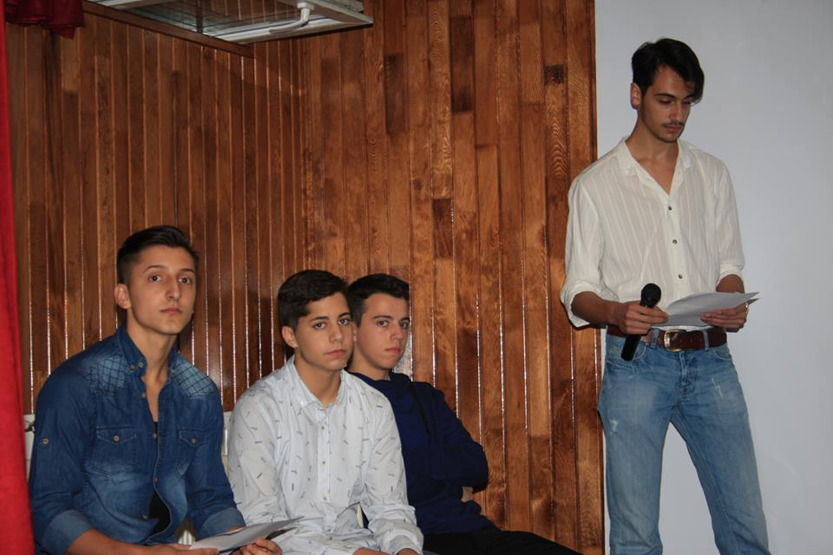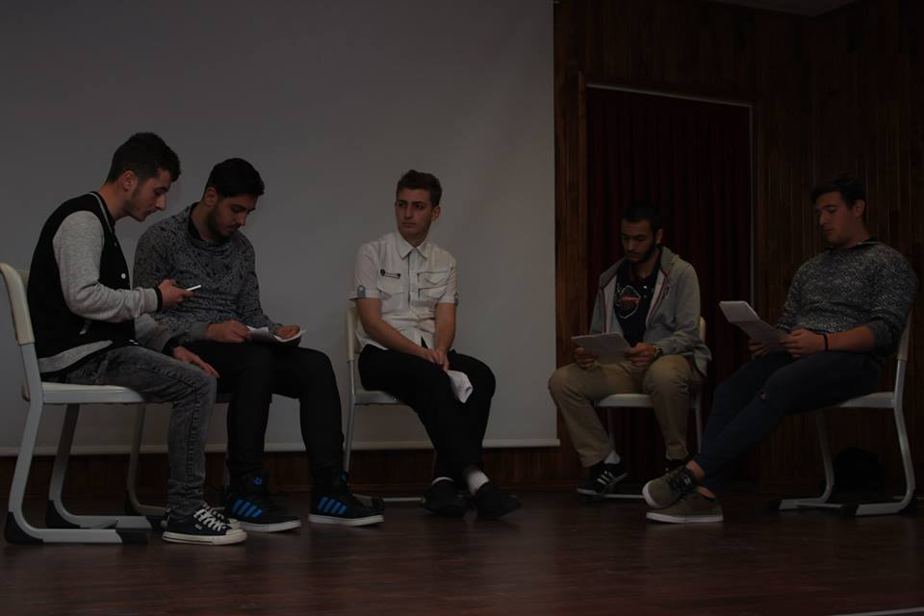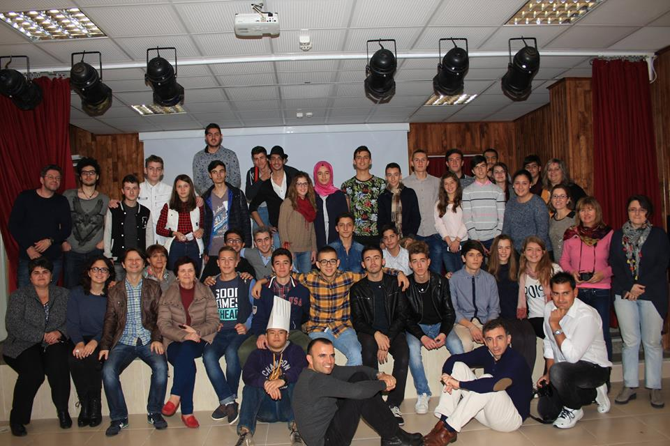
And after this hard work we went to Ramazan Bingol Restaurant,the food was so delicious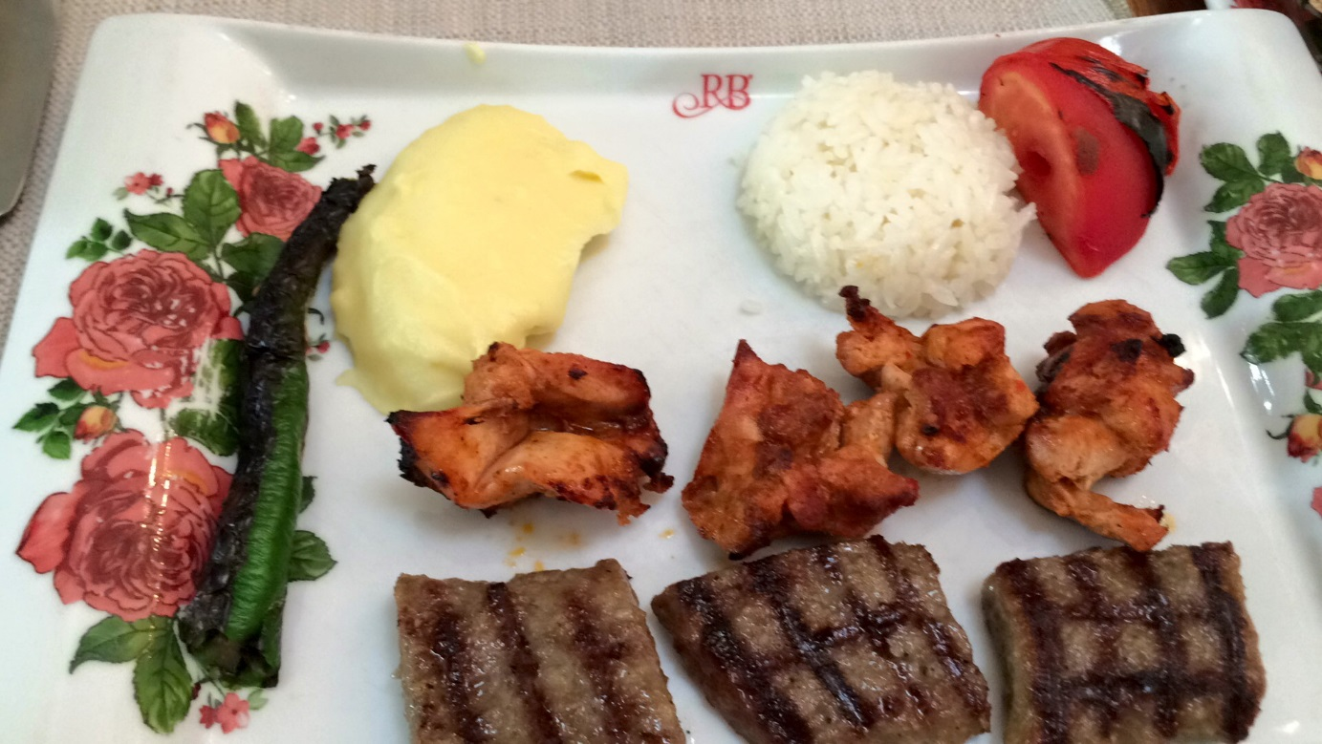
At 14:00 we visited Panaroma Istambul 2015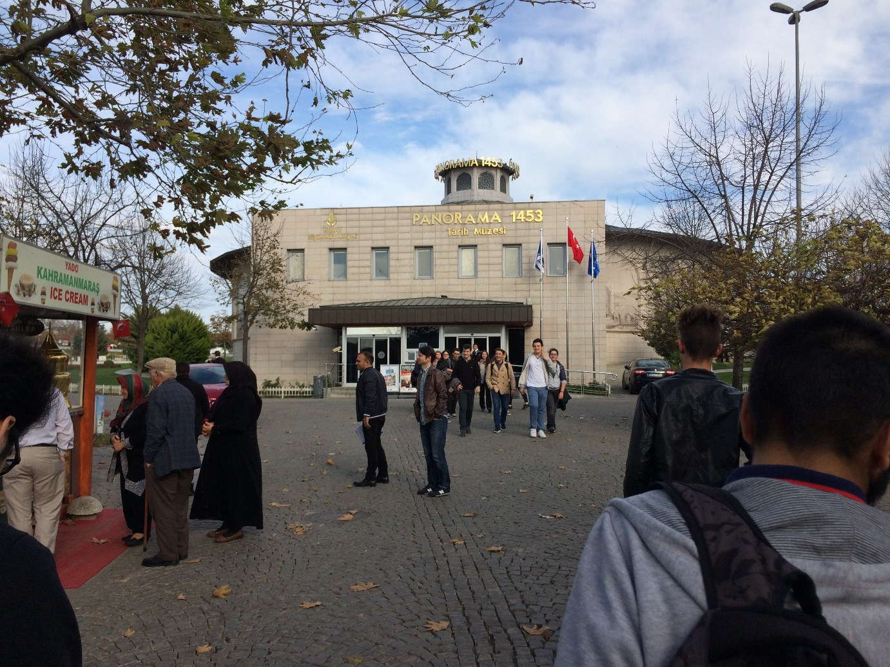
I saw there a lot of interesting things about war
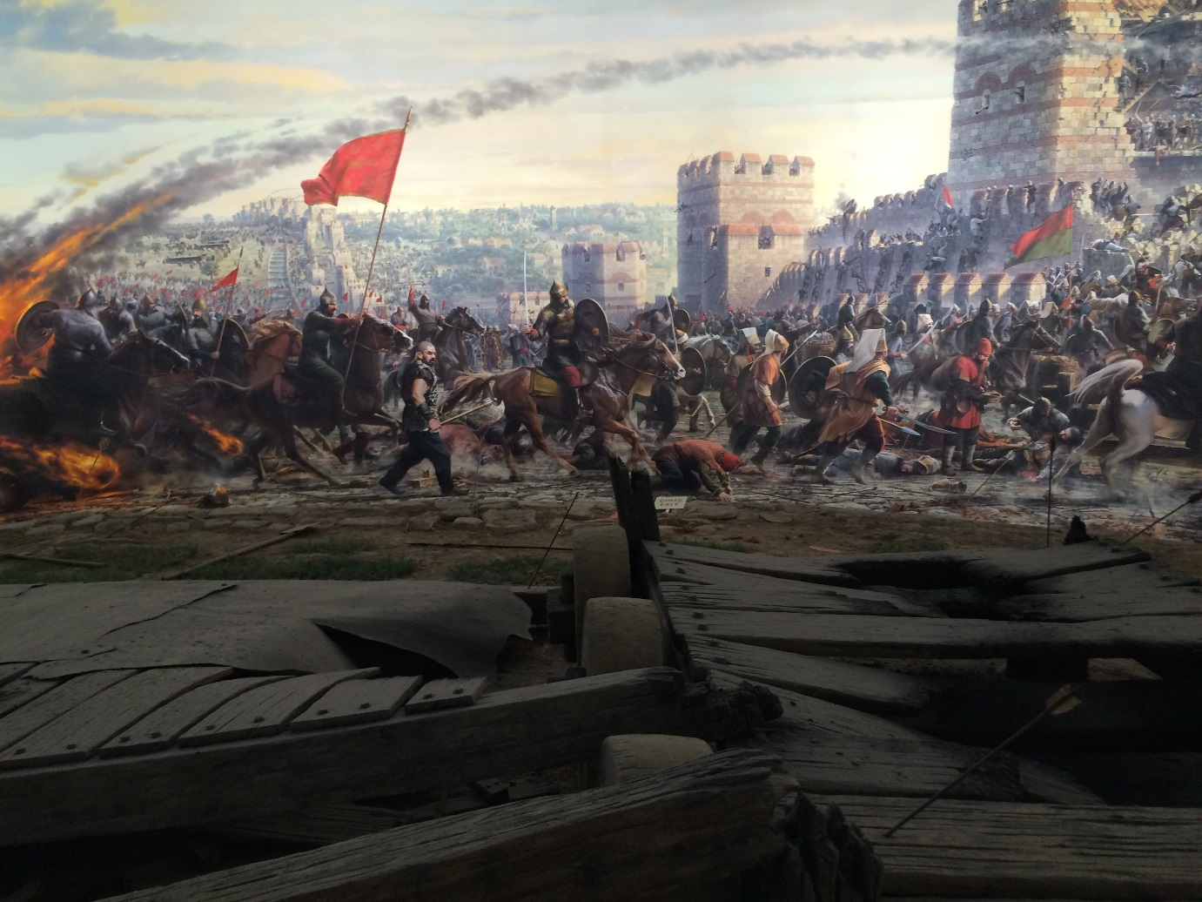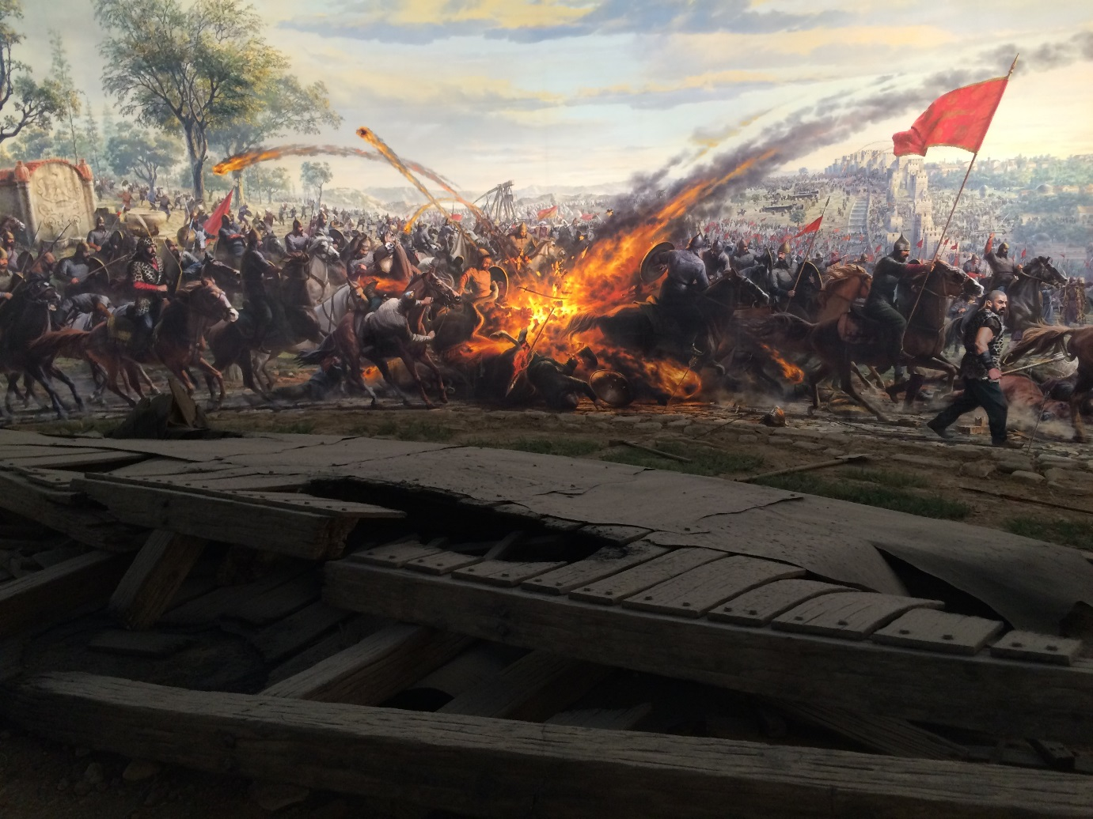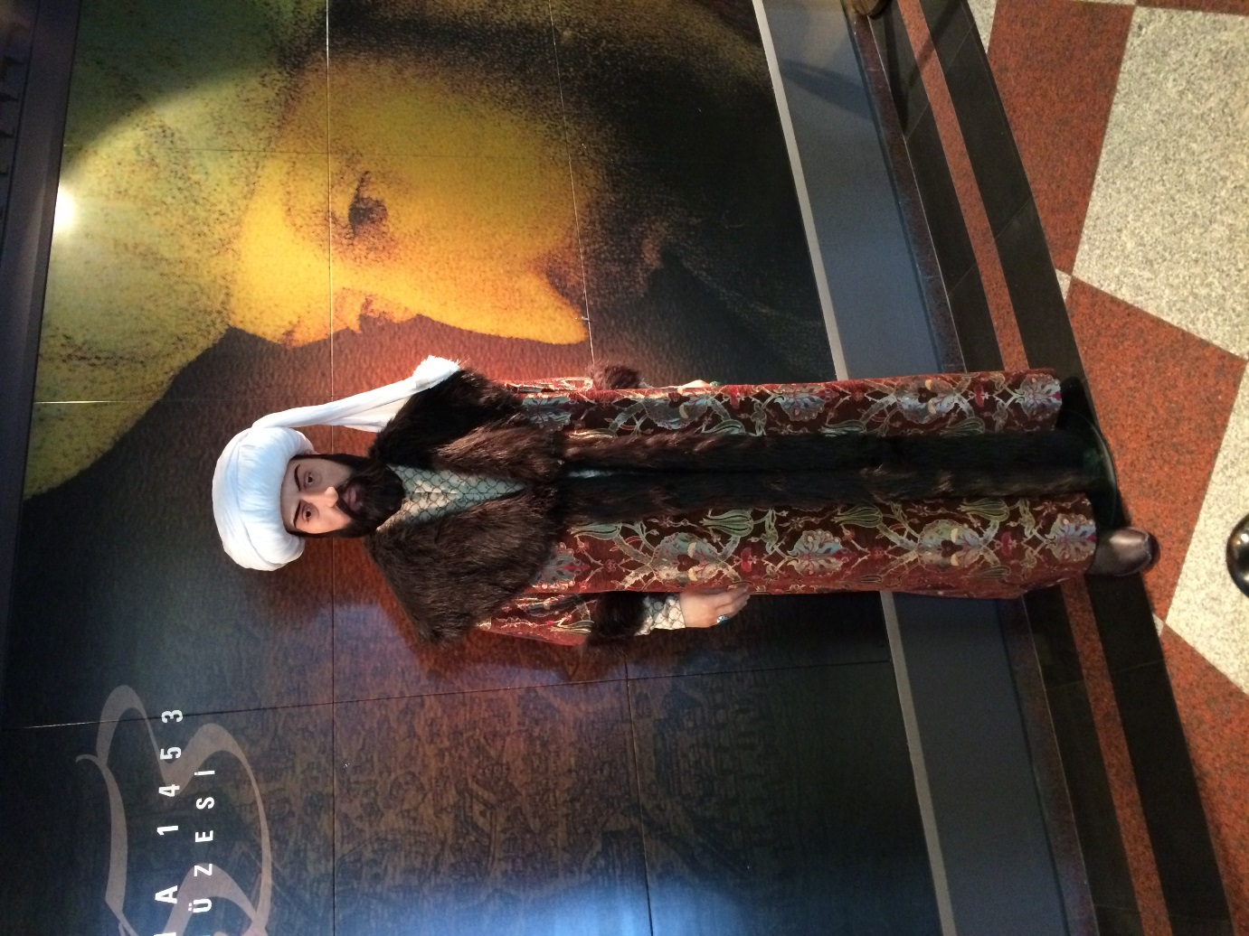

Day five 26.11.2015
This was Guide Day , we visited Topkapi Palace.
This is gate of salutation 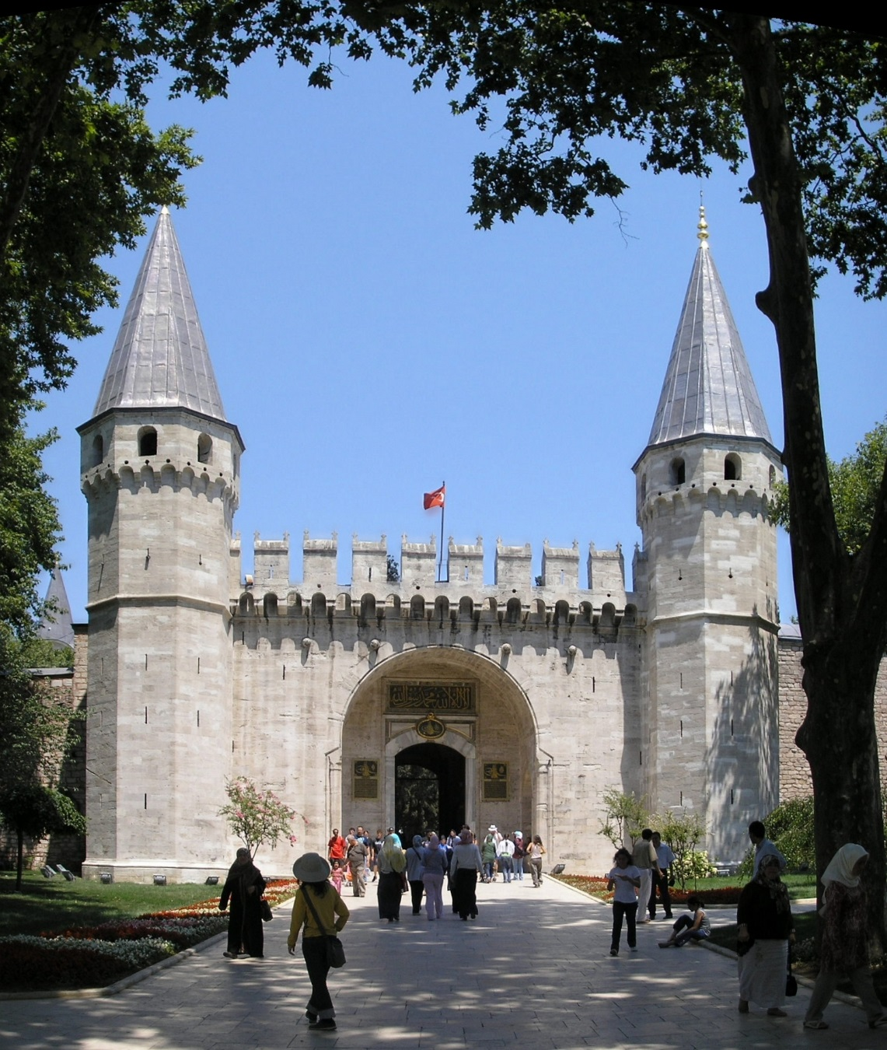
And this is from Topkapi palace garden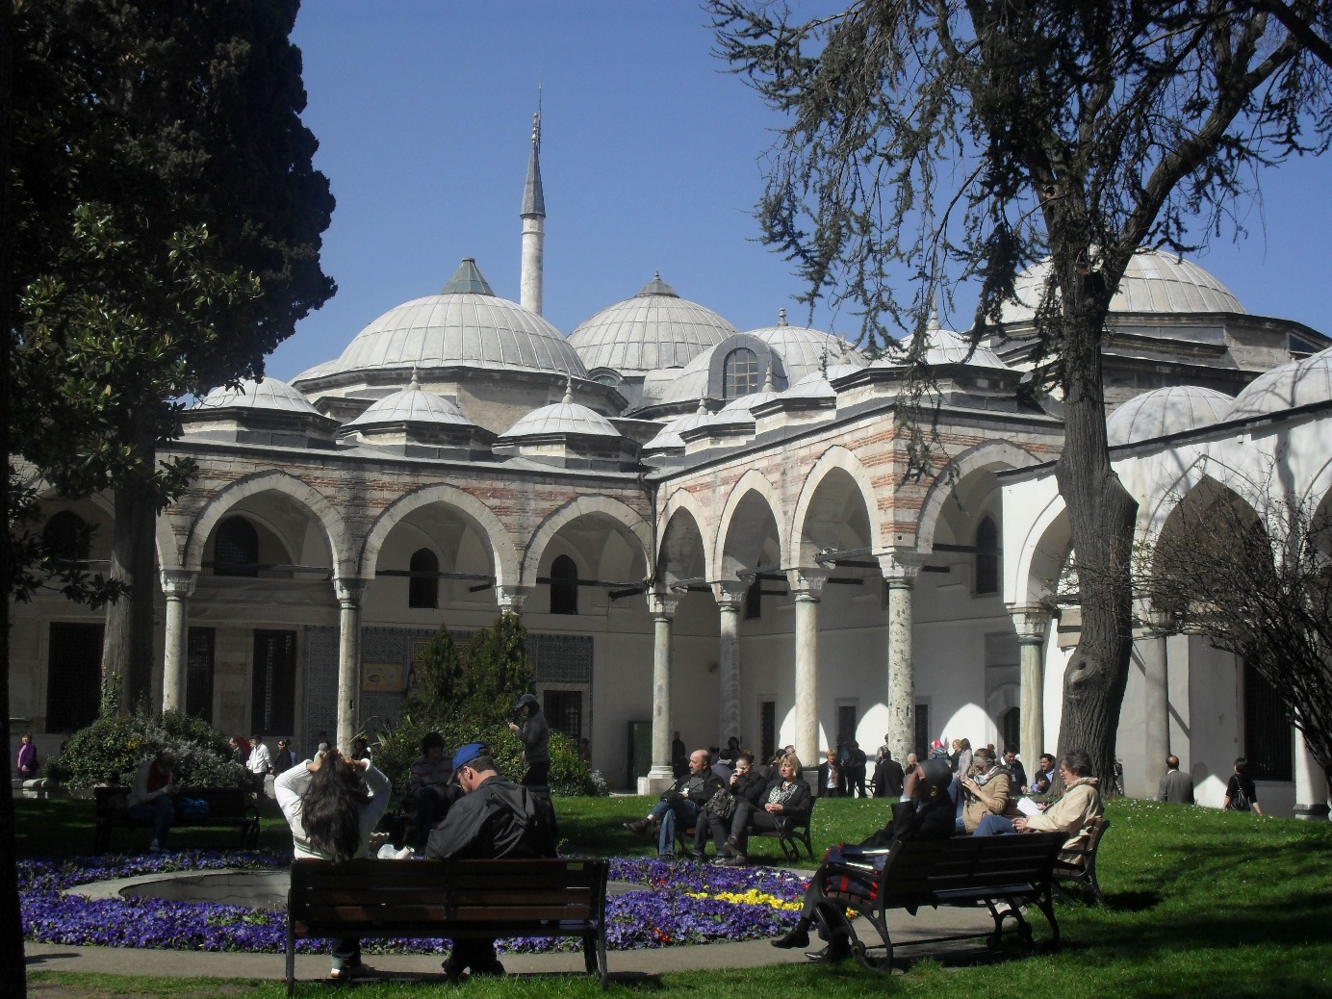
After this we saw Sultan Ahmet Mosque
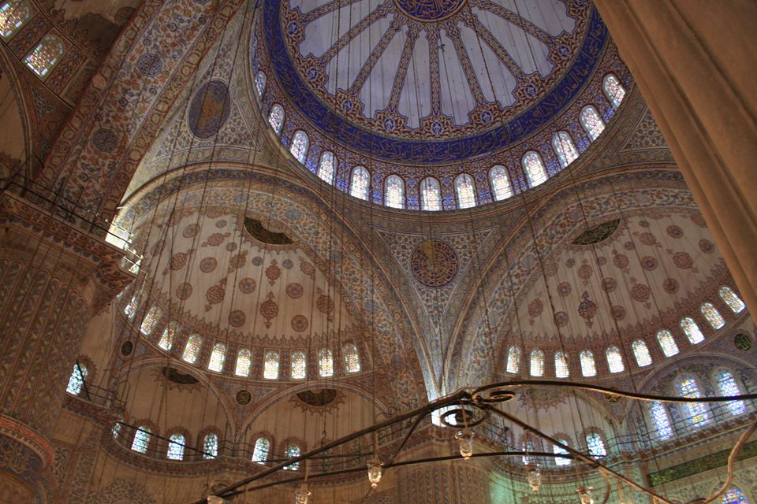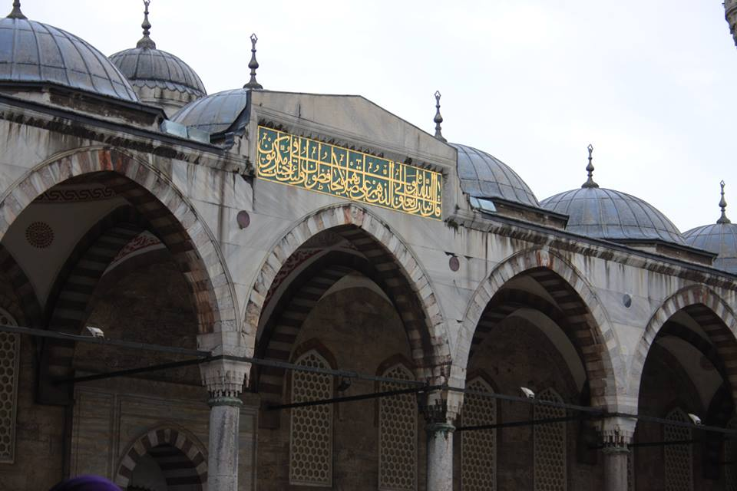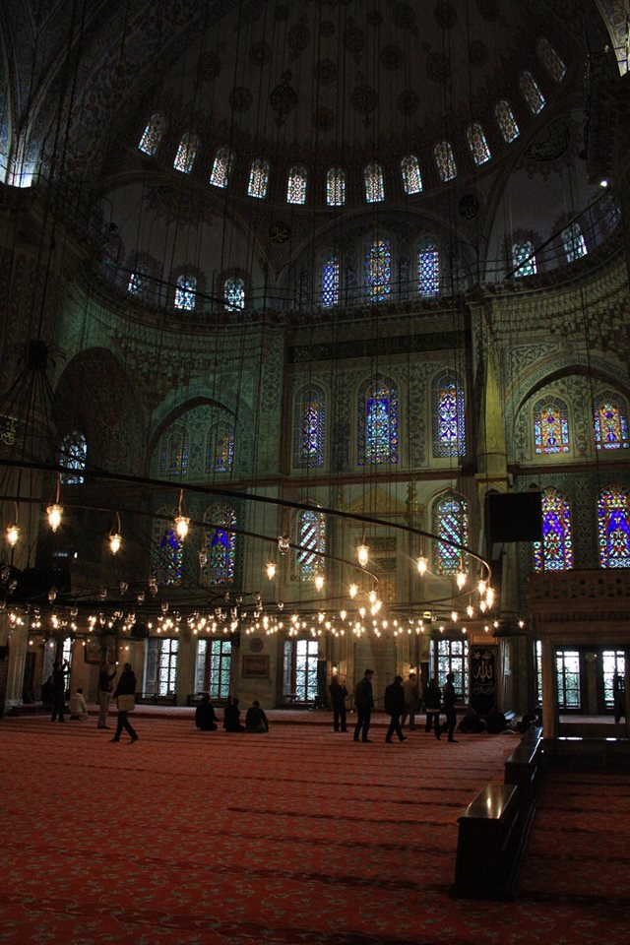
Codename know like Blue Mosque.

We visited Hagia Sophia a beautiful construction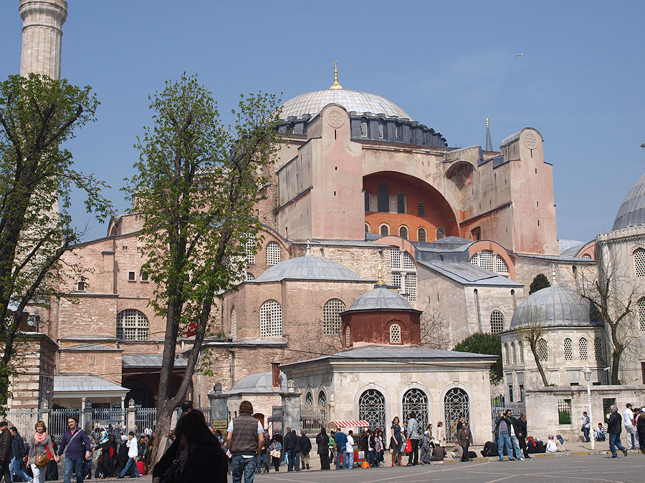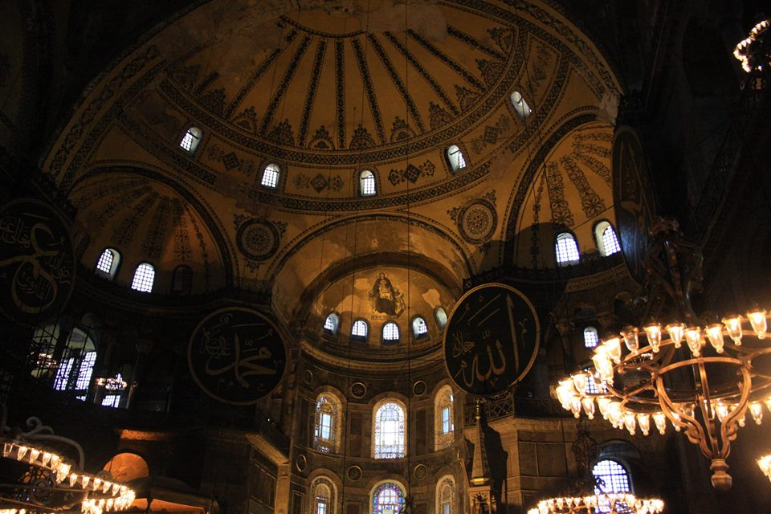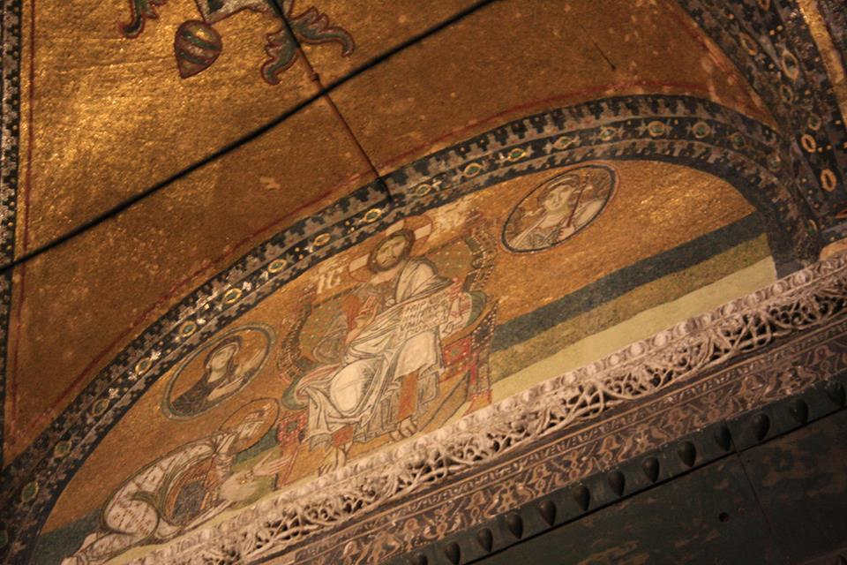

We saw some swords and armors from Suleiman Magnificent time.
This was the sword of our great Romanian Emperors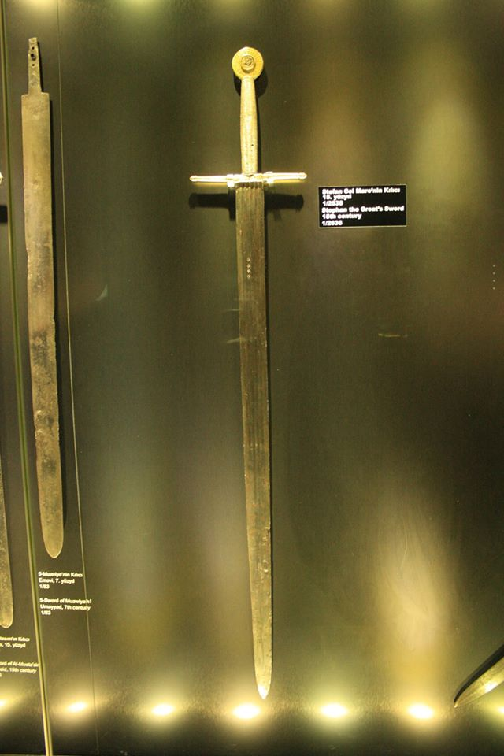
And one of his armours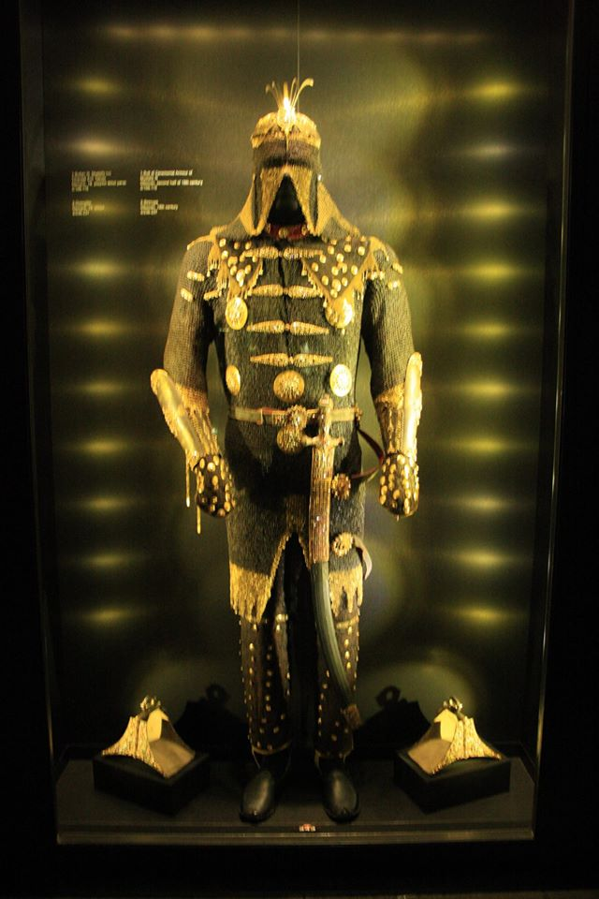

This beautiful day end with a visit at Basilica Cistern in the subway , a place used to storage a lot of water in old wars and there I learned about Medussa legend and I saw her head used to scare peoples and population.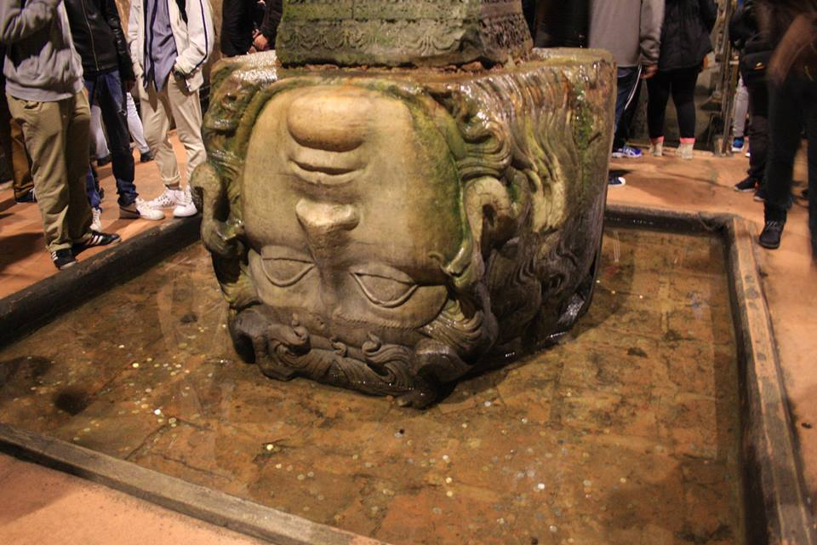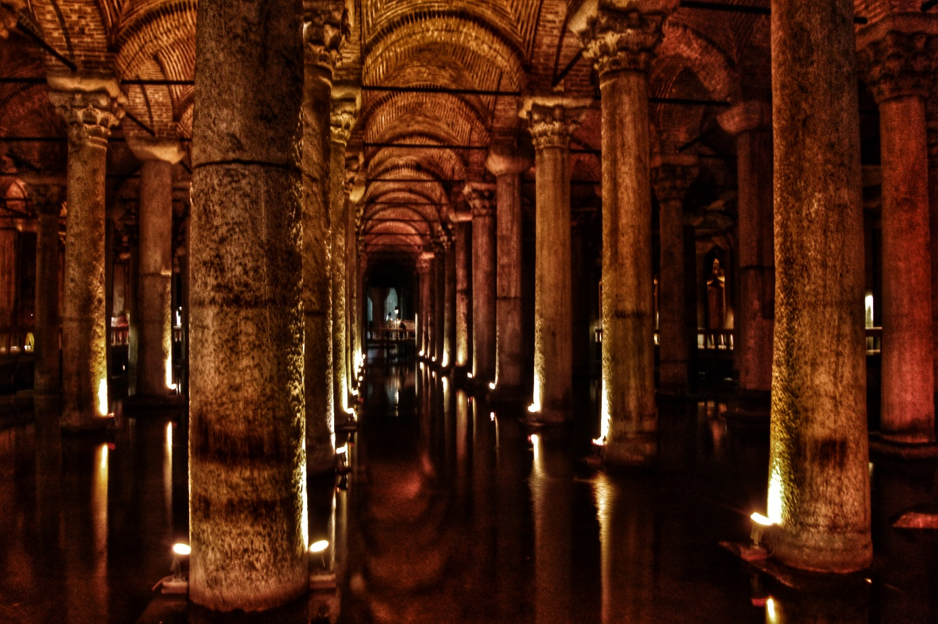
Six day 27.11.2015
We depart from school and went to Maiden’s Tower 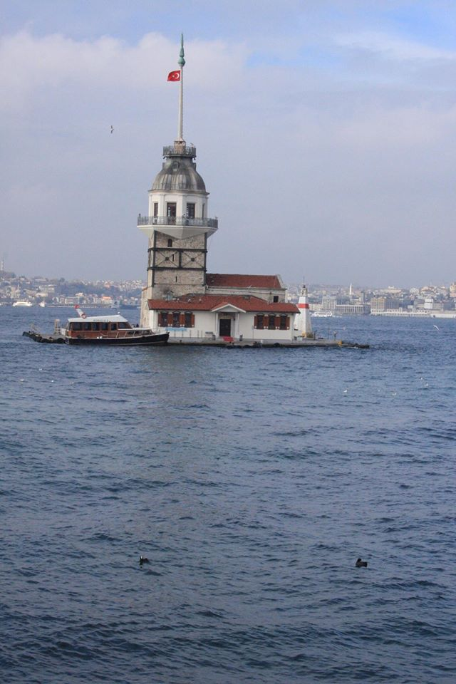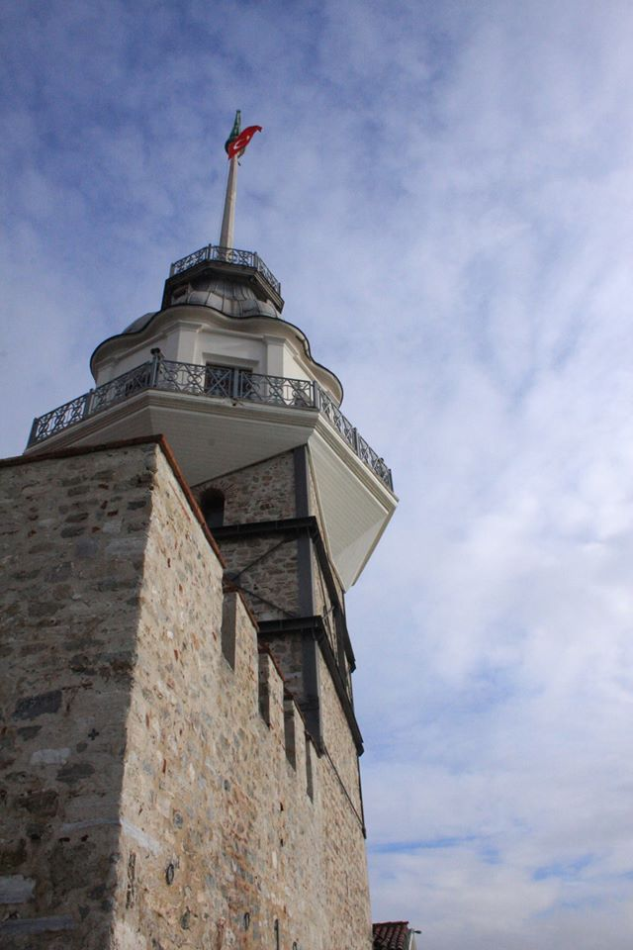
A beautiful view
After this we went to Camlica Hill there we eat to 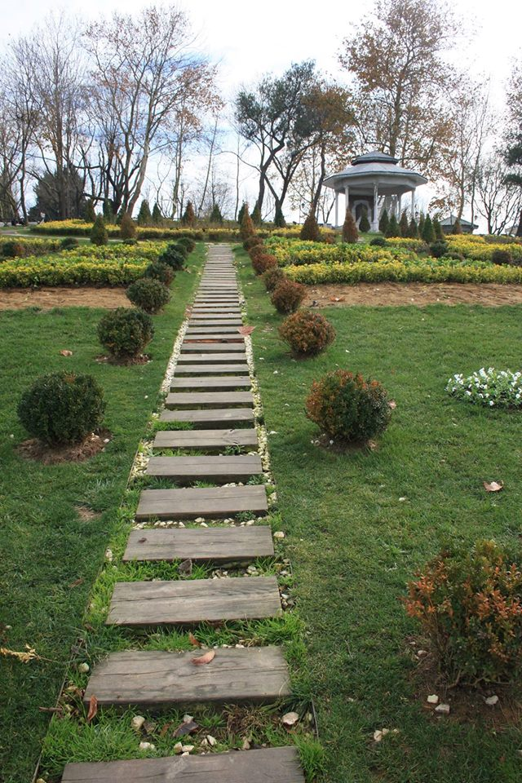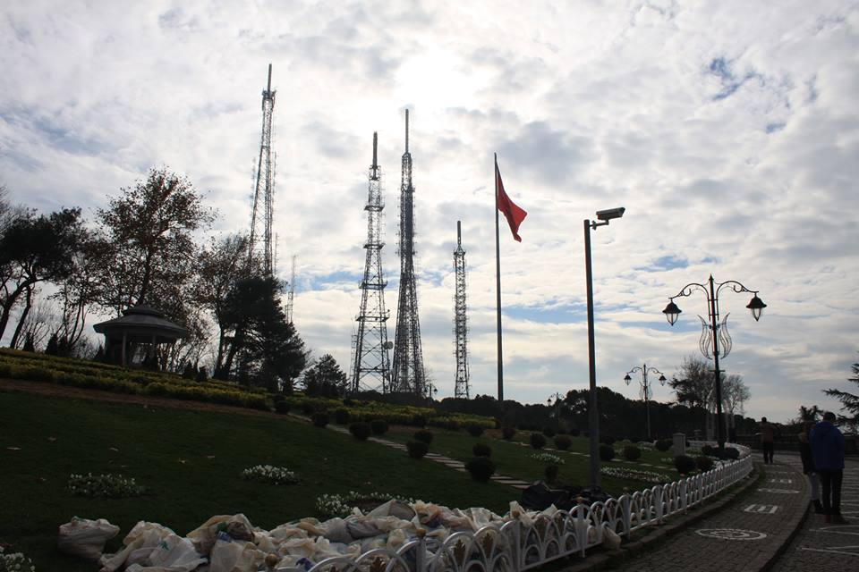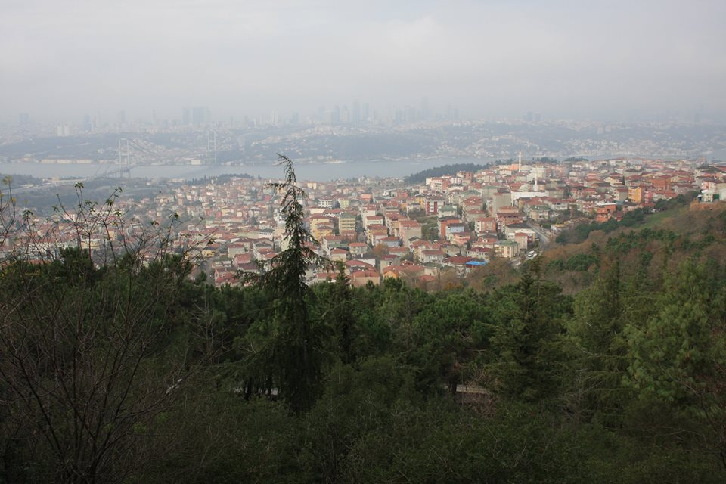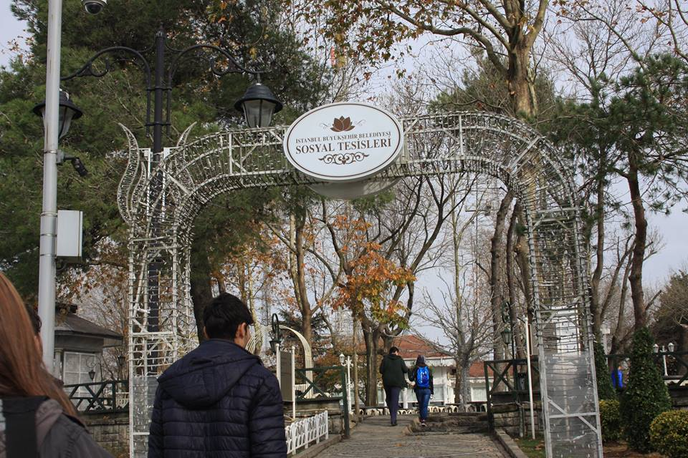

After this we went to Harbiye Military Museum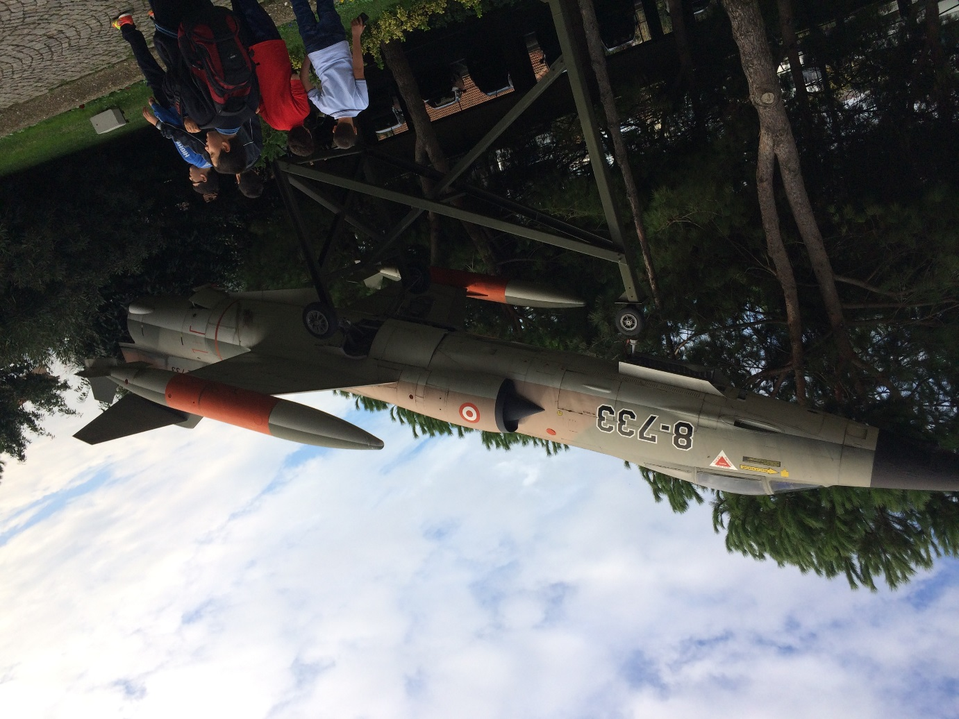
There we saw a lot of guns, armours and a beautiful show in the end .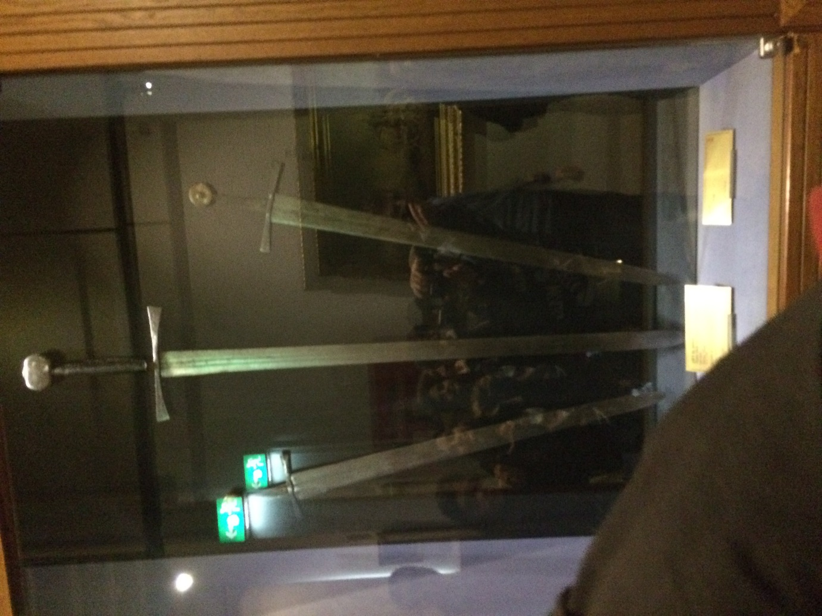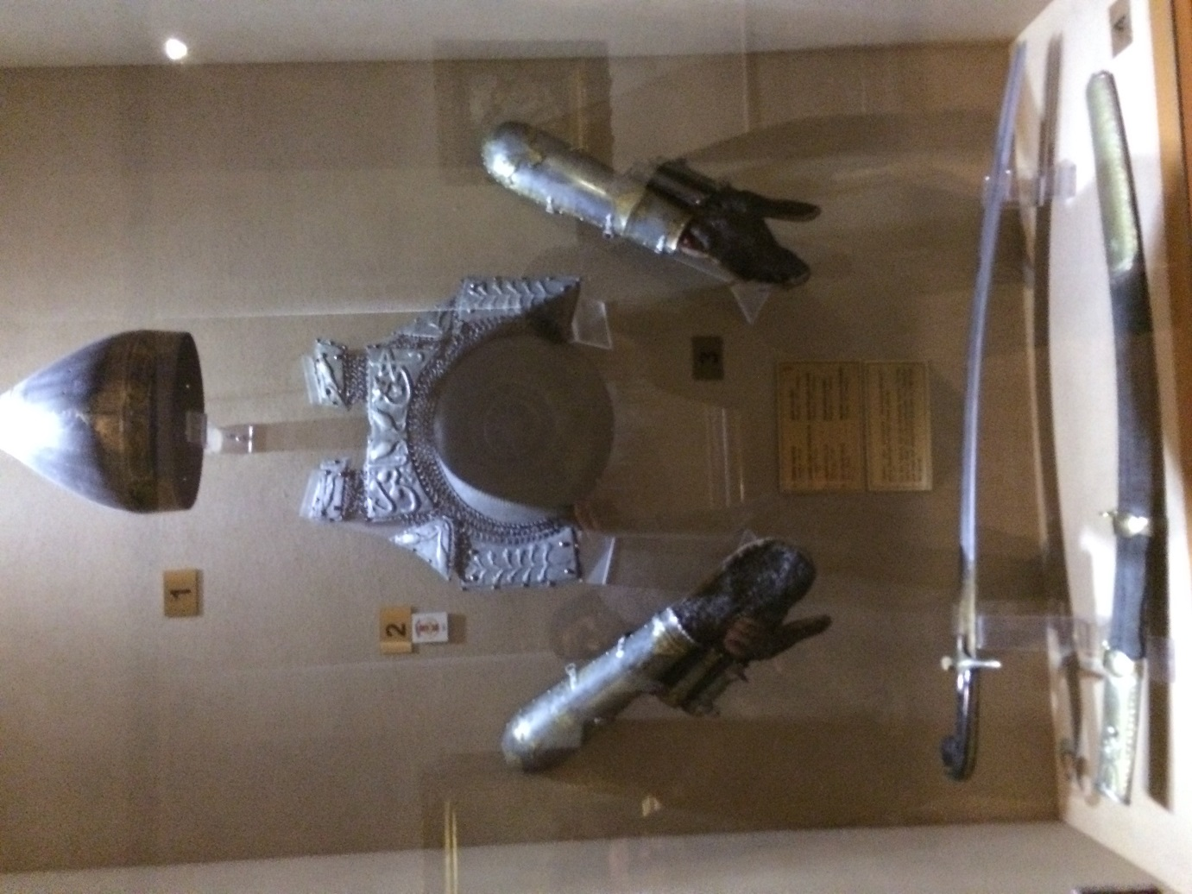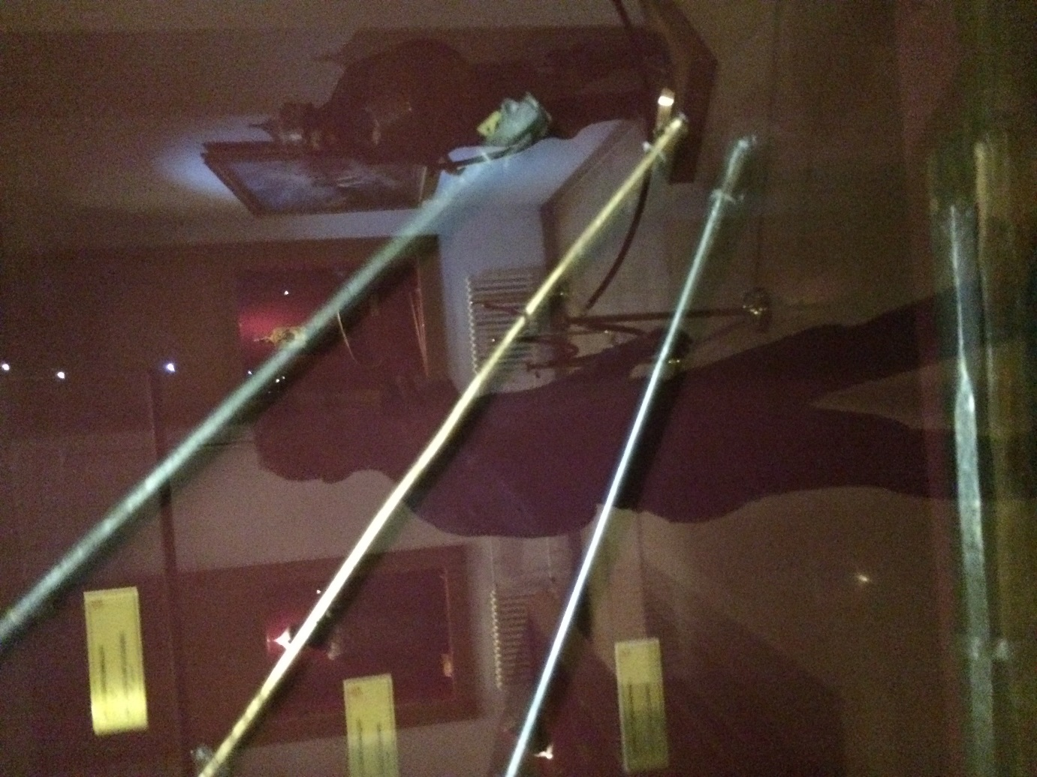
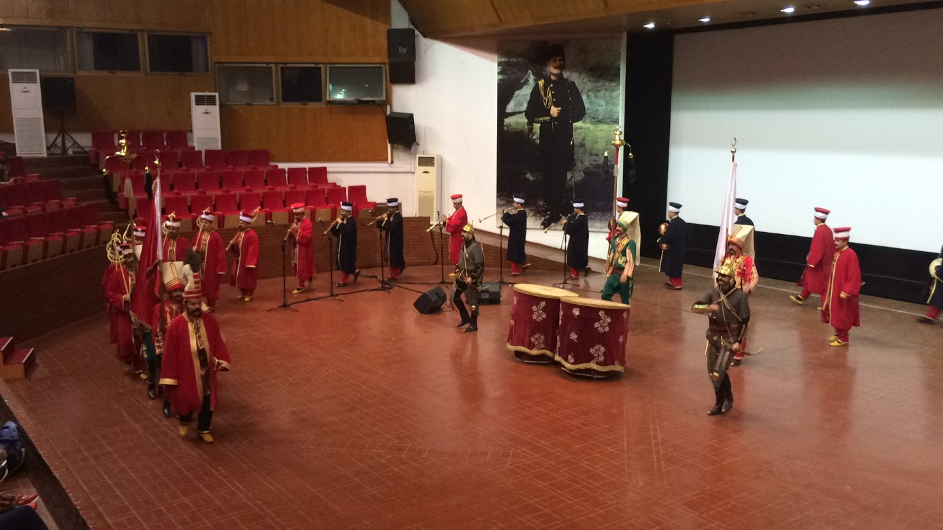
After this I went with Erasmus group to Taksim for shopping .
Was a great week with many beautiful memories.

