**Day 10**

We start the day , we have breakfast with all the family , like every day and ,Demm’s father , take us to the hotel. When all the countries were there , we leave it , and we went to the city hall. There , the mayor , were talking with us about the city . After that , we go to the theatre , there a specialist , were talking about , the theatre ,and some costumes.

When we lived the theatre , we went to a restaurant , all the countries together. We eat chicken and chips . We were eating with some greek girls, and suddenly , started to snow. Everybody go out to see the snow. We started to play with the snow , and our clothes were wet.

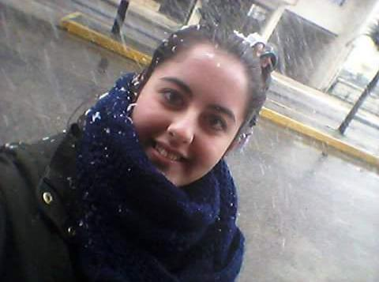

We were walking to a high school. There , all the countries were training the song of the project , while other children were singing , we were in another room , with our instruments. We tried to play the song , but it was impossible, because the partitura were different , so only the girls who play the flute , could play. After tried play, we were to the other room , and we sang with the other countries.

1964891_325155921027717_1406878999508373963_n.jpg

When we finished , we returned to our homes. I was playing with Alessandro , Demm and Helen to Wii . Although , Demm , was thw winning , in all te games , we spended a funny time. While I was having a shower. When we were ready , we were out , with some italians , french and greek children to aet in a restaurant . Irene and me decided to ate a typical food there , is like a kebab , a pita. When we finished , we went to a “Cafe” , where we drank some drinks , and we sang and talk for a long time.

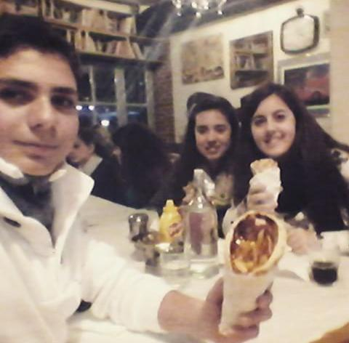

We returned at home very late but it was a fantastic nigth.

ANA GODOY PEDRAJAS - SPAIN