Meeting in Istanbul

Day 1

At 6:00 in the morning, began a big day, the day that the dream was becoming true, the trip in Istanbul. Me, my teachers and 2 other students took the bus from Tripolis to Athens international airport ‘’Eleftherios Venizelos’’. At 7pm we arrived at the Istanbul Atatürk airport.

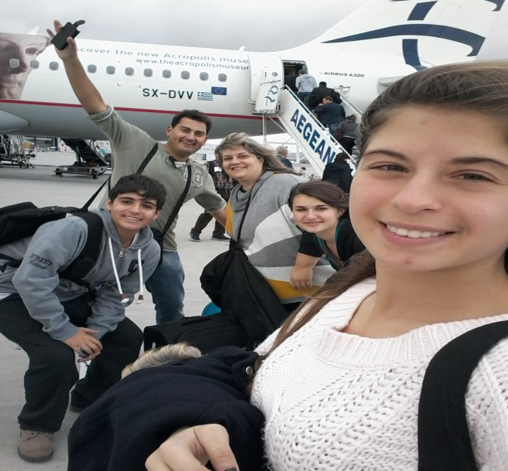

Then, the mini bus took us and we went to the school ‘’Sağmalcilar Anatolian High School’’ that the host families were waiting for us and then we went to the homes.
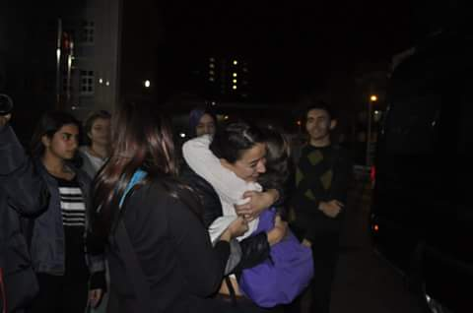

Day 2
At Monday morning we went to school and we guided to the school. We saw Turkish dances and then we went to a park and then for lunch.
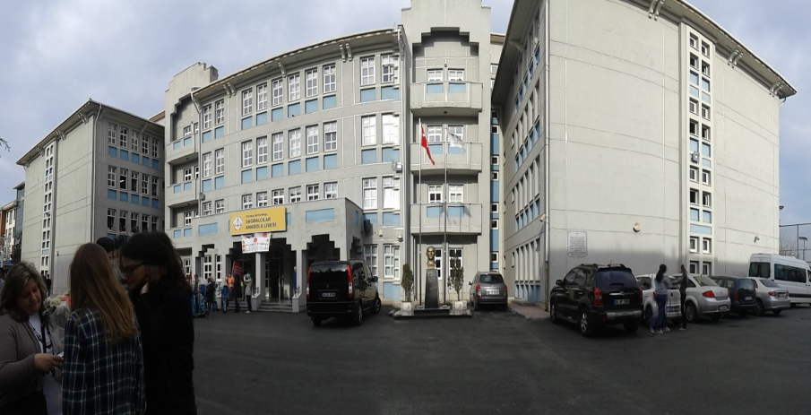
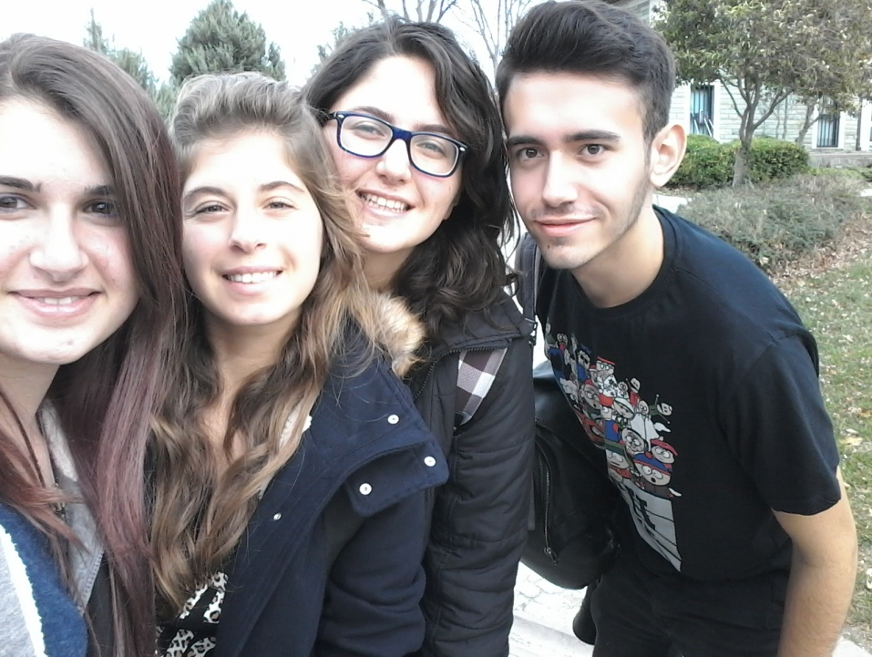
After lunch we went to see a Turkish art. When the program of the day was finished, the Greek students and teachers went to Fener. There we saw the Patriarchal School and the Patriarchate.
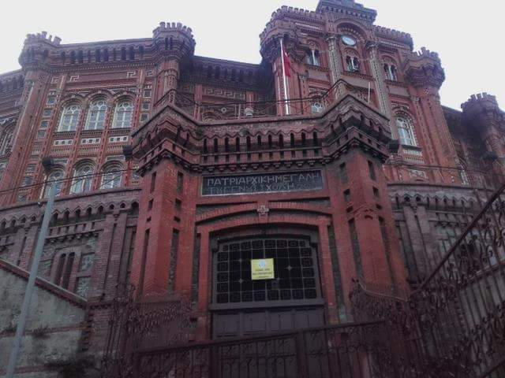

In the evening, all the students of the program went to Bosporus near the bridge.
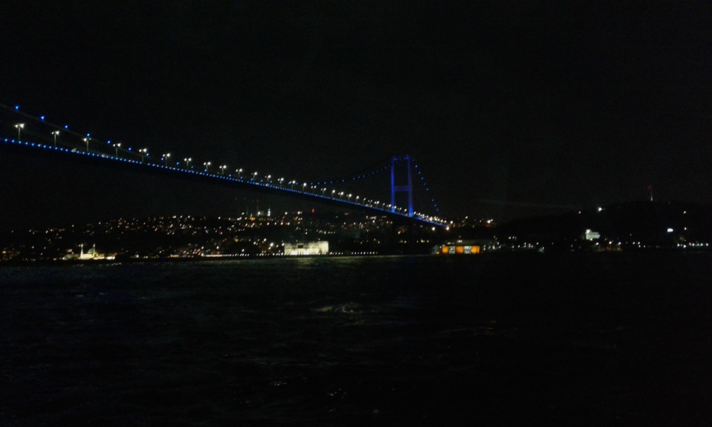
Day 3
In the third day, we went at ‘’Ülker’’ chocolate factory. This chocolate is so delicious!!!
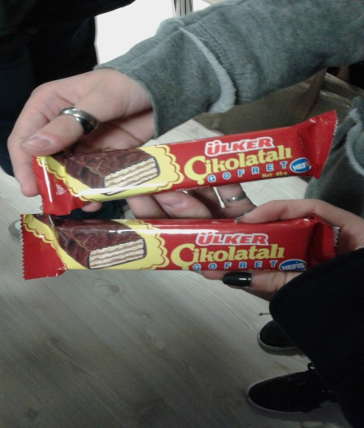
After our visit in the factory, we went back to school and we vote about the Erasmus+ logo. All countries had a logo to recommend, but the one that singled was the Turkish logo, that it was really very good. 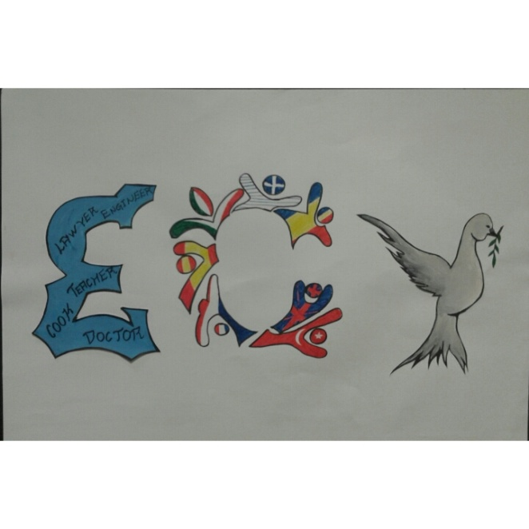
After the logo’s voting, everybody went home with the host families and then we went at ‘’Forum Istanbul’’ for bowling.
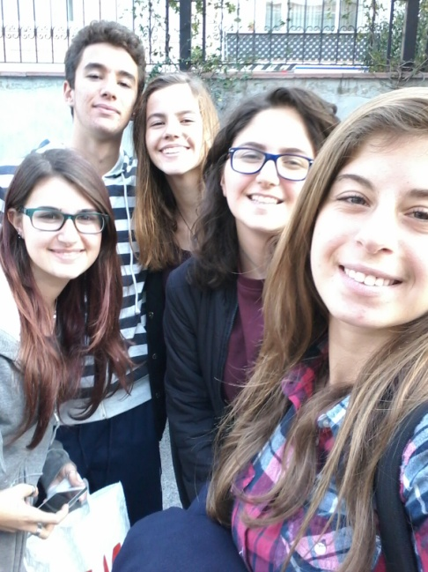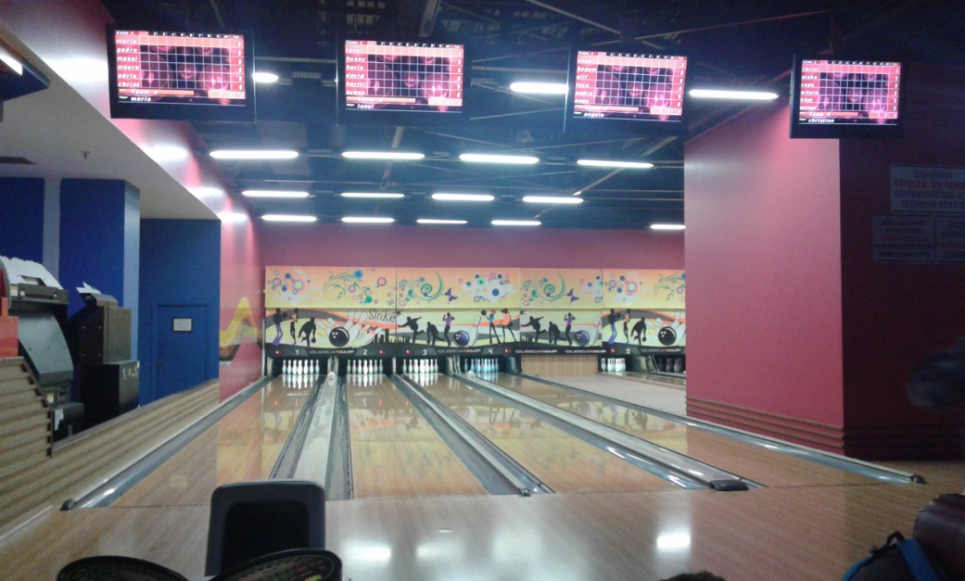
Day 4
The next day, we went at school in the morning because we had to play the drama. All dramas from all countries were very well prepared!!
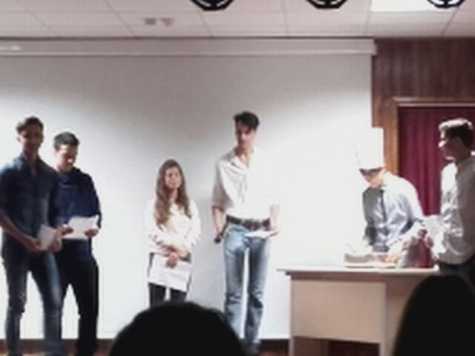
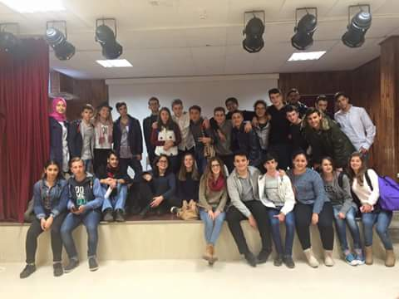
After all dramas we went for lunch and then we went in the ‘’Istanbul Panorama’’
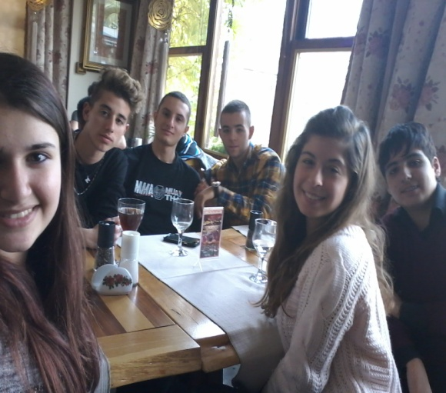

Late in the afternoon, when the day’s program was finish, all students from all countries went out for coffee.

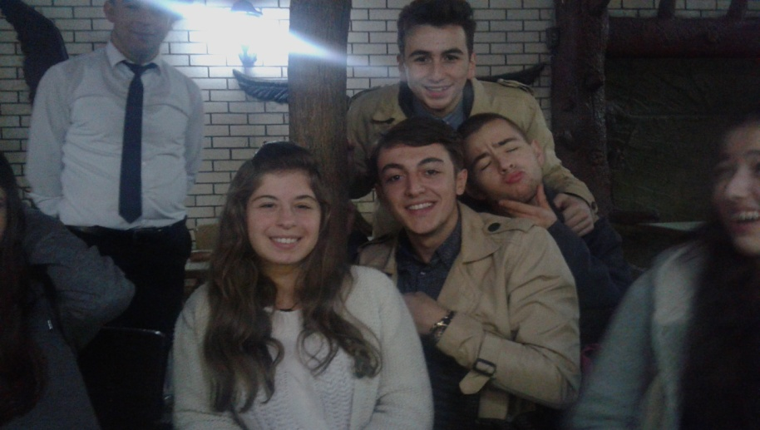
Day 5
In Thursday we went to Sultanhmet square, at Sultanhmet Cami and at Hagia Sofia.

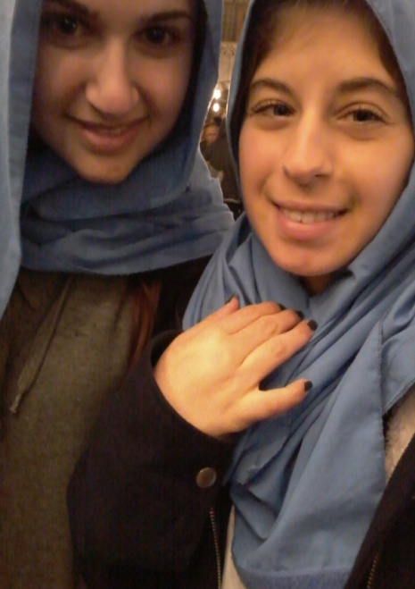
This experience was amazing!!!
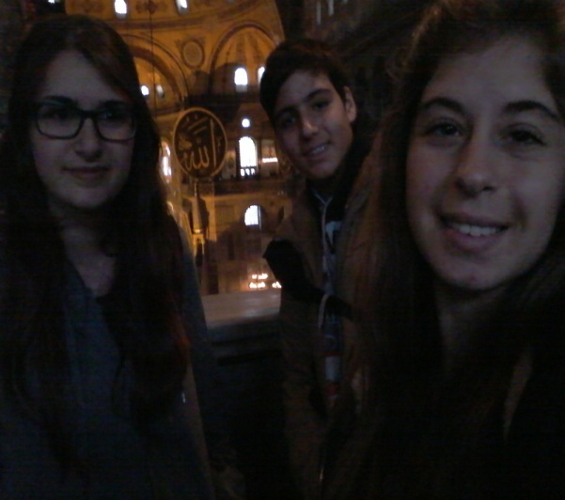
After Hagia Sophia, we went at the Basilica Cistern and then for lunch.
After lunch, we went to the Topkapı palace.
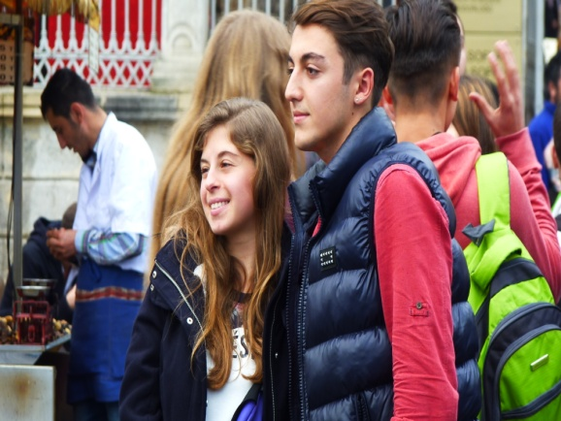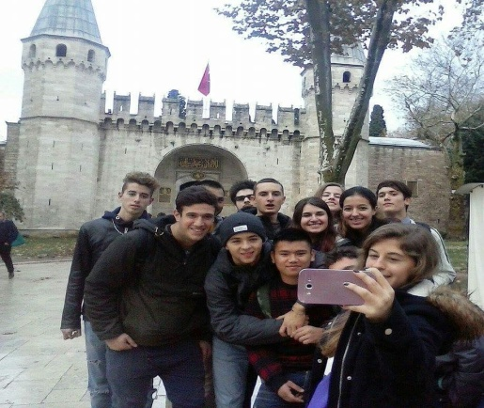

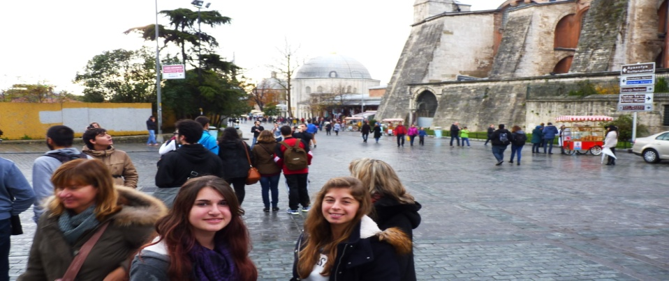
In the yard of the palace was this beautiful view.
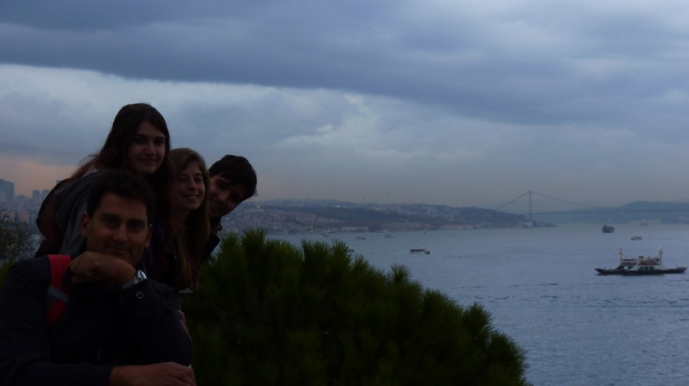
Day 6
Early in the morning, at Friday, we started the trip to Üskudar, the city at the other side of the Bosporus’s bridge
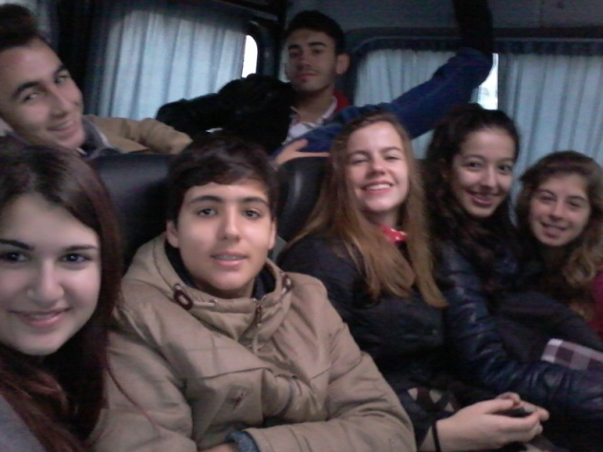
When we arrived, we went at Maiden’s tower and we picked a lot of photos the view, Istanbul view.
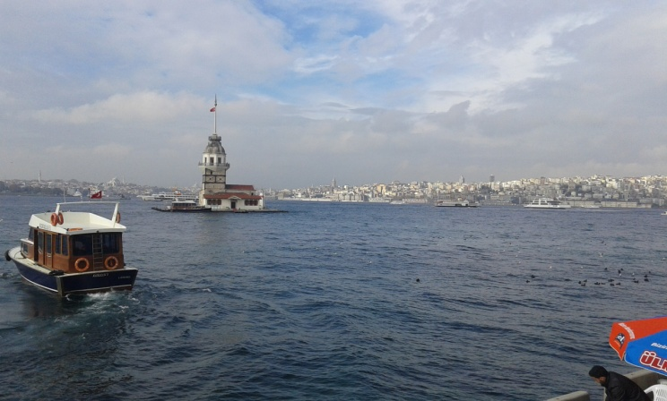
Next station was the Çamlıca hill, where we were free for lunch, and then my dream was becoming true...the Taksim square!!!
I love Taksim square!!!! I’m so happy that I have gone there!!!
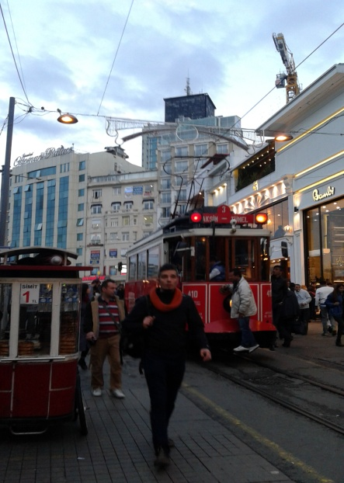

In the evening was the leaving party, but because of some problems it cancelled and all the students from all countries went outside all together to pass our last evening together.

Day 7
The last day started. Everybody was crying and everybody didn’t want this week to finish!!! We said goodbye to everyone and we went at the buses to leave for the airport.
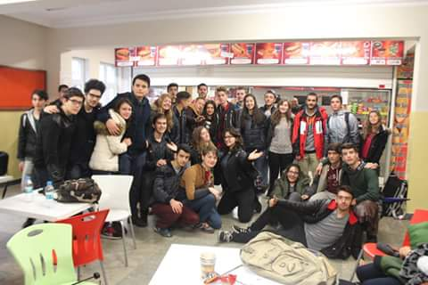
At the airport, while we were waiting for our flight, some students from the school made us a surprise and came in the airport to see us for the last time. It was very touching....I love them!!!
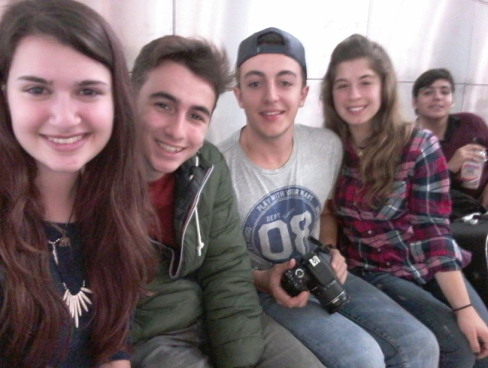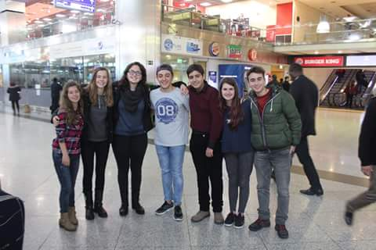
I miss Turkish, Italian, Romanian, Spanish students....I miss everybody!!!
I love them all and I hope to see them all again!!!
I miss you Istanbul!!! One day I will come again!!!

