Meeting in UK

Greek delegation:
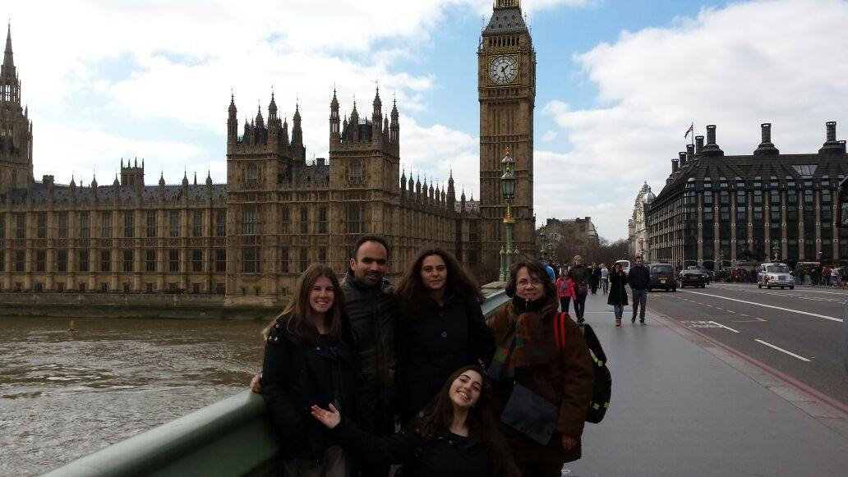
1st day:
On Sunday, we left Greece full of happiness and enthusiasm. We took the plane and at 8 o’clock we were in the airport of London, where we met the first friends we made. We took the bus and went to London and we had the opportunity to visit some of the sights there. After, we went to the train station and took the train. We arrived in Liverpool and we went to the Oldershaw Academy, where we met the host families. We went to the houses, we ate dinner and we slept because we were tired.
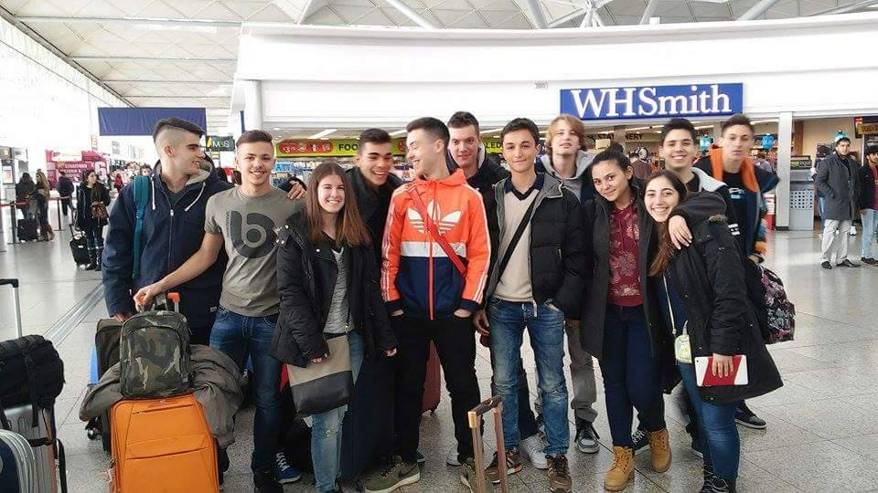
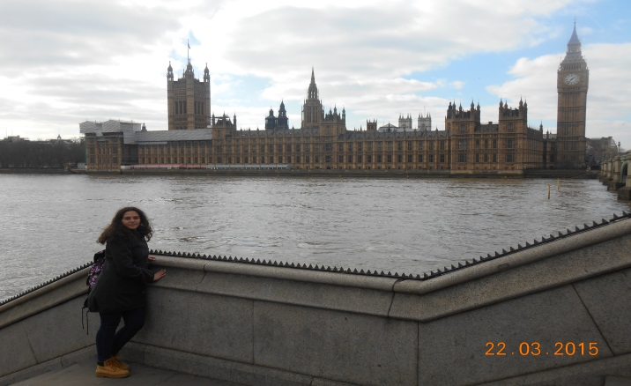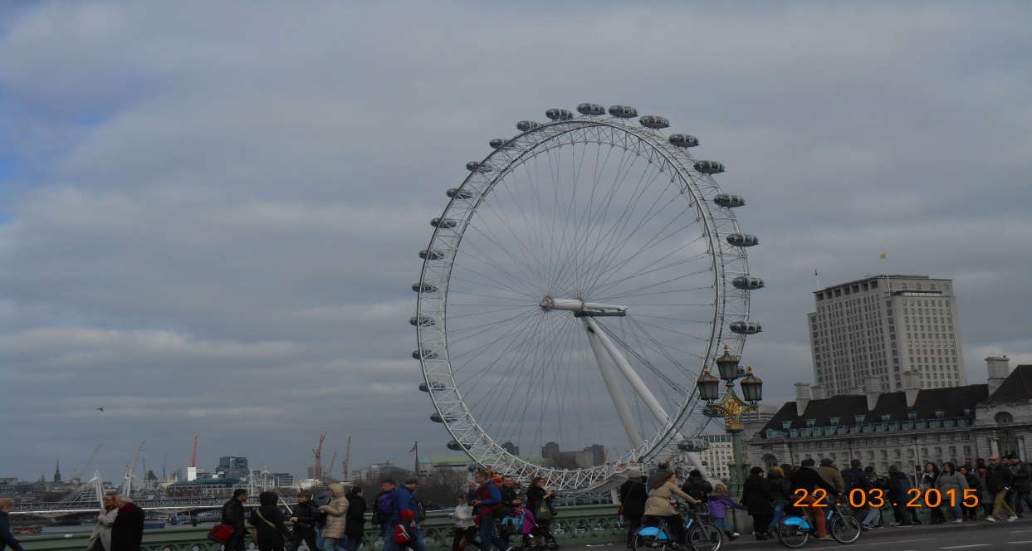
2nd day:
On Monday morning, after having had a good breakfast with the family, we went to the school, where we were greeted by the headmaster. After, all together, we visited the Cpl, a British company consisted of many teams, which are training employers and delivering business solutions. After the speech of the CEO of the company and a tour to Cpl, every country presented the video about the dream job. Then, we were free and a big group went to play bowling.
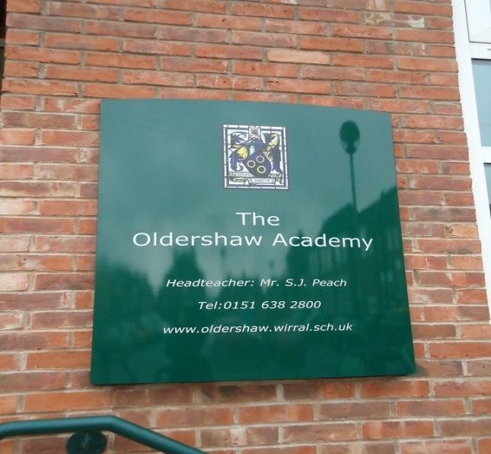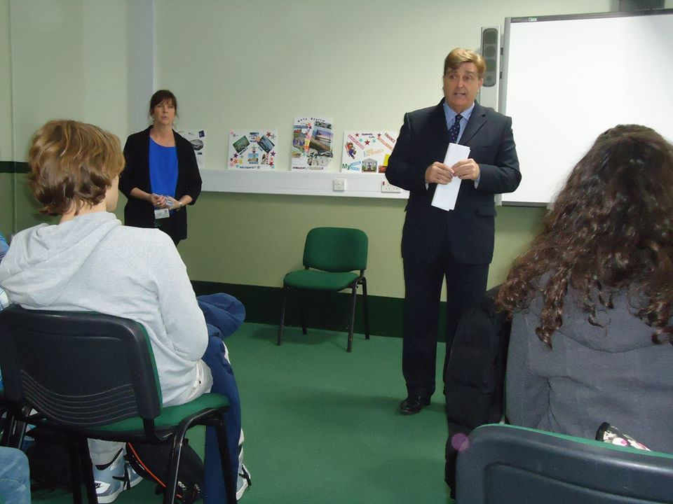
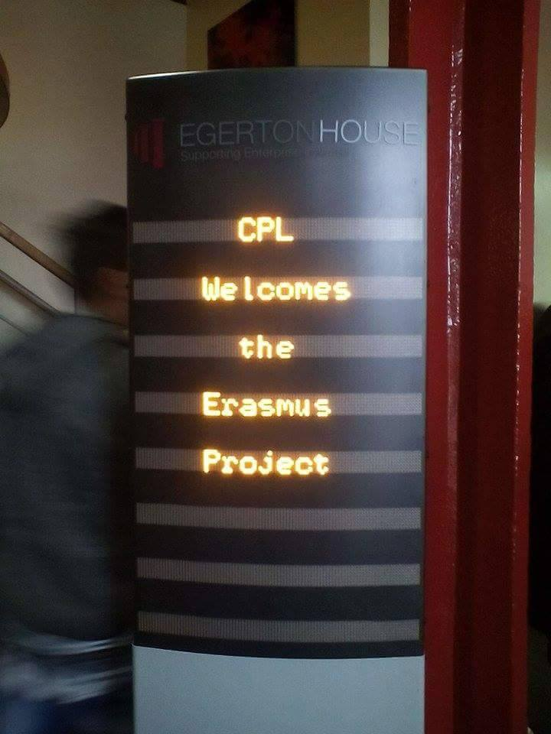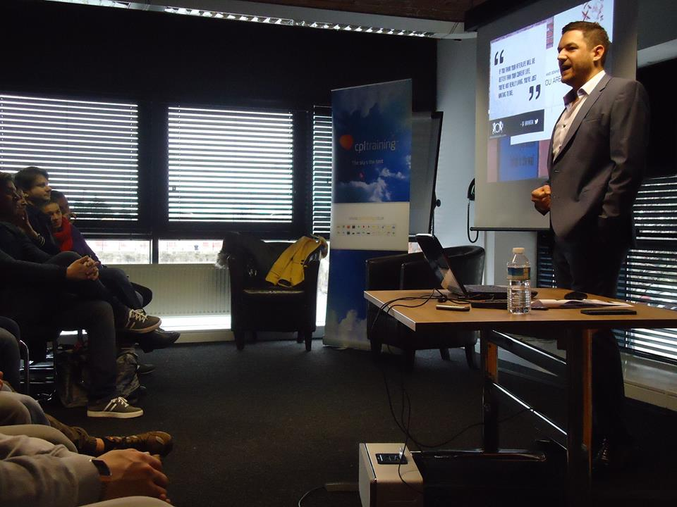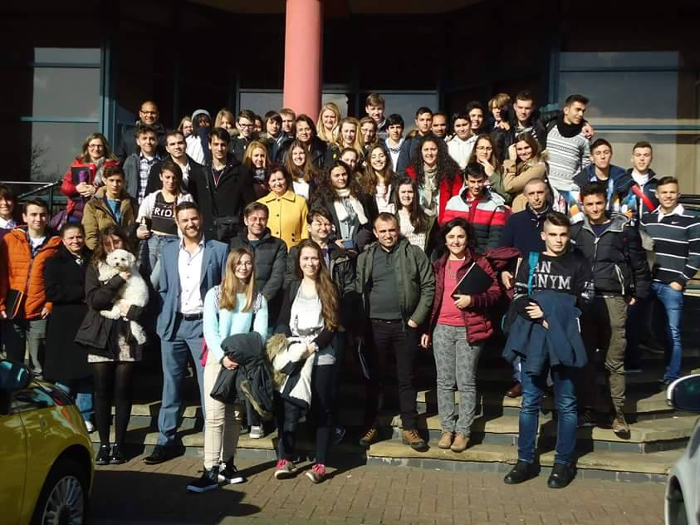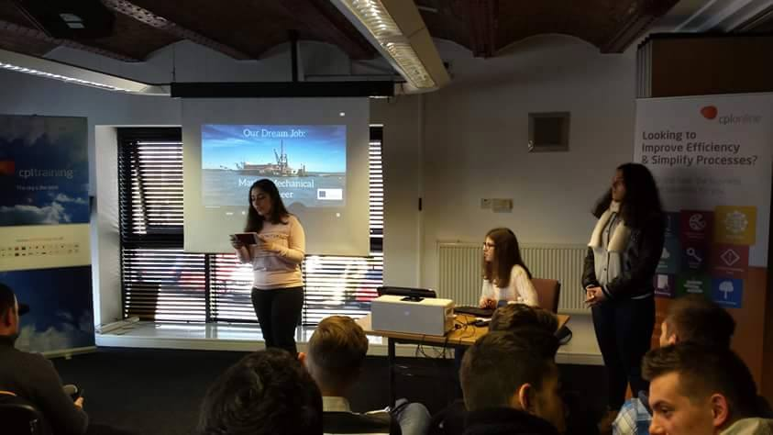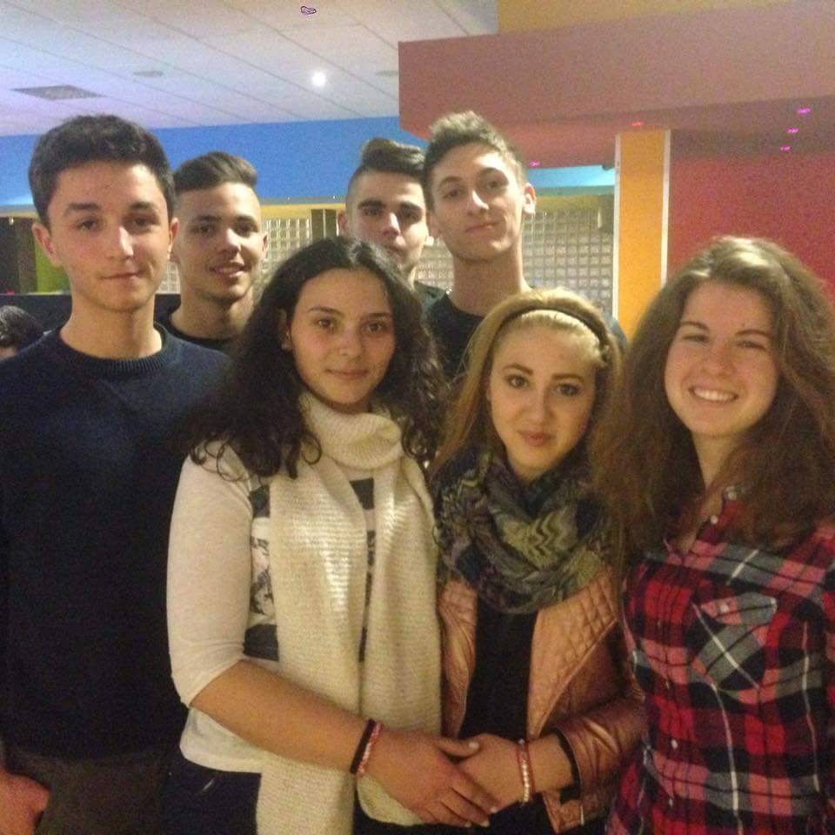

3rd day:
On Tuesday, students of the school went us a tour to show us their school. After having had a personality test, we visited the Ancient Roman City of Chester. We saw a lot of ancient sights. We had lunch and after we went a tour in the City Walls. Then, we took the bus, said goodbye to Chester and went back to Oldershaw Academy. At the afternoon, me and the family had some guests. We ate pizza, we played cards and we had fun.
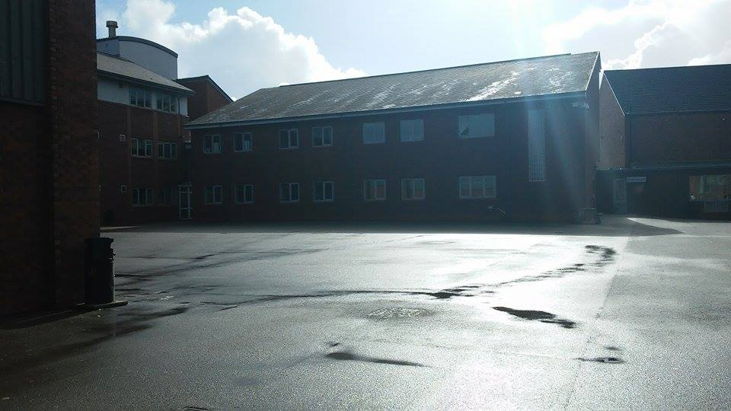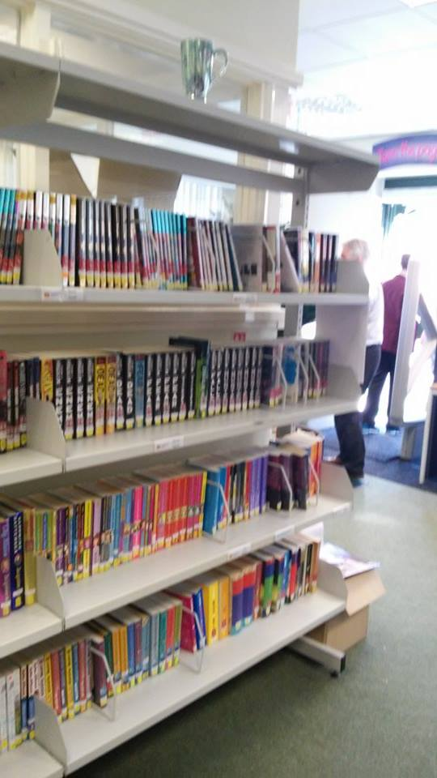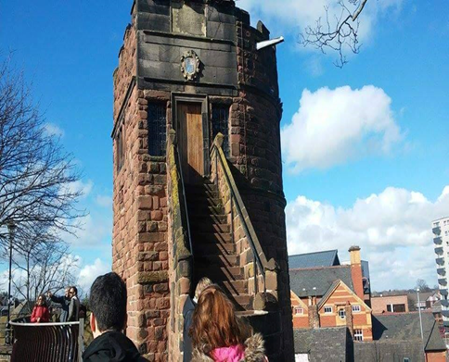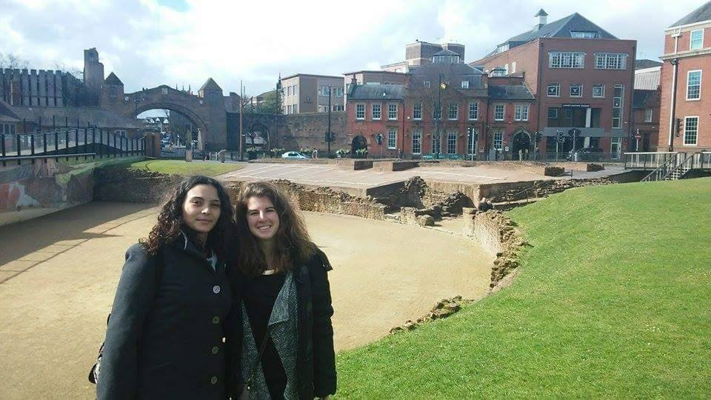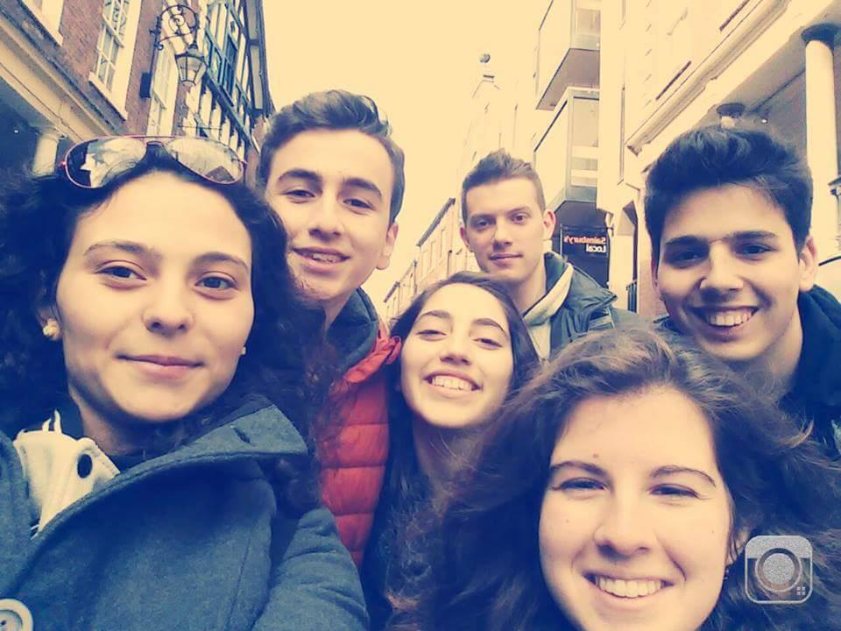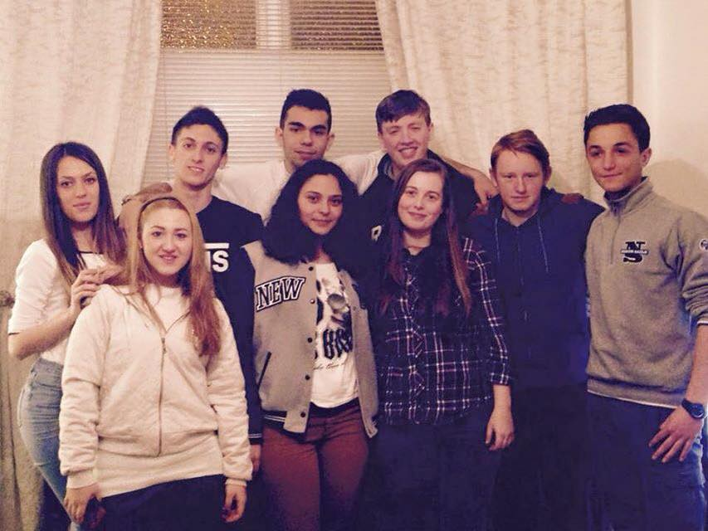
4th day:
The 4th day, after the full of power breakfast at home, we me the others at the school. There, both teachers and students attended to lessons with the hosts. After that, we departed for the Wallasey Town Hall in order to meet the Mayor. He said us about his duties and he gave us a tour of the building. After, we walked by the beach, enjoying the good weather and having chips for lunch in the New Brighton.When we returned back to school, we created our vision boards. In the afternoon, we took the train to Liverpool, we had dinner and we watched Andrew Lloyd Webber’s musical “Jesus Christ Superstar” at the Empire theatre.
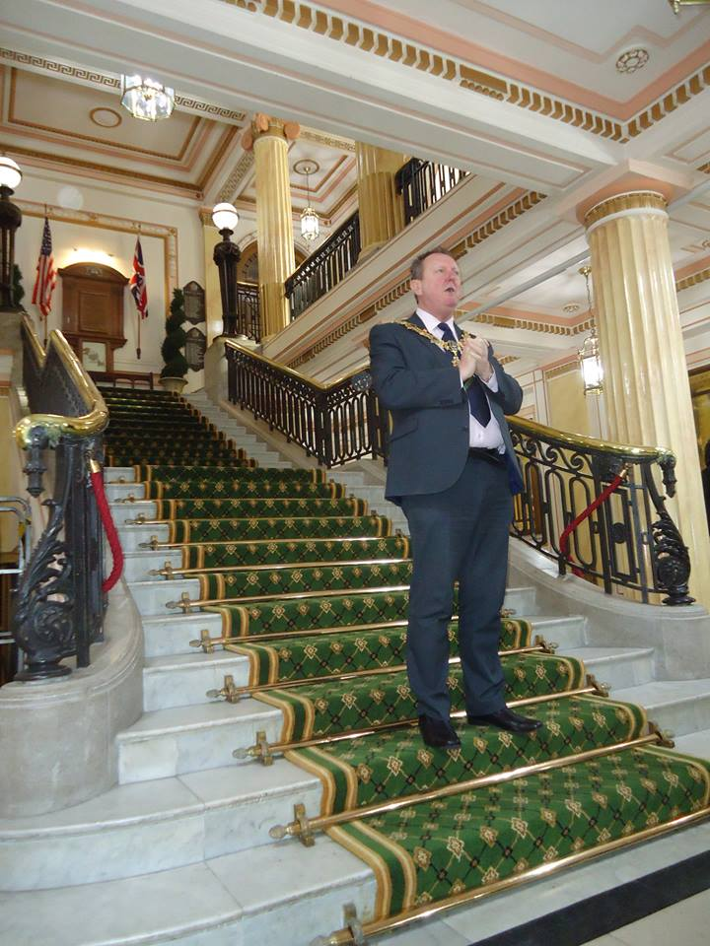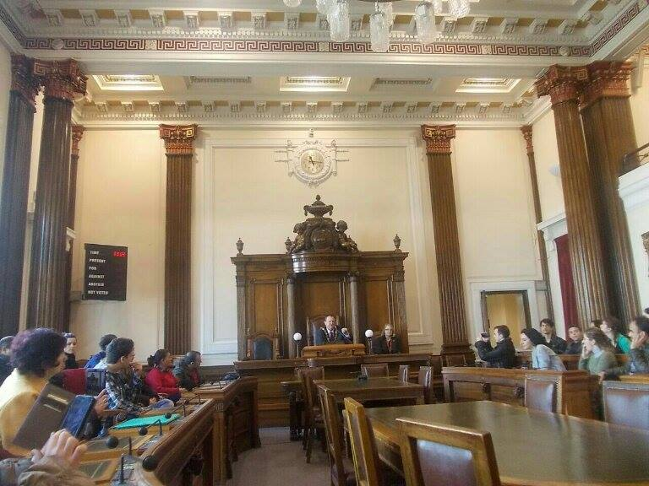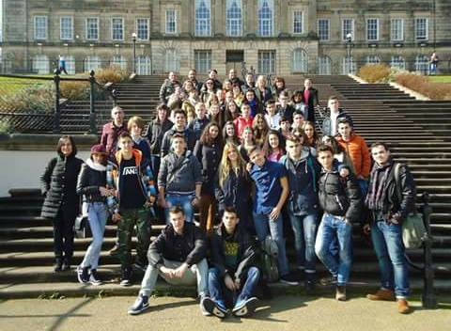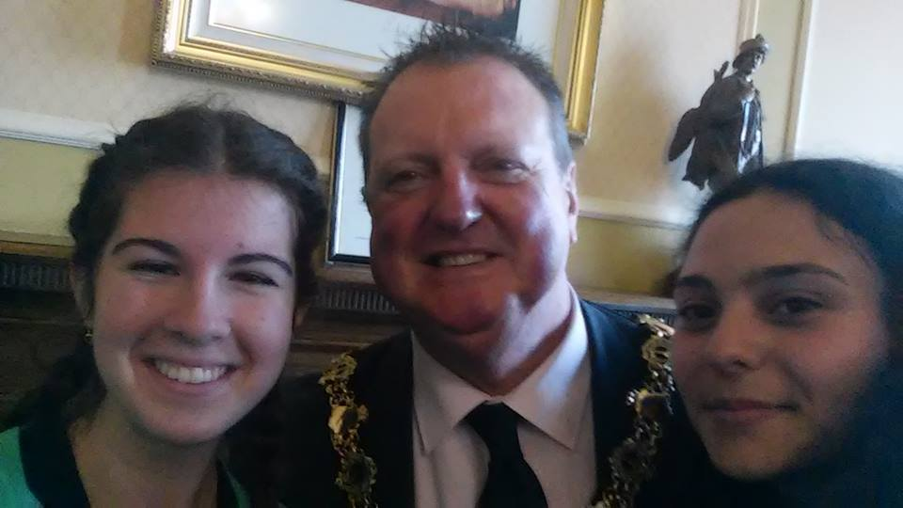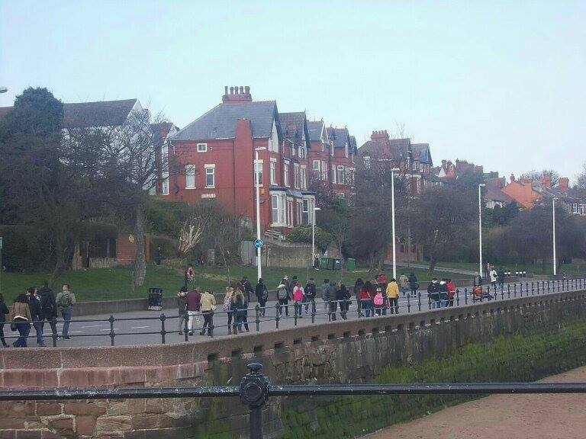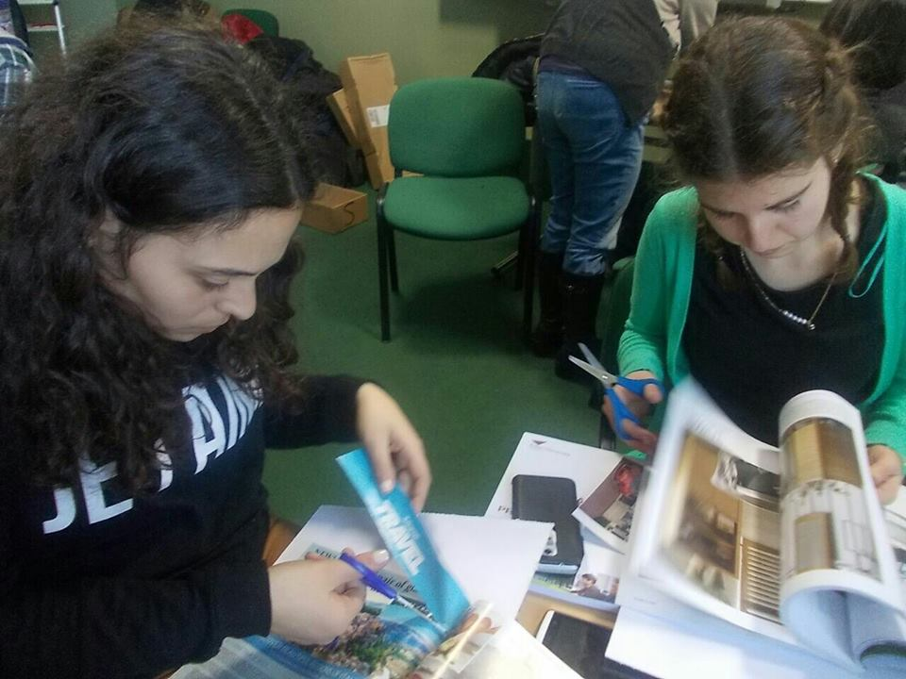

5th day:
On Thursday, we arrived to school with the hosts students. We had some workshops about communication skills, team building skills and a Mock Interview preparation. We had a break for lunch in the School Cafeteria. After that, we gained some useful information about apprenticeships. At the end, we had a mock job interview, in which all the greek delegation had very good comments. Then, we had free time and we had dinner in a friend of my host student, a short walk in the area and, finally, we went to a cafeteria.
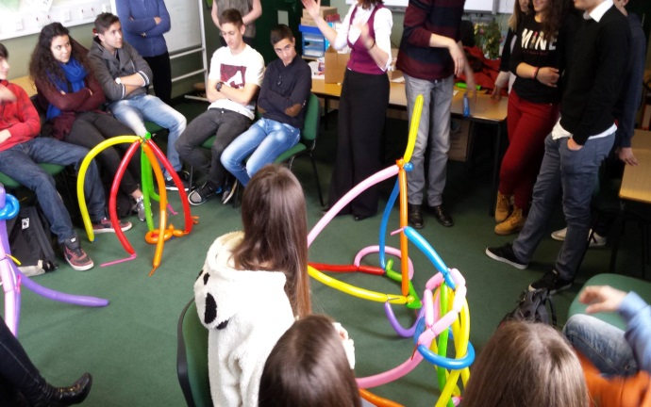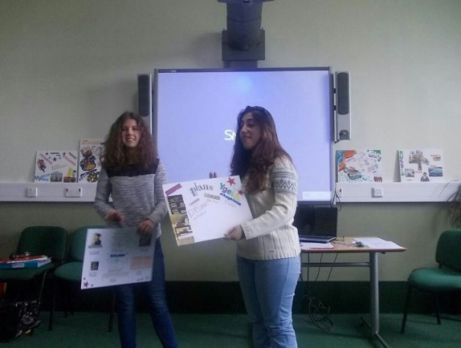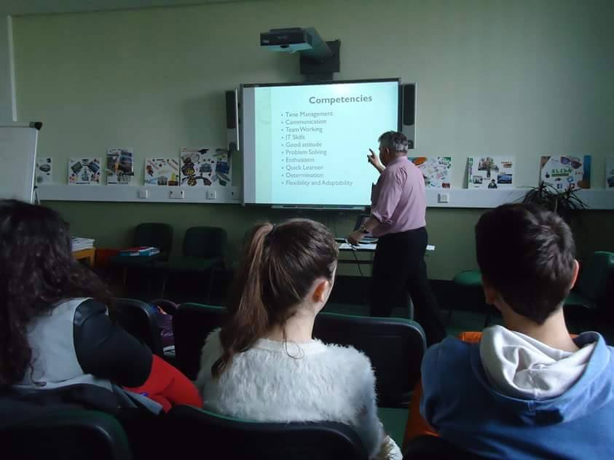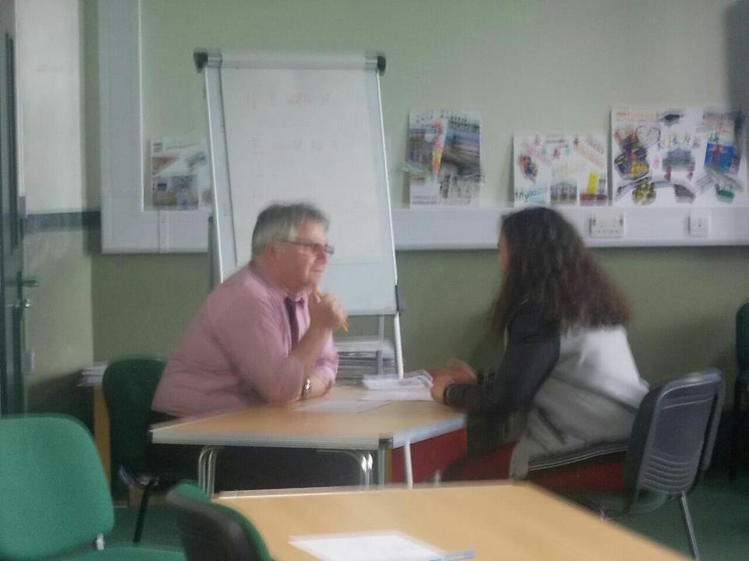
6th day:
On Friday, we arrived at the school, where a bus waited for us to go to Liverpool. There, we visited the Maritime Museum and the Liverpool museum. After, we should take part in the treasure hunt. We had free time for lunch and shopping in the city. We went a tour with some friends from England and Italy to shop. At the end, we went to the meeting place and we went back to school. In the evening, we went for dinner and a last walk in the area. We returned home and we played games and took some selfies.
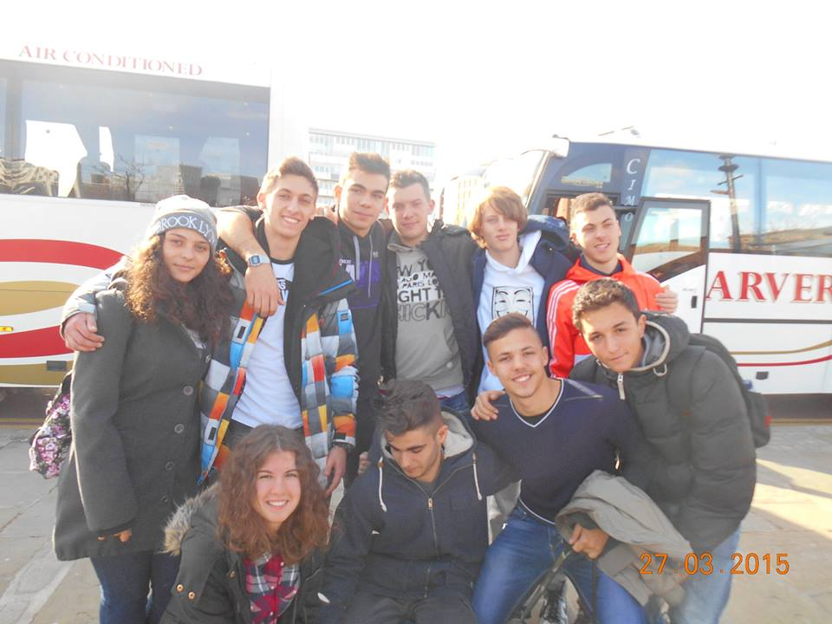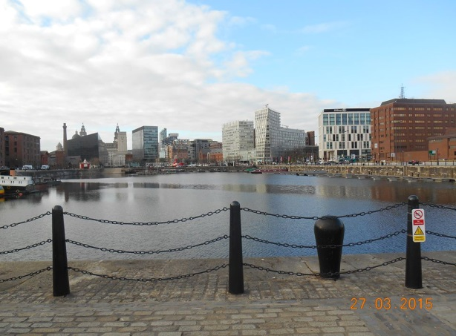
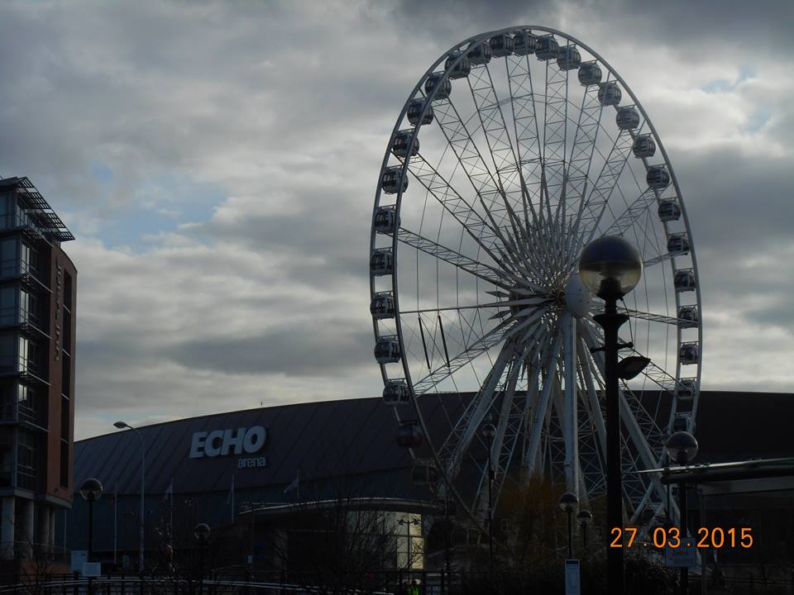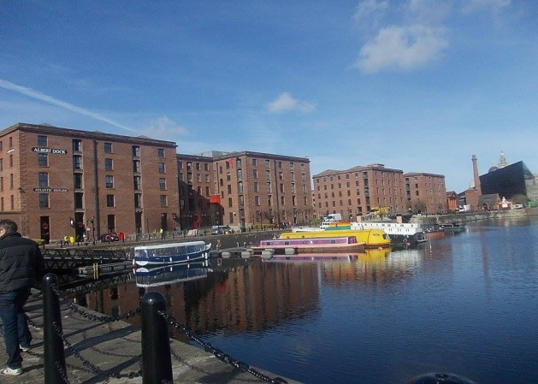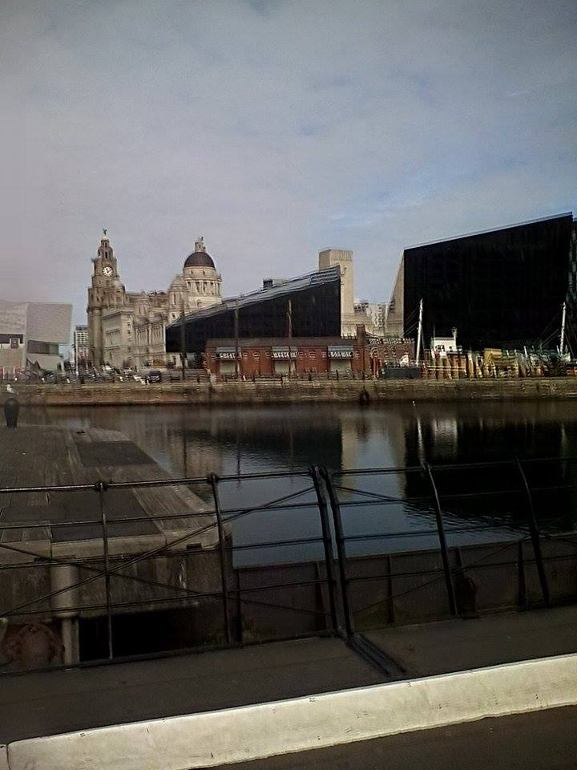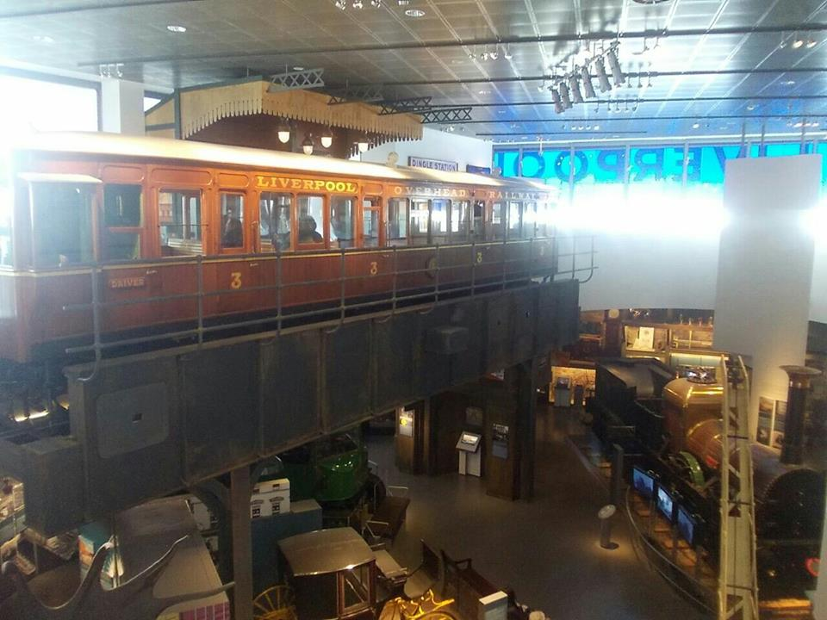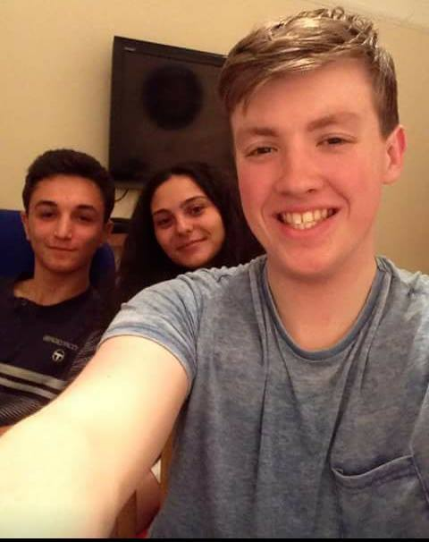

Mania Kafetzi, Greece

