**Activity Report**

1. **The Project’s section**

**Compilation of activities during COVID-19:**

– Section IV– P10 - Activity “Which Kind of a Book Would IWrite If I Were a Writer?

Turkish good practice models application

**Data:** February 2022

1. **Number of participants**
   1. Teachers-15
   2. Students - 150
2. **The activity’s objectives** 
   1. involving a minimum of 45 students and 12 teachers in the activity
   2. developing our students’ ablities to create stories
   3. to develop the highest psychological processes as imagination, critical thinking, introspection;
3. **Short description of the activity**

During this activity, we had taken the drama model offered by our Turkish partner as a model in C1 and, in base of the educational preparation of our colleague, we applied the local activity P10 in our school. The story was a proper composition and we tried to show how big it was its impact during the activity. The story was based on psychological elements as: imagination, memory, critical thinking, positive decisions lessons.

1. **Results** 
   1. **Quantitative results-** materials of the activity/ videos, story
   2. **Qualitative results**

* Improving the children’s vocabulary
* Developing their creativeness;
* Developing their self-esteem;
* Improving their abilities to create words;
* Involving all the primary school teachers in activities based on school abandon reduction;
* Promoting our activity in the local community;

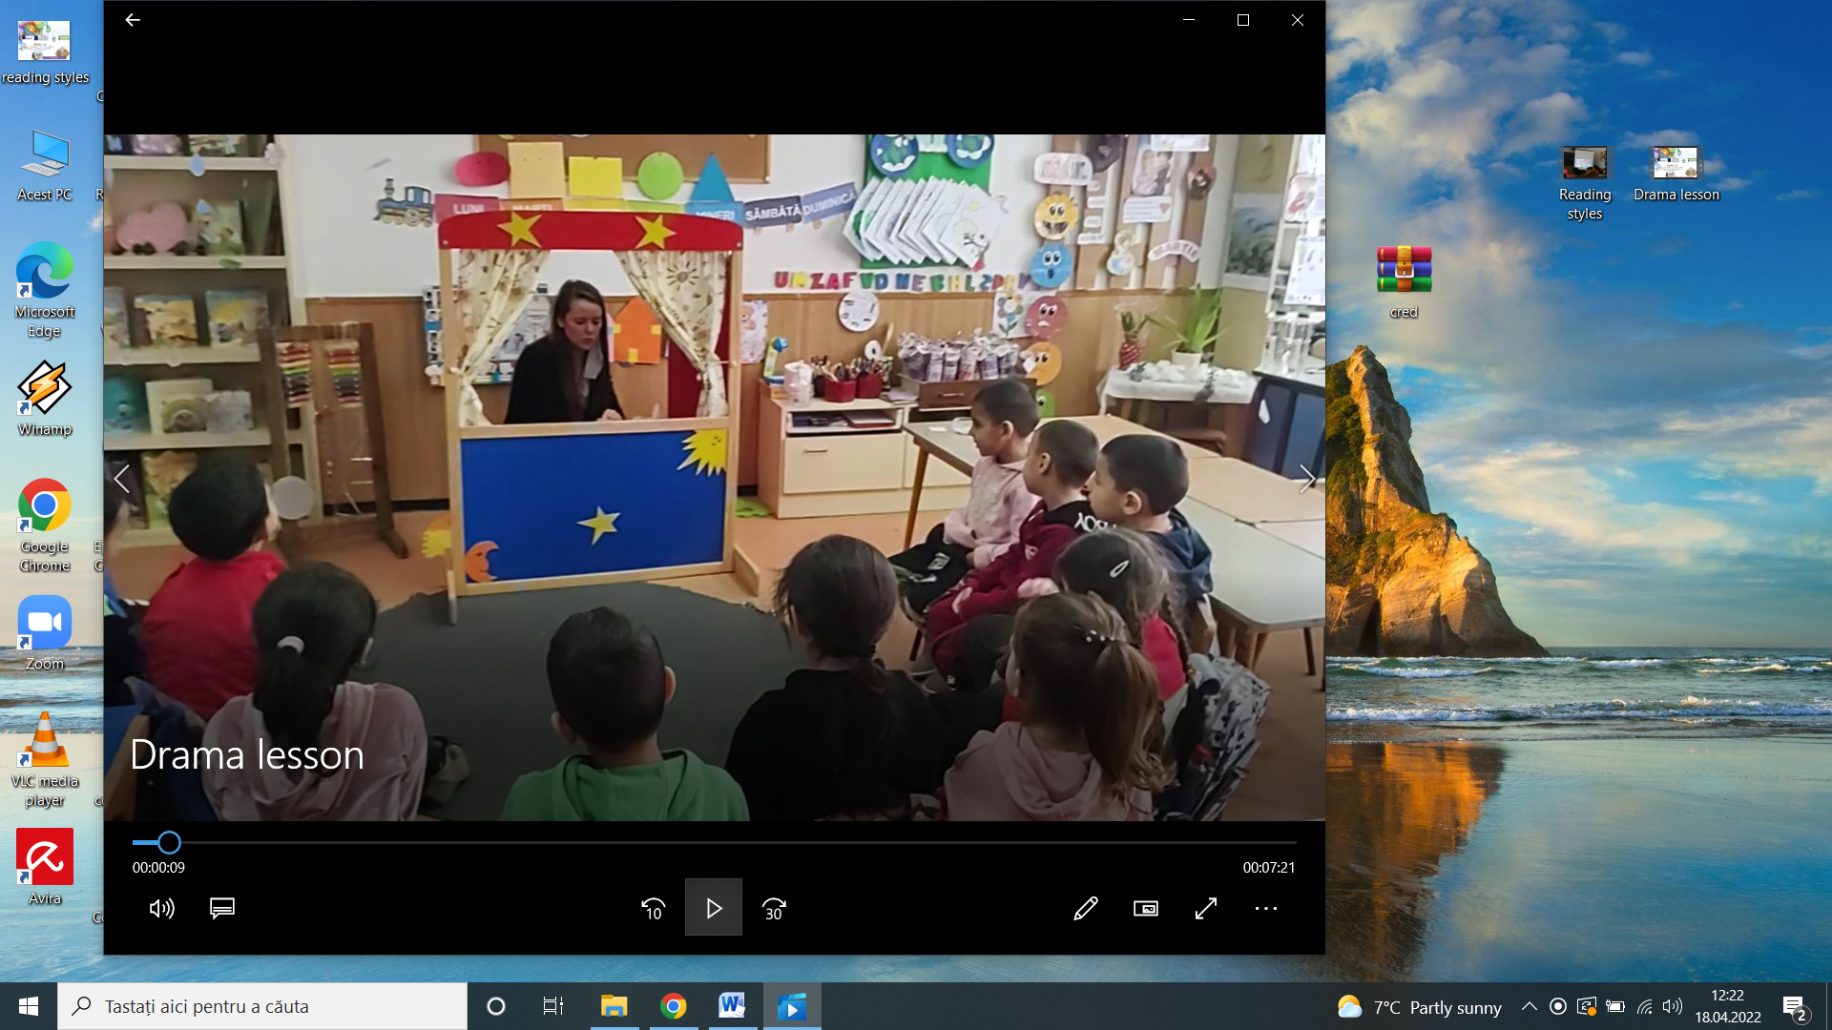

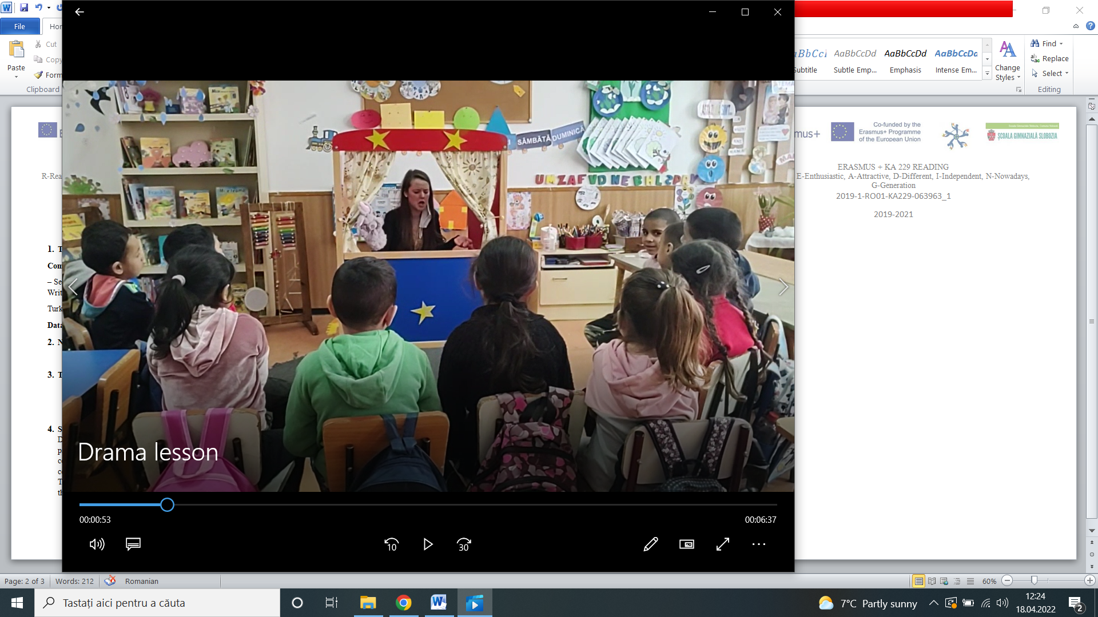

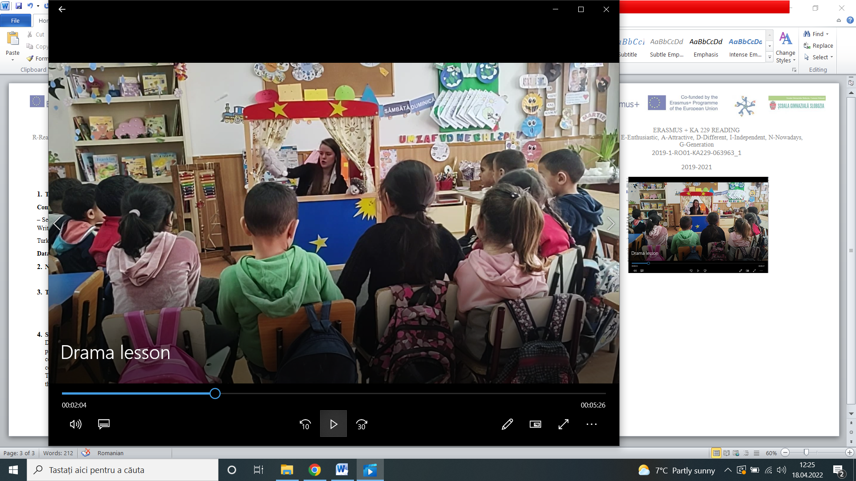

<https://www.youtube.com/watch?v=iSUVn2qRcVU>