TURKEY MEETING PROGRAM
19th October 2019 Saturday
-Arriving to İstanbul
-Turkish team (Four persons) will be historical peninsula after 14.00pm. Turkish team will stay Reydel Hotel in Eminönü.
-Turkish team will meet you “Eminönü Transit” station. Please send to me message via WhatsApp when you get on bus or taxi in airport.
-We can eat the dinner together.

20th October 2019 Sunday
-09.30 Meeting in front of German Fountain (very close to Sultan Ahmet Square)
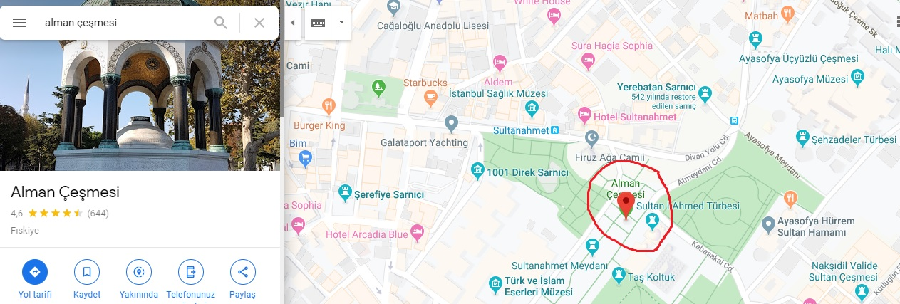

-09.40 Visiting Hagia Sophia Museum
-11.40 Visiting Topkapı Palace
-13.40 Lunch
-15.00 Visiting Sultan Ahmet Mosque (Blue Mosque)
-15.45 Bosporus Tour with private ship (I don’t know the price exactly, it can be 35 or 40 TL per person)
-17.00 Return to hotel and taking the suitcases
-17.30 Meeting in front of Sirkeci Train Station (Kennedy Street)
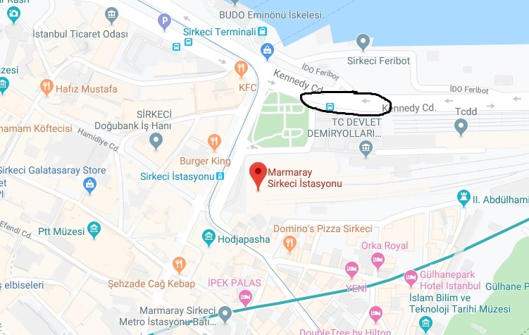
-18.00 When the Estonian team arrive to here, departure to Kütahya with private minibus (115 TL per person)
-21.30 resting Osmaneli district
-23.30 arriving to Kütahya

21 October 2019 Monday
-09.15 My team will pick up front of Hilton Hotel with cars
-09.30 Arriving to the school, visiting headmaster, school tour
-10.15 Starting meeting, presentation pre-school systems of the partner countries by partners
-11.00 Coffee Break
-11.15 Translating project leaflet and website content
-12.30 Leaving from school for Lunch “Döner Gazino Restaurant”
-14.00 Visiting City Director of National Education
-14.30 City Tour, Visiting Ulu Mosque, Tile Museum, Archaeology Museum
-16.00 Visiting Evliya Çelebi Museum, making “Ebru Art” (30 TL per person)
-17.30 Returning to the hotel
-20.00 Dinner in “Göksu Restaurant”

22 October 2019 Tuesday
-09.15 My team will pick up front of Hilton Hotel with cars
-09.30 Game performance of pre-school pupils
-10.15 Presentation of the game by prepared partners
-11.15 Coffee Break
-11.30 School Development Plan
-12.30 Leaving from school for Lunch “Çamlıca Restaurant”
-14.00 Visiting “Aizanoi Ancient City” Çavdarhisar district
-17.30 Returning to the hotel
-20.00 Dinner “Nar Restaurant”

23 October 2019 Wednesday
-09.15 My team will pick up front of Hilton Hotel with cars
-09.30 Arriving to the school
- Determining third meeting place and date, re-distribute tasks and roles, sharing Slovenian partners task and role
-11.15 Coffee Break
- Opening e-twinning account for everyone, updating eTwinning project pages,
- Preparing questionnaire for the parents
-13.00 Visiting “Nene Hatun Kindergarten”
- Performance of the pupils, lunch
-16.00 Visiting Tile Shops
-17.00 Returning hotel
-20.00 Dinner “Hanedan Konağı”, certificate ceremony, folkloric dance

24 October 2019 Thursday
-04.00 Leaving from hotel for Kütahya-Istanbul flight, there is a regular bus, I will learn the details of the bus and send to you information, and you can go to the Zafer Airport with taxi (140 Turkish Lira)
- You should be airport before 05.20, flight time 06.20, please check website of the Turkish Airlines
NOTE: We have free entrance for all museum without Evliya Çelebi Museum, because Ebru Art materials very expensive. Average meal and drinks price 35 TL per person.

