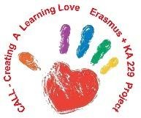
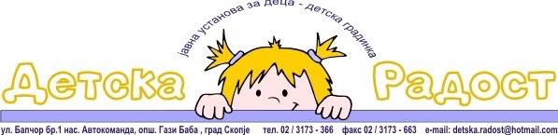

CREATING A LEARNING LOVE – CALL
MEETING IN NORTH MACEDONIA
28 February-04 March 2022

AGREEMENTS:

- “GAME BOOK”
Estonia made the e-Book.
Estonia is publish the working version of the book on TwinSpace - page https://twinspace.etwinning.net/73451/pages/page/1788555
And everything is finished with the book according to the deadline. See also the final version.
- “Welcome to Europe” BOOK:
Bulgaria has made changes to the book on European activity: "Welcome to Europe". Bulgaria published the working version of the book on TwinSpace - page https://twinspace.etwinning.net/73451/pages/page/1788555
- Unplugged coding activities - BOOK
Turkey is publish a working version of the book on TwinSpace - page https://twinspace.etwinning.net/73451/pages/page/1788555
Each partner should read the content and comment on what needs to be added or changed.North Macedonia team will also work and finished the book with coding activities.Dedline august 2022.

- Evaluation of the project
Questionnaires for parents and teachers https://twinspace.etwinning.net/73451/pages/page/1842356
Spain will prepare a questionnaire, one for the coordinators and one for all involved in the project. Then a video will be recorded where the teachers will talk about the project, and children will also be included to talk about the games they played.
Write now we can’t do it like it has been written in application. The situation has been changed by Covid and we can explain it in finale report. Dedline august 2022.

- Agreement for the meeting in Estonia
Preparation of presentations from all partner countries in the project.
Turkey - presentation on the development plan of the project and the WEB page of the project;
Estonia - presentation of the Games book
Bulgaria - presentation of the EU book
Spain - presentation with a game that will bring it to Estonia
North Macedonia - presentation of the seven coding activities and in general about them.
All presentations should be placed on the Google drive of the project.
Estonia will also present the use of IT in kindergartens as well as toy robots that can be used in games with children.

- NEXT MEETING
From 25 April to 29 April 2022-Estonia

PROJECT DEVELOPMENT
Dissemination of the project through the press, public presentation at local and national level. Publish materials in eTwinning.

