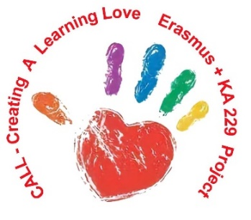

NORTH MACEDONIA MEETING PROGRAM
ERASMUS+ PROJECT KA229
“CREATING A LEARNING LOVE”
28 – 04 MARCH 2022
KINDERGARTEN “DETSKA RADOST”
SKOPJE
NORTH MACEDONIA
MONDAY 28.02.20122
Arrivals in Skopje
Accommodation in hotel “Continental”

TUESDAY 01.03.2022
9:30 Welcome at the kindergarten “Detska radost”
- Greetings from the children
-Visit the kindergarten “Mimosa” and “Pomegranate”
10:30 Coffee break at the kindergarten “Pomegranate”
11:30 – 1 March – day of Martenitsa activities:
“Welcome to Europe” Book geography sections leading by host school:
-Map Painting, finding capital cities on the map, map matching game (pupils match native language with the country)
-Traditional Clothes, Matching game
12:00 Lunch at kindergarten "Detska radost“
13:30 Visit to the
16:00 Free time
22:00 Rest in the hotel
WEDNESDAY 02.03.2022
9:30 Kindergarten “Sunflower” and
Kidergarten “Violet”
Greetings from the children
10:30 Coffee break at the kindergarten “Violet”
11:00 Meeting of the project coordinators:
-Talk about what has been done
-Discussion on 3 types of books - final products https://twinspace.etwinning.net/73451/pages/page/1788555
-Discussion of the project website http://callerasmus.com/
-Take a look at the set books
-Coding activities
-Agreement for the meeting in Estonia
-Preparation of presentations
-Setting up Google Drive
-Preparation of evaluation questionnaires for the coordinators and all involved in the project
-Preparation of videos for the project - experiences of teachers and impressions of children.
Next meeting in Estonia date: 25-29 April 2022
12:00 Promotion of the first folk book for children in Northern Macedonia - "I hear where the forests are" - Authors Bajsa Arifovska and Dushko Georgievski
Performance of children from the preschool group
13:00 Lunch at Kindergarten “Mimosa”
16:30 Free time
19:00 Together evening and awarding of certificates at hotel “Continental”
THURSDAY 03.03.2022
7:00 Meeting in front of the hotel
7:30 Visit to Ohrid Plaoshnik, St. John Kaneo, walk by the lake, walk in the city center, St. Naum
15:00 Dinner at “Ostrovo” restaurant- St. Naum, Ohrid
22:00 Rest in the hotel
FRIDAY 04.03.2022
Departure from Skopje, North Macedonia

