Our school
Cuatrovientos (Fourwinds in English) is a vocational education and training school providing degrees of Administration, Commerce and Marketing and IT. We have Basic, Middle and High degrees studies and also a “special educational needs” module in Commercial Services.
What makes us special is that Cuatrovientos is a cooperative of teachers and other school staff. Teachers are very involved and their relationship with students is very close.
We are located in Pamplona, beautiful historical city next to the Pyrinees and near the sea.

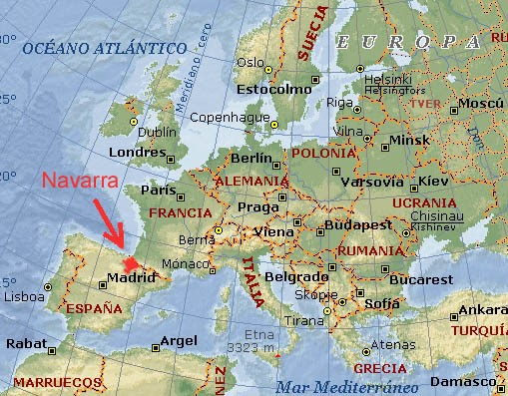

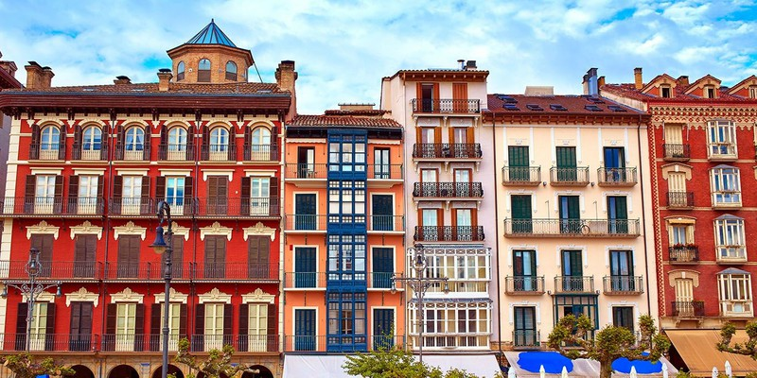
Our degrees are 2 year-long including a 3 month-period of internships. From a middle degree you can Access to the correspondence High Degree. We have agreements with many companies here and also abroad. We can go on Erasmus for the training period, mainly to Ireland, UK and France. This year some Erasmus will go to Austria too.
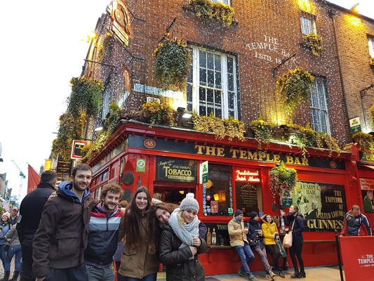
Our teachers also take part in Erasmus and have visited other schools in Croatia, Austria, France, UK and Ireland in the last years.
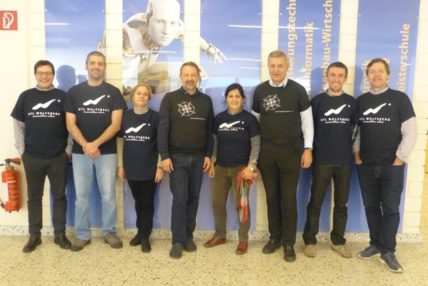
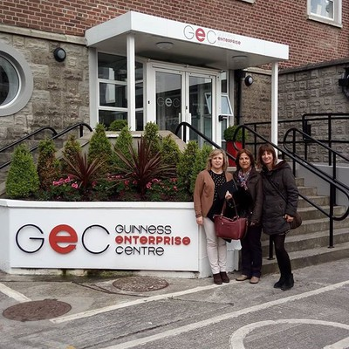

Our group
We are studying International Trade which is a Higher Degree. We are in our second year, so in March we will hopefully do our training period. We are 21 students aged 18 or over. Most of us have a good level of English, around B2.
We have the following subjects:
- International Freight Forwarding
- International Marketing
- Financing
- Storage Logistics
- International Negotiation
- International Digital Commerce
- English
- French
International negotiation:
Our negotiation teacher is Juan Carlos but we have a weekly 2-hour session also with Arantxa, and we do it in English. So far, we have been creating a cultural website of different business areas in the world. Now we have been invited to take part in a “real” negotation with our Portuguese partners, which makes us very excited. For that, we will represent Fourwinds Enterprise which is a company that we “created” last year under the business simulation methodology.
Fourwinds Enterprise
Just to share our activity with you, have a look at the last Trade Fair we organized to promote our products:
