CHASSIS |  | Worksheet: CH1 |  |  | Element: Chassis squad | Process: Manufacturing
MATERIAL |  |  | TOOLS | PROTECTIVE ELEMENTS | OPERATIONS | FINAL SCORE
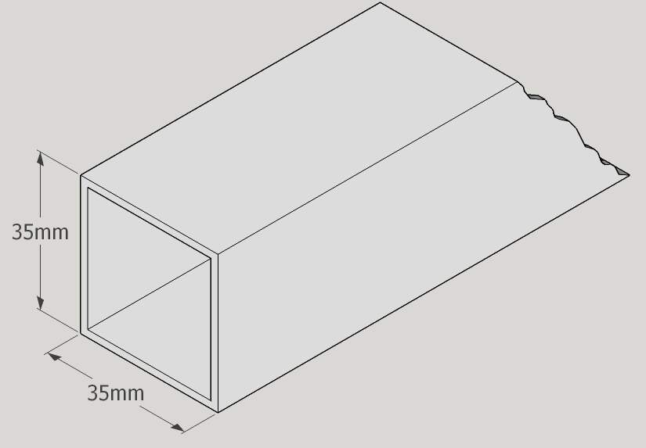  Square tube 35 x 35 mm |  |  | 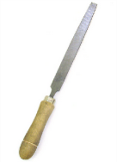  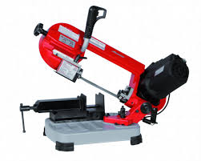 | 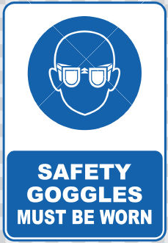 | 1º. Miter cut the square tube to 10 cm outer length.  2º. Deburring. | Piece A X 8 unit.  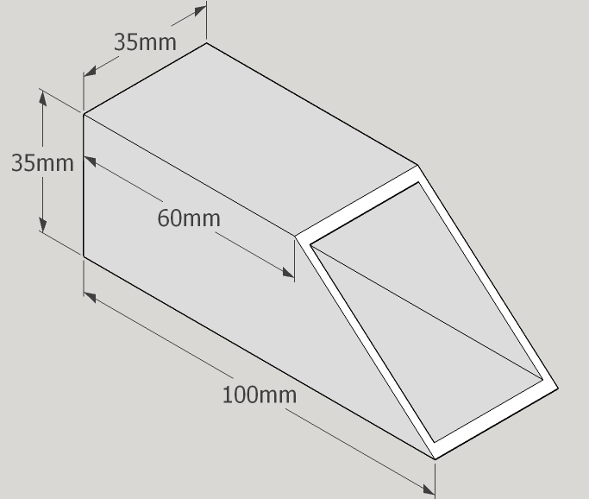
Piece A X 8 unit. |  |  | 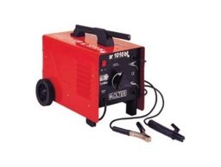  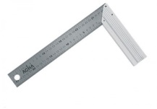 | 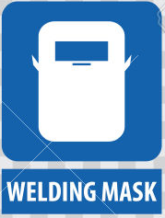 | 3º. Weld two pieces at 90 ° | Piece B x 4 unit  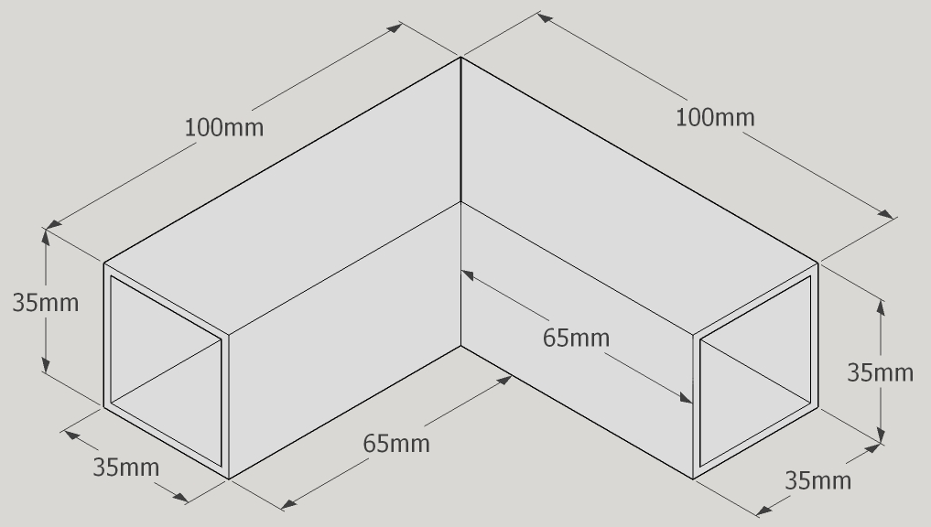
MATERIAL |  |  | TOOLS | PROTECTIVE ELEMENTS | OPERATIONS | FINAL SCORE
Piece B x 4 unit |  |  | 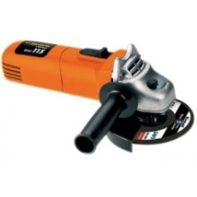 |  | 4º. Grinding welds | Piece C x 4 unit
CHASSIS |  | Worksheet: CH2 |  |  | Element: Chassis front squad | Process: Manufacturing
MATERIAL |  |  | TOOLS | PROTECTIVE ELEMENTS | OPERATIONS | FINAL SCORE
Piece C X 2 unit. |  |  | 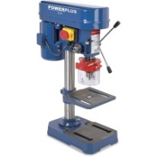 |  | 1º. Drill two through holes 8 mm diameter. | Piece D x 2 unit  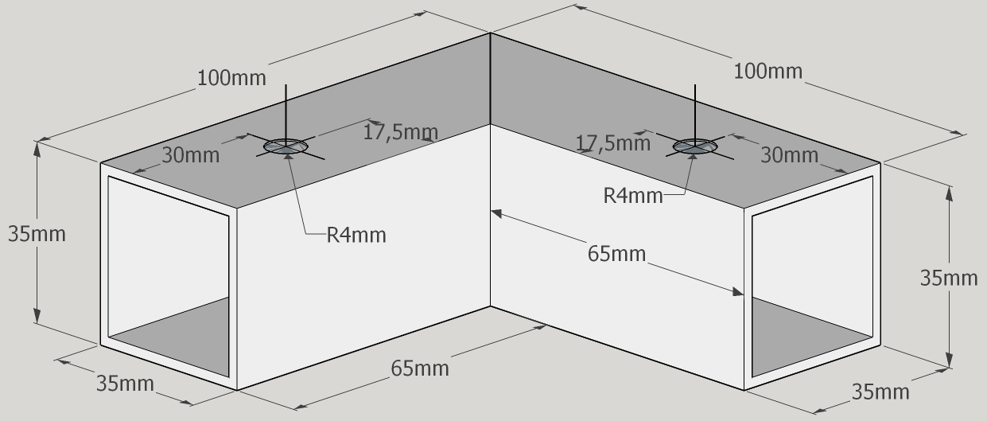
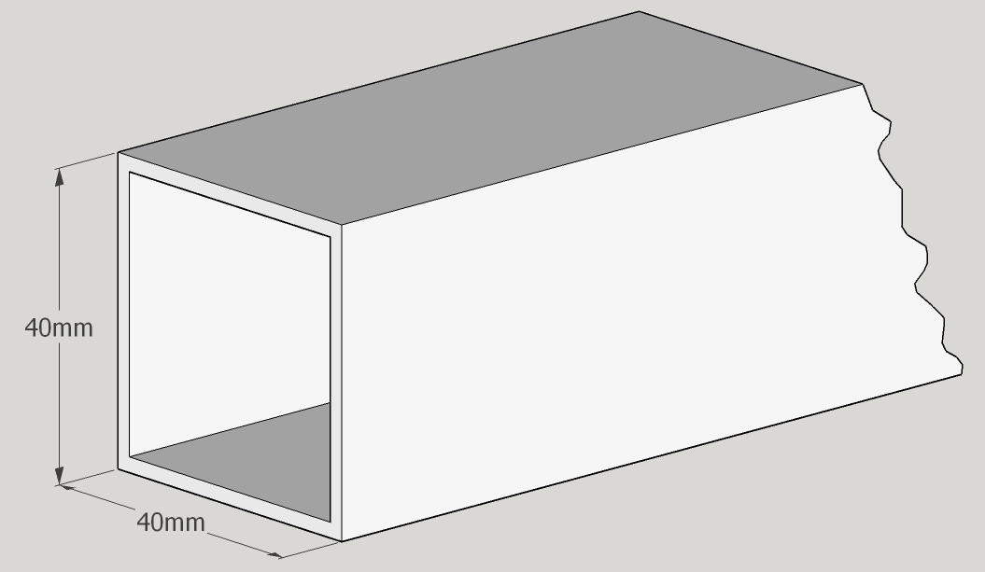  Square tube 40 x 40 mm |  |  | 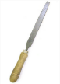  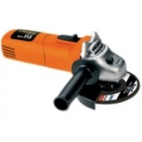  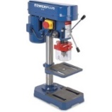 |  | 2º. Cut the square tube to 40 mm outer length.  3º. Deburring.  4º. Cut a side of the piece.  5º. Drill a trough hole 8 mm diameter. | Piece E x 2 unit  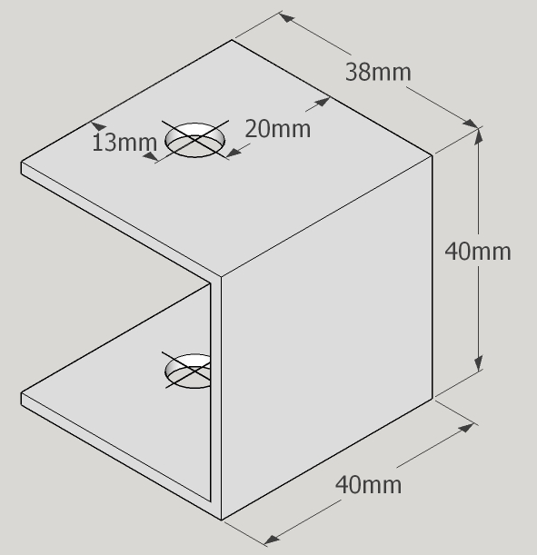
MATERIAL |  |  | TOOLS | PROTECTIVE ELEMENTS | OPERATIONS | FINAL SCORE
Square tube 35 x 35 mm |  |  |  |  | 6º. Cut the square tube to 35 mm outer length.  7º. Deburring. | Piece F x 4 unit  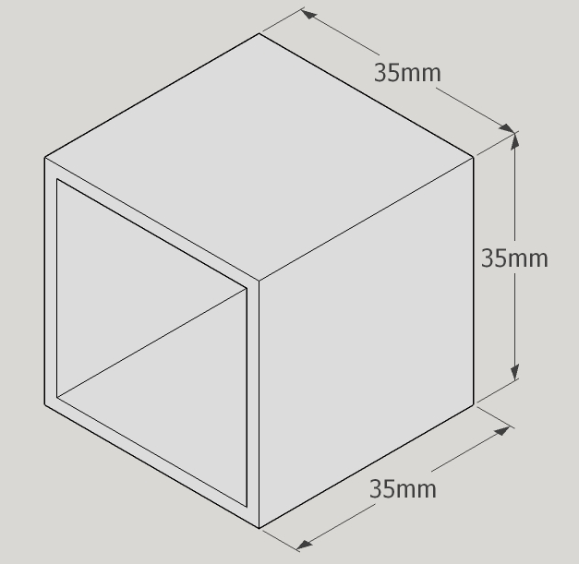
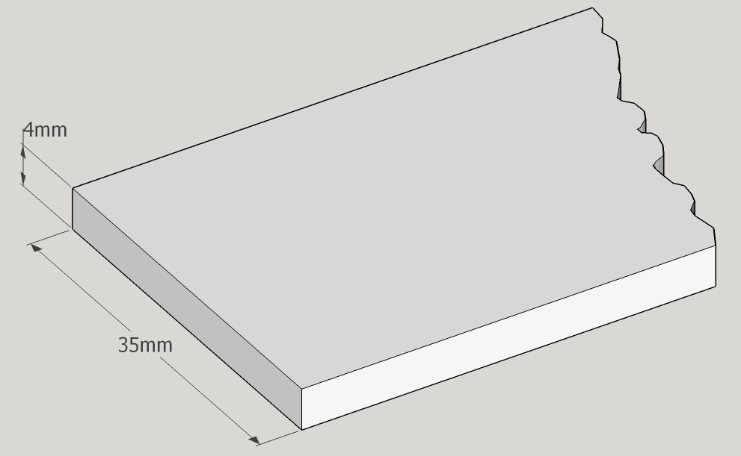  Plate 35 mm. |  |  |  |  | 8º. Cut the plate to 40 mm outer length.  9º. Deburring.  10º. Drill a trough hole 8 mm diameter. | Piece G x 4 unit  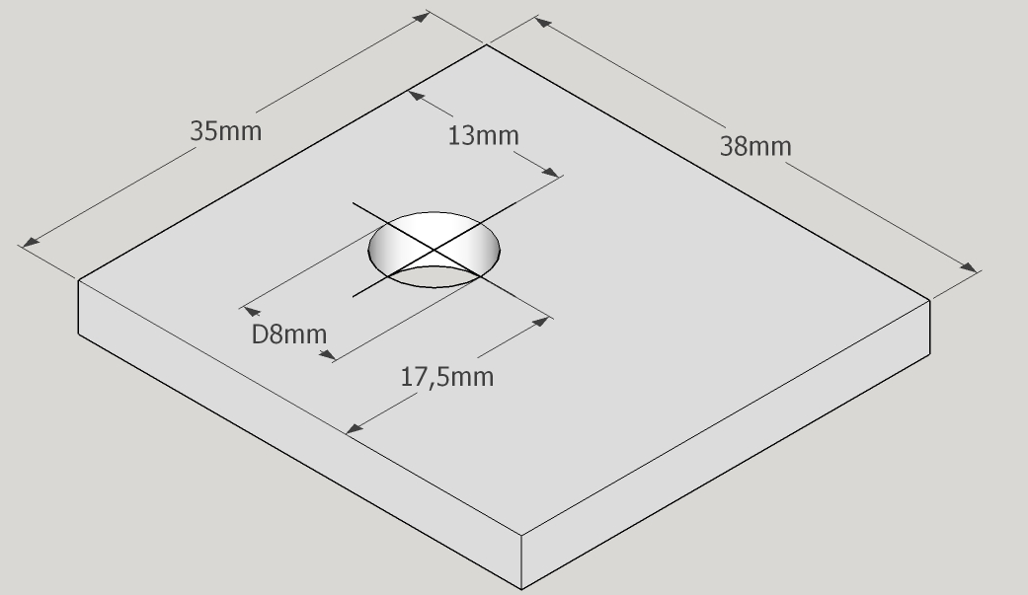
MATERIAL |  |  | TOOLS | PROTECTIVE ELEMENTS | OPERATIONS | FINAL SCORE
Piece G X 4 unit. Piece E x 2 unit |  |  |  |  | 11º. Two plates welded to the part E. | Piece H x 2 unit  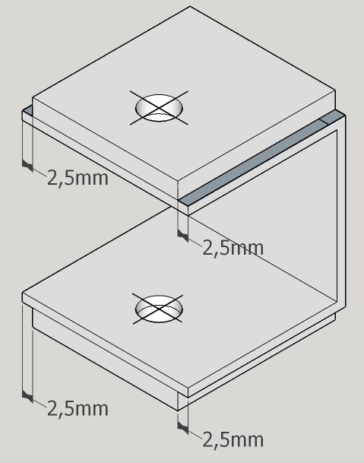
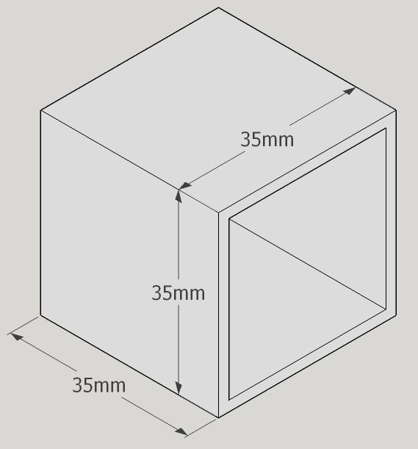  Piece H x 2 unit Piece F x 2 unit |  |  |  |  | 12º. Weld the two pieces. | Piece J x 2 unit  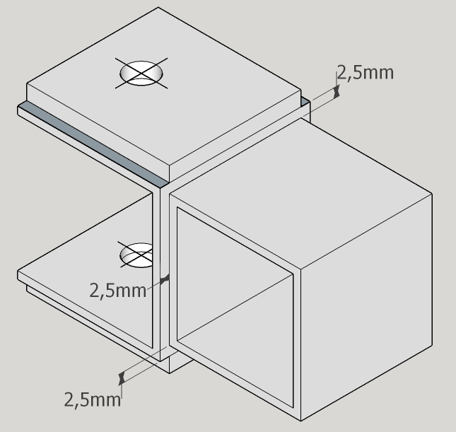
MATERIAL |  |  | TOOLS | PROTECTIVE ELEMENTS | OPERATIONS | FINAL SCORE
Piece J x 1 unit Piece D x 1 unit |  |  |  |  | 13º. Weld the two pieces. | Right front bracket K x 1 unit  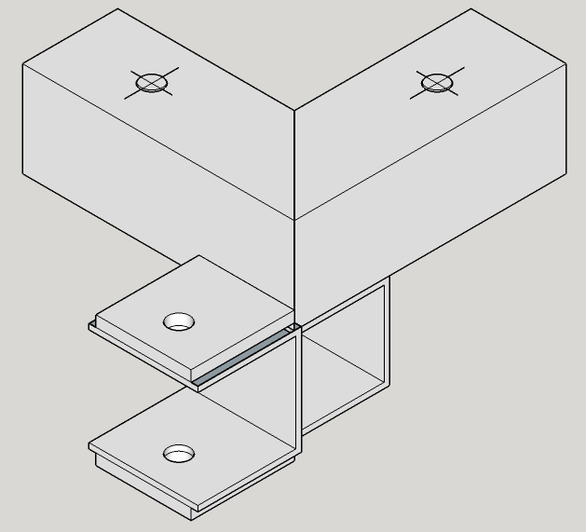
Piece J x 1 unit Piece D x 1 unit |  |  |  |  | 14º. Weld the two pieces. | Left front bracket K x 1 unit  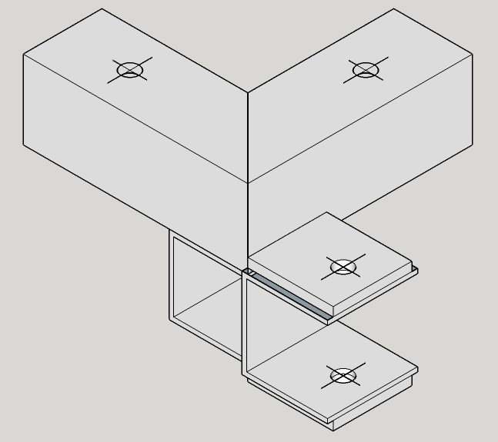
CHASSIS | Worksheet: CH3 |  |  |  | Element: Chassis back squad | Process: Manufacturing
MATERIAL |  |  | TOOLS | PROTECTIVE ELEMENTS | OPERATIONS | FINAL SCORE
Piece C x 2 unit |  |  |  |  | 1º. Drill two through holes 8 mm diameter. | 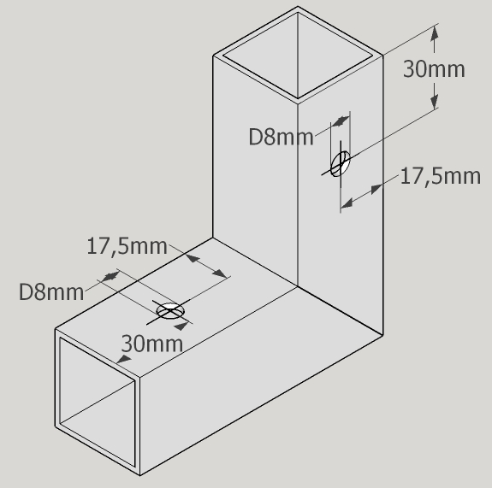Piece L x 2 unit
Piece F x 2 unit Piece L x 2 unit |  |  |  |  | 2º. Weld the two pieces. | 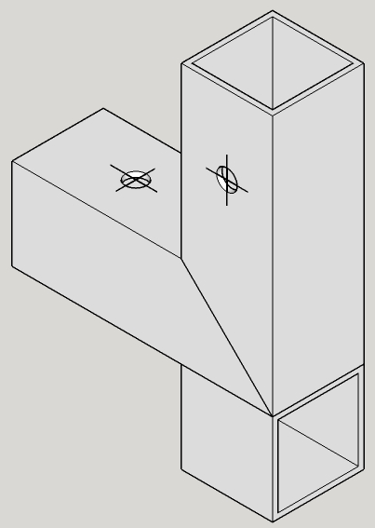Piece M x 2 unit
MATERIAL |  |  | TOOLS | PROTECTIVE ELEMENTS | OPERATIONS | FINAL SCORE
Square tube 40 x 40 mm |  |  | 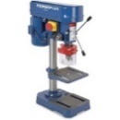 |  | 3º. Cut the square tube to 40 mm outer length.  4º. Deburring.  5º. Cut a side of the piece.  6º. Drill a trough hole 10 mm diameter.  7º. Round with hand grinder | 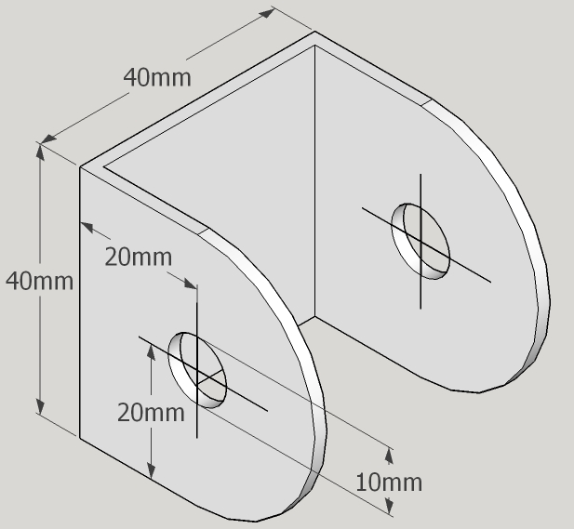Piece N x 2 unit
Piece N x 1 unit Piece M x 1 unit |  |  |  |  | 8º. Weld the two pieces. | Left back bracket P x 1 unit  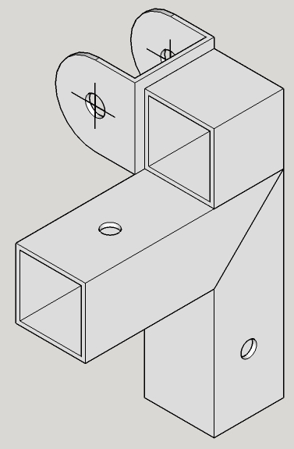

MATERIAL |  | TOOLS | PROTECTIVE ELEMENTS | OPERATIONS | FINAL SCORE
Piece N x 1 unit Piece M x 1 unit |  |  |  | 9º. Weld the two pieces. | Right back bracket Q x 1 unit  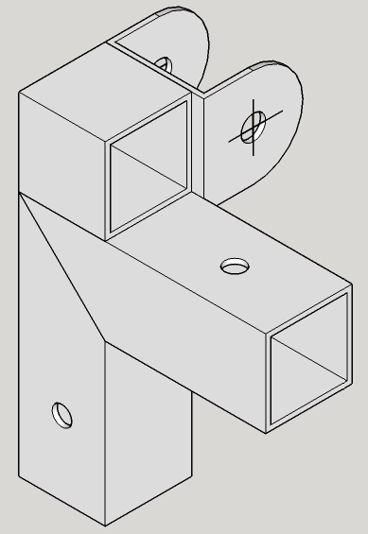
CHASSIS | Worksheet: CH4 |  |  | Element: Stringers and crosspieces | Process: Manufacturing
MATERIAL |  | TOOLS | PROTECTIVE ELEMENTS | OPERATIONS | FINAL SCORE
Square tube 40 x 40 mm |  | 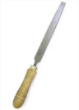  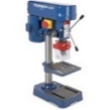 |  | 1º. Cut the square tube to 1215 mm outer length.  2º. Deburring.  3º. Drill two trough hole 8 mm diameter. | 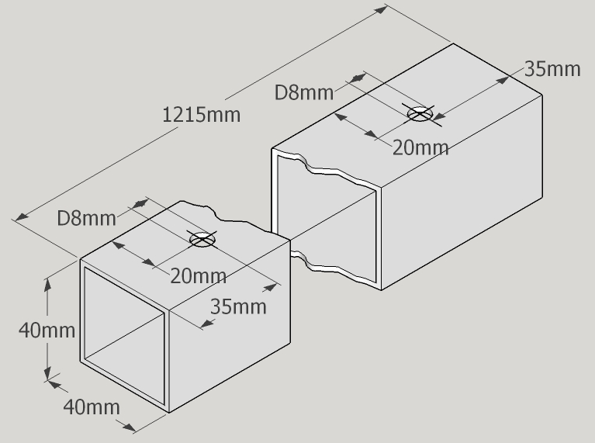Piece R X 2 unit.
Square tube 40 x 40 mm |  |  |  | 4º. Cut the square tube to 510 mm outer length.  5º. Deburring.  6º. Drill two trough hole 8 mm diameter. | Piece S x 1 unit  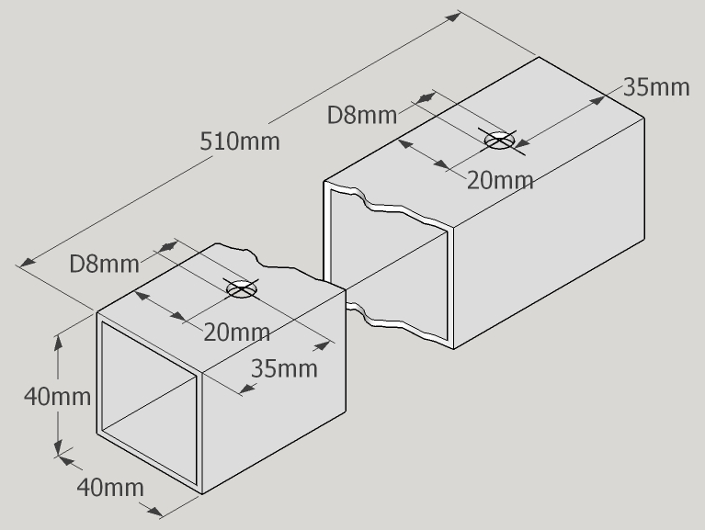
MATERIAL |  | TOOLS | PROTECTIVE ELEMENTS | OPERATIONS | FINAL SCORE
Square tube 40 x 40 mm |  |  |  | 7º. Cut the square tube to 510 mm outer length.  8º. Deburring.  9º. Drill two trough hole 8 mm diameter. | Piece T x 2 unit  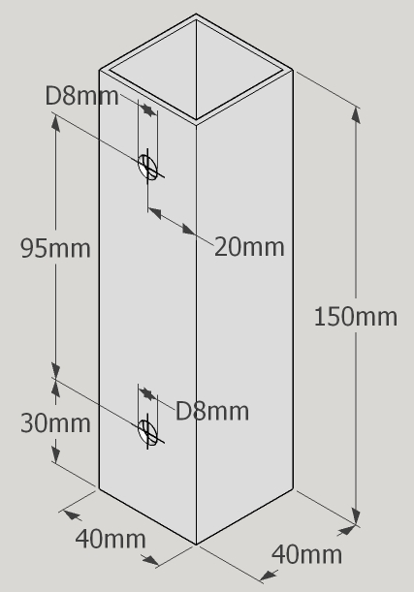
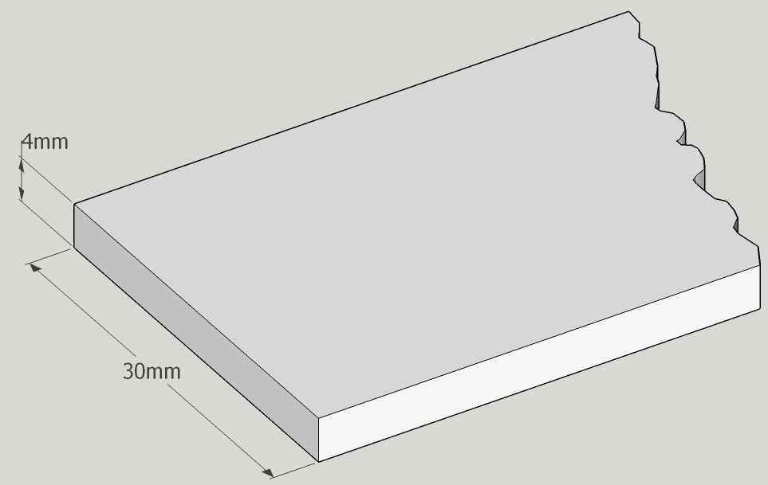  Plate 30 mm. |  |  |  | 10º. Cut the plate to 510 mm outer length.  11º. Deburring.  12º. Drill two trough hole 8 mm diameter. | Piece U x 2 unit  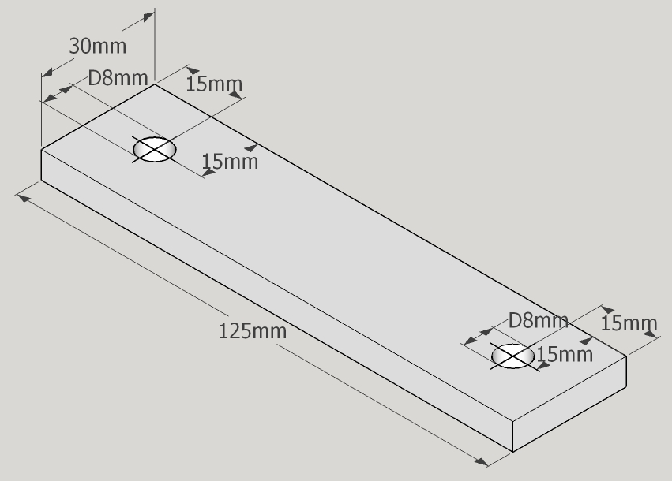
MATERIAL |  | TOOLS | PROTECTIVE ELEMENTS | OPERATIONS | FINAL SCORE
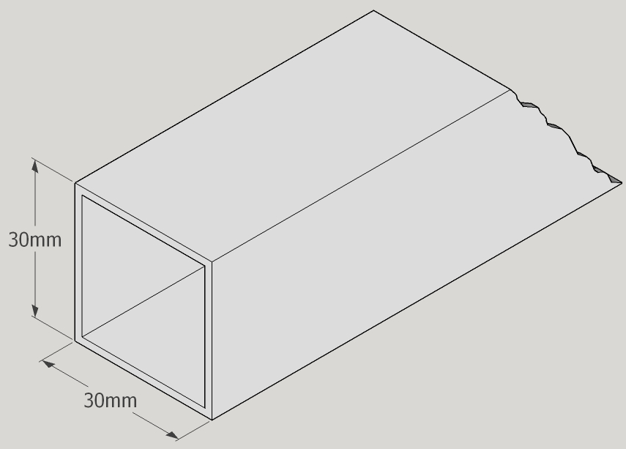Square tube 40 x 40 mm |  |  |  | 13º. Cut the square tube to 492 mm outer length.  14º. Deburring. | 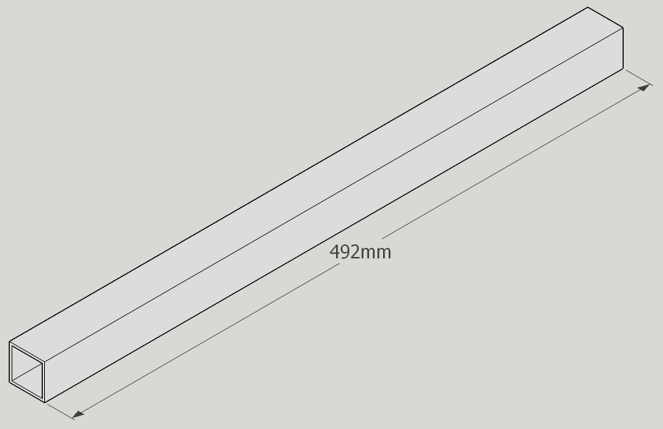Piece V x 1 unit
Piece U x 2 unit Piece V x 1 unit |  | 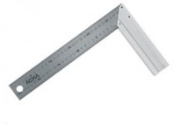  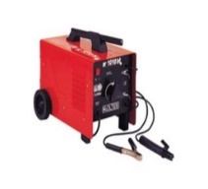 |  | 15º. Weld the three pieces. | Piece W x 2 unit  