STUB AXLES | Worksheet: SX2 |  |  | Element: Rear stub axle | Process: Manufacturing
MATERIAL |  | TOOLS | PROTECTIVE ELEMENTS | OPERATIONS | FINAL SCORE
Square tube 40 x 40 mm |  | 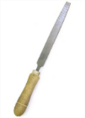  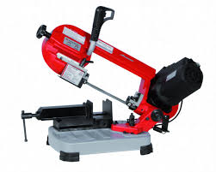  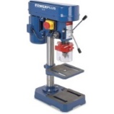 |  | 1º. Cut the square tube to 40 mm outer length.  2º. Deburring.  3º. Drill two hole 20 mm diameter. | Piece A X 2 unit.
Piece H (SX1) X 2 unit. Piece A X 2 unit. |  | 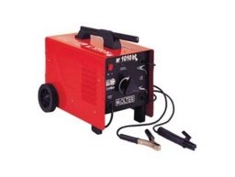 |  | 4º. Weld the two pieces. | Piece B X 2 unit.
MATERIAL |  | TOOLS | PROTECTIVE ELEMENTS | OPERATIONS | FINAL SCORE
Square tube 35 x 35 mm |  | 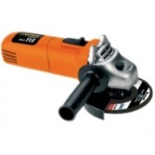  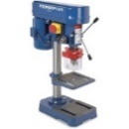  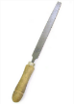 |  | 5º. Cut the square tube to 40 mm outer length.  6º. Deburring.  7º. Cut a side of the piece.  8º. Drill a trough hole 10 mm diameter.  9º. Round with hand grinder. | Piece C X 6 unit.
Piece B X 2 unit. Piece C X 4 unit. |  |  |  | 10º. Cut the plate to 134 mm outer length.  11º. Deburring.  12º. Drill a hole 8 mm diameter. | Piece D X 2 unit.

