EEVEE second learning meeting
7 – 14 th Febrary 2017, Seville, Spain

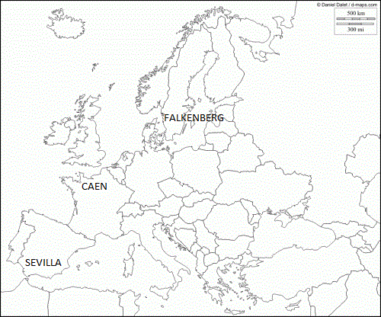

Schedule
Wednesday, 7th Feb | Partner students’ arrival
12:15  17:00 | French students go to host families  Swedish students go to host families
Thursday, 8th Feb
08:30 – 09:30 | Welcome to Director and European Coordinator Salesians Trinidad.  Presentation of Sevilla  School presentations “Spanish team k2, Swedish team K2 and French team K2”
09:30 – 11:00 | Students: Ice breaking activities  Teachers: First Meeting and visit to School
11:00 – 11:30 | Break
11:30 – 14:00 | First activity Mathematics workshops in teams (Group 1 students)  First Technical activity workshops in teams (Group 2 students)
14:00 – 15:30 | Lunch break at restaurant
15:30 – 17:30 | First activity Mathematics workshops in teams (Group 2 students)  First Technical activity workshops in teams (Group 1 students)
17:30 – 19:30 | Visit to Seville students and teachers (Visit to the viewpoint of the “Setas”)
19:30 – 22:00 | Teachers: Walking to Sevilla till Triana Quarter and dinner
Friday, 9th Feb
08:15 – 08:30 | Welcome
08:30 – 11:00 | Students: Sport activities and visit to school  Teachers: Second Meeting
11:00 – 11:30 | Break
11:30 – 14:00 | Second Technical activity workshops in teams (Group 1 students)  Third Technical activity workshops in teams (Group 2 students)
14:00 – 15:30 | Lunch break at restaurant
15:30 – 17:30 | Second Technical activity workshops in teams (Group 2 students)  Third Technical activity workshops in teams (Group 1 students)
Saturday, 10th Feb  10:00 – 17:00 | Cultural tour to Seville  - Alcázar  - Spain Square  - María Luisa Park  - Boat trip on the Guadalquivir river
Sunday, 11st Feb | Students by their host families
Monday, 12nd Feb
08:15 – 08:30 | Welcome
08:30 – 11:00 | Second activity Mathematics workshops in teams (Group 1 and 2 students)
11:00 – 11:30 | Break
11:30 – 14:00 | Meeting: Electric Vehicles (BMW, Nissan and Volkswagen)
14:00 – 15:30 | Lunch break at restaurant
15:30 – 17:30 | Fourth Technical activity workshops in teams (Group 1 and 2 students) Final Technical activities.  Teachers; Third Meeting
17:30 – 21:00 | Games and official snack/dinner in school with students and host families
Tuesday, 13hd Feb
08:15 – 08:30 | Welcome
08:30 – 10:00 | Students: Documentary videos and pictures preparations  Teachers: Fourth Meeting
10:00 – 11:00 | Showing students’ documentary videos and pictures. Group picture
11:00 – 11:30 | Break
11:30 – 14:00 | Meeting: Repsol autogas efficient vehicles
14:00 – 15:30 | Lunch break at restaurant
15:30 – 17:00 | Meeting Evaluation and Closing sesión
20:00 – 22:00 | Teachers: Official dinner in restaurant with direction
Wednesday, 14th Feb
Partner students departure
in groups in classes depending on departure time

