STUB AXLES | Worksheet: SX1 |  |  | Element: Front stub axle | Process: Manufacturing
MATERIAL |  | TOOLS | PROTECTIVE ELEMENTS | OPERATIONS | FINAL SCORE
Square tube 35 x 35 mm |  | 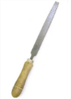  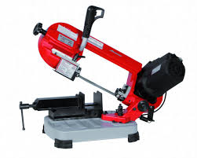 |  | 1º. Cut the square tube to 70 mm outer length.  2º. Deburring. | Piece A X 1 unit.
Piece A X 1 unit. |  | 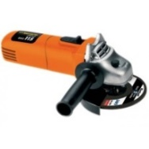 |  | 3º. Cut into round one end of the piece | Piece B X 2 unit.
MATERIAL |  | TOOLS | PROTECTIVE ELEMENTS | OPERATIONS | FINAL SCORE
Square tube 35 x 35 mm |  | 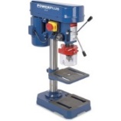 |  | 4º. Drill two hole 8 mm diameter. | Piece C X 2 unit.
Plate 30 mm. |  | 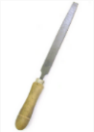 |  | 5º. Cut the plate to 134 mm outer length.  6º. Deburring.  7º. Drill a hole 8 mm diameter. | Piece D X 2 unit.
MATERIAL |  | TOOLS | PROTECTIVE ELEMENTS | OPERATIONS | FINAL SCORE
Piece D X 2 unit. Piece C X 2 unit. |  | 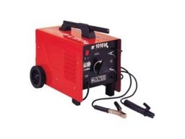 |  | 8º. Weld the two pieces. | Piece E X 2 unit.
Round bar of 20mm diameter |  |  |  | 9º. Cut the round bar to 132 mm outer length.  10º. Deburring. | Piece F X 4 unit.
MATERIAL |  | TOOLS | PROTECTIVE ELEMENTS | OPERATIONS | FINAL SCORE
Piece F X 4 unit. |  | 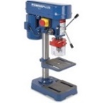  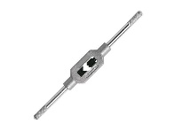  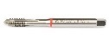 |  | 11º. Drill a trough hole 6,75 mm diameter and 20 mm length.  12º. Thread manufacture M8 x 20mm | Piece G X 4 unit.
Piece G X 4 unit. Washer 20 mm diameter x 4 unit. |  |  |  | 13º. Weld the two pieces. | Piece H X 4 unit.
MATERIAL |  | TOOLS | PROTECTIVE ELEMENTS | OPERATIONS | FINAL SCORE
Piece H X 1 unit. Piece E X 1 unit. |  |  |  | 14º. Weld the two pieces. | Piece J X 1 unit. (Right)
Piece H X 1 unit. Piece E X 1 unit. |  |  |  | 15º. Weld the two pieces. | Piece K X 1 unit. (Left)

