ERASMUS

STUDY OF THE FRAME

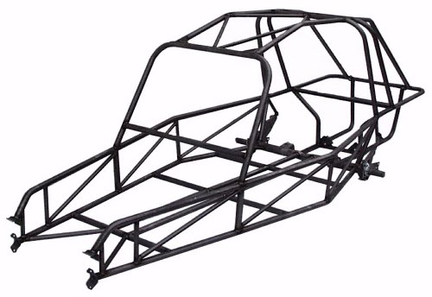

Functional specifications
Cost
Driver
Road
FC1
FC2
FC3
FC6

Organs of the vehicle

FP2
FP1
FC4
FC5

Frame

Regulation
Environment

FP1 : Connect all the organs of the vehicle on the road
FP2 : Protect the driver of the outside environment
FC1 : Respect the regulations
FC2 : Resist the attacks of the outside environment
FC3 : Participate in a good stability on the road
FC4 : Must be adapted to the user
FC5: Assure the connection of all the components
FC6 : Limit manufacturing costs and of use
To respect the imperatives bound to the functions FC3 and FC6, we settle the following criteria:

Mark | Function | Criterion of appreciation | Level
FC3 | Participate in a good stability on the road | Displacement  Maxi stress | 3 mm  25 Mpa
FC6 | Limit the costs to the use | Mass | Less than40 kg

STUDY OF PROFILES AND MATERIALS
Complete the picture(board) this below highlighting the various resistances according to profiles and materials (see secondary 1).
Profiles | Materials | Mass  (Kg) | Elastic resistance  (Mpa,N/mm²) | Stress  (Mpa,N/mm²) | Displacement  (mm)
30x30 | Plein carbon stell |  | 220 MPa
30x30 | 5086  Alu |  | 76 MPa
40x40 | Plein carbon stell |  | 220 MPa
40x40 R | Plein carbon stell |  | 220 MPa
40x40 | 5086  Alu |  | 76 MPa

In the reading of the results(profits), what profile corresponds at best to the specifications?
______________________________________________________________________________________________________________________________________
INFUENCE OF THE GEOMETRY OF THE FRAME

We are going to study the influence that a structure with triangulation with regard to a classic structure can have.
We shall use in both cases the same profile and the same material under an identical load.
Open by means of solidworks the file "structure" then proceed in the same way as previously

Geometry | Mass  (Kg) | Stress  (Mpa,N/mm²) | Displacement  (mm)



Which is the most resistant geometry ?
______________________________________________________________________________________________________________________________________

Let us study the influence that a reinforcement on the deformation of the frame can have.
Open the file " modified frame V6 with reinforcement with "solidworks 2014/2015" and study the following profile

Profiles | Materials | Mass  (Kg) | Elastic resistance  (Mpa,N/mm²) | Stress  (Mpa,N/mm²) | Displacement  (mm)
40x40 R | 5086  Alu |  | 76 MPa

This structure answers it the constraints put during the specifications?
______________________________________________________________________________________________________________________________________

SECONDARY 1
Open the file " modified frame V6 with reinforcement" with solidworks 2014/2015

1-In the menu solidworks choose tools then click add-ins


2- Choose solidworks simulation then click ok

1- Select the configuration 30x30 plein carbon steel


3- Click on run
2-Make a right click on 30x30 plein carbon steel then select Activate SW configuration

DISPLAY OF THE RESULTS

Click on mass properties


Make a right click on stress then select show

Make a right click on displacement then select show

Proceed in the same way to study the other configurations

