E.E.V.E.E.

Strength of materials

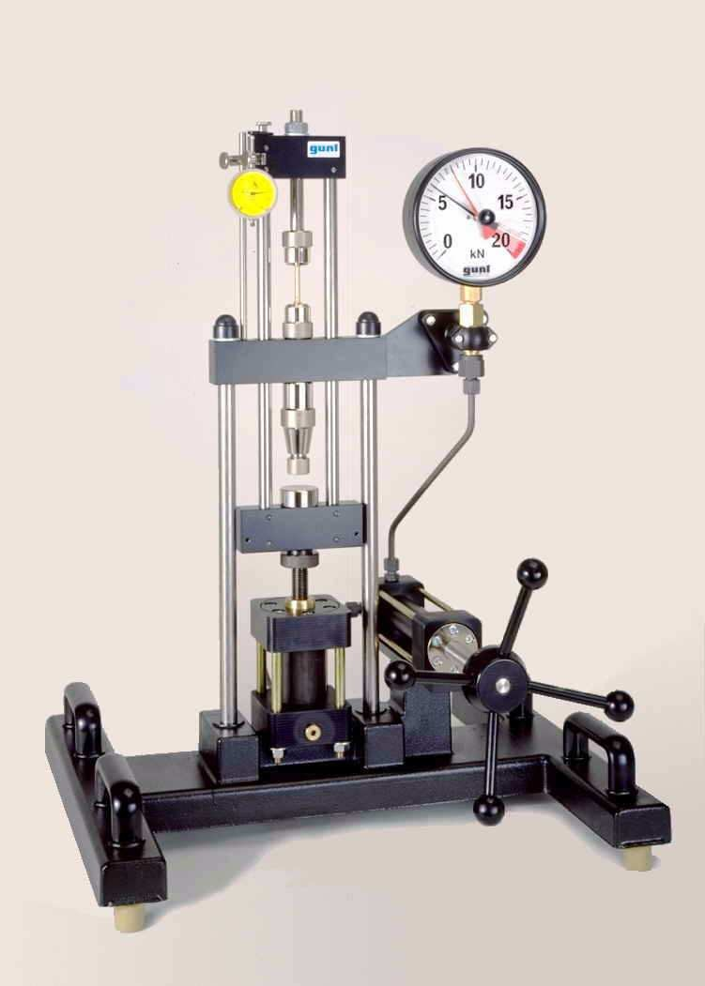

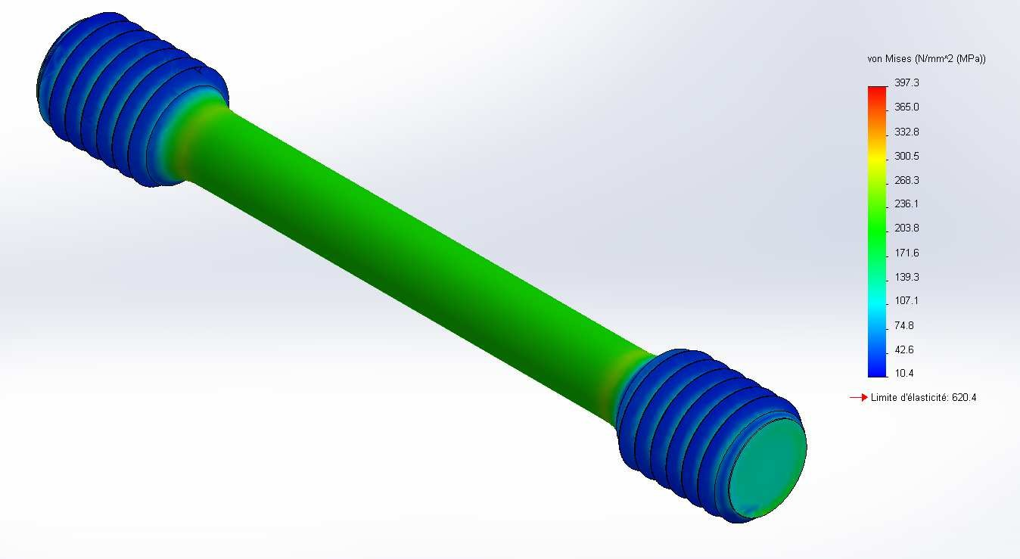

- Introduction:

The Strength Of Materials (SOM) study is a sometimes necessary step between the design and the realization of a part. She permits :
- to justify its sizing
- to determine the choice of materials
- to limit its cost.
It will also make it possible to evaluate its possible deformations, and thus its lifetime.

- Beam concept:

SOM is an experimental science, whose relationships are based on a model called a beam.
Beam is a solid whose section varies gradually.

The middle line of the beam is the place of the centers of surfaces of successive straight sections. The straight sections are the flat sections and perpendicular to the middle line of the beam.

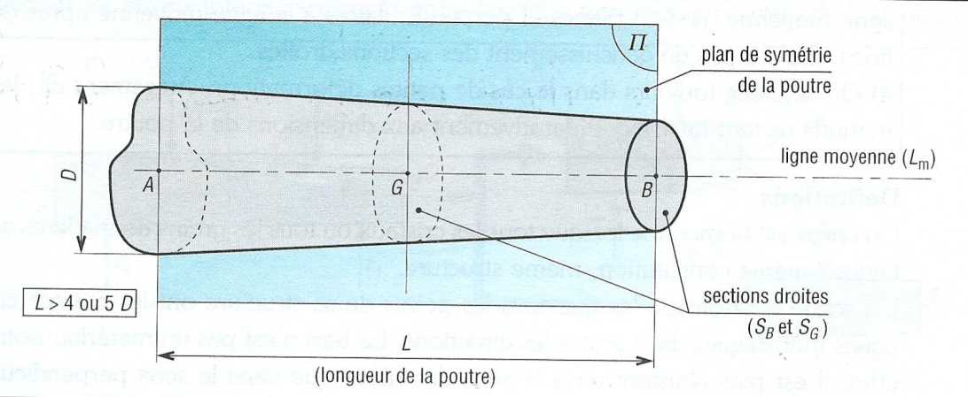

- Concept of solicitations:

The beam below is subject to external forces. The direction and direction of these efforts relative to the mean line define the type of solicitation that the beam undergoes.

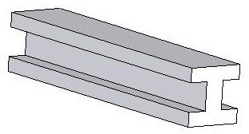

Simple solicitation

Traction:

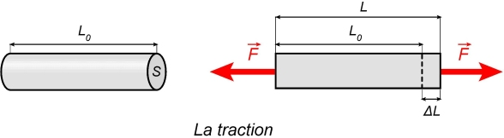

Shear:

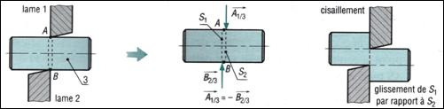

Torsion:
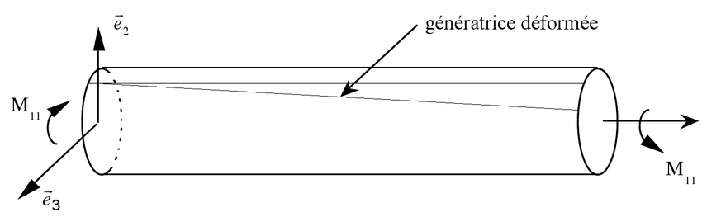

Flexion:

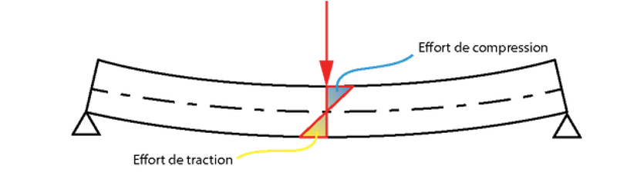

- Concept of constraints:

Constraints represent cohesive efforts in a solid that allow the material to withstand stresses.
Constraints arise from interaction between small parts of the material (crystals, molecules, etc.).

TRACTION

Principle and diagrams
The tensile test consists in exerting on a standardized tensile specimen increasing forces which will progressively deform it until rupture.
From this test, a number of characteristics of the material are deduced.

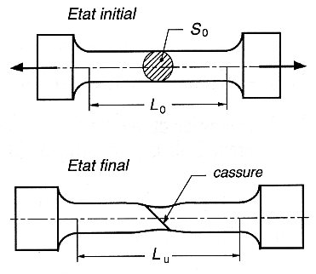

The traction machine imposes on the tensile specimen an increasing elongation ΔL / Lo and at the same time measures the resultant force with a dynamometer. A diagram is thus obtained according to the materials.

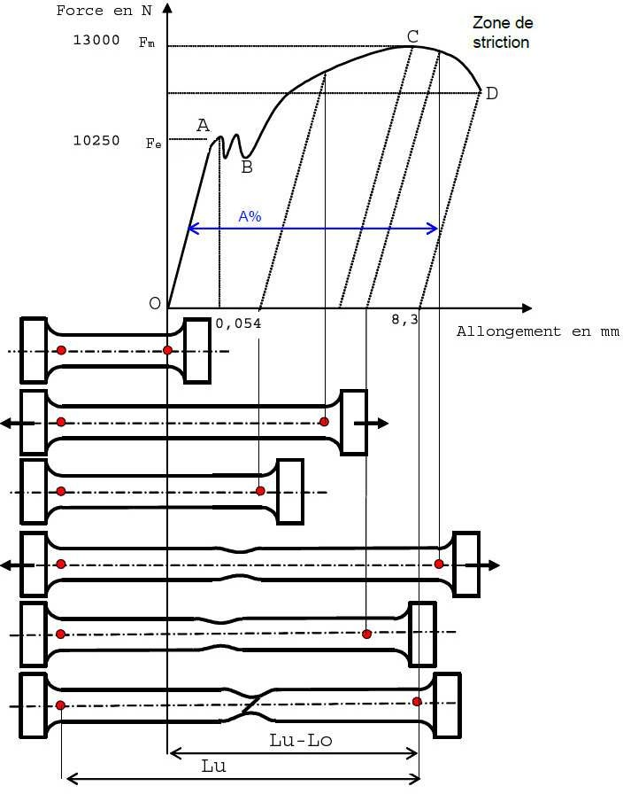
Fig 1

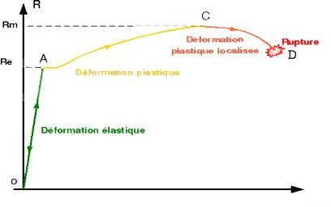
ε

We can distinguish three phases of deformation:

- From 0 to A: It is the elastic phase, where the deformation is reversible and proportional to the effort.

- From A to C: The permanent and homogeneous deformation is called plastic deformation. The material is cracking. The deformation is irreversible.

- From C to D: The deformation is no longer homogeneous, it occurs on a part of the tensile specimen, this phenomenon is called necking or localized plastic deformation.

- D: Break point of the tensile specimen.

We can also note two characteristic constraints:

Constraint = F / initial section in N / mm²

- Yield strength (Re): the elastic limit stress of the material.

- Tesile strength (Rm): the maximum stress, the tensile strength (maximum force applied to the specimen)

The testing machine:

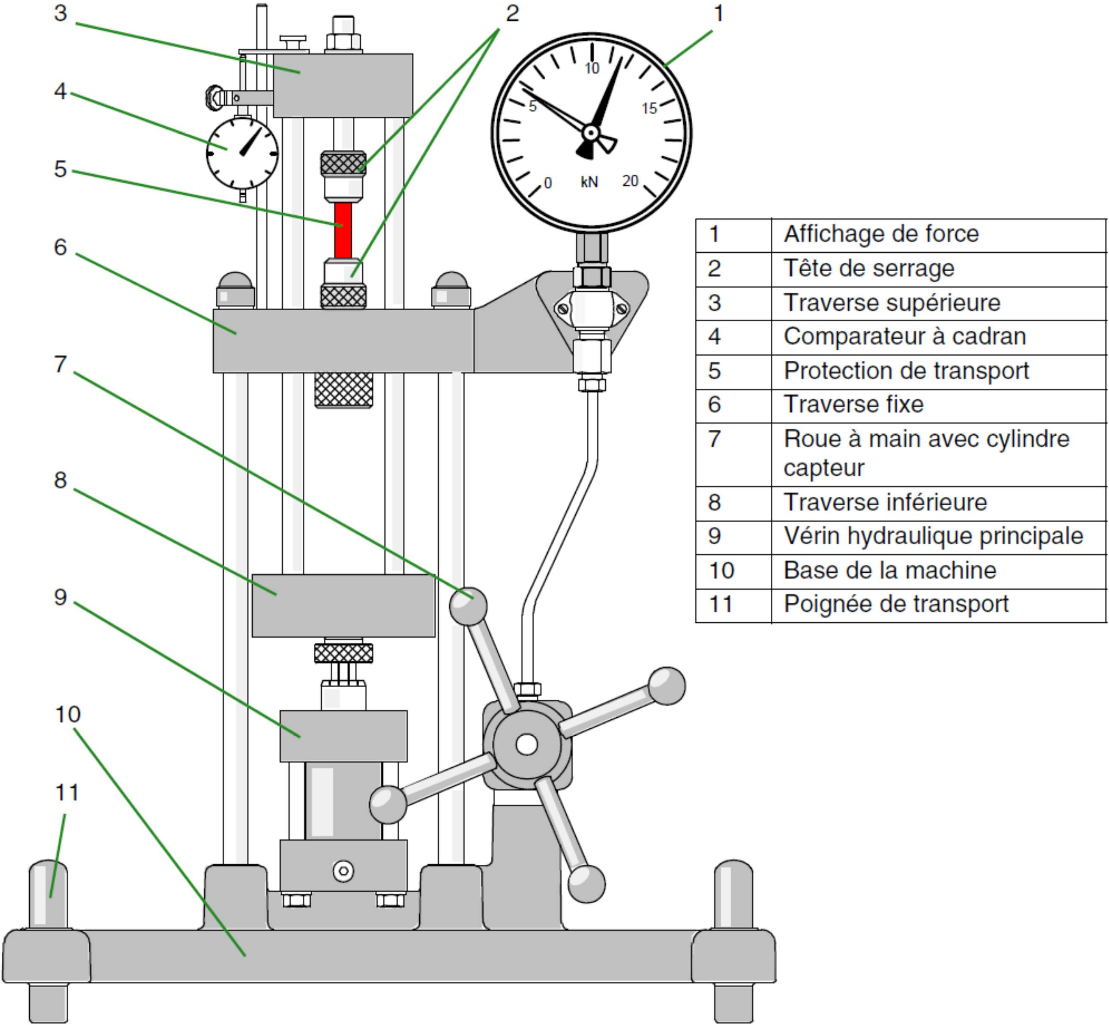
Never exceed 20kN under penalty of deterioration of the machine

Various tests can be performed on this machine. For traction, the tensile specimen will be fixed in the upper part of the machine (red test tube in the figure opposite).
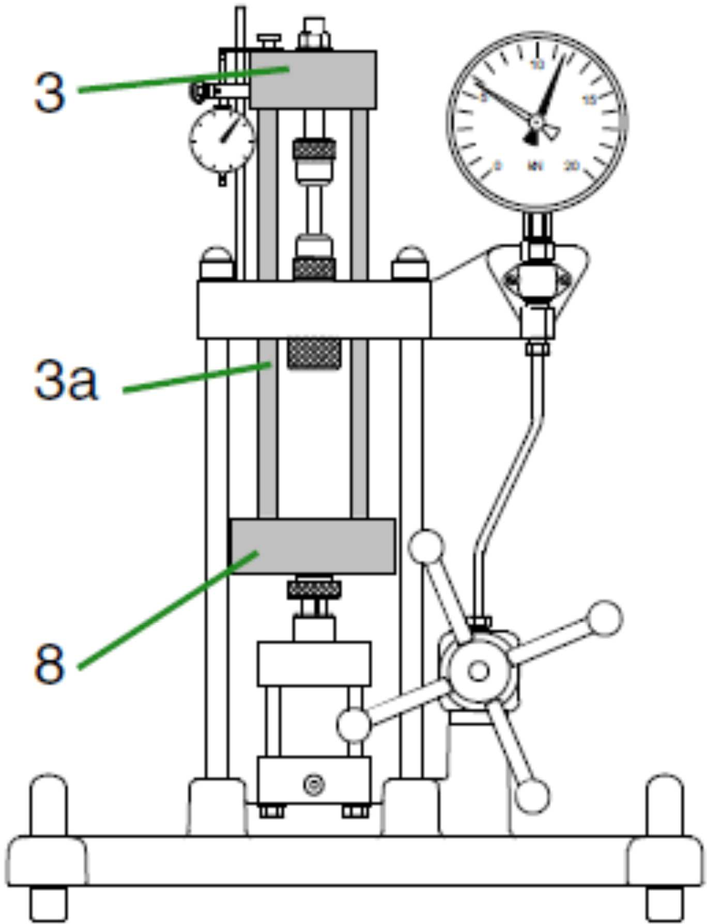

The tensile specimen is fixed between the fixed crosspiece 6 and the movable upper cross member 3 (gray zone in the figure opposite).
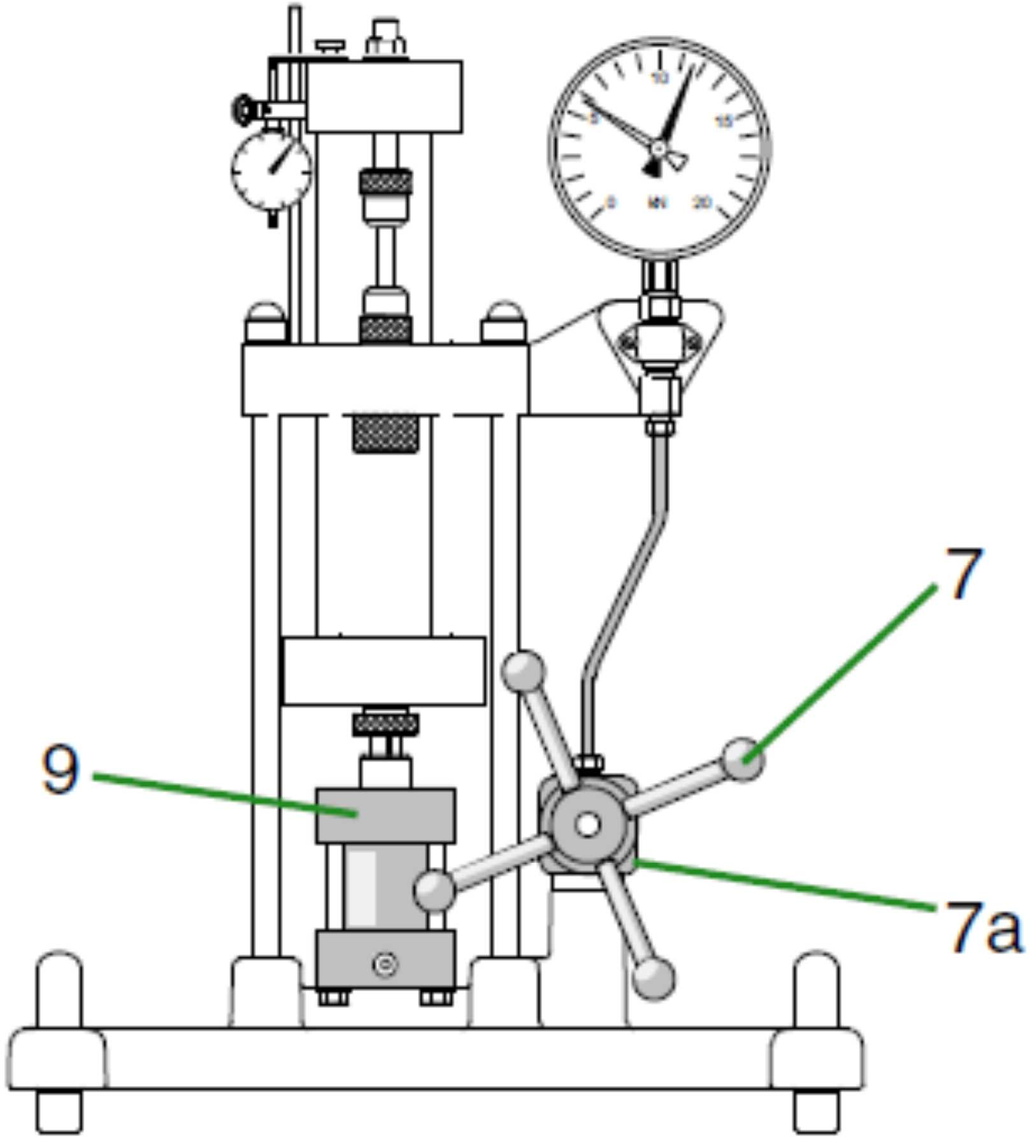

The force is generated hydraulically by manually operating the steering wheel (handwheel). The piston 9 makes it possible to convert the hydraulic energy into mechanical translation energy.
Operating mode:

A cylindrical sample with a length of 30 mm and a diameter of 6 mm is used. Different specimen materials are provided: annealed steel, copper, brass and aluminum.
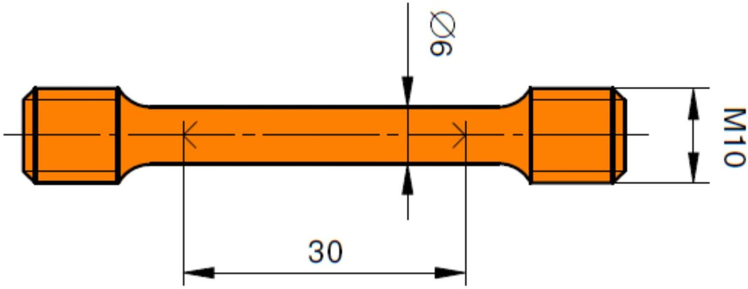

Preparation of the test

• Screw the pulling sample into the lower clamping head by hand until it stops.
• Screw the pulling sample into the upper clamping head until it stops, turn the clamping head by hand.
• Tighten the nut at the upper clamping head by hand until the clamping head is fixed without play in the upper cross member.
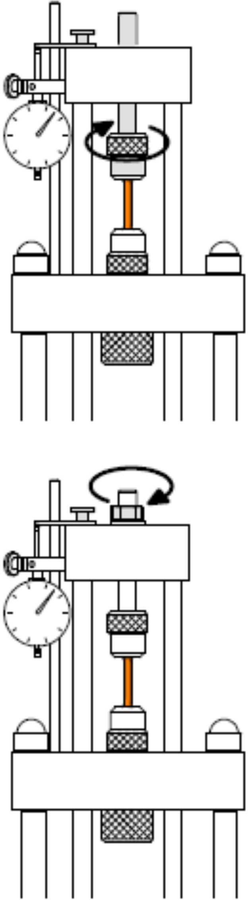
• Pre-force the specimen very slightly with the steering wheel.
• Set to zero the pointer resulting from the display of the force (in kN).
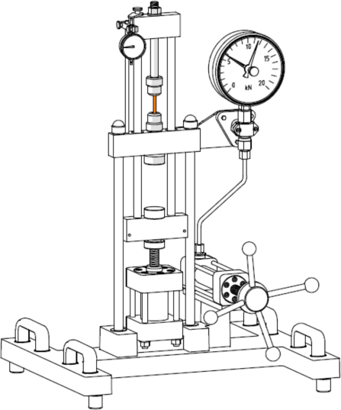
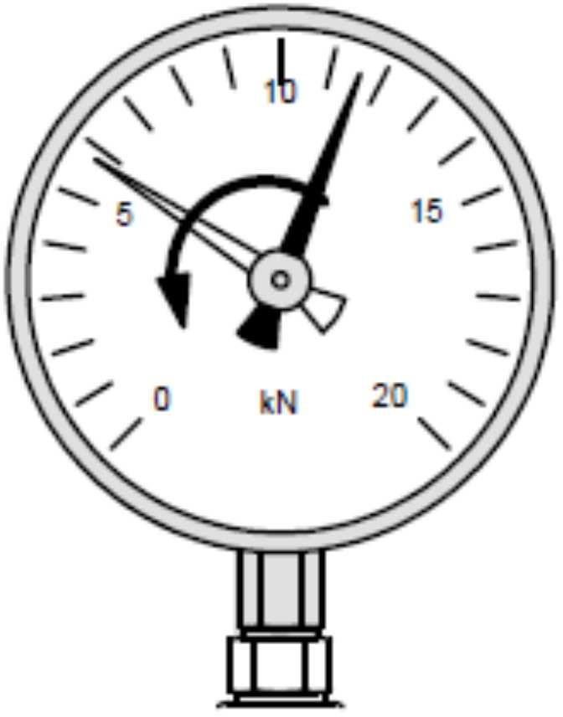
Display of the effort
Display of the deformation

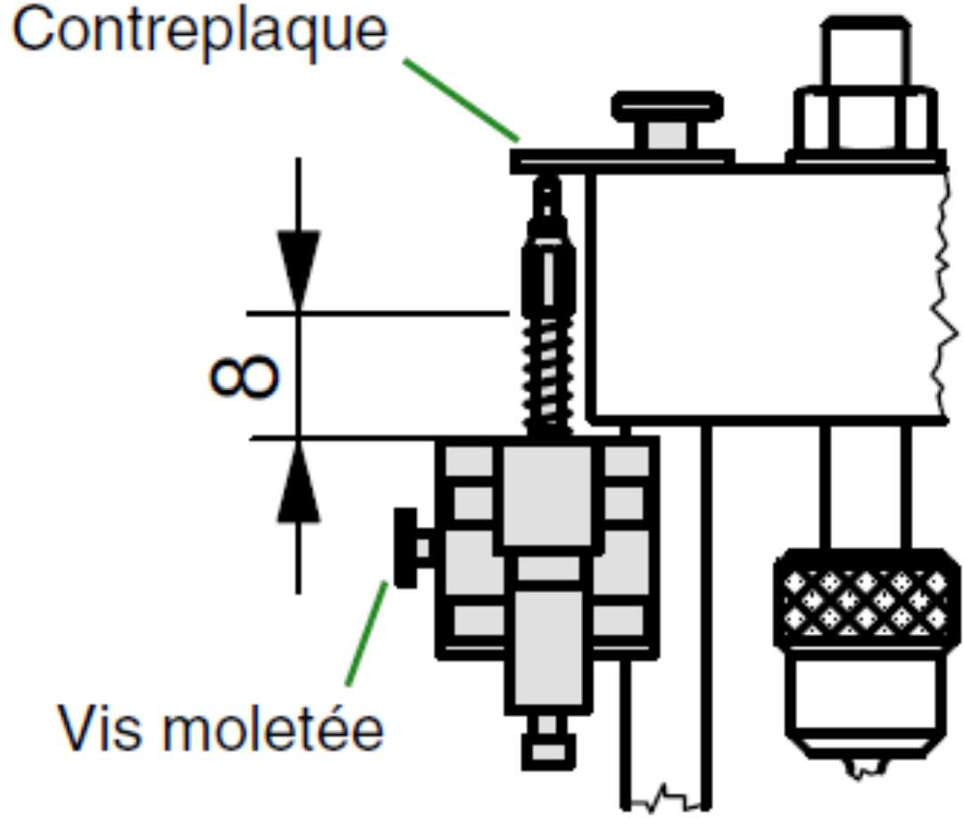
- Fix the displacement sensor for the acquisition unit WP 300.20 against the counter plate with a measuring distance of approximately 8 to 10 mm and lock it with the knurled screw.

• Launch the GUNT software

• Launch the software module for acquisition of the tensile test data via the menu
Start tensile test
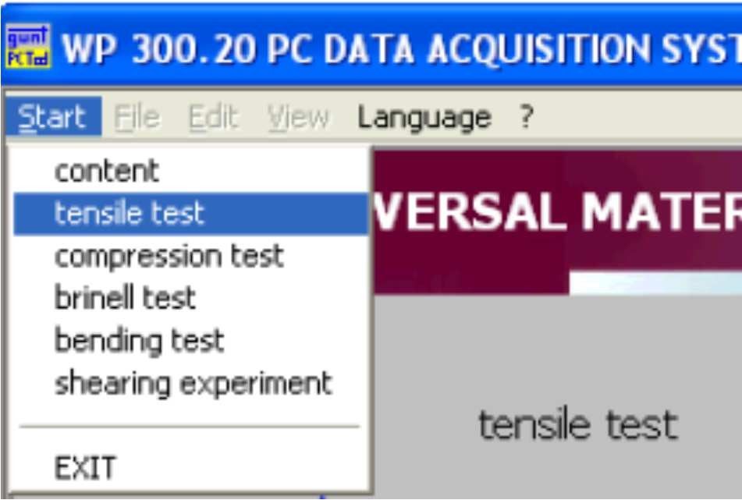

- Create a new project
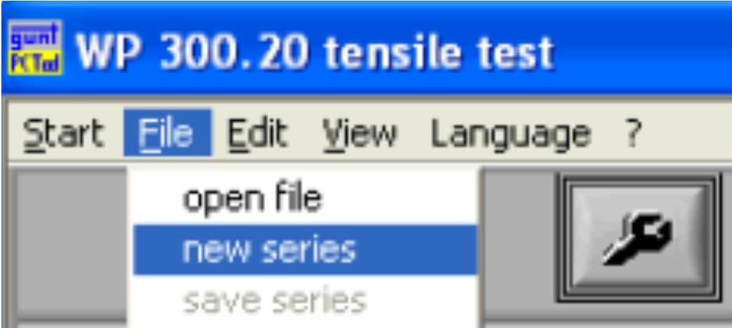

• Enter a name for the test in the "Name" field in the next dialog window. You can choose it freely. In addition, you can add a comment in the "Comment" field, for example to note special features.
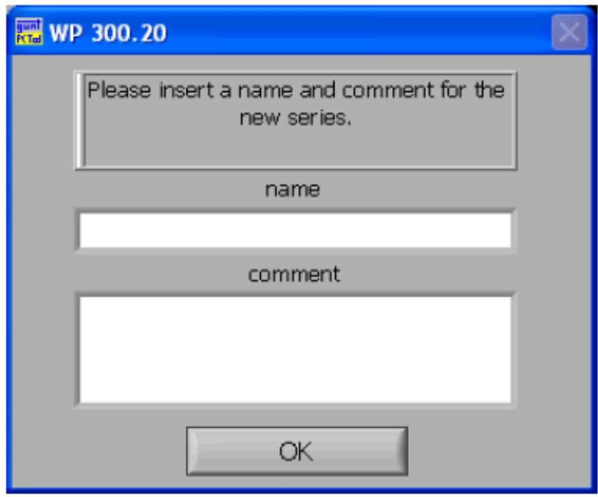

• Using the View Settings menu, open a dialog window where you can specify details about the pull sample and the data acquisition interval.
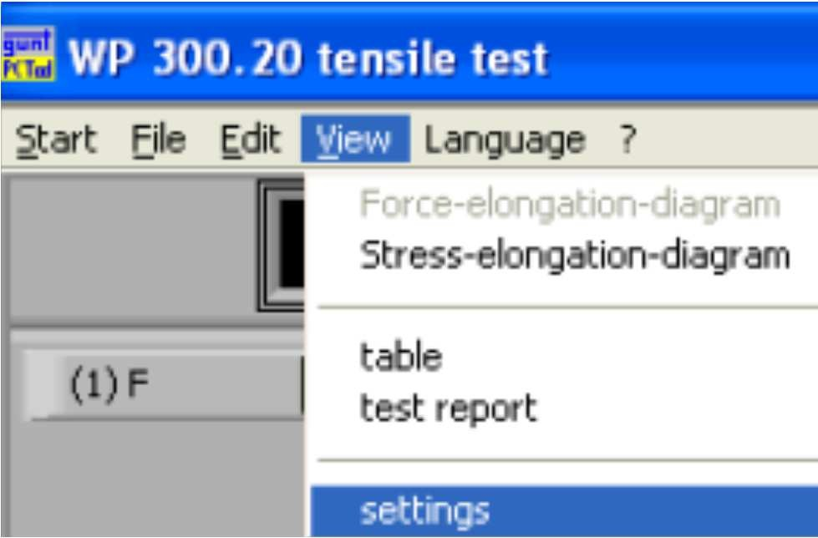
• In the "Specimen Type" field of the "Setup" dialog box that opens, check the type of draw sample used, either for a flat sample or for a round sample. Generally, round samples are used.

• Select the material of the tensile sample in the "material" field or enter a missing material via the define entry of the drop-down menu.

• Enter the tensile sample measurements in the fields
- Diameter of the test piece d0 in mm
- Initial length L0 in mm
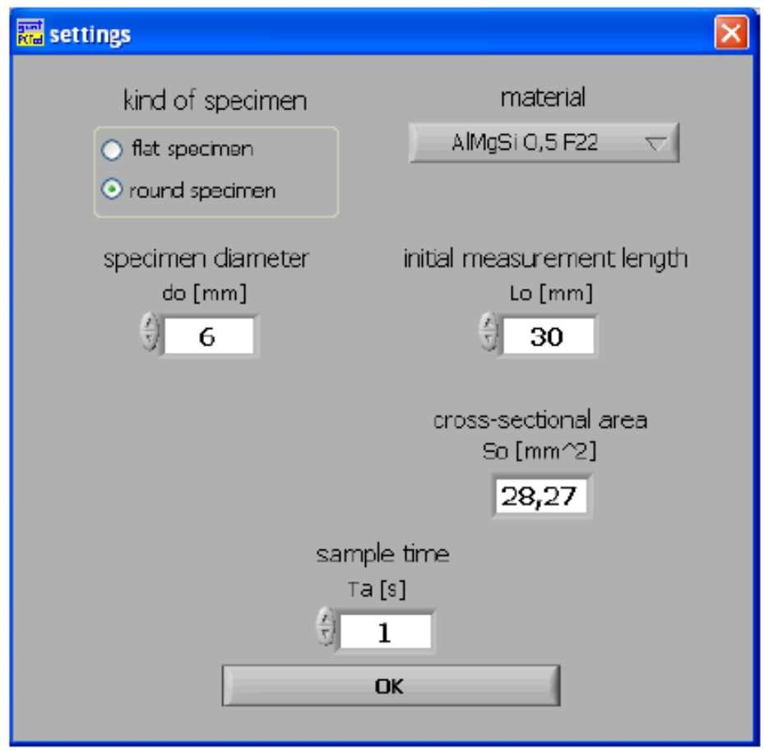

• The preparation of the project is finished. Now you have to calibrate the sensor values.
• Preload the sample slightly (max 0.5kN) to decrease the influence of games

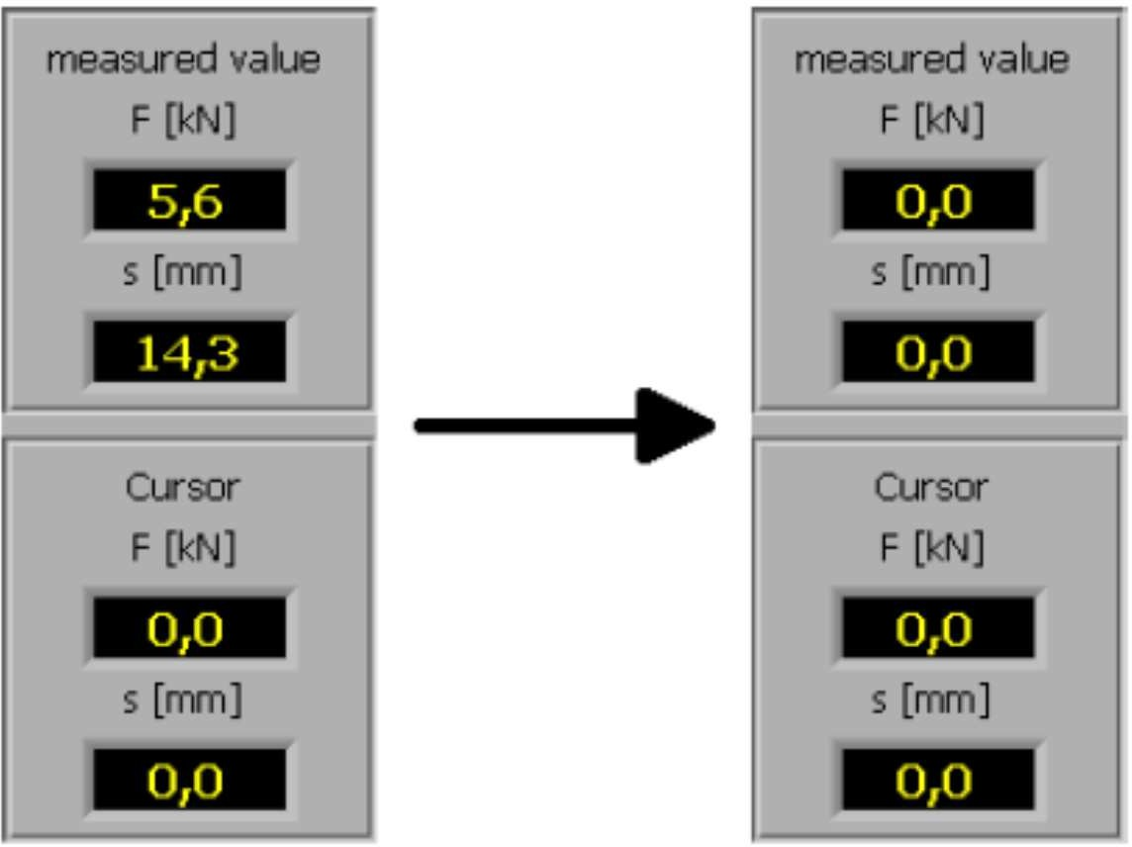

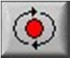
• Put all the displays of the software to ZERO

• Start data acquisition

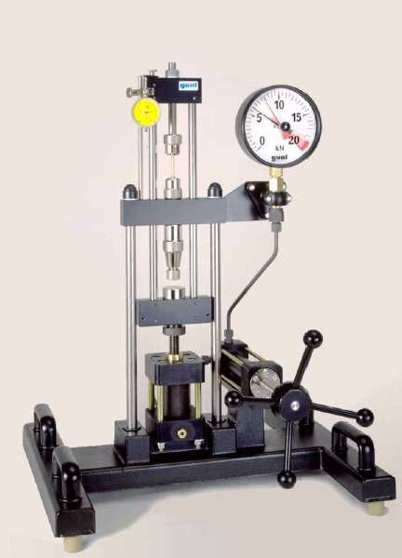
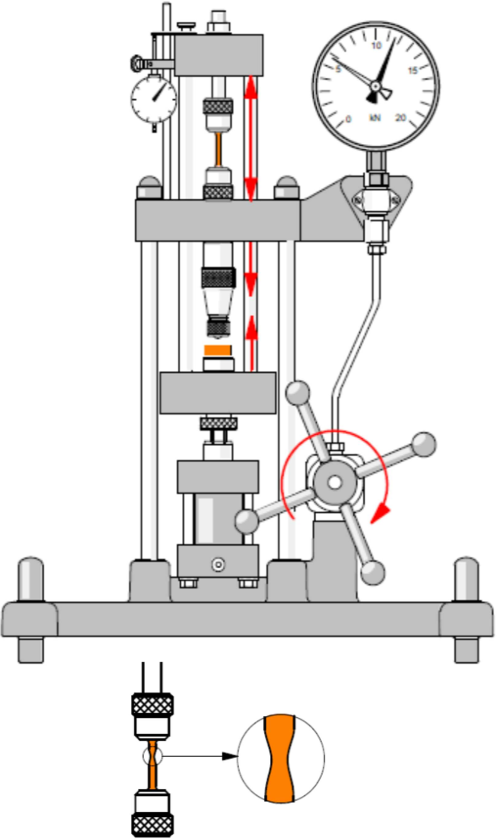
Realization of the test

• The traction sample is loaded slowly by turning the handwheel
regularly. Avoid any shock or shock;

• Observe the shape of the curve generated on the computer monitor

• Observe the section of the tensile specimen at all times;

• Observe the elongation either on the comparator or on the monitor;

• Observe the value of the force either on the dynamometer or
on the monitor;

• During necking, the force no longer increases but is reduced rather;

• Depending on the material of the tensile sample, the sample breaks off slowly or abruptly

• Raise the maximum force
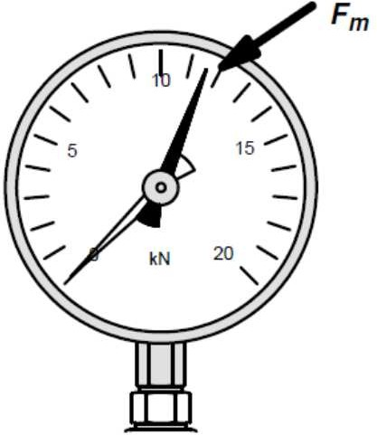

• Disassemble the tensile specimen.

Results of the test

To determine the length LF (final or ultimate length LU) of the tensile specimen piece after the rupture, the two ends of the sample are joined exactly at the breaking point and the distance between the two measurement marks is measured.
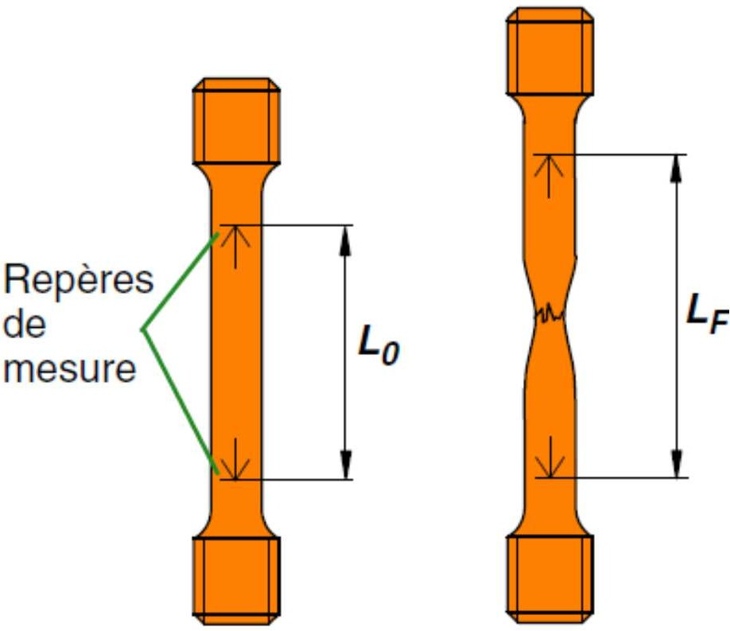

The values ​​obtained in a table are noted.

Sample N ° | Material | Fe in N | Fm in N | L₀ in mm | L_{F} in mm
1 | Steel
2 | Aluminum
3 | Copper
4 | Wood

Force in N

Lengthening in mm

From ore to steel
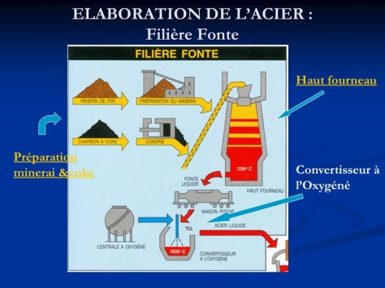
To transform the ore into cast iron, it must be melted. Coke (for combustion) is then mixed with the ore that has been previously prepared.

When the blast furnace reaches the temperature of 1250 ° C, we get melting.

The melt is then melted at 1600 ° C to be purified of the carbon contained in an oxygen converter. We get steel.
After various operations: continuous casting, rolling and / or drawing, and machining we obtain a finished Product.
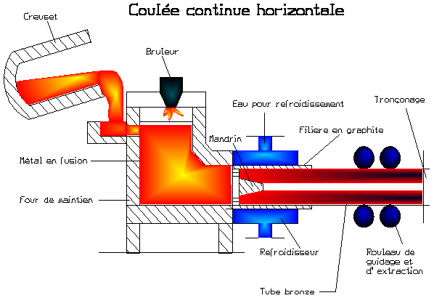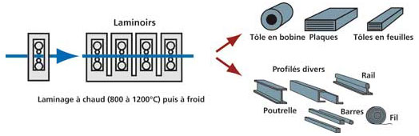
Steel: 100% recyclable
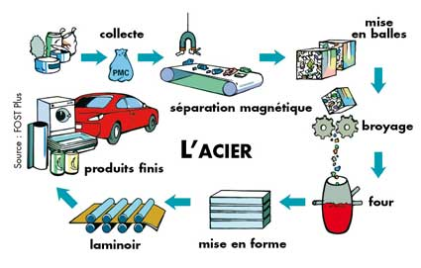

The iron and steel industry in Calvados
- The ore:
Soumont Saint Quentin
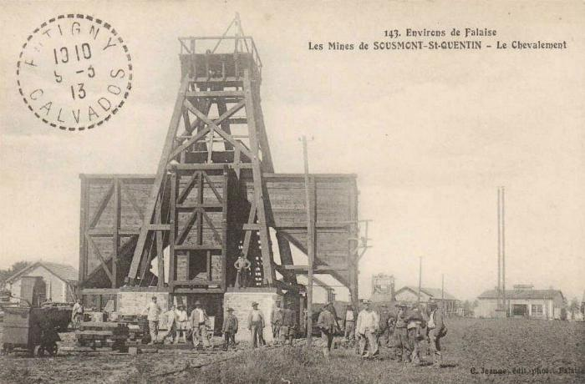 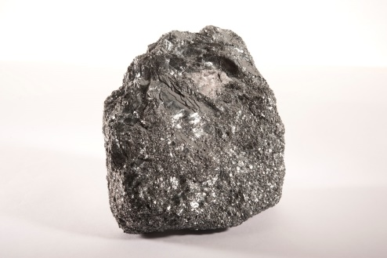iron-ore
In 1902, the Soumont-Saint-Quentin Concession was granted, covering an area of ​​773 hectares, making it the largest iron mine in the West. It is the SMS (Société des mines de Soumont) which is responsible for production. The activity will cease on July 28, 1989, following the decision of the SMN (Société metallurgique de Normandie), a single client of the mine, to use other types of ores.
- Blast furnaces:
Colombelles
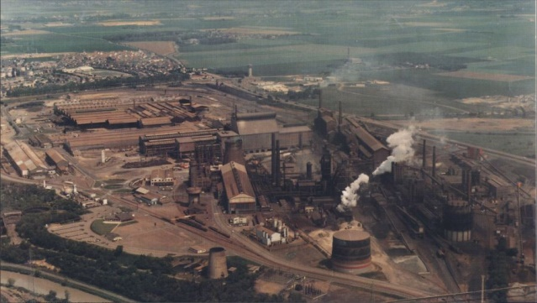
The Metallurgical Society of Normandy (SMN) was a Lower Normandy company launched in 1917 and closed in 1993, headquartered in Mondeville, but mainly located in the town of Colombelles, in the agglomeration of Caen.

- Non-ferrous metals:

Dives sur mer
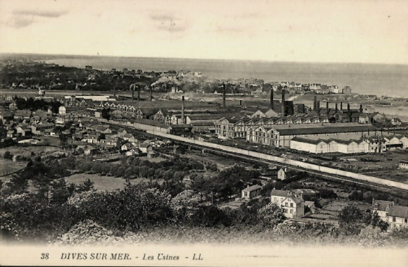 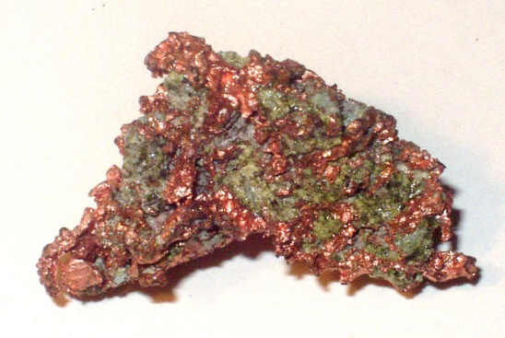 copper ore
The industrial era will mark Dives-sur-Mer in depth and forge a new identity. The railway and the port are assets that seduce the engineer Eugene Secretan and in 1891 the creation of a metallurgical plant turns the city into a thriving industrial city. It operates a copper drawing patent Elmore and Secrétan and will become the French Electrometallurgical Society, later Cegedur and Trefimetaux as and when the diversification of its fabrications: copper, brass, aluminum, duralumin, nickel silver, plastic ... The plant will employ up to 2,000 workers and will still have close to 1,000 workers when it is closed in 1986.

