Project k219
enineering energy vehicle for european environment
(EEVEE)

First Technical activity workshops

Steel Cube Tetrahedron

Description: The objective of this practice is to obtain a cube tetrahedron with steel of 0.8mm thickness and 65mm of length with the help of the tools and materials that we have at our disposal in the workshop.
Use materials: We will have a 200mm x 200mm steel blade in which we must get the six faces of our tetrahedron. To cut these, we will be able to use the radial machine with a cut-off disc, a jigsaw that works with our compressed air system, a metal scissors or a manual saw. Spot welding that we will do with the corresponding machine. If it is necessary to sand the oxidized area at the end of the process we use a polishing machine with a 320 disc. 5mm rivets and their corresponding clincher, pneumatic drill and 5mm drill bit. Finally, to prime the cube, we need paper tape, a cutter and a canister of aerosol primer.
Process to follow:
-Cutting the blade: with the size of 200mm x 200mm, we draw the six squares to be trimmed from 65mm x 65mm. After that, we will cut the squares with one of the possible machines named in the use materials.
-Cut seams: we will cut a small L-shaped plates which will serve us to make the subsequent welding union by points, cut a maximum of 11, but can be cut as many as necessary.
-Rounding vertices: the corners of the tetrahedron faces will be rounded to give a better esthetic to the final piece, it can be done with manual file, with the polishing stone or with the radial machine with a roughing-in equipped disc.
-Welding: Here we see with would be the process of placing the L-unions along with the sheet that would base. The point joints will be made in such a way that there are four in the base as equidistant as possible in separation.
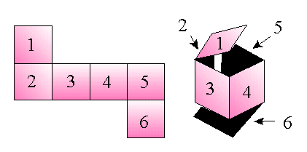
-Placing the last face: the blade that is placed at the top will not be able to place it like the others with welding points for obvious reasons. The way to put it is the following; In the four L located in the upper area where the last face is supported, we will drill with the 5mm bit and the pneumatic drill.

At the same height of where we drill the L will make a perforation in the top plate so, later, can use the rivets 5mm with the clincher. In this way, 65mm of length cube tetrahedron will be completed.

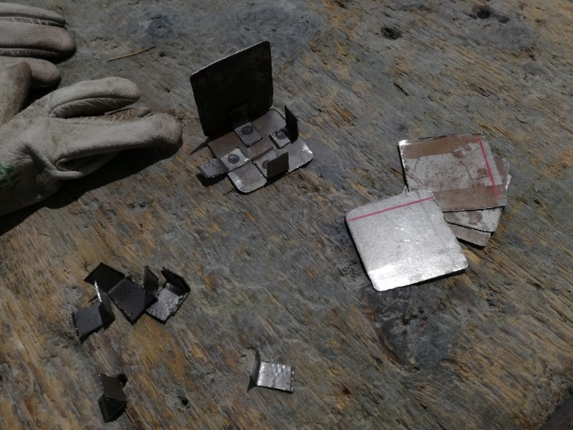

-Priming: With paper tape we mask the rivets in such a way that they are not covered with the priming. Before priming, we must sand it with our polisher and 320p disc to leave it optimally for priming. After removing the oxide, proceed to prime with the aerosol putting about 25/30cm of the piece that will be placed suspended in the air with a cable to be able to prime it correctly. After a few passes, let stand for about 2 hours, remove the masking of the rivets and the practice is finished.

