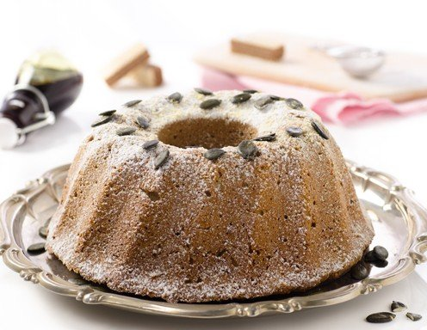
Old Viennese Gugelhupf

Ingredients:
250g butter
250g sugar
1 pkg. vanilla sugar
4 pcs. eggs
lemon peel
350g flour
1 pkg. baking powder
7-8 tbsp milk
100g raisins
50g grated almonds

Preparation
- For the Gugelhupf, whisk butter, sugar and yolk until foamy and add vanilla sugar and lemon peel.

- Mix the baking powder and flour and add the milk. Add the raisins and nuts to the dough. Finally prepare the beaten egg white and fold into the dough.

- Bake the Gugelhupf in a preheated oven at 180 degrees for approx. 60 minutes, allow to cool and serve.

