Martin Schongauer
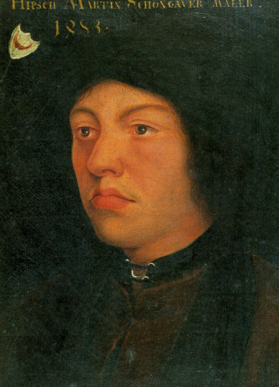
Martin Schongauer was born around 1450 in Colmar and died in 1491 in Vieux-Brisach.
He is a German painter of the late Middle Ages.
It is an engraver on wood and on copper.
He died prematurely in 1491.
Bartholdi realized a statue of him.
This statue is in the Unterlinden Museum in Colmar.

One of his paintings: One of his engravings:

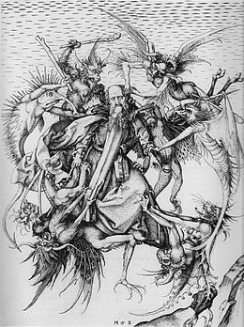
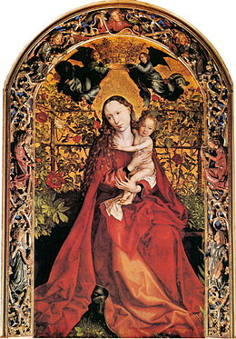
1473 : La Vierge au buisson de roses 1470-1475 : La Tentation de saint Antoine

